

**TECHNICAL UNIVERSITY OF KENYA**

**FACULTY OF APPLIED SCIENCES AND TECHNOLOGY**

**SCHOOL OF COMPUTING AND INFORMATION TECHNOLOGY**

**DEPARTMENT OF COMPUTER SCIENCE AND INFORMATICS**

**PROJECT TITLE: PATAHOSTEL**

PRESENTED BY:

STUDENT NAME: JAMES ALVINE

REG NO: SCEE/02768/2019

SUPERVISED BY: MR. SHADRACK MWANZIA

: MRS. PAMELA JEPKORIR

**PROPOSAL SUBMITTED TO THE SCHOOL OF COMPUTING AND**

**INFORMATION TECHNOLOGY IN PARTICIAL FULFILLEMENT FOR**

**THE DIPLOMA IN TECHNOLOGY IN COMPUTER**

**TECHNOLOGY PROJECT OF THE**

**TECHNICAL UNIVERSITY OF KENYA**

SUBMISSION DATE:

**2023**

# DECLARATION

**DECLARATION BY STUDENTS**

This is to certify that the project report entitled **PATAHOSTEL** being submitted by **JAMES ALVINE** having registration number **SCEE/02768/2019** in partial fulfilment for the award of the Diploma in Technology in Computer Technology project of the Technical University of Kenya.

Name: JAMES ALVINE

Reg. No: SCEE/02768/2019

Signature………………….

Date……………………….

**DECLARATION BY SUPERVISORS**

This project report has been submitted for examination with our approval as the candidates’ University Supervisor.

Mr. SHADRACK MWANZIA

Signature………………….

Date……………………….

Mrs. PAMELA JEPKORIR

Signature…………………

Date………………………

# LIST OF ABBREVIATIONS

**ACRONYMS AND ABBREVIATIONS**

API - Application Programming Interface

i.e. - that is

e.g. – examples

IDE -Integrated Development Environment

# ABSTRACT

Hostel allocation and booking system is a web application that will improve hostel application procedure within Nairobi region more so Ngara, South B and Kasarani and any other part of a given county. This project tends to use google maps to look for nearby hostel locations and online booking application method for hostel rather than physically search for available hostels and physically booking for rooms.

Students always take a lot of time to locate available hostels and at some point, get lost, at some point, the person searching for hostel may be conned by street children and even lost his/he valuable assets.

This is an important project for students since hostel booking will be done online hence ensuring safety of students from street children and also prevent spread of COVID-19. This system is flexible, safe and convenient as is will keep all records with a flexible as every record is secure. The system is easy to locate hostels, Digitizing the booking process making it process by making it online. The system will also have search bar which will enable users to key in their preferred location

Table of Contents

DECLARATION i

LIST OF ABBREVIATIONS ii

ABSTRACT iii

CHAPTER ONE: INTRODUCTION 1

1.1Introduction 1

Problem statement 3

1.4Objective 3

1.4.1 General objectives 3

1.4.2 Specific objectives 3

1.5Justification 4

1.6Scope of study 4

1.7Limitations of the proposed system 4

1.8Project Risk and Mitigation 5

1.8.1Mitigation 5

1.9Project Schedule 6

1.10Budget and Resources 7

CHAPTER TWO: LITERATURE REVIEW 9

2.0Introduction 9

2.1Reviewed similar system 9

*2.1.1Qwetu Hostel* 9

*2.1.2Vuno kejani* 9

*2.1.3Roometo* 10

2.2.0Tools and methodologies used in the reviewed system 10

*2.2.1Qwetu hostel* 10

*2.2.2Vuno Kejani* 11

*2.2.3Roometo* 11

2.3Gaps in the existing systems and the proposed solution. 12

CHAPTER THREE: METHODOLOGY 13

3.1Methodology and data 13

3.1.1Methodology 13

3.1.2Tools to be used in the methodology 15

3.2Sources of data 16

3.3Data collection methods 16

3.4Resources required/materials 17

CHAPTER FOUR: SYSTEM ANALYSISY AND REQUIREMENT MODELING 18

4.1Introduction to the system analysis 18

4.2Objectives of the system analysis 18

4.3Problem definition 18

4.4Feasibility study 18

4.5System analysis tools 19

4.6System investigation 19

4.6.1Introduction 19

4.6.2Data collection 19

4.6.3Fact recording 20

4.7System analysis 20

CHAPTER 5: SYSTEM DESIGN 22

5.1Introduction to system design and nature modelling tool 22

5.2Objectives of system Design 22

5.3Program Design Tools 22

5.4Logical Design 22

5.5Physical Design Description 24

5.5.1 Data Dictionary 24

CHAPTER SIX: SYSTEM IMPLEMENTATION 25

6.1 Coding/Environment/Debugging/Techniques 25

CHAPTER SEVEN: USER MANUAL -DOCUMENTATION 26

7.1 Installation environment 26

7.2 Installation Requirements 26

7.3 Installation Procedures 26

7.4 User instructions 26

7.5 System Conversion Methods 26

7.6 User Training 27

7.7 File conversion 27

***LIST OF FIGURES***

**Figure 1** 2

Figure 2 13

***LIST OF TABLES***

**Table 1. 1** 6

**Table 2** 7

# CHAPTER ONE: INTRODUCTION

# Introduction

Patahostel is web platform that will be designed specifically for students where they can search for available hostel room(s) and accommodation services. As we all know, hostels can be the second home for most students in higher education level. The beautify of this platform is that it helps students more so those new to a given county get their desired hostels directions through the use of geolocator and google navigator which students will find it easy for them to get to their desired hostels.

# Background of the Study

In Kenya, higher level of education i.e., Universities and colleges, at some point they annually admit first years. The current statistic for students’ admission in universities and colleges shows that since 2017 to date shows that there has been increase admission rate in both urban and rural areas. Most students go to universities or collages in constituencies that they have never been to, as a result during their admission, students may not get institutional hostels, or they may prefer different hostels from that of the institution. It always ends in tears and self-pity when students fail to get hostel within their region/ constituencies. ***fig.1*** shows the statistics of students enrolled annually (• Kenya: university enrollment 2017-2021 | Statista March 7, 2022).

The increased number of students enrollment in universities do not also correspond to the expansion of physical infrastructure more so hostel which has made most students finding themselves living off campus(Oluoch, Ndunge, and Musuya n.d.), a situation that at some extent poses a big challenge for most student (Hostels a big problem in higher education - The Citizen March 6, 2022).

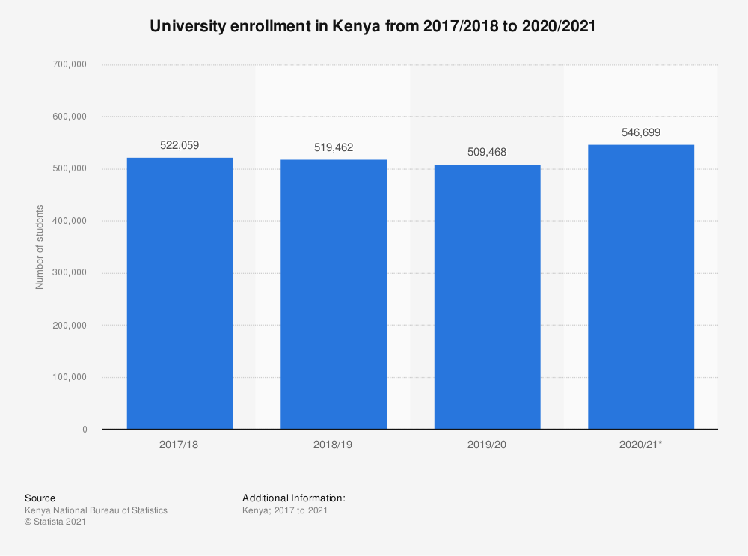

**Figure 1**

Students’ accommodation is an educational input that contributes to the academic performance of students.

There has been hostel shortage, this may happen when a student in need of accommodation missies’ chance for his/her stay. There is a stress of having to shuttle long distance from places of abode to places of study was enough to diminish the energy needed to concentrate on learning.(Hostels a big problem in higher education - The Citizen March 6, 2022).

Therefore, to ease an relieve the kind of stress that most student face when searching for hostels in Kenya. Patahostel website will prevent this stress that most student face(Chandra 2018).

This web-app will enable students from diverse walks of Kenya to easily find hostels of their choice and within their search area, for example, if a student admitted at Technical University of Kenya is new to Nairobi and resides at Mombasa, he/she can easily use Patahostel to get hostel at affordable prices plus their location included.

The available hostel management systems are designed only to manage all hostel activities like hostel admissions, fees, room, mess allotment, hostel stores & generates related reports for smooth transactions. They don’t give directions and any direction to their destinations and some even don’t recommend students to available hostels

Patahostel web-app will be of benefit to student. Once a student has registered an account, he/she will be directed to dashboard where they will give their current location and the user would like to search hostels from, after which the user will get available hostel, the structure of the hostels and how they look inside since the focus of most students is how need the rooms are. Through this process, Patahostel shall have majorly reduce students more so freshers stress level, money that may have been used as transport and time since everything will be done online for hostel and room search.

# Problem statement

With the increased number of students admitted annually, the number of students in need of hostels has also increased making it difficult to get hostel from the institution they have been admitted to. (Hostels a big problem in higher education - The Citizen March 6, 2022).A student who is new in town will end up stressed and confused not knowing where to start from.

# Objective

The core objectives which have been designated as fundamental to the project are:

# General objectives

1. To enable students search for their preferred hostel
2. To register Agents in search for hostel

# Specific objectives

1. To connect students and hostel agents/landlords easily.
2. To Create a web form that will capture details such as Name, email for the Agent
3. To give location for the desired chosen hostel
4. Allow students to register and view hostel details

# Justification

The project will be of much importance to university and college students as it uses it will use google maps to get to know the location of the chosen hostel, another thing to add on, patahosetel will host hostel services for other counties in Kenya.

There will be need to include how each hostel are rated so that students can decide which hostel to go for.

# Scope of study

The proposed system will be able to do the following:

1. Allow other hostel to market their services.
2. Use location feature to get the listed hostel.
3. Show the user available hostel in his/her region.
4. Provide more details about hostels e.g., the security of the hostel.
5. Allow interested students to communicate with the landlord/landlady.

# Limitations of the proposed system

Some of the limitations that are likely to be encountered;

1. *Lack of knowledge* on how APIs works and its use to this system my become a challenge thus the need to have programming knowledge in the development of this system.
2. *Lack of finance* to host the website and purchase of better-quality APIs.
3. *Frequent advancement in technology* whereby from time to time the website will have to be maintained so as to cope up with the technological trends and advancement that happens.
4. *This system entirely relies on internet access*, without the end user will not be able to access the end user may not fully get the of the website and it services. The developer has to remain online while developing the system so that the system can effectively run and deploy its programs.
5. *Time constrain* as the system requires plenty of time to design and ensure that it’s working efficiently.

# Project Risk and Mitigation

Some of the risk that are likely to be faced in the system are:

1. Competition risk. Existing hostel platform tend to have almost similar function an some which may come in the future may cause competition. In which it will lead to high competition of the systems created to do such a task.
2. Financial risk. Market risk is the risk arise when consumer/user of my system are concerned. In case of reduction of consumers that will lead to reduction in the income generated affecting profitability.
3. Security and fraud risk. This includes security of the data stored in the system. Systems are prone to security and fraud issues such as hacking by unauthorized people. This may tend to ruin the privacy of some users’ details.

# Mitigation

1. To help in managing competition, this system will have an extension where new features can be updated to meet the demand that keep on arising. Also, the system will be simple and will cover all aspects required this will make is simple and efficient.
2. The system will be undergoing frequent checkups to ascertain no unauthorized individual access any of the data stored.
3. To avoid market risk, market expansion through online platforms will be necessary so as to be able to access a large market that’s available worldwide. This will maximize profits hence mitigating financial risk created by unavailable market.

# Project Schedule

The project A is to be completed within a time frame of 35days (1 semester). Project B will take 3 Months (1 semester). That will be enough time to account for all conflicts arising and ensure no doubts will come my way.

Some of the project goals include writing the programming code to make the system. This will be done upon accomplishment of the literature review; the system will be designed using sun programs for different tasks. I will also write down literature work that will act as a guideline to whoever will wish to understand how the system was developed. Finally, I will try out system implantation/put to test of the system.

The system basically depends fully on me to develop it and ensure it is running efficiently. My project schedule will be shared by the project supervisor to ascertain everything is done as required.

**Table 1. 1**

# Budget and Resources

Patahostel is an incredible webapp that has combined costs of all activities, task and milestones that the project must fulfil, the total amount needed to finish the project.

The following table show the budget and resources for the software development:

|  |  |  |  |  |
| --- | --- | --- | --- | --- |
| ITEM | COST(Ksh.) | QUANTITY | TOTAL COAST  (Ksh.) | AVAILABILITY |
| Laptop | 35,000 | 1 | 35000 | available |
| Internet bundles plan | 1500 |  | 1500 | available |
| Mobile phone | 15,000 | 1 | 15000 | available |
| ***Total cost*** |  |  | 51,000 |  |

**Table 2**

# CHAPTER TWO: LITERATURE REVIEW

# Introduction

In the market, many systems are designed to manage all hostel activities like admission, fees, room, mess allotment, hostel stores and generates related reports for smooth transactions. Some systems are made such that they do not fit the technological advancement the world has reached.

# Reviewed similar system

# *Qwetu Hostel*

Qwetu Residences are home to more than 3800 students and who get to study, learn and connect with friends and peers. With six residences which are currently operational, Qwetu is the only

Private student accommodation provider in Kenya, the residences are fully equipped to host students during their campus life! (Most preferred student accommodation in Nairobi - Qwetu.co.ke n.d.).

This system favors students available in Nairobi County, the website allows user to key in their details and apply for the available room, thereafter, the user will have to choose the type of room, Qwetu hostel has one of the best luxurious hostels found in Nairobi.

The problem with this system is that it only in a given region which is Nairobi County, which does not favor other student who come from other regions.

Another disadvantage of this hostel is that Qwetu hostel is expensive in that it may not favor every student as some rely in financial aid which may delay at some point.

# *Vuno kejani*

Vuno kejani is a hostel searching platform Kenya. It was founded in 2021 and has helped students from various higher learning institutions find a hostel near the institution that they are learning in. They link up students with agents of various hostels through a user-friendly platform. The various hostels listed in the app and website offer their users an opportunity to select the best hostel according to their preferences and taste. They are not real estate agents. Vuno kejani is a marketplace that displays hostels for students of higher learning institutions who are looking for a hostel to live in Kenya.  
Once you have found a hostel you want to live in, you will contact the agent on the property page. You will send your Email Address and a contact number from which you will be called.

. (Vuno Kejani March 10, 2022).

# *Roometo*

 Roometo is an online platform that specializes in student accommodation. It helps students, both in college and university, find an alternative place to stay. It also provides recommendations and reviews, a way for them to ensure their users settle for the most affordable, secure and comfortable place.

Although officially started in late 2017, it started fiddling with way back in 2013. Henry, co-founder and CEO of Roometo, when he joined campus, he found out that much like other universities Technical University did not have enough accommodation for all its students. It wasn't unique to him alone. His co-founders also suffered the same fate. The co-founder and his team hated the process. A sheet of paper, with a list of names and contacts.” What's a new kid in a new town to do with all that information? We didn't really pursue the idea, until 2017.”

And so, in 2017 they decided to do something about it. It took a few months for them to come up with the first iteration and test it out. It was simple for them, one would simply fill a form expressing interest in a hostel and we would follow up with phone calls March 10, 2022).

# Tools and methodologies used in the reviewed system

# *Qwetu hostel*

*Advantages*

1. Offers 24/7hr service to students.
2. Offers transportation for students
3. has locations for their available hostels

disadvatages

1. it only belongs to Qwetu community and does not provide alternatives to other hostels.
2. it is only available in Nairobi
3. accommodation fee is very expensive

# *Vuno Kejani*

This is a mobile android app that helps students from different counties search for rooms of their choice. It also helps student know their preferred room type at a cheaper rate.(Vuno Kejani March 10, 2022).

Advantages

1. It is available in play store hence easy to access
2. Provides price range of different types of rooms
3. Other available hostels are showcased.
4. Has hostels from other counties.

Disadvantages

* Only people with android phones can use it.

# *Roometo*

Roometo is a web-app that allows student book for room,get their location and select the hostel type plus their price. This platform covers hostel majorly in Nairobi. (About:: Roometo March 10, 2022).

Advantages

1. Roometo has a chat boot which is in real time
2. Readily available online
3. Other available hostels are showcased
4. Provides prices for each type of rooms

Disadvantage

1. This platform is that it only covers Nairobi region

# Gaps in the existing systems and the proposed solution.

The most outstanding problems facing the reviewed systems include; it can be hard to tell if the end user is a student, it is very difficult to know who exactly is in need of hostel without enough evidence.  The best way to avoid such problems is to include a copy of school id and national ID.

Two of the existing systems provide their services only to students available in Nairobi region, this makes it difficult for other students from other counties and only favors students in Nairobi. students from other county also lack hostel and they may need help. In such a case, in order to help other students in other institutions is to provide them with a system better that will entirely serve the whole country.

A cross-platform software application will be of great importance as there are some students who may prefer one platform to another e.g., one may prefer to use webapp to android because he/she may lack space in his device to install smartphone application. A cross platform may be of great importance.

# CHAPTER THREE: METHODOLOGY

Different methodology techniques can be used in research on a proposed system and the specific reason why some methodology techniques are preferable. Data extracted need to be analyzed by efficient analyzing tools to generate accurate information. The system has to be implemented and tested if it is working as intended. All this has got time schedule and project cost. Finally, there is expected final product of the problem being addressed.

# Methodology and data

# Methodology

To develop this system, patahostel will use agile scrum methodology which is a system development methodology of both agile and scrum. With the help of SCRUM, a development methodology which is a sprint-based project management system with the goal of delivering the highest value to stakeholders and agile which is flexible and often used for software development which needs to be finished quickly.

This methodology will also help the project since it relies on incremental developments, where the goal of each sprint is to build the most important features first and come out with a potentially deliverable product. More features are built into the product in subsequent sprints and are adjusted based on stakeholder and customer feedback between sprints.

Moreover, other project management methods emphasize building an entire product in one operation from start to finish, agile scrum methodology focuses on delivering several iterations of a product to provide stakeholders with the highest business value in the least amount of time.

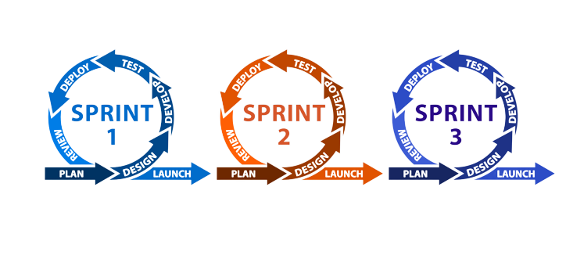

Figure 2

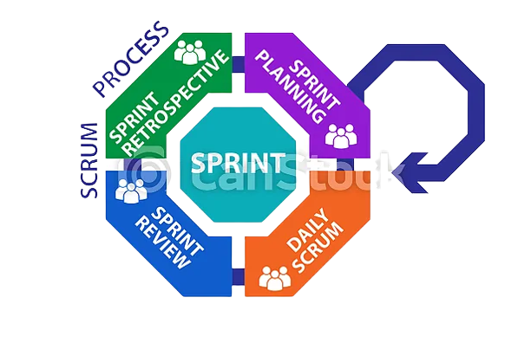

Figure 3

Steps in Agile Scrum

*The scrum methodology consists of the following phases:*

1. **Initiate** - This phase includes the processes related to initiation of a project: Create Project Vision, Identify Scrum Master and Stakeholder(s), Form Scrum Team, Develop Epic(s), Create Prioritized Product Backlog, and Conduct Release Planning.
2. **Plan and Estimate** -This phase consists of processes related to planning and estimating tasks, which include Create User Stories, Approve, Estimate, and Commit User Stories, Create Tasks, Estimate Tasks, and Create Sprint Backlog.
3. **Implement**- This phase is related to the execution of the tasks and activities to create a project's product. These activities include creating the various deliverables, conducting Daily Standup Meetings, and grooming (i.e., reviewing, fine-tuning, and regularly updating) the Product Backlog at regular intervals.
4. **Review and Retrospect**- This phase is concerned with reviewing the deliverables and the work that has been done and determining ways to improve the practices and methods used to do project work.
5. **Release**- This phase emphasizes on delivering the Accepted Deliverables to the customer and identifying, documenting, and internalizing the lessons learned during the project.

# Tools to be used in the methodology

1. Use of flow chart

System flow chart are a way of displaying how data flows in a system and how decisions are made to control event. The use of flow chart will be of importance since it will illustrate how each symbol connected together to show what happens to data and where it goes which will be drawn using open-source tool called flowchart maker.

1. Use Case diagram

This is a graphical depiction of a user's possible interactions with a system. A use case diagram shows various use cases and different types of users the system has and will often be accompanied by other types of diagrams as well.

The use of case diagram will be of great help as the graphical representation will bring more meaning as it drills a lot of details due to how it provides higher-level view of the system.

1. Entity relationship diagram

An entity relationship diagram is used in software development during planning phase of a project. They are used to visualize the database tables and their relationship; they can also be used for troubleshooting the database. This proposed project will use entity relationship diagram entities are related to each other.

# Sources of data

Data is essential, this system rely heavily on data from different sources

1. *primary sources*

This is a data collected for the first time by the. The sources I will employ will include; conducting interviews, questionnaires, government census and huma observation

1. *secondary data*

this is a data collected from another source which could be primary data but collated by a pervious researcher e.g., internet research.

This type of data cannot be traced back to the level of individual cases.

# Data collection methods

Patahostel will use the following methods to certain that they will work effectively:

1. Questionnaires

This is one of the most common used methods of getting information because they are easy to administer. The developer will use questionnaire as a way to get information from students who come from different universities. Since we are in a digital world, it will be easier to share the links through social media like WhatsApp which will make it cost effective.

1. Observations

Observation is the use of eyesight to see and ears to listen to what is happening in our environment. This method will effective during admission periods. Through observation, it will be possible to see how students will line up to get school accommodation.

# Resources required/materials

*Hardware specifications*

1. One Laptop with at least Memory RAM of 4GB and above.
2. ROM of 500GB and above, Core i5 Processor with 2GHz or more.
3. System type: 64-bit Operating system)
4. Network interface card (Wireless adapter-WIFI)

*Software specifications*

1. Windows operating system.
2. Visual studio – this is an IDE that will help when using react framework.
3. Backend development tools – they will include mongo DB for database and firebase for authentication.
4. Antivirus- Kaspersky Antivirus.

# CHAPTER FOUR: SYSTEM ANALYSISY AND REQUIREMENT MODELING

# Introduction to the system analysis

in this chapter, system analysis will involve studying current *patahostel* system. Starting from creating account, searching/ filtering preferred hostel to booking the desired room and location, will break each micro-service and see the system functionality and interrelationship. This helps a lot in determining system problems.

# Objectives of the system analysis

Some of the system analysis objective include:

1. To see if the output is of value to end user.
2. To produce a model of the final system.
3. To identify improvements.
4. To define requirement for the new system.

# Problem definition

1. Newly enrolled students may lack accommodation services from their host institution and may be forced to look for an alternative somewhere else.
2. Time consuming for students to walk from street to street in search for hostel/rental houses.

# Feasibility study

Technically, the system requires One Laptop (Memory RAM: 4GB and above, ROM: 500GB and above, Processor 2GHz or more, Core i5, System type: 64-bit Operating system), Internet connection (Wireless adapter-WIFI), Software (Visual Studio. These are simple gargets that can be found easily.

Economically, the system requirements are economically managed. Most of the requirements such as laptop and internet connection are readily available. The expected expenditure on the system is as follows; 1 Laptop – Ksh. 35,000(available), a smartphone -Ksh 15,000(Available) and internet bundles – Ksh1000. The total cost amounts to Ksh. 51,000.

Legally, the system is permitted as it is environment friendly, it does not pollute the environment in whatever way. In fact, it reduces the paper work hence reducing paper trash. The system will also be original and has its own copyright and documentation. The system will perform the specified job and not any other.

Operational wise, the system run and maintenance will be done to keep it alive

On schedule plan, the project A is to be completed within a time frame of 93 days (1 term). That is term 1 year 3. Project B will take 3 Months (1 term). By then I should have had enough time to account for all conflicts arising and ensure no doubts will come my way.

The proposed system is viable and possible. The project cost is affordable, technically the system will work efficiently to perform the intended purpose, the time allocated to design the project is enough to cover all aspects of the system. Legal issues are all taken in consideration and the system fits. Based on technical, economical, operational and schedule feasibility, all aspects are achievable.

# System analysis tools

Some of the design tools used include.

1. Flow chart

A flowchart is a picture of the separate steps of a process in sequential order. It is a generic tool that can be adapted for a wide variety of purposes, and can be used to describe various processes, such as a manufacturing process, an administrative or service process, or a project plan.

1. Use of case diagram

This is a graphical depiction of a user's possible interactions with a system. A use case diagram shows various use cases and different types of users the system has and will often be accompanied by other types of diagrams as well.

# System investigation­­

# Introduction

System investigation is meant to find out what the system is being built to do and if the system is possible to develop.

# Data collection

This contains methods for data collection.

1. Questionnaires

This is one of the most common used methods of getting information because they are easy to administer.

1. Observations

Observation is the use of eyesight to see and ears to listen to what is happening in our environment. This method will effective during admission periods.

# Fact recording

The existing and the new developed system requires the following; On input; a keyboard to type the data into the system and a phone to key in details. One output requirement we use the monitor/screen to display the output. System requirements, the computer should have at least 4GB RAM 500GB ROM, Windows Operating System and vs code as code editor. On the system personnel, he/she should be skilled in data entry through typing and also basic knowledge of using website to apply for rooms which is work of observation.

# System analysis

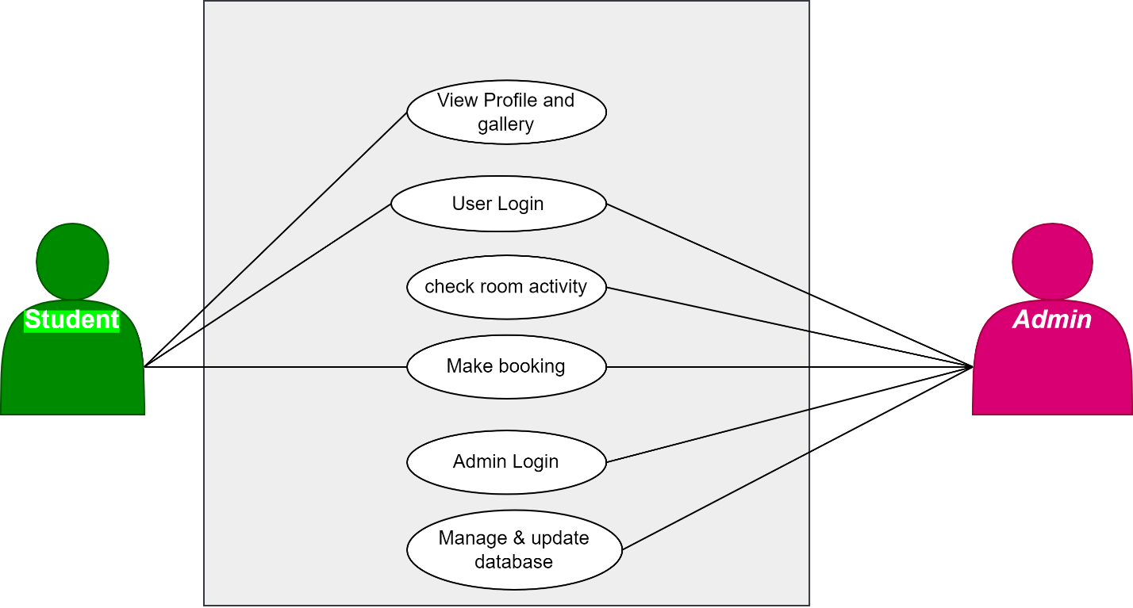

***Fig .3*** *Fig 3 shows a use case diagram where students can apply and the process involved in hostel application*.

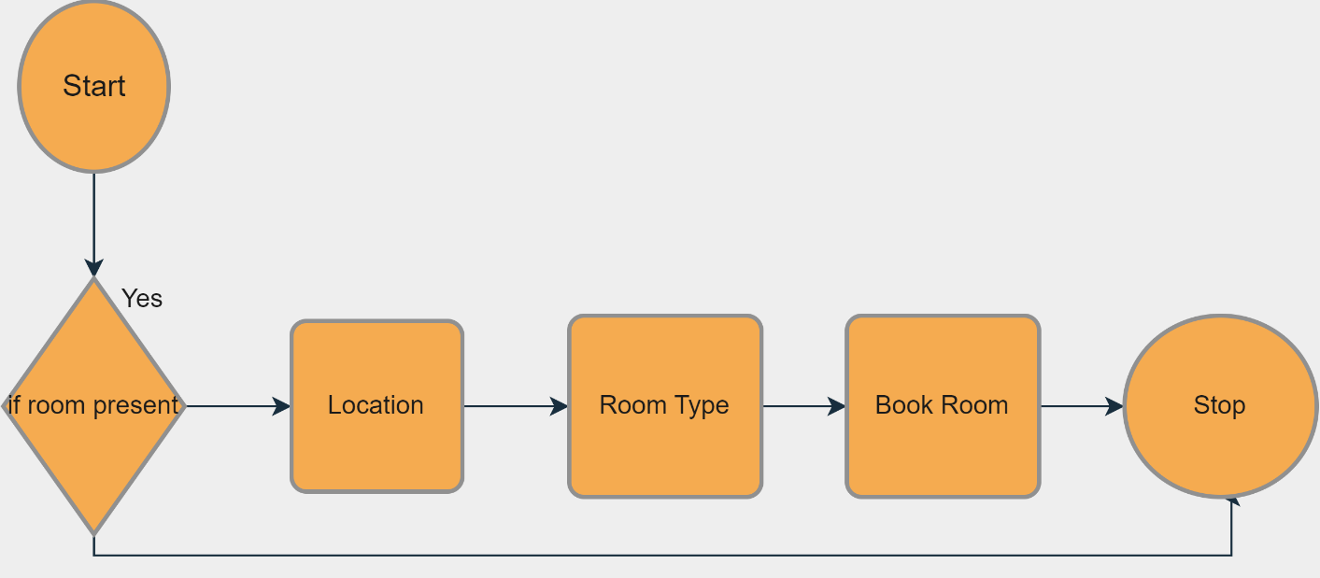

Fig 4 System Flowchart

# CHAPTER 5: SYSTEM DESIGN

# Introduction to system design and nature modelling tool

Upon the design of this system, university students should be able to use the web app to apply for their desired hostel.

# Objectives of system Design

Some of the design objective include:

1. To Determine how the new system will operate.
2. To make sure that the output is of more value to the end user.
3. To determine if the system objectives are obtained.

# Program Design Tools

This Consists of the steps a programmer should do before they start coding the program in a specific language.

Some of the program design tools used;

1. Flow chart

A flowchart is a picture of the separate steps of a process in sequential order. Flowchart will show the chronological order of various processes along with data coming in and going out of each process to achieve a meaningful information.

1. Case diagram

This is a graphical depiction of a user's possible interactions with a system. A use case diagram shows various use cases and different types of users the system has and will often be accompanied by other types of diagrams as well.

# Logical Design

* + 1. **Logical Data Design-Normalization to generate tables**

This is a graphical depiction of a user's possible interactions with a system. A use case diagram shows various use cases and different types of users the system has and will often be accompanied by other types of diagrams as well.

First Normal form

This is a graphical depiction of a user's possible interactions with a system. A use case diagram shows various use cases and different types of users the system has and will often be accompanied by other types of diagrams as well.

Second normal form

Here, every non-prime attribute should be fully functionally dependent on prime key attribute.

Third normal form

There is No dependencies on non-key attributes

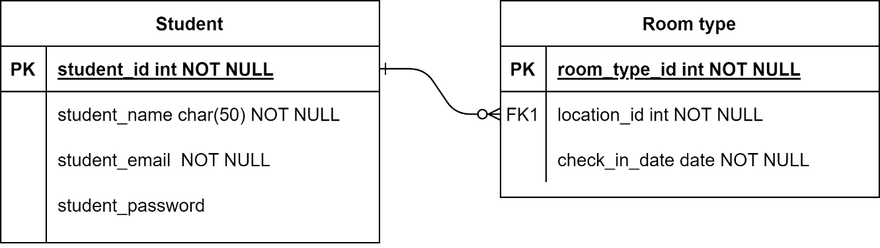

* + 1. Entity Attributes relationship

This Visualizes the relationship between entities.

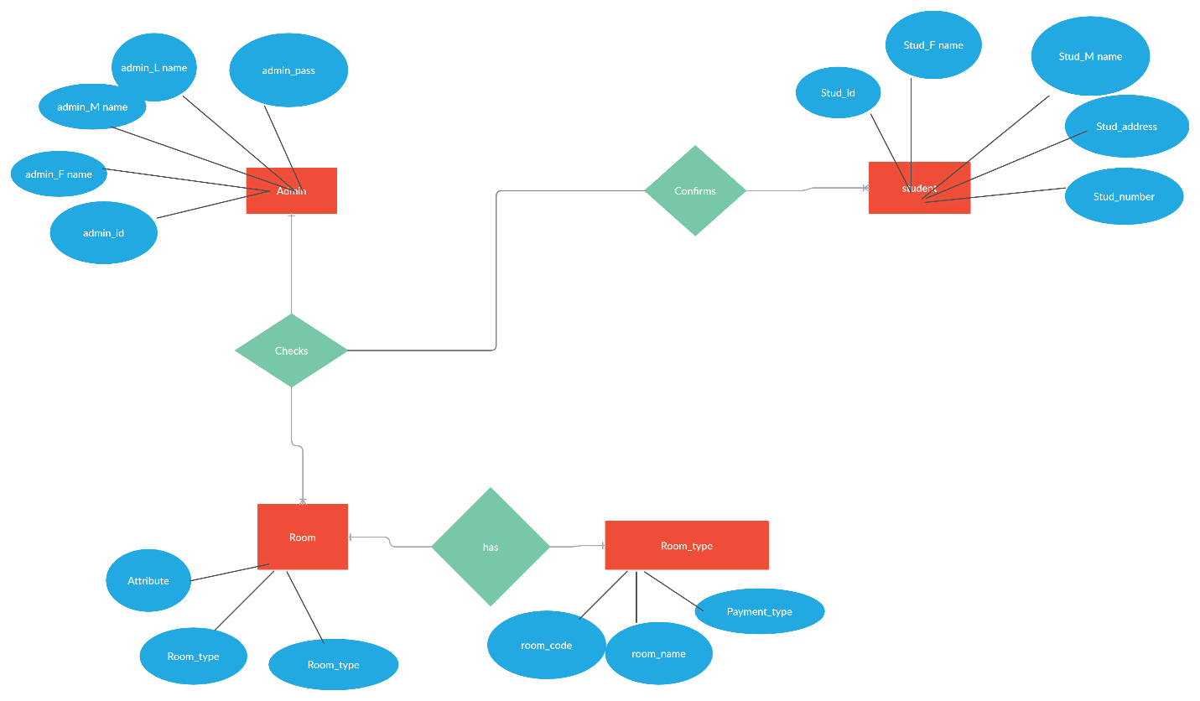

* + 1. Entity Life History

Entity life history (ELH) is diagrammatic method of recording how the information may change over time, and models the complete catalogue of events that can affect a data entity from its creation to its deletion, the context in which each event might occur, and the order in which event may occurs.

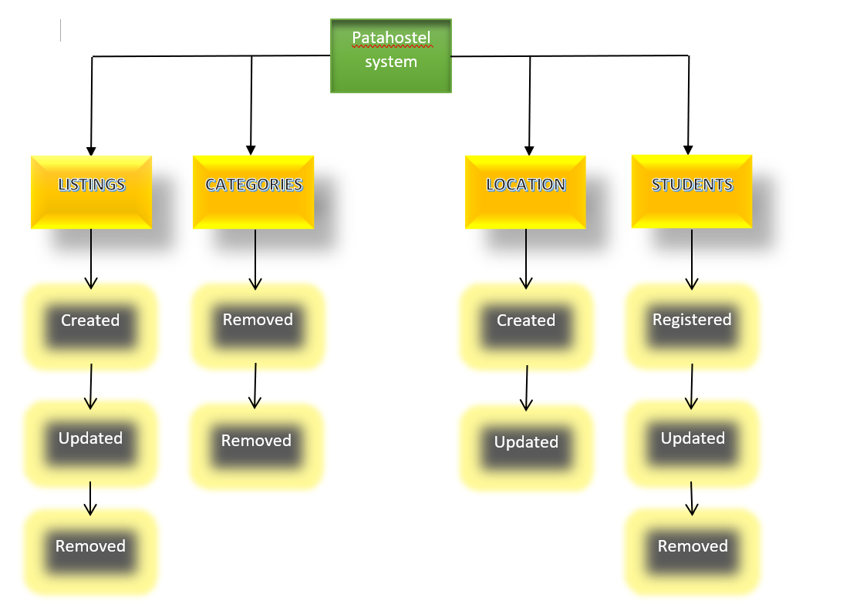

*Fig 5.4.3 entity life history*

**Students entity**

Having this entity, students can register and system administrator can remove or update details.

**Location entity**

Here, the student can choose location and the administrator update or even create new locations.

listings

# Physical Design Description

This focuses on how data is entered into a system, verified, processed, and displayed as output. It produces the working system by defining the design specification that specifies exactly what the candidate system does.

### Data Dictionary

Data dictionary contains metadata, that is about the database. The dictionary is very important as it contains information such as what is in the database, who is allowed to access

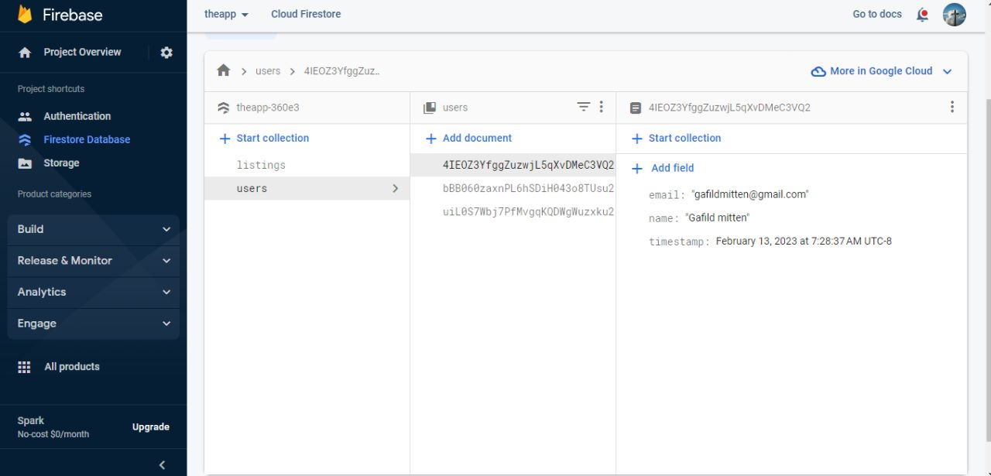

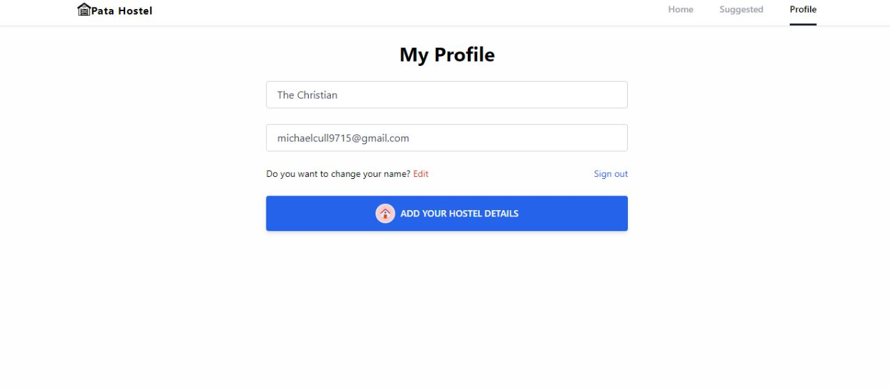

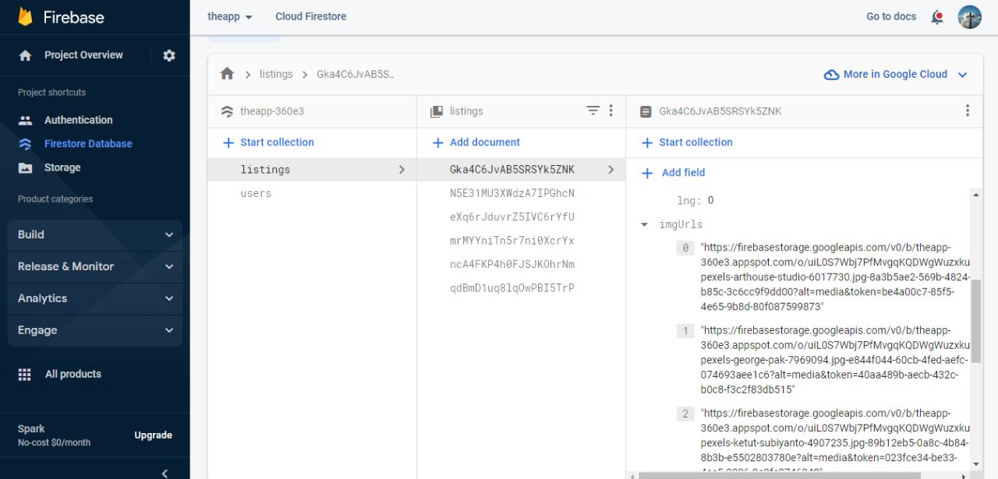

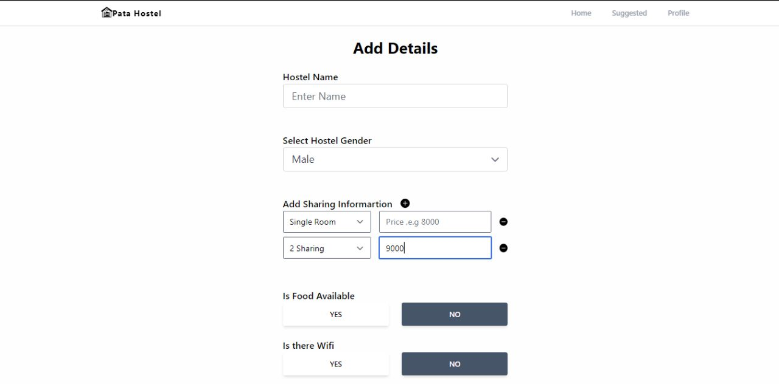

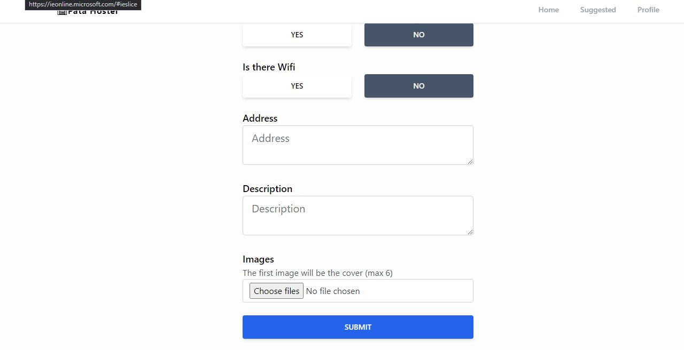

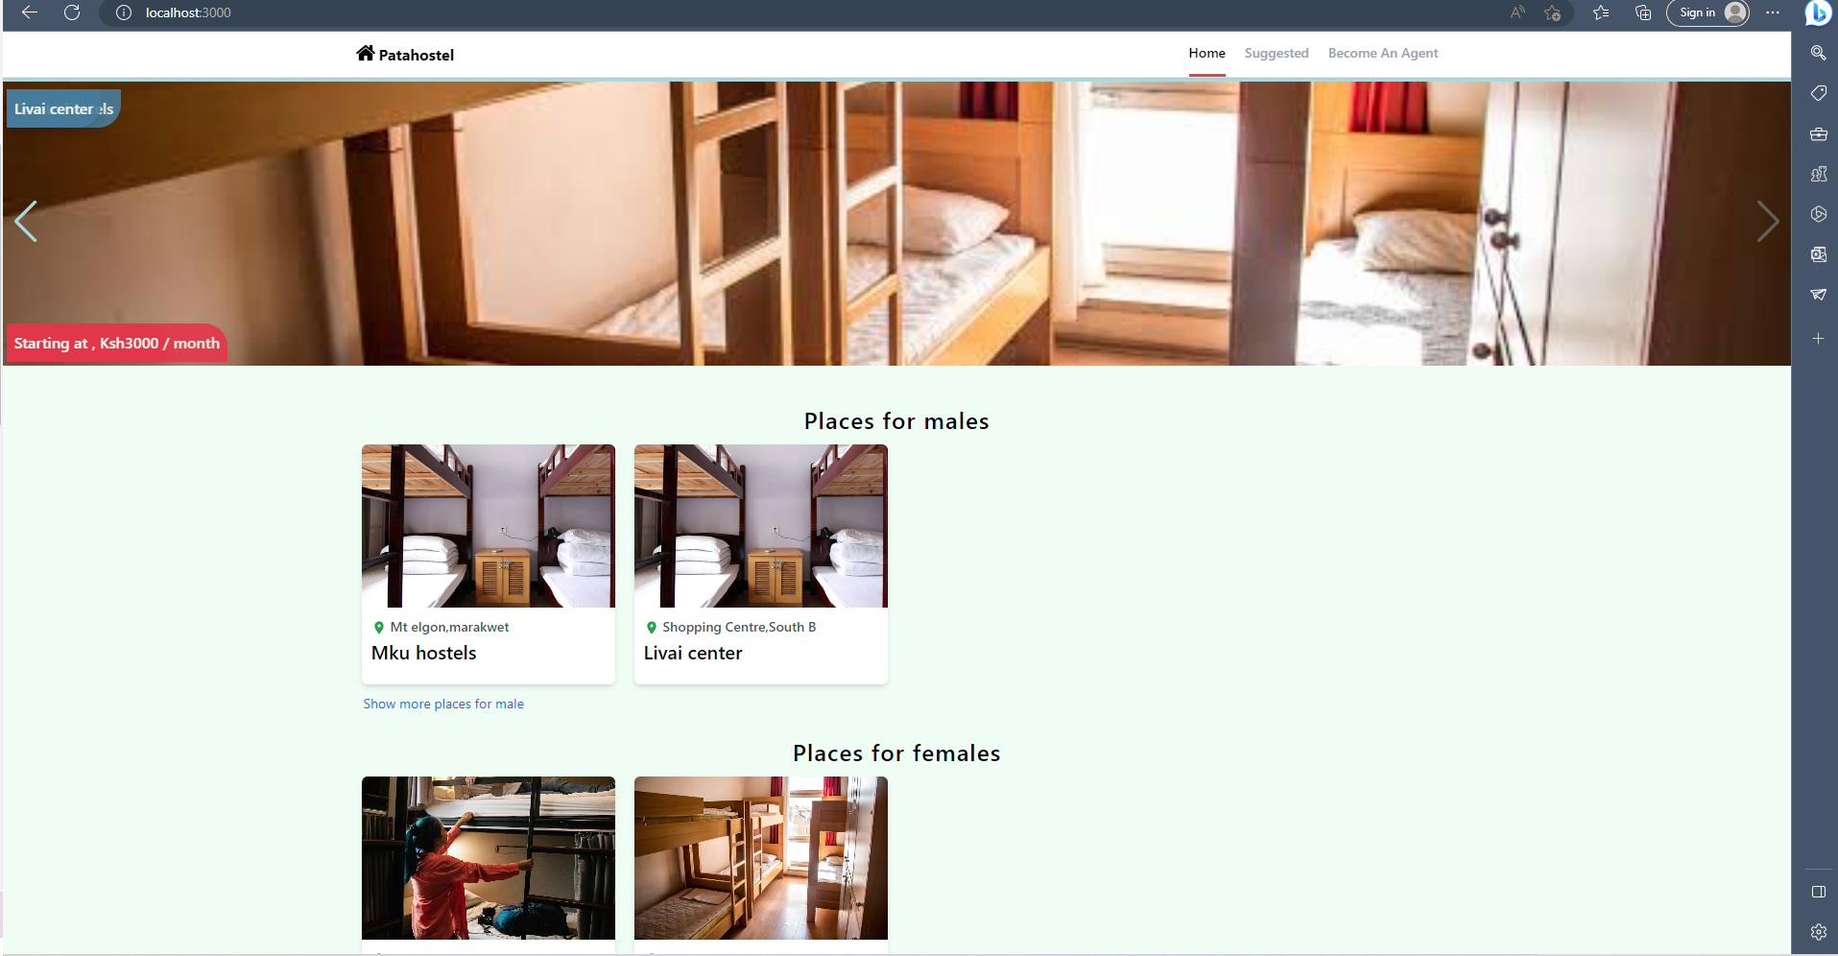

# CHAPTER SIX: SYSTEM IMPLEMENTATION

### Coding/Environment/Debugging/Techniques

Patahostel web app implemented coding using html, JavaScript and boostrap5, the environment used in the process of development and debugging is visual studio.

* 1. **Program listing**

Program listing is the complete listing of a computer program, source code, and all files that make up the software program.

* 1. **Test system/program testing**

System testing is the level of testing that validate the complete and fully integration of software. The purpose of a system test is to evaluate the end-to-end system specifications.

System Testing involves testing the software code for following:

1. Testing the fully integrated applications including external peripherals in order to check how components interact with one another and with the system as a whole. This is also called End to End testing scenario.
2. Verify thorough testing of every input in the application to check for desired outputs.
3. Testing of the user’s experience with the application.
   1. **Test Plan**

Unit testing is used in this module testing to validate that each module is functioning as it should. A good example is student login and signup.

* 1. **Test Data**

Unit testing is used in module testing to validate that each module is functioning as it should be. A good example is the students login and register page

* 1. Sample Run-Output Result

# CHAPTER SEVEN: USER MANUAL -DOCUMENTATION

This manual gives you a step-by-step overview of how to set up patahostel.

## **Installation environment**

For the environment to run smoothly and properly, bellow is the require the following program:

1. Operating system windows, Linux or macOS
2. Browser; any browser, most preferred (chrome)
3. Text editor (Vs code)
4. Hosting server (netlify, localhost and Git repository hosting services)

## **Installation Requirements**

In order to install Patahostel webapp, you should have a computer of 4GB RAM,500GB Hard disk and any of the listed operating system.In addition, 5GB of internet bundles is required.

You should have any text editor of your choice, if you don’t have one, use the following link to download vs code: <https://code.visualstudio.com/>

Be sure to use node.js/nvm, use the following link to install for your desired OS. https://nodejs.org/en/

## **Installation Procedures**

In order to install and run the application smoothly, you should:

1. get into <https://github.com/JamesAlvine/hostel> and clone it in your desired file location (*git clone* [*https://github.com/JamesAlvine/hostel*](https://github.com/JamesAlvine/hostel) ).
2. when done cloning, make sure that you run *git install* and git *update* to update the repo to avoid bugs.
3. When done, be sure to run *npm start* in order to run the server locally.

## **User instructions**

For a student to access patahostel services on his laptop or phone, he must be connected to the internet.

For a student to also access the booking section, he must be logged in to the patahostel account or register first.

## **System Conversion Methods**

The system conversion used are:

Direct cut over, this is where I can convert an old system into the new system when the new system becomes operational. It is less expensive and involves less risk of system failure.

Parallel conversion. The old and the new system will work together for a period of time before the new system completely takes it over.

**CHAPTER EIGHT: LIMITATIONS, CHALLENGES, CONCLUSION AND RECOMMENDATION**

## **Limitation and challenges**

The following are some of the restrictions and difficulties I encountered while researching and developing the system:

Time constraint: Due to the commencement of the project, gathering of requirements, and system installation, there was a time limit. Nevertheless, I made every effort to stay to the schedule and finish inside the time.

Internet: While designing the system, I frequently had to rely on the school's Wi-Fi, which occasionally went down, to add specific features or integrate them.

## **Degree of success**

Since the system needs to be updated frequently to enhance user experience and efficiency, the project's success rate is approximately 95%.

## **Learning experience**

This has been a beneficial learning experience because it has helped me identify my areas for improvement and served as advice for managing system development projects in the real world.

## **Conclusion**

In summation, the system is now hosted and available for use by Patahostel Company and customers.

## **recommendation**

System updates that also boost system performance are necessary to enhance user interface, reliability, and new technology.

**REFFERENCES**

“• Kenya: University Enrollment 2017-2021 | Statista.” https://www.statista.com/statistics/1135785/university-enrollment-in-kenya/ (March 7, 2022).

“About :: Roometo.” https://roometo.com/about (March 10, 2022).

Chandra, Pooja. 2018. “A Study of Stress among Hostellers.” *International Journal of Science and Research* 8: 2319–7064. www.ijsr.net.

“Hostels a Big Problem in Higher Education - The Citizen.” https://www.thecitizen.co.tz/tanzania/magazines/success/hostels-a-big-problem-in-higher-education-2615654 (March 6, 2022).

“Most Preferred Student Accommodation in Nairobi - Qwetu.Co.Ke.” https://qwetu.co.ke/ (March 10, 2022).

Oluoch, Kelly, Miriam M Ndunge, and Alloys W Musuya. *THE INFLUENCE OF AVAILABILITY OF COLLEGE HOSTEL ACCOMODATION FACILITIES ON STUDENTS’ ACADEMIC PERFORMANCE IN KENYA MEDICAL TRAINING COLLEGES IN WESTERN KENYA REGION*. www.iprjb.org.

“Vuno Kejani.” https://apppage.net/preview/com.vunostore.test (March 10, 2022).