# Welcome to your English activity worksheet

### Activity 1

Talk about each of the images (What, where, who, how, why). Use your imagination.

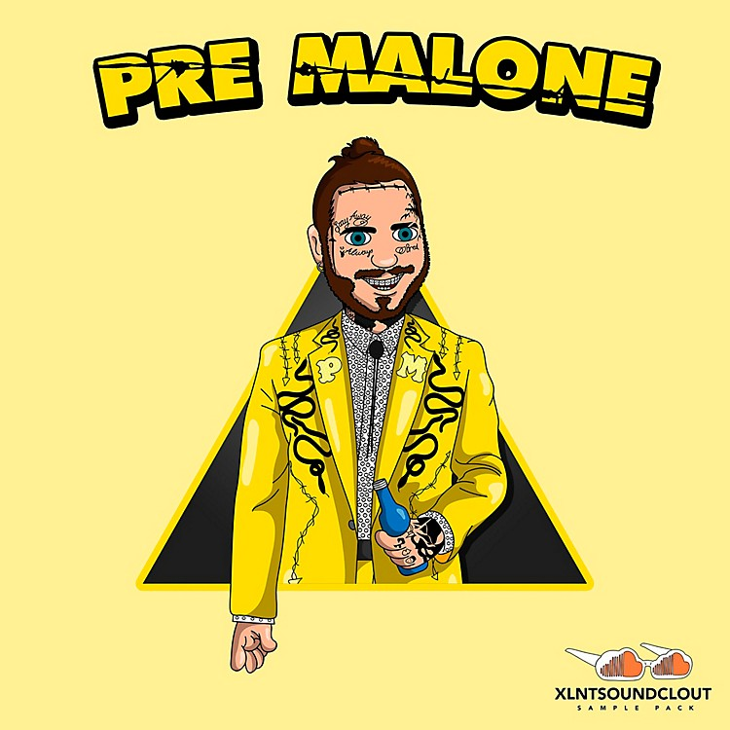

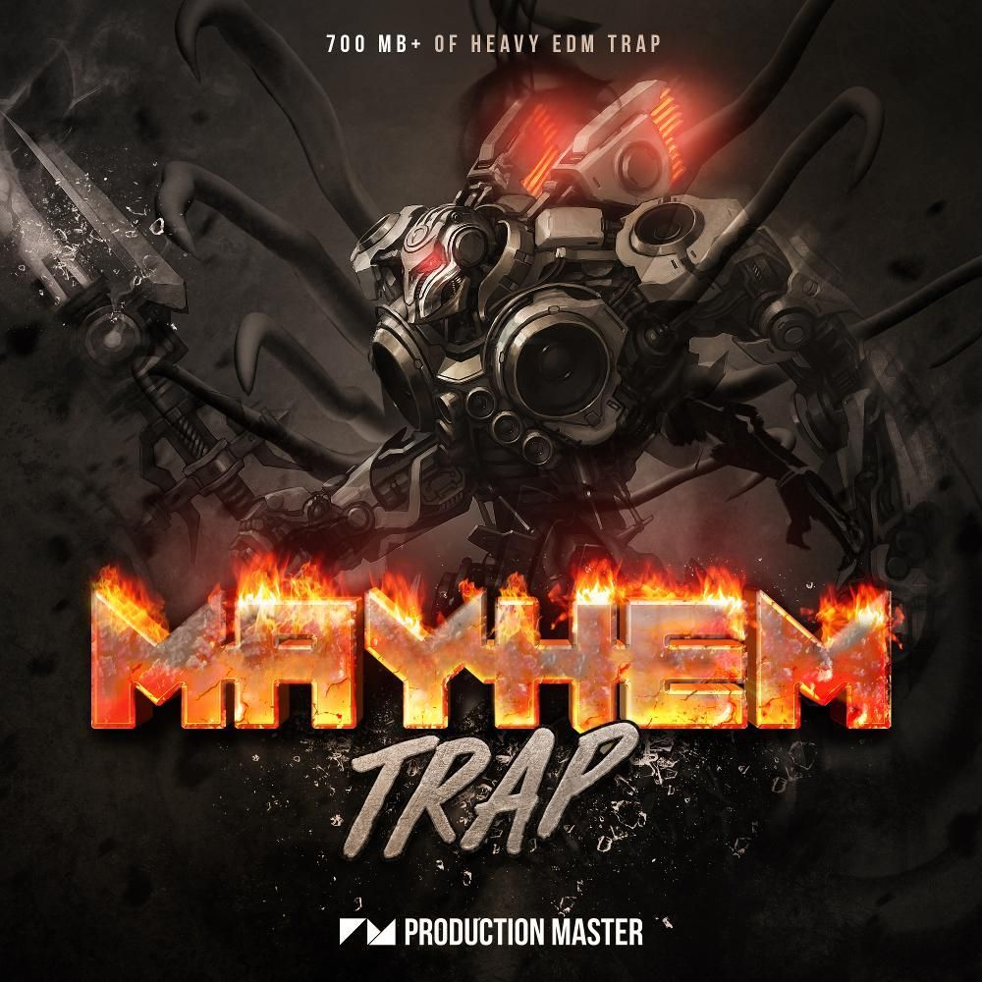

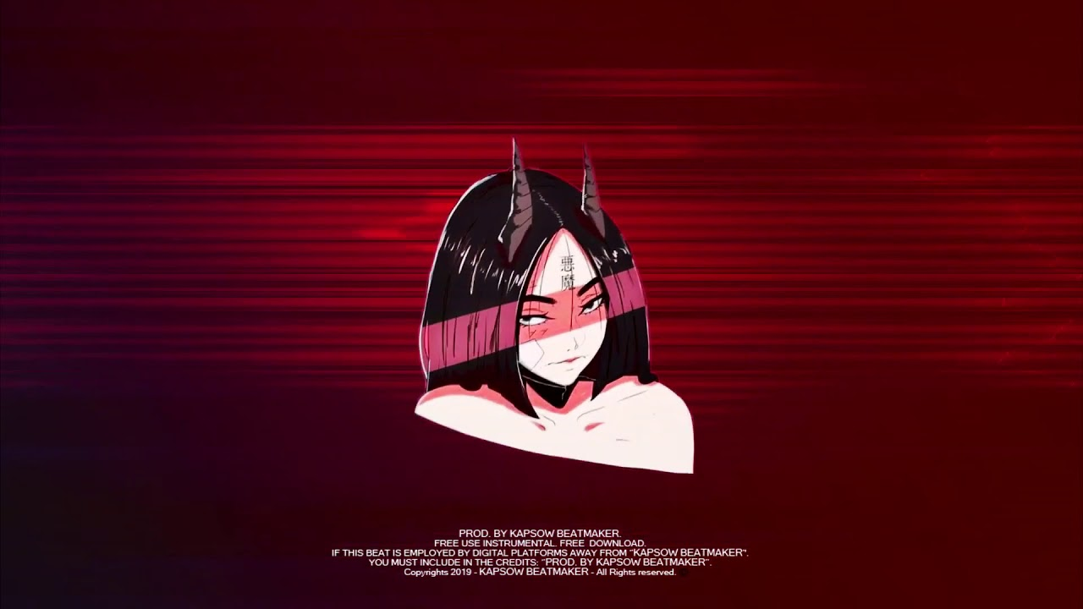

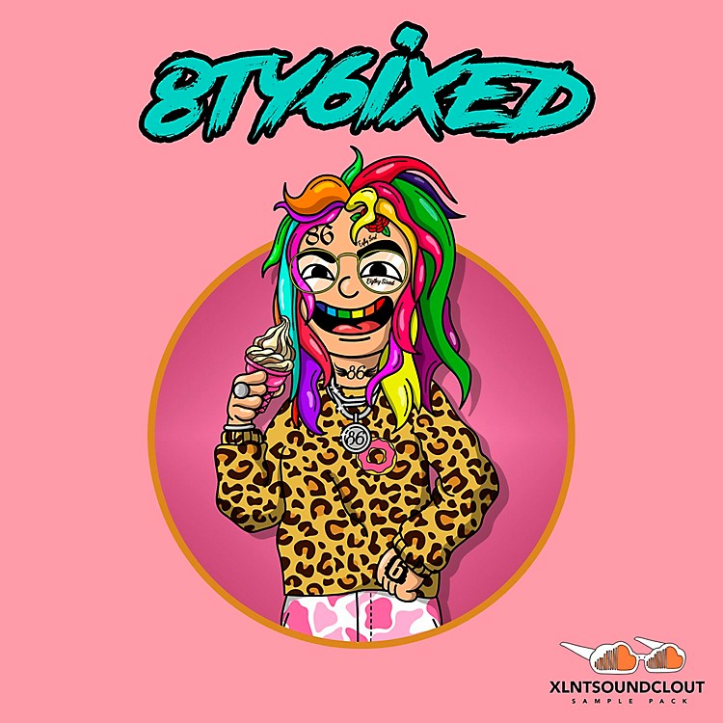



### Activity 2

Read the below article.

##### Characteristics

In trap music, lyrical themes must revolve around the general life and culture in the "trap" or in the actual southern "trap house" where narcotics are being sold. The term "trap" refers to places where drug deals take place. Other topics also include street life, acquiring wealth, violence, American vehicles, and life experiences that artists have faced in their southern American surroundings. By definition, if the "trap" is not discussed in the song, it is not "trap" music.

Trap music employs multilayered thin- or thick-textured monophonic drones with sometimes a melodic accompaniment expressed with synthesizers; crisp, grimy, and rhythmic snares, deep 808 kick drums, double-time, triple-time, and similarly divided hi-hats, and a cinematic and symphonic use of string, brass, woodwind, and keyboard instruments to create an energetic, hard-hitting, deep, and variant atmosphere. These primary characteristics, the signature sound of trap music, originated from producer Shawty Redd. Trap may use a range of tempos, from 50 BPM (programmed at 100 BPM to achieve finer hi-hat subdivision) to 88 (176) BPM, but the tempo of a typical trap beat is around 70 (140) BPM.

Early producers creating trap music included Lil Jon from Atlanta, Georgia, where the term originated as a reference to places where drug deals are made, who along with Mannie Fresh from New Orleans and DJ Paul from Memphis, Tennessee worked with local acts in Atlanta including Dungeon Family, Outkast, Goodie Mob, and Ghetto Mafia. In 1992, one of the earliest records to release was UGK's "Cocaine In The Back of the Ride" from their debut EP, "The Southern Way". Later in 1992, they released the popular "Pocket Full of Stones" from their major-label debut album Too Hard to Swallow. It was also featured in the 1993 film Menace II Society. In 1996, Master P released his single "Mr. Ice Cream Man" from his fifth studio album Ice Cream Man. Fans and critics started to refer to rappers whose primary lyrical topic was drug dealing as "trap rappers". T.I.’s 2001 song "Dope Boyz", from his debut album I'm Serious, includes the lyrics "the dope boyz in the trap nigga / the thug nigga, drug dealer where you at". David Drake of Complex wrote that "the trap in the early 2000s wasn't a genre, it was a real place", and the term was later adopted to describe the "music made about that place".

##### History

Early producers creating trap music included Lil Jon from Atlanta, Georgia, where the term originated as a reference to places where drug deals are made, who along with Mannie Fresh from New Orleans and DJ Paul from Memphis, Tennessee worked with local acts in Atlanta including Dungeon Family, Outkast, Goodie Mob, and Ghetto Mafia. In 1992, one of the earliest records to release was UGK's "Cocaine In The Back of the Ride" from their debut EP, "The Southern Way". Later in 1992, they released the popular "Pocket Full of Stones" from their major-label debut album Too Hard to Swallow. It was also featured in the 1993 film Menace II Society. In 1996, Master P released his single "Mr. Ice Cream Man" from his fifth studio album Ice Cream Man. Fans and critics started to refer to rappers whose primary lyrical topic was drug dealing as "trap rappers". T.I.’s 2001 song "Dope Boyz", from his debut album I'm Serious, includes the lyrics "the dope boyz in the trap nigga / the thug nigga, drug dealer where you at". David Drake of Complex wrote that "the trap in the early 2000s wasn't a genre, it was a real place", and the term was later adopted to describe the "music made about that place".

During the early- to mid-2000s, trap music began to emerge as a recognized genre after the mainstream success of a number of albums and singles with lyrics that covered life in "the trap", drug dealing and the struggle for success. Several Southern rappers with drug dealer personas such as T.I., Young Jeezy, Gucci Mane, Boosie Badazz, Young Dolph, Lil Wayne, and Rick Ross produced crossover hits and helped expand the popularity of the genre, with trap records beginning to appear more heavily on mixtapes and radio stations outside of the South. Though trap artists were somewhat diverse in their production styles, the signature and quintessential trap sound (typically based around synth, orchestra, and string swells with tight, bass-heavy 808 kick drums) that would come to be associated with the genre developed in Atlanta during trap's mid-2000s breakthrough. Some of the notable trap producers during the mid to late 2000s include DJ Toomp, Fatboi, Drumma Boy, Shawty Redd, D. Rich, and Zaytoven. The first wave of the trap sound was influenced by earlier Southern producers such as Lil Jon, Mannie Fresh, and DJ Paul.

With the exception of Outkast, let me think, Goodie Mob... with the exception of that, before I came in the game, it was Lil Jon, Outkast, Goodie Mob, okay so you had crunk music and you had Organized Noize. There was no such thing as trap music, I created that, I created that. I coined the term, it was my second album, Trap Muzik it dropped in 2003. After that, there was an entire new genre of music created. An open lane for each of you to do what you do, and live your lives, on T.V., and be accepted by the masses. The masses have accepted you 'cause I opened the door and you walked through it. Don't forget who opened that door, cuz.

##### 1990s–2003: Origins

Early producers creating trap music included Lil Jon from Atlanta, Georgia, where the term originated as a reference to places where drug deals are made, who along with Mannie Fresh from New Orleans and DJ Paul from Memphis, Tennessee worked with local acts in Atlanta including Dungeon Family, Outkast, Goodie Mob, and Ghetto Mafia. In 1992, one of the earliest records to release was UGK's "Cocaine In The Back of the Ride" from their debut EP, "The Southern Way". Later in 1992, they released the popular "Pocket Full of Stones" from their major-label debut album Too Hard to Swallow. It was also featured in the 1993 film Menace II Society. In 1996, Master P released his single "Mr. Ice Cream Man" from his fifth studio album Ice Cream Man. Fans and critics started to refer to rappers whose primary lyrical topic was drug dealing as "trap rappers". T.I.’s 2001 song "Dope Boyz", from his debut album I'm Serious, includes the lyrics "the dope boyz in the trap nigga / the thug nigga, drug dealer where you at". David Drake of Complex wrote that "the trap in the early 2000s wasn't a genre, it was a real place", and the term was later adopted to describe the "music made about that place".

During the early- to mid-2000s, trap music began to emerge as a recognized genre after the mainstream success of a number of albums and singles with lyrics that covered life in "the trap", drug dealing and the struggle for success. Several Southern rappers with drug dealer personas such as T.I., Young Jeezy, Gucci Mane, Boosie Badazz, Young Dolph, Lil Wayne, and Rick Ross produced crossover hits and helped expand the popularity of the genre, with trap records beginning to appear more heavily on mixtapes and radio stations outside of the South. Though trap artists were somewhat diverse in their production styles, the signature and quintessential trap sound (typically based around synth, orchestra, and string swells with tight, bass-heavy 808 kick drums) that would come to be associated with the genre developed in Atlanta during trap's mid-2000s breakthrough. Some of the notable trap producers during the mid to late 2000s include DJ Toomp, Fatboi, Drumma Boy, Shawty Redd, D. Rich, and Zaytoven. The first wave of the trap sound was influenced by earlier Southern producers such as Lil Jon, Mannie Fresh, and DJ Paul.

With the exception of Outkast, let me think, Goodie Mob... with the exception of that, before I came in the game, it was Lil Jon, Outkast, Goodie Mob, okay so you had crunk music and you had Organized Noize. There was no such thing as trap music, I created that, I created that. I coined the term, it was my second album, Trap Muzik it dropped in 2003. After that, there was an entire new genre of music created. An open lane for each of you to do what you do, and live your lives, on T.V., and be accepted by the masses. The masses have accepted you 'cause I opened the door and you walked through it. Don't forget who opened that door, cuz.

##### 2003–2015: Rise in mainstream popularity

During the early- to mid-2000s, trap music began to emerge as a recognized genre after the mainstream success of a number of albums and singles with lyrics that covered life in "the trap", drug dealing and the struggle for success. Several Southern rappers with drug dealer personas such as T.I., Young Jeezy, Gucci Mane, Boosie Badazz, Young Dolph, Lil Wayne, and Rick Ross produced crossover hits and helped expand the popularity of the genre, with trap records beginning to appear more heavily on mixtapes and radio stations outside of the South. Though trap artists were somewhat diverse in their production styles, the signature and quintessential trap sound (typically based around synth, orchestra, and string swells with tight, bass-heavy 808 kick drums) that would come to be associated with the genre developed in Atlanta during trap's mid-2000s breakthrough. Some of the notable trap producers during the mid to late 2000s include DJ Toomp, Fatboi, Drumma Boy, Shawty Redd, D. Rich, and Zaytoven. The first wave of the trap sound was influenced by earlier Southern producers such as Lil Jon, Mannie Fresh, and DJ Paul.

With the exception of Outkast, let me think, Goodie Mob... with the exception of that, before I came in the game, it was Lil Jon, Outkast, Goodie Mob, okay so you had crunk music and you had Organized Noize. There was no such thing as trap music, I created that, I created that. I coined the term, it was my second album, Trap Muzik it dropped in 2003. After that, there was an entire new genre of music created. An open lane for each of you to do what you do, and live your lives, on T.V., and be accepted by the masses. The masses have accepted you 'cause I opened the door and you walked through it. Don't forget who opened that door, cuz.

By the end of the decade, a second wave of trap artists gained momentum and frequently topped the Billboard hip hop charts. Trap producer Lex Luger gained huge popularity, and produced more than 200 songs in 2010 and 2011, including a number of singles for mainstream rap artists such as Rick Ross' "B.M.F. (Blowin' Money Fast)". Since Luger's rise, his signature trap sound has been the heavy use of 808s, crisp snares, fast hihats, synth keys, and orchestration of brass, strings, woodwind, and keyboards. Many of his sounds have been adopted by other hip hop producers trying to replicate his success. As such, Luger is often credited with popularizing the modern trap sound. Since the 2010s, an array of modern trap producers have gained industry popularity, most notably 808 Mafia's Southside and TM88, Sonny Digital, Young Chop, DJ Spinz, Tay Keith and Metro Boomin. Some producers expanded their range to other genres, such as contemporary R&B (Mike WiLL Made It) and electronic music (AraabMuzik).

##### 2015–present: Expansion and mainstream ubiquity

In May 2015, trap music once again surfaced the top of mainstream music charts as New Jersey rapper Fetty Wap's hit single "Trap Queen" peaked at number two on the US Billboard Hot 100 chart. Fetty Wap's subsequent singles, "My Way" and "679", also reached the top 10 of the Billboard Hot 100 chart. Brooklyn-based rapper Desiigner gained major recognition in 2016 upon the release of "Panda" as his debut mixtape single which topped the US Billboard Hot 100 chart. The commercial success of trap songs also began to be assisted by Internet memes, as was the case with Rae Sremmurd and Gucci Mane's "Black Beatles" which reached number-one on the Billboard Hot 100 chart after exposure through the 'Mannequin Challenge' internet phenomenon. Similarly, in 2017 the collaboration between Migos and Lil Uzi Vert "Bad and Boujee", with the now popularly spread lyrics "Raindrop (Drip), Drop top (Drop Top)" reached number-one after internet meme exposure. 2 Chainz released his fourth studio album Pretty Girls Like Trap Music in June 2017. Rapper Cardi B became extremely popular with her song "Bodak Yellow", which went to number one on the Billboard Hot 100 in 2017.

We're the pop stars. Trap rap is pop now. People's ears have adjusted to what we have to say and how we say it.

— 2 Chainz in a June 2017 interview with Rolling Stone.