# Welcome to your English activity worksheet

### Activity 1

Talk about each of the images (What, where, who, how, why). Use your imagination.

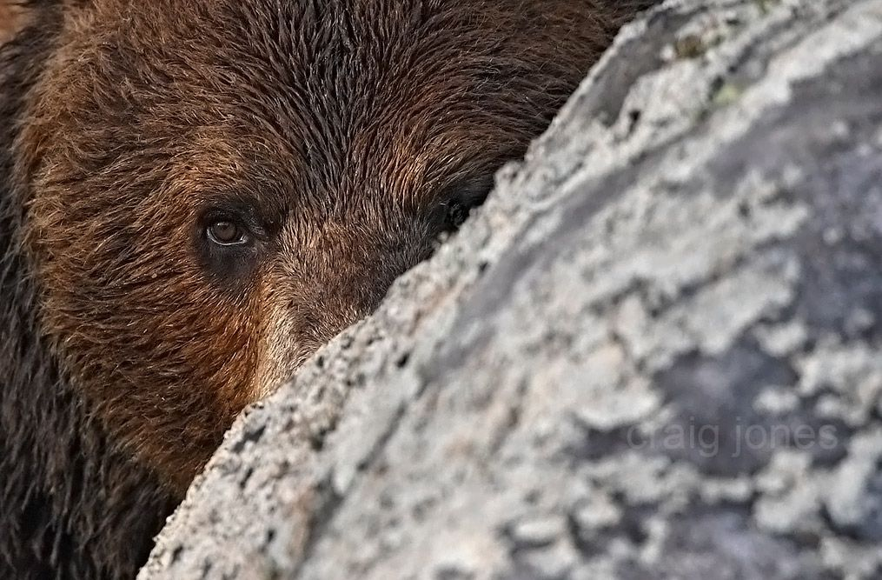

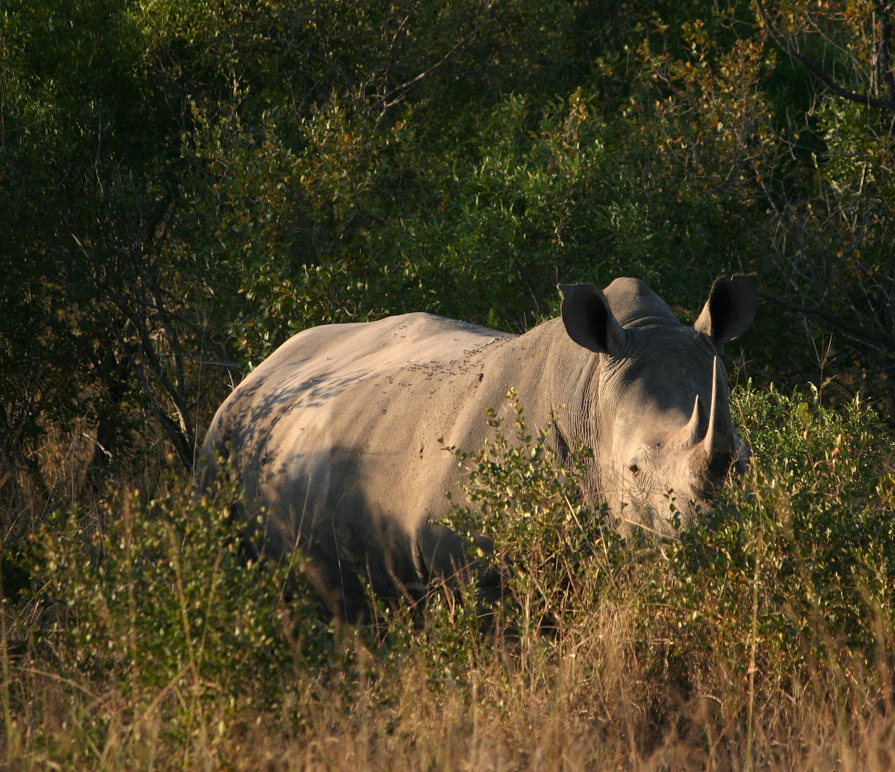

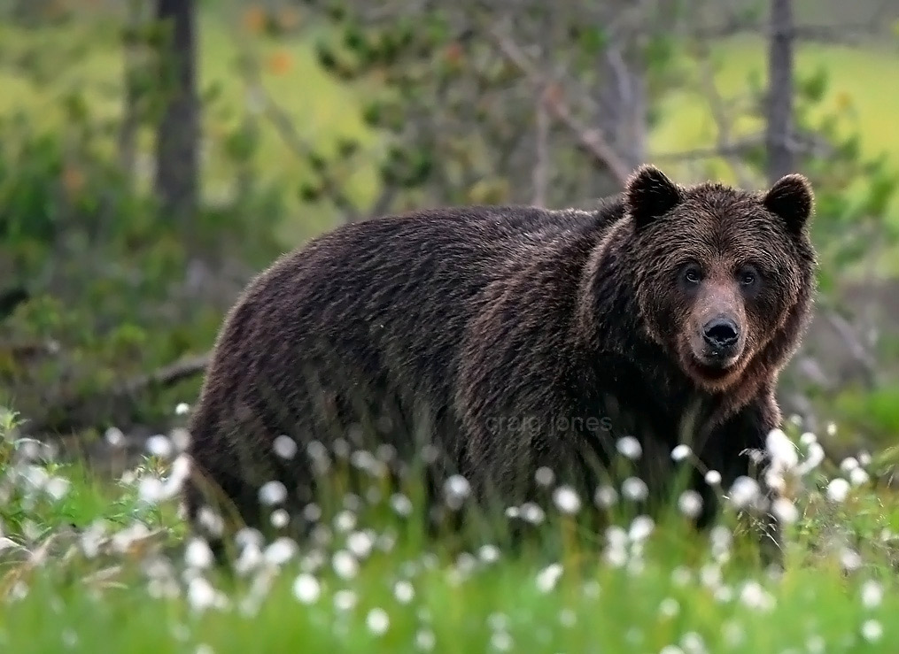

### Activity 2

#### Activity 2.1:

Review the below vocabulary. Write some example  
phrases. Think about how it can be used in the different tenses (past, present, future, present perfect simple),  
with affirmations, negations, and questions, and for different subjects.

ten owned managed protected designated restricted

#### Activity 2.2:

Read the below article. After each paragraph tell yourself or write a short summary of what you have read.

Within the United Kingdom there are fourteen national parks, and one further area with "equivalent status". There are ten in England, three in Wales and two in Scotland.   
The national parks of the United Kingdom, (Welsh: parciau cenedlaethol, Scottish Gaelic: pàircean nàiseanta), are areas of relatively undeveloped and scenic landscape. Despite their name, they are quite different from national parks in many other countries, which are usually owned and managed by governments as protected community resources, and which do not usually include permanent human communities. In the UK an area designated as a national park may include substantial settlements and human land uses that are often integral parts of the landscape. Land within national parks remains largely in private ownership. These parks are therefore not truly "national parks" according to the internationally accepted standard of the IUCN but they are areas of outstanding landscape where habitation and commercial activities are restricted.