# Welcome to your English activity worksheet

### Activity 1

Talk about each of the images (What, where, who, how, why). Use your imagination.





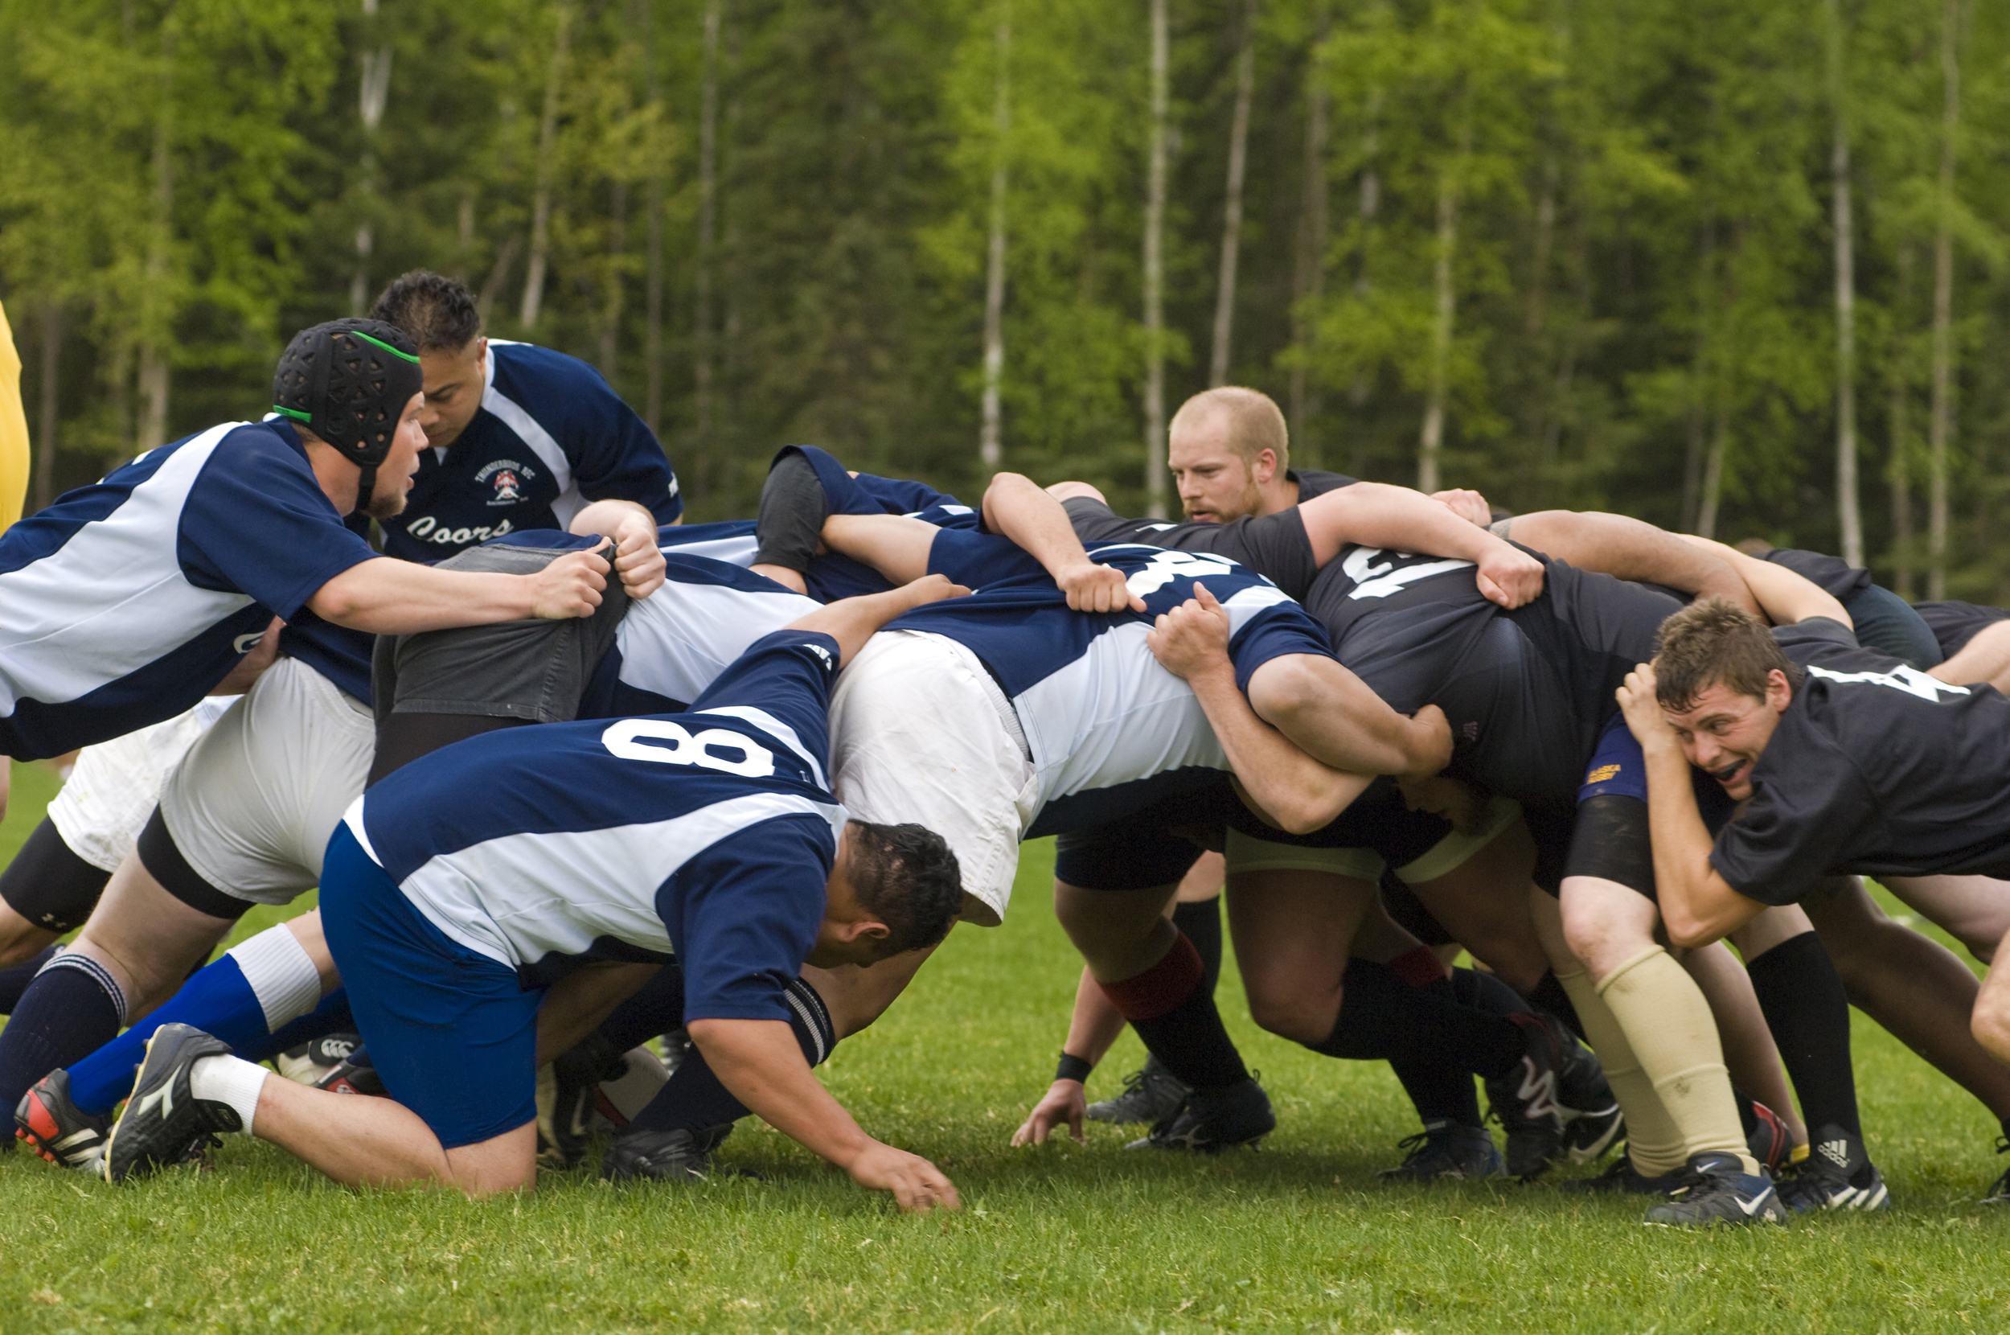



### Activity 2

#### Activity 2.1:

Review the below vocabulary. Write some example  
phrases. Think about how it can be used in the different tenses (past, present, future, present perfect simple),  
with affirmations, negations, and questions, and for different subjects.

International matches place game Scotland

#### Activity 2.2:

Read the below article. After each paragraph tell yourself or write a short summary of what you have read.

International matches have taken place since 1871 when the first game was played between Scotland and England at Raeburn Place in Edinburgh. The Rugby World Cup, first held in 1987, is held every four years. The Six Nations Championship in Europe and The Rugby Championship in the Southern Hemisphere are other important international competitions that are held annually.  
Rugby union spread from the Home Nations of Great Britain and Ireland, with other early exponents of the sport including Australia, New Zealand, South Africa and France. The sport is followed primarily in the British Isles, France, Oceania, Southern Africa, Argentina, and to a lesser extent Italy, Uruguay, the United States, Canada, and Japan, its growth occurring during the expansion of the British Empire and through French proponents (Rugby Europe) in Europe. Countries that have adopted rugby union as their de facto national sport include Fiji, Georgia, Madagascar, New Zealand, Samoa, Tonga, and Wales.  
In 1845, the first laws were written by pupils at Rugby School; other significant events in the early development of rugby include the decision by Blackheath F.C. to leave the Football Association in 1863 and, in 1895, the split between rugby union and rugby league. Historically rugby union was an amateur sport, but in 1995 formal restrictions on payments to players were removed, making the game openly professional at the highest level for the first time.   
Rugby union is a popular sport around the world, played by male and female players of all ages. In 2014, there were more than 6 million people playing worldwide, of whom 2.36 million were registered players. World Rugby, previously called the International Rugby Football Board (IRFB) and the International Rugby Board (IRB), has been the governing body for rugby union since 1886, and currently has 101 countries as full members and 18 associate members.  
Rugby union, commonly known simply as rugby, is a close-contact team sport that originated in England in the first half of the 19th century. One of the two codes of rugby football, it is based on running with the ball in hand. In its most common form, a game is played between two teams of 15 players each, using an oval-shaped ball on a rectangular field called a pitch. The field has H-shaped goalposts at both ends.