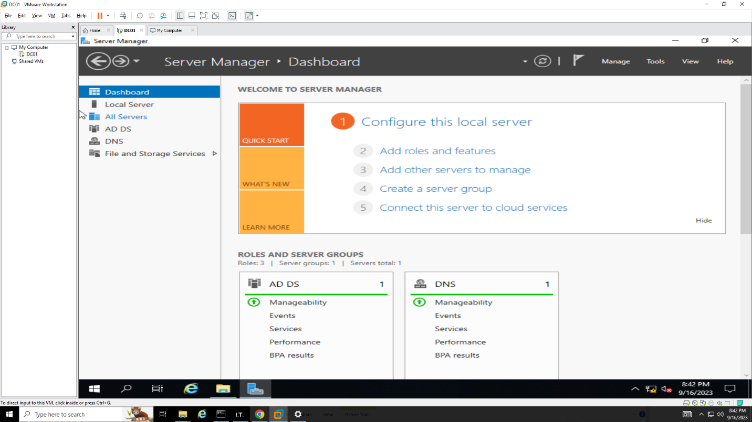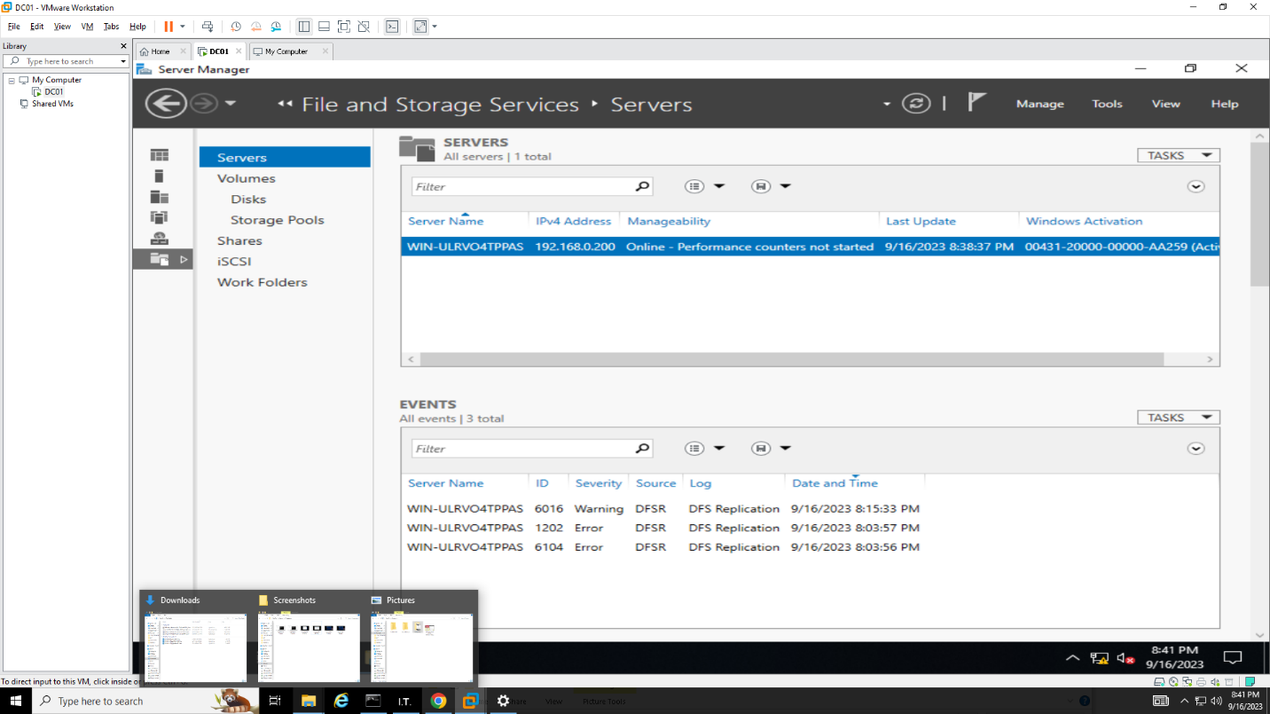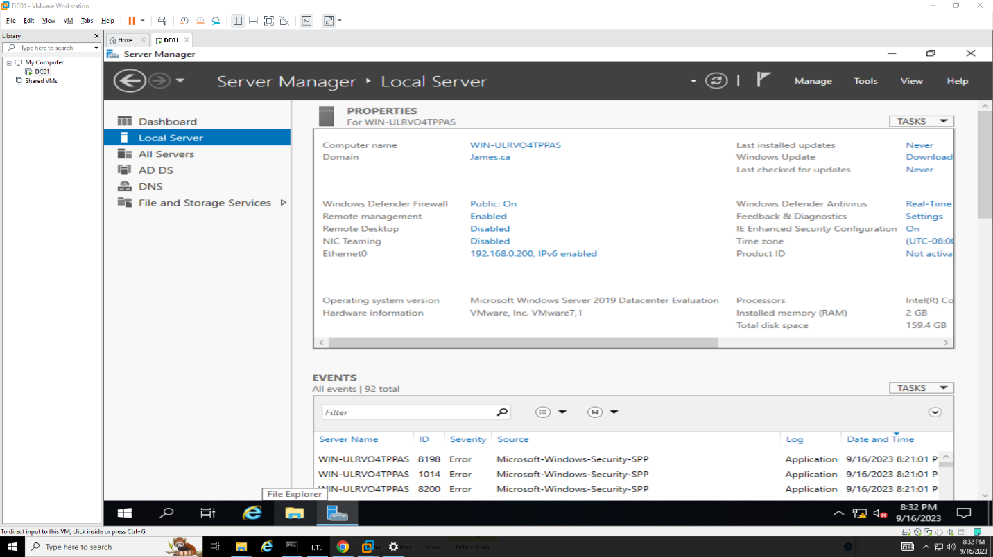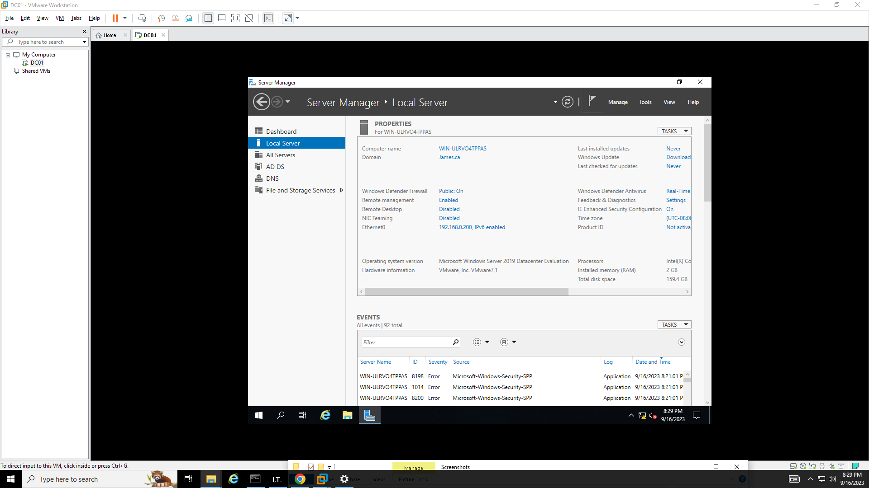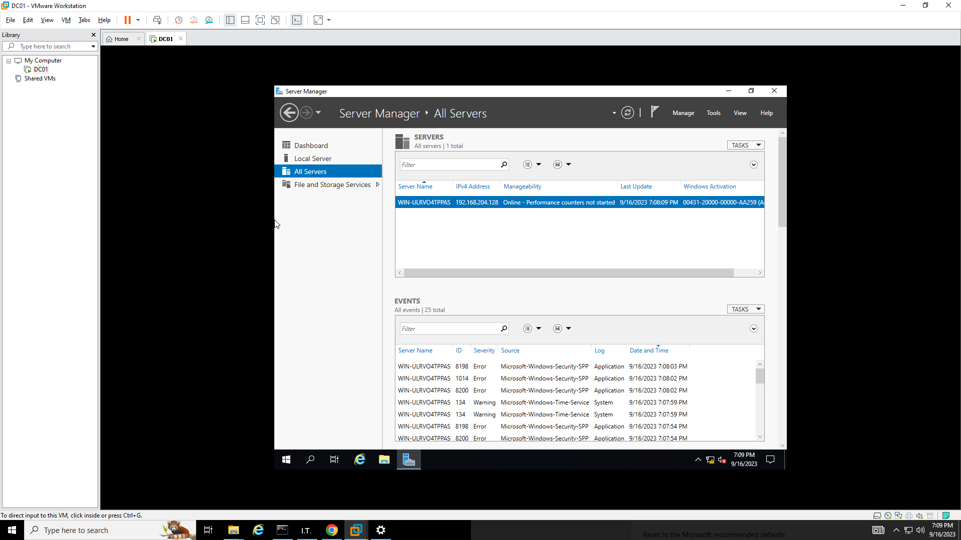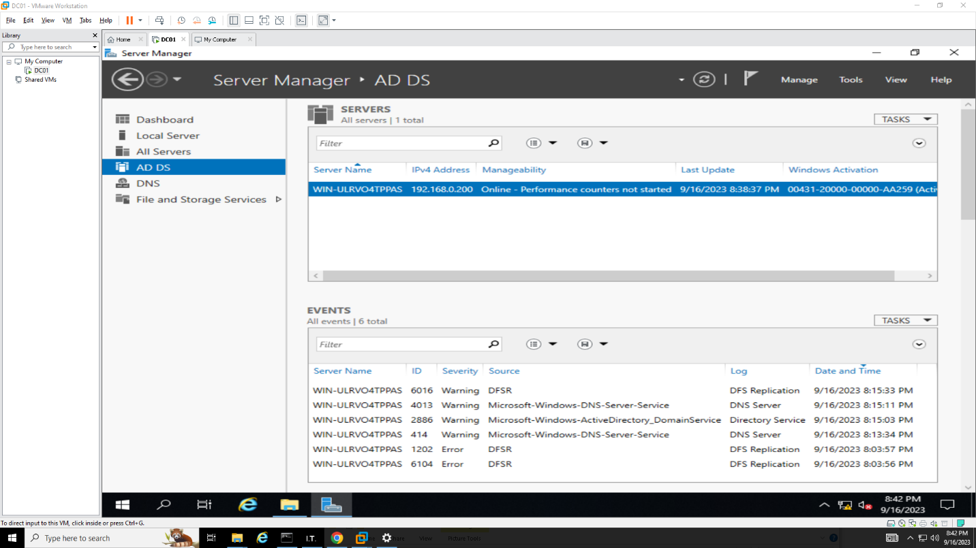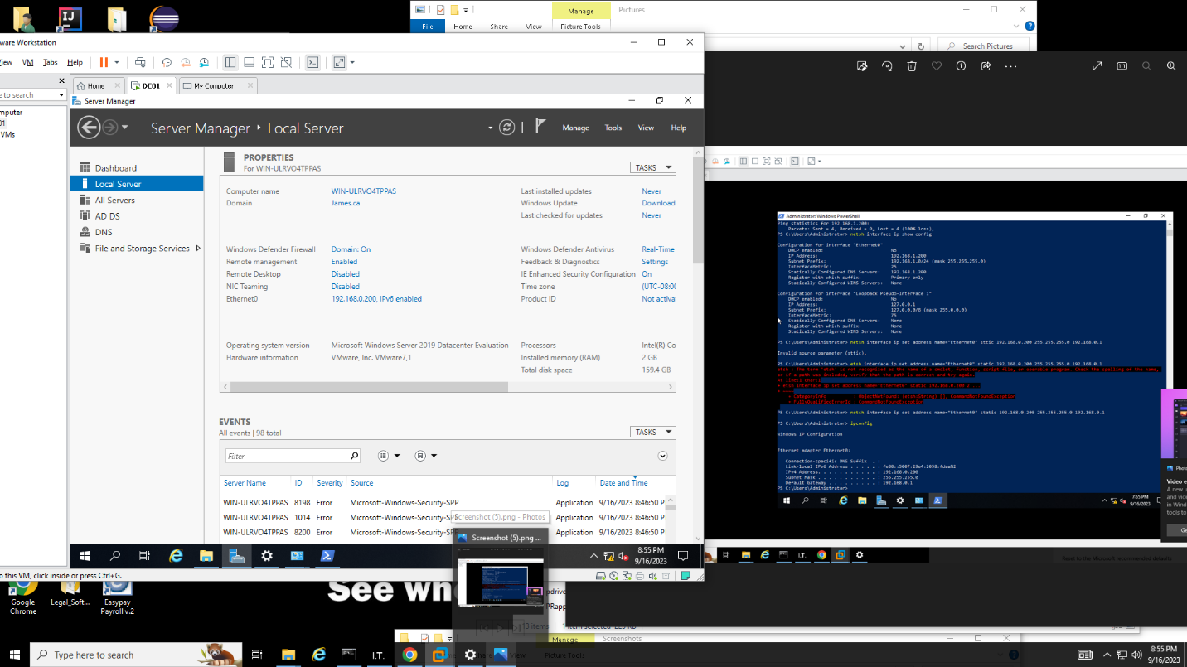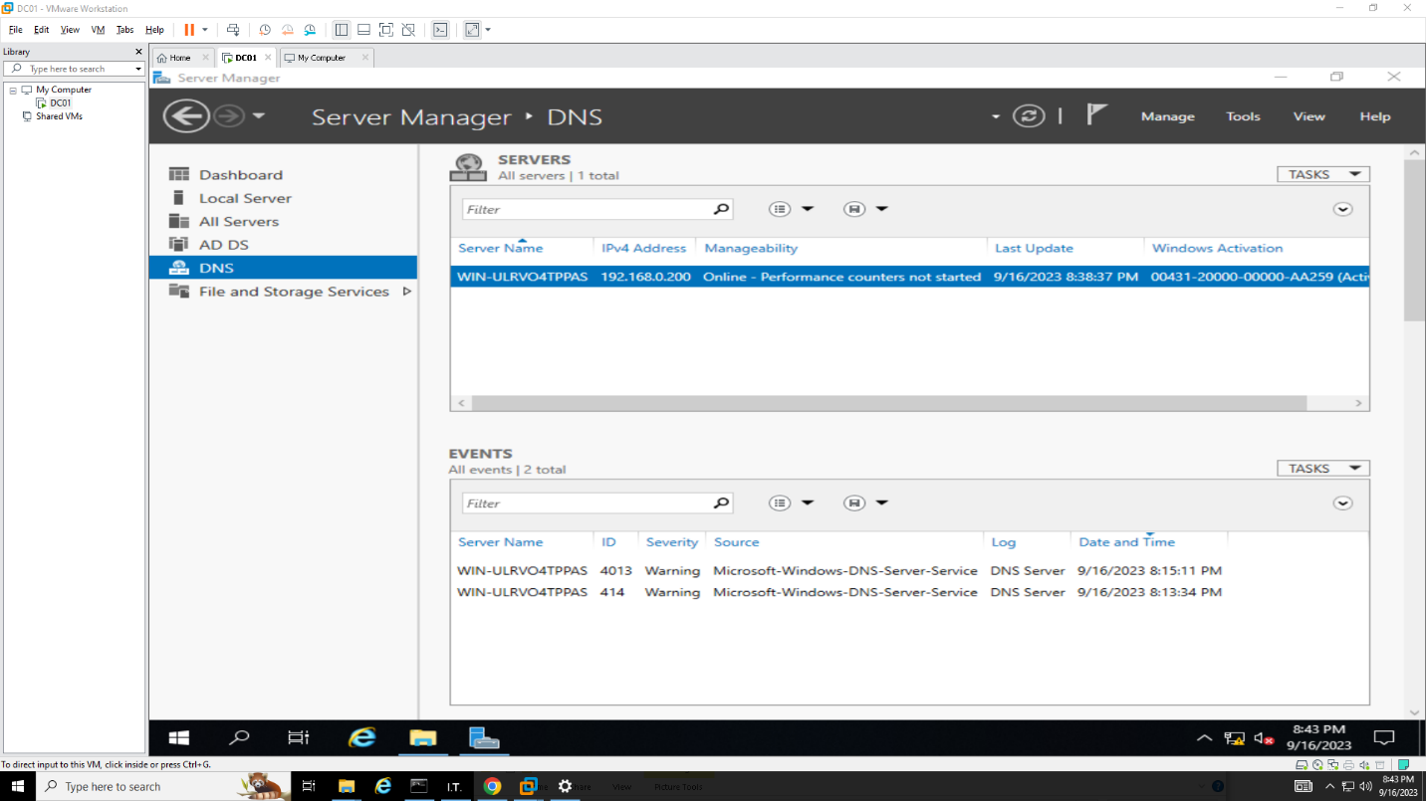Theoretical Part

Describe in 350-500 words the purpose of ADDS

Active Directory Domain Services (AD DS) is an essential purpose in a Windows-based network environment. AD DS is a core component of the Windows Server operating system, and its installation brings important benefits to network management, security, and user authentication. Here are the primary purposes of installing AD DS:

Resource Management: AD DS extends its management capabilities to include network resources such as printers, file shares, and applications. These resources can be organized and secured through AD DS, simplifying access control and resource sharing.

Centralized User Authentication: AD DS provides a centralized authentication mechanism for users and computers in a network. Once installed, it allows users to log in using a single set of credentials (username and password) across all Windows-based devices and resources in the domain. This simplifies user management and enhances security.

User and Group Management: AD DS enables the creation, management, and organization of user accounts, groups, and organizational units (OUs). This hierarchical structure makes it easier to manage and apply security policies and access controls to different parts of the network.

Group Policy: Group Policy is a powerful feature of AD DS that allows administrators to define and enforce policies, settings, and configurations for users and computers in the domain. This ensures consistency and security across the network.

DNS Integration: AD DS relies on DNS (Domain Name System) for name resolution. When AD DS is installed, it automatically configures DNS, ensuring that domain-joined computers can locate domain controllers and other resources by name.

Security: AD DS enhances network security by enabling the enforcement of access control policies, password policies, account lockout policies, and more. It provides a secure environment for storing sensitive information and protecting against unauthorized access.

Scalability: AD DS is designed to scale to accommodate networks of varying sizes, from small businesses to large enterprises. It can handle thousands of users, computers, and devices within a single domain.

Trust Relationships: AD DS supports trust relationships between domains, allowing resources in one domain to be accessed by users and computers in another domain. This is valuable for organizations with complex network structures.

Backup and Recovery: Active Directory can be backed up and restored, ensuring that critical user and system configuration data can be recovered in case of data loss or hardware failures.

In conclusion installing Active Directory Domain Services (AD DS) is crucial for establishing a secure, organized, and efficient network environment. It centralizes user authentication, simplifies user and resource management, enhances security, and provides a foundation for essential network services and applications. AD DS is a fundamental component of Windows-based network infrastructures and is essential for businesses and organizations.

Describe in 350-500 words the purpose of automation in PowerShell

PowerShell automation serves several key purposes in the world of technology and system administration. PowerShell, with its robust scripting capabilities and integration with Windows systems, is a powerful tool for automating various tasks. Here are some of the purposes of automation in PowerShell:

Compliance and Security: Automation can help enforce security policies and compliance requirements by ensuring that systems are configured correctly and consistently. PowerShell scripts can be used to audit and remediate security vulnerabilities and ensure that systems adhere to regulatory standards.

Self-Service Portals: PowerShell automation can be leveraged to create self-service portals or dashboards for end-users or other teams. These portals allow authorized users to initiate specific tasks without needing in-depth technical knowledge.

Task Efficiency: Automation in PowerShell is designed to streamline and expedite repetitive and time-consuming tasks. IT administrators can write scripts to perform tasks such as user provisioning, software installation, system updates, and log analysis much faster and with fewer errors than manual execution.

Consistency: PowerShell automation ensures that tasks are executed consistently every time they are run. This reduces the risk of human errors that can occur during manual processes and helps maintain a standardized and reliable environment.

Resource Savings: By automating routine tasks, organizations can allocate their IT resources more efficiently. Instead of spending valuable human hours on repetitive chores, IT professionals can focus on more strategic and complex projects that require their expertise.

Remote Management: PowerShell automation allows administrators to manage remote machines and devices easily. This is particularly important in modern IT environments where many systems are distributed across various locations.

Integration: PowerShell can be integrated with other Microsoft and third-party tools and services. This means that automation can be part of a larger workflow that includes actions like sending email notifications, interacting with databases, or interacting with cloud services.

In summary, the purpose of automation in PowerShell is to simplify, expedite, and improve the management and administration of IT systems and resources. It enhances efficiency, consistency, scalability, and security while reducing the manual effort required for routine tasks.

Describe in 350-500 words the purpose of PowerShell

PowerShell is a versatile and powerful automation and scripting language primarily developed by Microsoft. Its purpose encompasses a wide range of tasks and functions within the IT and system administration domains. Here are the key purposes of PowerShell:

Automation: PowerShell's primary purpose is to automate routine and repetitive tasks in IT administration. It allows administrators to script actions, making it possible to execute tasks consistently and efficiently. This automation ranges from simple tasks like file management to complex processes such as server provisioning and configuration management.

Active Directory Management: PowerShell is commonly used to manage and administer Active Directory services. Administrators can create, modify, and delete user accounts, groups, and other objects, as well as query and manipulate Active Directory data.

Management: PowerShell is used for managing various aspects of Windows operating systems and software components. It provides cmdlets (command-lets) that enable administrators to control system settings, user accounts, network configurations, services, and more.

Scripting: PowerShell is a powerful scripting language, allowing users to write scripts to perform specific tasks or automate complex workflows. Scripts can be saved and reused, saving time and reducing the risk of errors.

Reporting: PowerShell can generate detailed reports and logs by gathering information from systems and applications. This is crucial for auditing, monitoring, and troubleshooting purposes.

Server Administration: PowerShell is instrumental in server administration tasks, including the provisioning and configuration of Windows servers. It can be used to install roles and features, set up virtual machines, and manage server settings.

Cloud Integration: PowerShell offers modules and cmdlets for managing cloud services, such as Microsoft Azure and AWS. This allows administrators to automate cloud resource provisioning, configuration, and management.

Troubleshooting: PowerShell is a valuable tool for diagnosing and troubleshooting system issues. Administrators can use it to gather system information, check logs, and perform diagnostic tests.

Customization: PowerShell allows users to customize and extend its functionality. They can create custom functions, modules, and scripts to meet specific organizational needs.

In summary, PowerShell serves as a versatile automation and scripting language with a broad range of purposes in IT and system administration. It empowers administrators to automate tasks, manage systems, generate reports, integrate with various technologies, and customize its functionality to suit specific requirements, ultimately improving efficiency and productivity in the IT environment.