
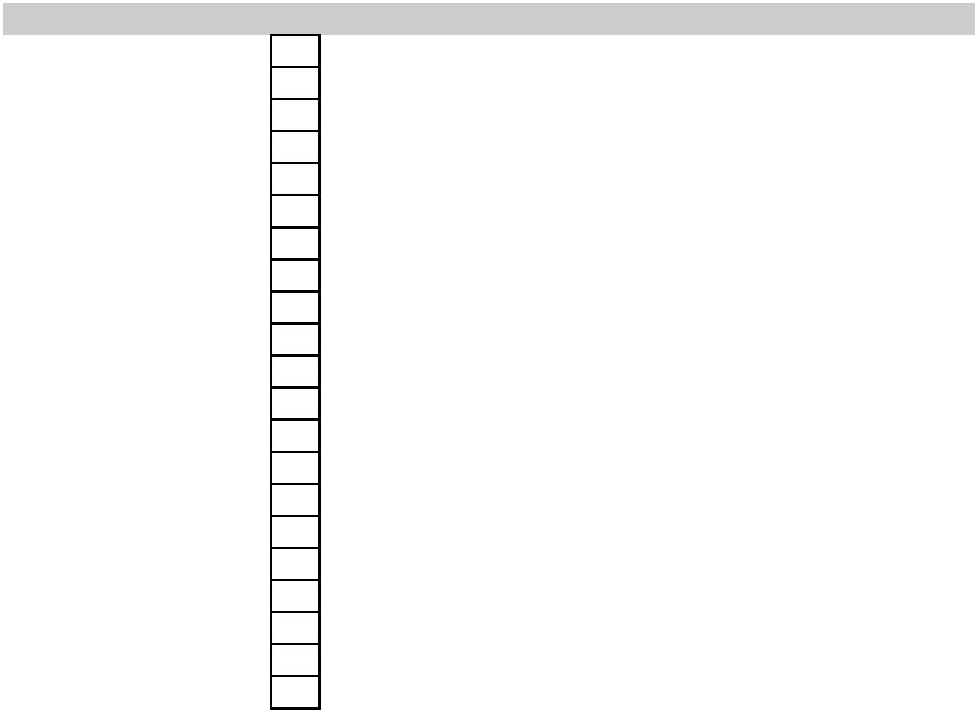

Parts List Windsensor WiFi 1000 ©Norbert Walter 2018
Position Amount Item Material
Dokumentation
1 1 Technical Description
2 1 Assembly Instructions
3 1 Setup Guide
4 1 Circuit Diagram Board
5 1 Circuit Diagram Cabling
6 1 Parts List
7 1 Software & Documentation (CD)
3D-Parts
8 3 Cup PLA
9 1 Frame PLA
10 1 Sleeve PLA
11 1 Vane Sleeve PLA
12 1 Vane Arm PLA
13 1 Vane Head PLA
14 1 Magnet Holder PLA
Mechanic Parts
15 1 Balance Weight V4A
16 1 Stator Aluminium
17 1 Magnetic Shield Tinplate
18 1 Mount Aluminium
19 1 Shim M10 V4A Steel
20 1 Washer M10 V4A Steel
21 1 Hexagon Nut M10 V4A Steel
22 2 Ball Bearing 608ZZ V4A Steel
23 1 Pipe ø10mm, 300mm Aluminium
24 1 Threaded Rod M3x80 V4A Steel
25 2 Socket Cap Screw M3x8 V4A Steel
26 1 Socket Cap Screw M3x10 V4A Steel
27 1 Washer M3 V4A Steel
28 2 Shim M3 V4A Steel
29 2 Hexagon Nut M3 V4A Steel
30 3 Socket Set Screw M3x4 V4A Steel
31 1 Washer M6 Nylon
32 1 Magnet D3x6 Neodym
33 1 Magnet D3x3 Neodym
34 1 Reflective Film red 200 x 50mm PVC
35 1 Reflective Film white 50 x 20mm PVC
Elektronik
36 1 Circuit Board, assembled incl. SW FR4 1mm
37 1 8pol. Cable D 5 x 800mm CAT5e
38 2 DC/DC-Converter
Page 1



Assembly Aids
39 1 Spirit
40 1 Silicone Oil / Fine Oil
41 1 Clear Coat for paintable Hard Plastics, e.g. Dupli-Color
42 1 Acrylic Adhesive, e.g. Weicon RK-1300
43 1 Adhesive Tape
44 4 Q-Tips
45 1 Cable Ties, width 4-6mm
46 1 9V Battery PP3
47 1 Superglue optional
Tools
48 1 Tweezers
49 1 Stanley Knife / Scalpel
50 1 Hex Key Wrench M3
51 1 Hex Key Wrench M2
52 1 Spanner M5.5
53 1 Spanner M17
54 1 Spanner M22
55 1 Fine Pliers
56 1 Wirecutting Pliers
57 1 Electronics Soldering Iron
58 1 Tin Solder Wire
59 1 Screwdriver small
60 1 Digital-Multimeter
61 1 Desoldering Braid optional
62 1 Oscilloscope optional
Software
63 1 Firmware Windsensor optional
64 1 Arduino IDE V1.8.5 optional
65 1 Laptop/PC optional
66 1 USB-RS232 Serial Converter 3,3V optional
67 1 USB-Cable optional
Page 2

