Data Sheed

Windsensor WiFi 1000

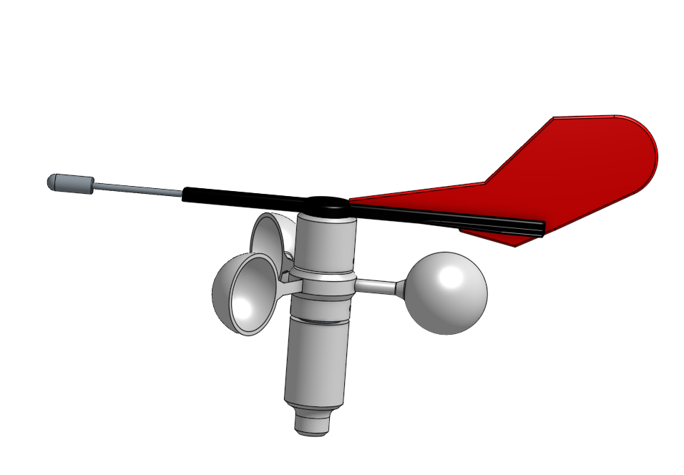

The Windsensor WiFi 1000 is used to display wind direction and wind speed. Data is transmitted wirelessly via a WiFi network connection to a central unit such as an OpenPlotter. The data is compatible with NMEA0183 and supports all common telegrams. A direct connection and display of the data via a mobile phone or tablet with commercially available navigation software is also possible. The wind sensor only requires a wired power supply, which can be tapped from a top light. This eliminates the need for the time-consuming laying of a cable in the mast.

Thanks to its compact design and purely digital signal processing, the wind sensor can be used for a wide range of applications and is insensitive to interference due to its radio-based data transmission. A suitable selection of materials and the use of robust industrial stainless steel ball bearings ensure low wear and a long lifetime.

All manufacturing documents are publicly accessible and are subject to OpenSource licenses, so that in the event of a fault the wind sensor itself can be repaired or, if necessary, extended per your own requirements.

Technical Data

Designation | Value / Range of values | Comment
Wind speed | 0…40 m/s, 0…78 kn
Start wind speed | 1 m/s
Wind direction | 0…360°
Resol. wind direction | 0,3…6° bei 0…40kn
Type of function | magnetic, Hall sensor
Ambient temperature | 0…60°C
Storage temperature | -10…80°C
Air Humidity | 0…100%
Power supplay | 5V | reverse polarity protected
Consumption | 1W | typical
Data transmission | WiFi 11 bgn
Data rate | 3 Mbit
Range | app. 50 m | free field
Data protocols | NMEA0183 WiFi
 | NMEA0183 serial | 3,3V logic level
 | JSON WiFi | data transmission
 | HTTP Access Point | for parameter settings
 | TCP Socket | data connection
NMEA0183 Data types | MWV
 | VWR
 | VPW
 | INF | custom Code
Tightness class | IP63 | protected against spray water
Dimensions L x W x H | 295 x 180 x 170 mm | without tube and base
Weight | 275 g | with tube and base
 | 165 g | without tube and base
Plastic | PLA: enclosure parts | painted
Metal | Alu: stator, tube, base | seawater resistant
 | V4A: tip, threaded rod
 | V4A: screws, nuts
Approvals | none
Warranty | none
Licenses | CC-BY-NC-SA | hardware
 | OpenSource, GPL 3.0 | software

Creator | Norbert Walter  Wiesbadener Str. 1  40225 Düsseldorf  Germany  norbert-walter@web.de
 | © The Data Sheed is subject to the Creative Common License.

