Why you shouldn’t use internet explorer

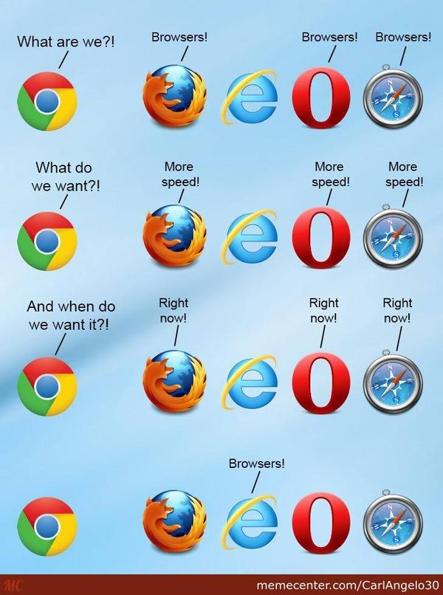It was august 1995 the world was floppy disk crazy and the first version of internet explorer was released. Internet explorer came out punching and for the following 3 years battled the reigning champion of the Web browsing world Netscape navigator. However by the year 2000 internet explorer had come out on top and managed to become the world's most used internet browser, holding over 85% market share. But as with the floppy disk all good things must come to an end, something which seems to be reinforced every year in the technology market. But why are people now saying that internet explorer’s usefulness has come to an end?

The first and most prominent reason is its speed with other browsers such as Google Chrome and Firefox both loading web pages and Booting (opening) in less than half the time of Internet explorer. This really does mean that in the end internet explorer is just not convenient to use and it’s going to get a lot more annoying for simple things like casual use on a tablet or a laptop when you need to quickly check something. This may seem like a small thing but there’s nothing worse than waiting for something to load when you’re in a rush.

This is mostly because of its age, and the design philosophy around web browsers at the time (20 years ago). A big part of that philosophy was making it run smoothly on low-end computers which at the time was about half the speed of your smartphone. Even the lowest end tablets today have the processing capability to run web browsers without a noticeable performance decrease. Slightly more power-hungry web browsers that are designed around the understanding of the processing capability of modern computers still follow this lightweight philosophy. These web browsers (like google chrome and Firefox) are better and will continue to get better as Moors law[1] pushes computing forward into the future.

Another big problem internet explorer has is the fact that Microsoft has been known to take years to properly update it. In ___ internet explorer 6 had complete market dominance with no change in sight. However, from the ashes of Netscape navigator rose phoenix… before it was banished when it was discovered that the name was already taken… but then rose Firefox which supported new standards like CSS2 [2] and image standards like SVG [3]. Suddenly Apple came out with safari and internet explorer had to fight for its market share. But still there was no real improvement and internet explorer 6 remained. Now, I could write this whole essay on internet explorer 6 but that is a story for another time. For now all you need to know is that it was a web developer’s nightmare. It was so bad that the only way to get your web pages working correctly was to use exploits within Internet Explorer so that web pages would work properly.

This created its own problems as Microsoft was aware that this was how people were getting their sites to work. This meant that when internet explorer 7 did come out they were unable to fix most of the problems without breaking everyone’s sites. So while the new version fixed some of its issues, quite frankly it still sucked. It was only in 2009 that they actually fixed most of internet explorer’s problems. Although Internet Explorer is actually usable today, it is still lagging behind most other browsers in features. Even simple things like a lot of page animation and JavaScript still don’t work on internet explorer. This might seem like a small thing but as a web designer you spend ¼ of your time writing your website, ¼ of your time making it work on phones and scale, and ½ your time making it work on internet explorer.

The final issue with internet explorer (not the final issue I could keep going for hours) is a simple one. It comes with windows. This may seem like a good thing but this means that you are far more likely to get hacked or scammed using it than you are on any other browser. This is partly because of its terrible security… actually 90% because of its terrible security. On the other hand it’s partly because of the people who use it. The user base for internet explorer is generally people who don’t have the greatest knowledge of computers and who are therefore a scammer’s greatest target. Whether it’s that simple Adobe flash video on that website you went to (for the love of god don’t use flash player on any websites you’ve never been to before) or that odd email you got, most viruses are designed for internet explorer users.

Internet explorer’s slow speed, outdated design, and bad security make it a terrible internet browser that should not be used. There is a reason there are news reports of people getting hacked simply by clicking a link, 90% of them would have been using internet explorer or a slow outdated browser like it. There is a reason the newest version of windows, windows 10, comes with another lighter weight internet browser, Microsoft edge. Microsoft has now realized how bad internet explorer is and they are even trying to find alternatives. It is clear that the age of internet explorer is over and it must be replaced with a better, faster web browser.

Most used web browsers by country as of June 2015

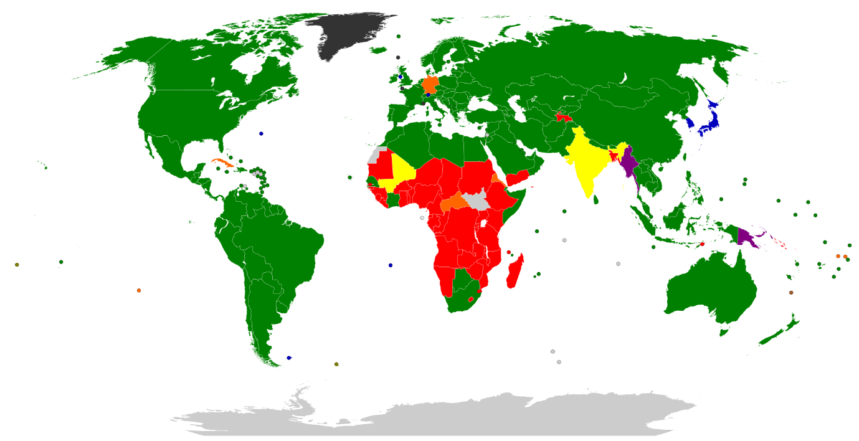

KEY: GOOGLE CHROME IS GREEN, INTERNET EXPLORER IS BLUE, THAT’S ALL THAT MATTERS.

Disclaimer: all my statements about market share apart from the map above were based purely off US market share. All of the bold statements I made about Chrome and Firefox searching and starting faster than internet explorer were based off real tests using the latest versions of each respective browser. Due to accepting a large sum of money from myself to write this my views are incredibly biased.

Bibliography:

PC world article 5/01/16: <http://www.computerworld.com/article/2470270/internet/12-reasons-not-to-use-internet-explorer--ever.html>

Wikipedia 4/02/16: <https://en.wikipedia.org/wiki/Usage_share_of_web_browsers>

Wikipedia 4/02/16: <https://en.wikipedia.org/wiki/Netscape_Navigator>

Lifehacker speed tests 5/02/16: <http://lifehacker.com/5976082/browser-speed-tests-chrome-24-firefox-18-internet-explorer-10-and-opera-1212>

Tech reader prediction of Moores law 5/2/16: <http://www.techradar.com/au/news/computing/moore-s-law-how-long-will-it-last--1226772>

Zdnet article by ed botte 5/2/16: <http://www.zdnet.com/article/protect-yourself-from-flash-attacks-in-internet-explorer/>

Map by statecounter.com