Tactics

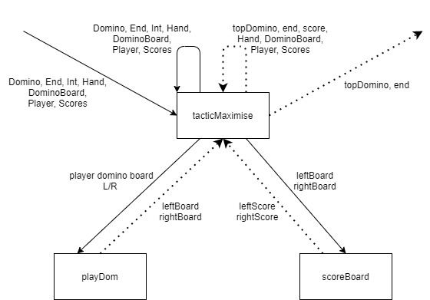

TacticMaximise:

A recursive function that iterates through the players hand to find the highest scoring playable domino. Will keep calling itself until it has iterated through the whole hand or has found a domino that’ll win the round, as it iterates it compares the domino it’s given to see if it scores higher if it does it’ll replace the domino else it’ll carry on iterating.

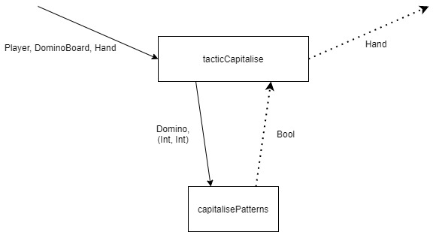

TacticCapitalise (special):

A function that uses list comprehension to produce a hand of playable dominoes from the players hand that will make the other player continue to knock. capitalisePatterns is a function that will check if the domino is made of either end numbers.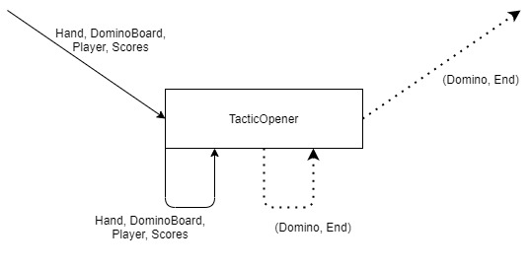

tacticOpener (special):

Checks if the player has a (4,5) in hand and plays it if it can, else just plays the last domino in hand.

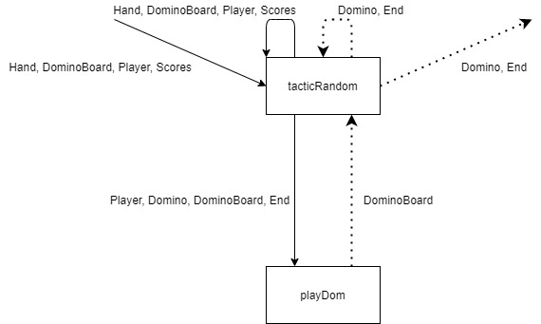

tacticRandom:

Plays the first playable domino in hand.

Players

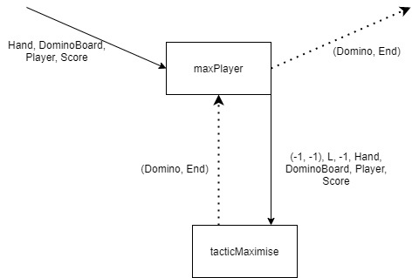

maxPlayer:

Just implements tacticMaximise so only plays the highest scoring domino each turn. It gives tacticMaximise an invalid domino and negative score so that it does not play an illegal move and even if it will score nothing it will still play a move when forced to, so it does not hold onto dominos illegally.

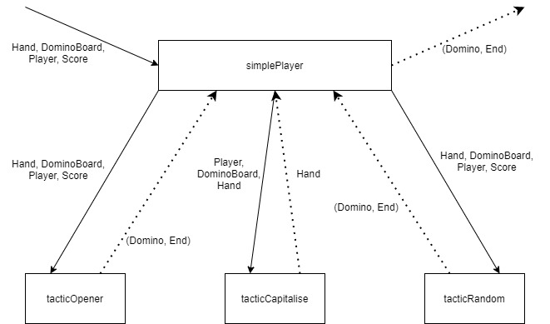

simplePlayer:

Implements all the special tactics and tacticRandom

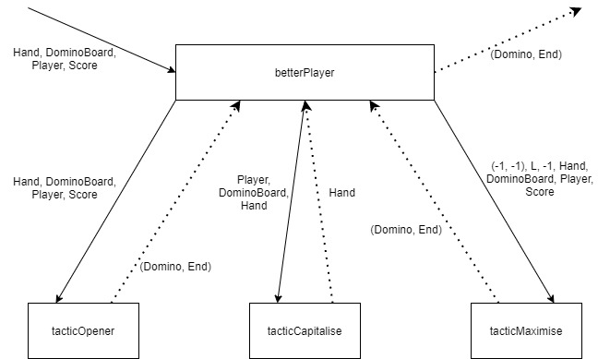

betterPlayer:

Implements both tacticMaximise and all special tactics.