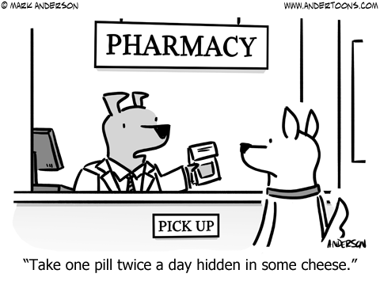

Project Report: Pharmacy

CS 6360.002 – Team 23

Ishan Sharma – ixs171130, rahul nalAwade - rsn170330

2017

# Introduction

Pharmacies are essential component of healthcare in the United States and handle the function of selling medical drugs. Even though the pharmacies do not seem different than any other shop, their functioning is very different due to various laws regarding drugs.

For example, most of the drugs available in a pharmacy cannot be purchased without a prescription. Even with a signed prescription, there is a limit on the quantity that can be purchased. Additionally, pharmacist can do a background check on customer’s medical history to ensure that they are not involved in drug abuse.

In addition, there are other laws on the operations of pharmacy like requirement for safe disposal of expired medicine and requirement of license for employees that mix/prepare the drugs.

Thus, preparing a Database Management System for a pharmacy not only requires study of how things are handled from a customer or employee point of view but also the relevant laws. With this project, our aim was to develop a comprehensive system that could deal with challenges faced in day to day operation of a modern pharmacy. We studied the relevant laws and prepared a system that complies with the required Federal and State laws.

Table of Contents

Introduction 2

Requirements 4

Customer 4

Insurance 4

Employee 4

Prescription 4

Order 5

Bill 5

Medicine(Inventory) 5

Notifications 5

Laws Affecting Pharmacies 6

Food, Drug and Cosmetic (FDC) Act of 1938 6

Comprehensive Drug Abuse Prevention and Control Act(CASA) of 1970 6

Poison Prevention Packaging Act(PPPA) of 1970 6

Omnibus Budget Reconciliation Act (OBRA) of 1990 6

Health Insurance Portability and Accountability Act(HIPPA) of 1996 7

ER Modelling 8

ER Diagram 8

UML 9

Relations and Normalization 11

Relations 11

Normalization 13

Table Creation 15

Procedures & Triggers 18

Procedures 18

Generate Bill 18

Add Drug to Order 19

Report Expiring Drugs 19

Dispose Expired Drugs 20

Send Notifications 20

Triggers 21

Notifications 21

Employee Validation 21

Conclusion 22

Citations and References 23

# Requirements

During research phase, we arrived at following requirements based on the pharmacy flow:

## Customer

When a customer arrives in the pharmacy, we identify them based on their SSN. If they are a new customer, they are asked for their name, date of birth, phone number, gender and address. The address and date of birth are required to be recorded for drug control purposes under Omnibus Budget Reconciliation Act of 1990.

## Insurance

89.6% of US population has health insurance coverage (National Center for Health Statistics, 2017). The coverage was significantly boosted by ACA(also called Obamacare). One reason for high coverage is that medical costs are very high in the country and without insurance, a large portion of population can’t afford the healthcare.

If a customer has health insurance, we store the insurance ID (unique for each customer), company name, start date, end date and Co-Insurance. Co-Insurance is a percentage amount that insurance company pays for a medicinal purchase (Managing your healthcare costs, n.d.). Given the customer SSN and insurance ID, the system should be able to automatically calculate the amount paid by insurance company and customer.

## Employee

An employee has same details as a customer but they are also given a company ID, that is unique for them. An employee has to have one of the following roles:

1. Pharmacist
2. CPhT (Certified Pharmacy Technician)
3. Intern (can work in the pharmacy part time)
4. Cashier

Apart from cashier, all other roles require a license from State’s Medical Board as they directly deal with mixing and preparation of drugs. For the purpose of this report, we follow laws of Texas state.

## Prescription

Most of the drugs in the pharmacy can only be sold with a prescription. A prescription contains customer’s SSN, the prescribing Doctor’s ID (required by law) and when the prescription was prescribed.

Each prescription contains a number of prescribed drugs with drug name, quantity and refill limit of each of them. By law, a pharmacy cannot sell more than prescribed quantity or anything that is not listed on prescription.

The prescription is required to be stored under CASA (1970).

## Order

An order is created from the prescription. This data has to be stored separately because customer may:

1. Buy less medicine than prescription specifies
2. Come back for refills based on same prescription

Each order has a unique Order ID that is automatically assigned by the system. Each order can have multiple drugs, each with their ordered quantity and price. We also record batch number of the drug. This data can be requested by the government under Comprehensive Drug Abuse Prevention and Control Act (CASA) and has to be stored.

## Bill

Once an order has been completed, a bill is generated by the system. This bill is handed over to the customer and contains order information, insurance information as well as breakdown of amount paid.

The breakdown should be automatically calculated by the system based on insurance, customer and medicine data.

## Medicine(Inventory)

Drugs are divided into “over the counter”, “restricted” and “prescription only”. Federal Law only divides restricted drugs into 5 schedules and require “readily accessible” inventory for schedule 2 drugs.

While not needed by law everywhere, it is beneficial to store an up to date inventory for record keeping as well knowing when we run out of stock.

## Notifications

The system should be able to generate notifications based on the following four events:

1. Stock for a medicine is low (less than 100 tablets)
2. Some medicine will expire in next 60 days
3. Drugs are marked for disposal
4. Drugs are successfully disposed

The notifications are sent to all the employees who are Pharmacists.

## Laws Affecting Pharmacies

Since drugs are highly regulated, a system designed to manage a pharmacy has to follow all the required laws. The following are most important laws that we discovered during course of our research for the project:

### Food, Drug and Cosmetic (FDC) Act of 1938

This law is more concerned with purity of drugs than regulation. It requires medicine makers to perform pretesting and sell only drugs that pass strict processes. We record the batch number for every order and all the medicine in stock. It helps us keep track of manufacturers who pharmacy purchases drugs from and in case of discrepancy in drug quality, find the responsible party.

### Comprehensive Drug Abuse Prevention and Control Act(CASA) of 1970

CASA (Virgil Van Dusen, 2006) is one of the most impactful laws affecting a pharmacy. It requires comprehensive record keeping for restricted drugs. This act also separates restricted drugs into 5 categories, from Schedule I to V.

Schedule I drugs are not allowed to be sold by any pharmacy under any condition. If a drug is reclassified as Schedule I from any other category, the pharmacy has to destroy it responsibly.

Schedule II drugs can be sold, but accurate records have to be kept. The records need to be “readily retrievable” in case of an enquiry by law enforcement agencies. Schedule II drugs can’t have refills and each purchase requires a separate prescription signed by the doctor.

Schedule III to V drugs can have refills for up to 6 months.

### Poison Prevention Packaging Act(PPPA) of 1970

PPPA is concerned with ensuring drug safety for children. Before the act, there were many cases where children accidently consumed a drug when an adult was not around. To work around this, PPPA requires all drug packaging to be hard to open for children. All packaging has to be tested on at least 200 children below 5 years of age. If more than 20% cannot open the package in less than 5 minutes and more than 90% of the adults can comfortably open the packaging, it is deemed safe for use.

This is something that pharmacist and other staff have to take care of. We do not model this in our system.

### Omnibus Budget Reconciliation Act (OBRA) of 1990

OBRA-90 (Sandra Christensen, 1991) focuses on how the pharmacists interact with customers and reducing the money wasted on drug related issues. Under the act, a pharmacist can access the central medication history of a patient if they need that a review is required before dispensing a medicine.

### Health Insurance Portability and Accountability Act(HIPPA) of 1996

HIPPA is concerned with ensuring security of sensitive patient data. It requires the IT infrastructure to be secure and in case of any breaches, the affected parties have to be notified. Apart from that, proper authorization has to be put in place to ensure that only authorized employees have access to the patient data. Also, patient health conditions should not be revealed to anyone except the patient.

# ER Modelling

The final ER diagram and UML diagram are shown below with explanations.

## ER Diagram

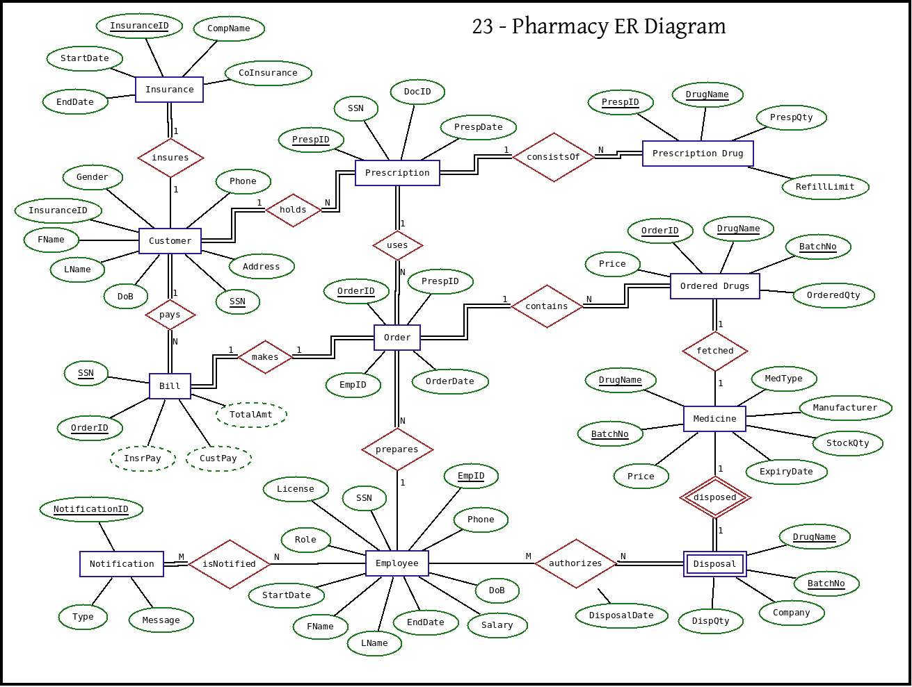

## UML

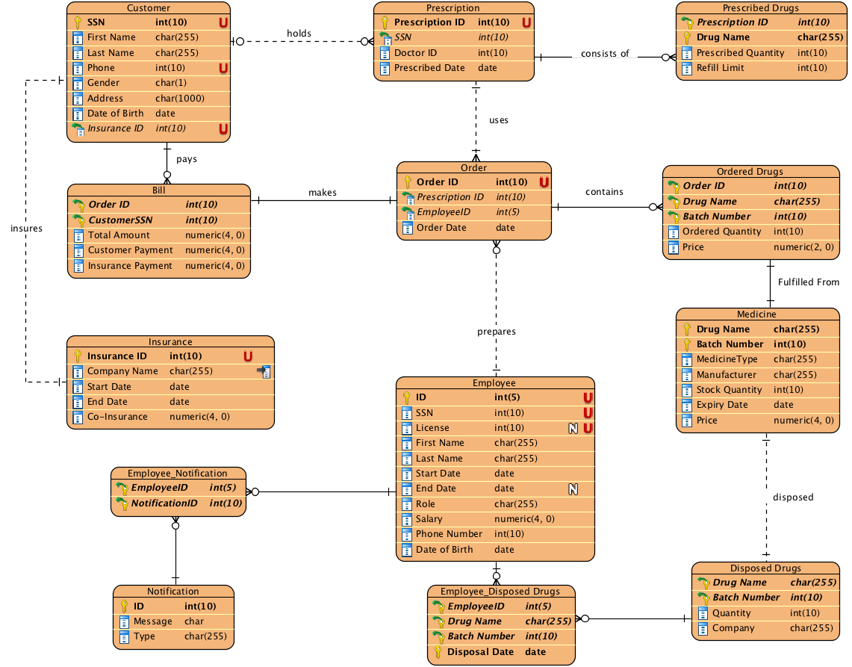

1. A single customer can have multiple prescriptions. Thus, the relation between them is one to many.
2. A prescription consists of multiple drugs, so the relation is one to many. In case of refills, a prescription can generate multiple orders. So, this relation is one to many as well.
3. A single order can contain multiple drugs, thus relationship is one to many. One order, however, can generate only one bill. Thus, the relation between bill and order is one to one.
4. A customer can make multiple purchases and hence, the relation between customer and bill is one to many. This is due to the fact that every bill has only one customer.
5. In medicine table (stock), drug name and batch number can uniquely identify every drug we have in inventory. Batch number is assumed to be unique among manufacturers.
6. Disposed drugs are weak entity and use foreign key Drug Name and Batch Number as their primary key.
7. One employee can receive multiple notifications and one notification can be sent to multiple employees, thus relationship is many to many.
8. Multiple employees can dispose same drug. Similarly, one employee can dispose multiple drugs. Hence, relationship is many to many.
9. One employee can prepare multiple orders. However, a specific order can only be prepared by one employee. Thus, relationship is one to many.

# Relations and Normalization

## Relations

The final relations are listed below:

|  |  |  |  |  |  |  |  |
| --- | --- | --- | --- | --- | --- | --- | --- |
| **Customer** |  |  |  |  |  |  |  |
| SSN | First Name | Last Name | Phone | Gender | Address | Date of Birth | Insurance ID |

Primary Key: SSN

Foreign Key: Customer(Insurance ID) 🡪 Insurance(Insurance ID)

|  |  |  |  |  |
| --- | --- | --- | --- | --- |
| **Insurance** |  |  |  |  |
| Insurance ID | Company Name | Start Date | End Date | Co-Insurance |

Primary Key: Insurance ID

|  |  |  |  |  |  |  |  |
| --- | --- | --- | --- | --- | --- | --- | --- |
| **Employee** |  |  |  |  |  |  |  |
| ID | SSN | License | First Name | Last Name | Start Date | End Date | Role |
| Salary | Phone Number | Date of Birth | |  |  |  |  |

Primary Key: ID

|  |  |  |  |
| --- | --- | --- | --- |
| **Prescription** |  |  |  |
| Prescription ID | SSN | Doctor ID | Prescription Date |

Primary Key: Prescription ID

Foreign Key: Prescription(SSN) 🡪 Customer(SSN)

|  |  |  |  |
| --- | --- | --- | --- |
| **Prescribed Drugs** | |  |  |
| Prescription ID | Drug Name | Prescribed Quantity | Refill Limit |

Primary Key: Prescription ID, Drug Name

Foreign Key: Prescribed Drugs(Prescription ID) 🡪 Prescription(Prescription ID)

|  |  |  |  |
| --- | --- | --- | --- |
| **Order** |  |  |  |
| Order ID | Prescription ID | EmployeeID | Order Date |

Primary Key: Order ID

Foreign Key: Order(Prescription ID) 🡪 Prescription(Prescription ID), Order(Employee ID) 🡪 Employee(ID)

|  |  |  |  |  |
| --- | --- | --- | --- | --- |
| **Ordered Drugs** | |  |  |  |
| Order ID | Drug Name | Batch Number | Quantity | Price |

Primary Key: Order ID, Drug Name, Batch Number

Foreign Key: Ordered Drugs(Order ID) 🡪 Order(Order ID), Ordered Drugs(Drug Name, Batch Number) 🡪 Medicine(Drug Name, Batch Number)

|  |  |  |  |  |
| --- | --- | --- | --- | --- |
| **Bill** |  |  |  |  |
| Order ID | CustomerSSN | Total Amount | Customer Payment | Insurance Payment |

Primary Key: Order ID, Customer SSN

Foreign Key: Bill(Order ID) 🡪 Order(Order ID), Bill(Customer SSN) 🡪 Customer(SSN)

|  |  |  |  |  |  |  |  |  |  |  |  |
| --- | --- | --- | --- | --- | --- | --- | --- | --- | --- | --- | --- |
| **Medicine** | |  |  | | |  | |  | |  |  |
| Drug Name | | Batch Number | Medicine Type | | | Manufacturer | | | Quantity | Expiry Date | Price |
| Primary Key: Drug Name, Batch Number  **Disposed Drugs** | | | |  |  | |
| Drug Name | Batch Number | | | Quantity | Company | |

Primary Key: Drug Name, Batch Number

Foreign Key: Disposed Drugs(Drug Name, Batch Number) 🡪 Medicine(Drug Name, Batch Number)

|  |  |  |
| --- | --- | --- |
| **Notification** |  |  |
| ID | Message | Type |

Primary Key: ID

|  |  |  |  |
| --- | --- | --- | --- |
| **Employee_Disposed Drugs** | | |  |
| Employee ID | Drug Name | Batch Number | Disposal Date |

Primary Key: Employee ID, Drug Name, Batch Number, Disposal Date

Foreign Key: Employee_Disposed Drugs(Employee ID) 🡪 Employee (Employee ID), Employee_Disposed Drugs(Drug Name, Batch Number) 🡪 Disposed Drugs(Drug Name, Batch Number)

|  |  |
| --- | --- |
| **Employee Notification** | |
| Employee ID | Notification ID |

Primary: Employee ID, Notification ID

Foregin Key: Employee Notification(Employee ID) 🡪 Employee(ID), Employee Notification(Notification ID) 🡪 Notification(Notification ID)

## Normalization

The following dependencies exist in our schema:

1. Insurance(Insurance ID, Company Name, Start Date, End Date, Co-Insurance)

Insurance ID 🡪 Company Name, Start Date, End Date, Co-Insurance

2. Customer(SSN, First Name, Last Name, Phone, Gender, Address, Dateof Birth, Insurance ID)

SSN 🡪 First Name, Last Name, Phone, Gender, Address, Date of Birth, Insurance ID

3. Prescription(Prescription ID, SSN, Doctor ID, Prescribed Date)

Prescription ID 🡪 SSN, Doctor ID, Prescribed Date

4. Prescribed_Drugs(Prescription ID, Drug Name, Prescribed Quantity, Refill Limit)

Prescription ID, Drug Name 🡪 Prescribed Quantity, Refill Limit

5. Order(Order ID, Prescriptio ID, Employee ID, Order Date)

Order ID 🡪 Prescriptio ID, Employee ID, Order Date

6. Ordered Drugs(Order ID, Dug Name, Batch Number, Ordered Quantity, Price)

Order ID, Dug Name, Batch Number 🡪 Ordered Quantity, Price

7. Bill(Order ID, CustomerSSN, Total Amount, Customer Payment, Insurance Payment)

Order ID, CustomerSSN 🡪 Total Amount, Customer Payment, Insurance Payment

8. Employee(Employee ID, SSN, First Name, Last Name, Start Date, End Date, Role, Salary, Phone Number, Date of Birth)

Employee ID 🡪 SSN, First Name, Last Name, Start Date, End Date, Role, Salary, Phone Number, Date of Birth

9. Employee_Notification(Employee ID, Notification ID)

All Keys.

10. Notification(Notification ID, Type, Message)

Notification ID 🡪 Type, Message

11. Employee_Disposed_Drugs(Employee ID, Drug Name, Batch Number, Disposal Date)

All Keys.

12. Disposed Drugs(Drug Name, Batch Number, Quantity, Company)

Drug Name, Batch Number 🡪 Quantity, Company

13. Medicine(Drug Name, Batch Number, Medicine Type, Manufacturer, Stock Quantity, Expiry Date, Price)

Drug Name, Batch Number 🡪 Medicine Type, Manufacturer, Stock Quantity, Expiry Date, Price

None of the above dependencies violate 3NF rules, so above relations are in 3NF.

# Table Creation

SQL commands for creating the tables in our database:

**CREATE TABLE** CUSTOMER (  
 SSN **NUMBER**(10) **NOT NULL**,  
 first_name **CHAR**(255) **NOT NULL**,  
 last_name **CHAR**(255) **NOT NULL**,  
 phone **NUMBER**(10) **NOT NULL UNIQUE**,  
 gender **CHAR**(1) **NOT NULL**,  
 address **CHAR**(1000) **NOT NULL**,  
 date_of_birth **DATE NOT NULL**,  
 insurance_id **NUMBER**(10) **NOT NULL UNIQUE**,  
 **PRIMARY KEY** (SSN)  
);  
**ALTER TABLE** Customer  
 **ADD CONSTRAINT** insures **FOREIGN KEY** (insurance_id) **REFERENCES** Insurance (insurance_id) **ON DELETE SET NULL**;  
  
**CREATE TABLE** Prescription (  
 prescription_id **NUMBER**(10) **NOT NULL**,  
 SSN **NUMBER**(10) **NOT NULL**,  
 doctor_id **NUMBER**(10) **NOT NULL**,  
 prescribed_date **DATE NOT NULL**,  
 **PRIMARY KEY** (prescription_id)  
);  
**ALTER TABLE** Prescription  
 **ADD CONSTRAINT** holds **FOREIGN KEY** (SSN) **REFERENCES** Customer (SSN);  
  
**CREATE TABLE** "PRESCRIBED_DRUGS" (  
 prescription_id **NUMBER**(10) **NOT NULL**,  
 drug_name **CHAR**(255) **NOT NULL**,  
 prescribed_quantity **NUMBER**(10) **NOT NULL**,  
 refill_limit **NUMBER**(10) **NOT NULL**,  
 **PRIMARY KEY** (prescription_id,  
 drug_name)  
);  
**ALTER TABLE** "PRESCRIBED_DRUGS"  
 **ADD CONSTRAINT** "consists of" **FOREIGN KEY** (prescription_id) **REFERENCES** Prescription (prescription_id) **ON DELETE CASCADE**;  
  
**CREATE TABLE** "Order" (  
 order_id **NUMBER**(10) **NOT NULL**,  
 prescription_id **NUMBER**(10) **NOT NULL**,  
 EmployeeID **NUMBER**(5) **NOT NULL**,  
 order_date **DATE NOT NULL**,  
 **PRIMARY KEY** (order_id)  
);  
**ALTER TABLE** "Order"  
 **ADD CONSTRAINT** prepares **FOREIGN KEY** (EmployeeID) **REFERENCES** Employee (**ID**);  
**ALTER TABLE** "Order"  
 **ADD CONSTRAINT** uses **FOREIGN KEY** (prescription_id) **REFERENCES** Prescription (prescription_id);  
  
**CREATE TABLE** "ORDERED_DRUGS" (  
 order_id **NUMBER**(10) **NOT NULL**,  
 drug_name **CHAR**(255) **NOT NULL**,  
 batch_number **NUMBER**(10) **NOT NULL**,  
 ordered_quantity **NUMBER**(10) **NOT NULL**,  
 Price **NUMBER**(2) **NOT NULL**,  
 **PRIMARY KEY** (order_id,  
 drug_name,  
 batch_number)  
);  
**ALTER TABLE** "ORDERED_DRUGS"  
 **ADD CONSTRAINT** "contains" **FOREIGN KEY** (order_id) **REFERENCES** "Order" (order_id) **ON DELETE CASCADE**;  
**ALTER TABLE** "ORDERED_DRUGS"  
 **ADD CONSTRAINT** "Fulfilled From" **FOREIGN KEY** (drug_name, batch_number) **REFERENCES** Medicine (drug_name, batch_number);  
  
**CREATE TABLE** Insurance (  
 insurance_id **NUMBER**(10) **NOT NULL**,  
 company_name **CHAR**(255) **NOT NULL**,  
 start_date **DATE NOT NULL**,  
 end_date **DATE NOT NULL**,  
 co_insurance **NUMBER**(4) **NOT NULL**,  
 **PRIMARY KEY** (insurance_id)  
);  
**CREATE INDEX** "Insurance_Company Name"  
 **ON** Insurance (company_name);  
  
**CREATE TABLE** Employee (  
 **ID NUMBER**(5) **NOT NULL**,  
 SSN **NUMBER**(10) **NOT NULL UNIQUE**,  
 License **NUMBER**(10) **UNIQUE**,  
 first_name **CHAR**(255) **NOT NULL**,  
 last_name **CHAR**(255) **NOT NULL**,  
 start_date **DATE NOT NULL**,  
 end_date **DATE**,  
 **role CHAR**(255) **NOT NULL**,  
 salary **NUMBER**(4) **NOT NULL**,  
 phone_number **NUMBER**(10) **NOT NULL**,  
 date_of_birth **DATE NOT NULL**,  
 **PRIMARY KEY** (**ID**)  
);  
  
**CREATE TABLE** Medicine (  
 drug_name **CHAR**(255) **NOT NULL**,  
 batch_number **NUMBER**(10) **NOT NULL**,  
 MedicineType **CHAR**(255) **NOT NULL**,  
 Manufacturer **CHAR**(255) **NOT NULL**,  
 stock_quantity **NUMBER**(10) **NOT NULL**,  
 expiry_date **DATE NOT NULL**,  
 Price **NUMBER**(4) **NOT NULL**,  
 **PRIMARY KEY** (drug_name,  
 batch_number)  
);  
  
**CREATE TABLE** Bill (  
 order_id **NUMBER**(10) **NOT NULL**,  
 CustomerSSN **NUMBER**(10) **NOT NULL**,  
 total_amount **NUMBER**(4) **NOT NULL**,  
 customer_payment **NUMBER**(4) **NOT NULL**,  
 insurance_payment **NUMBER**(4) **NOT NULL**,  
 **PRIMARY KEY** (order_id,  
 CustomerSSN)  
);  
**ALTER TABLE** Bill  
 **ADD CONSTRAINT** makes **FOREIGN KEY** (order_id) **REFERENCES** "Order" (order_id);  
**ALTER TABLE** Bill  
 **ADD CONSTRAINT** pays **FOREIGN KEY** (CustomerSSN) **REFERENCES** Customer (SSN);  
  
**CREATE TABLE** "Disposed Drugs" (  
 drug_name **CHAR**(255) **NOT NULL**,  
 batch_number **NUMBER**(10) **NOT NULL**,  
 Quantity **NUMBER**(10) **NOT NULL**,  
 Company **CHAR**(255) **NOT NULL**,  
 **PRIMARY KEY** (drug_name,  
 batch_number)  
);  
**ALTER TABLE** "Disposed Drugs"  
 **ADD CONSTRAINT** disposed **FOREIGN KEY** (drug_name, batch_number) **REFERENCES** Medicine (drug_name, batch_number);  
  
**CREATE TABLE Notification** (  
 **ID NUMBER**(10) **NOT NULL**,  
 Message **CHAR**(255) **NOT NULL**,  
 **Type CHAR**(255) **NOT NULL**,  
 **PRIMARY KEY** (**ID**)  
);  
  
**CREATE TABLE** Employee_Notification (  
 EmployeeID **NUMBER**(5) **NOT NULL**,  
 NotificationID **NUMBER**(10) **NOT NULL**,  
 **PRIMARY KEY** (EmployeeID,  
 NotificationID)  
);  
**ALTER TABLE** Employee_Notification  
 **ADD CONSTRAINT** FKEmployee_N849182 **FOREIGN KEY** (EmployeeID) **REFERENCES** Employee (**ID**) **ON DELETE CASCADE**;  
**ALTER TABLE** Employee_Notification  
 **ADD CONSTRAINT** FKEmployee_N664471 **FOREIGN KEY** (NotificationID) **REFERENCES Notification** (**ID**) **ON DELETE CASCADE**;  
  
**CREATE TABLE** "EMPLOYEE_DISPOSED_DRUGS" (  
 EmployeeID **NUMBER**(5) **NOT NULL**,  
 drug_name **CHAR**(255) **NOT NULL**,  
 batch_number **NUMBER**(10) **NOT NULL**,  
 disposal_date **DATE NOT NULL**,  
 **PRIMARY KEY** (EmployeeID,  
 drug_name,  
 batch_number,  
 disposal_date)  
);  
**ALTER TABLE** "EMPLOYEE_DISPOSED_DRUGS"  
 **ADD CONSTRAINT** FKEmployee_D470142 **FOREIGN KEY** (EmployeeID) **REFERENCES** Employee (**ID**);  
**ALTER TABLE** "EMPLOYEE_DISPOSED_DRUGS"  
 **ADD CONSTRAINT** FKEmployee_D990025 **FOREIGN KEY** (drug_name, batch_number) **REFERENCES** "Disposed Drugs" (drug_name, batch_number);

# Procedures & Triggers

## Procedures

We have 4 stored procedures:

1. Generate Bill
2. Add Drug to Order
3. Report Expiring Drugs
4. Dispose Expired Drugs

### Generate Bill

Making payments is slightly different in the pharmacy as majority of customers have insurance that supports co-payment. It means that insurance company pays a part of the bill while the patient pays rest of it. The data is stored in the database in the insurance table.

When the bill is generated, total amount is calculated based on ordered drugs and then copayment and customer payment is automatically calculated.

**CREATE OR REPLACE  
PROCEDURE** *GENERATE_BILL* (  
 order_id **IN INT**,  
 ssn **IN INT**,  
 insurance_id **IN INT** )  
**AS** total_amount **NUMBER**;  
 copayment_percentage **NUMBER**;  
 copayment_amount **NUMBER**; -- this is the amount insurance company pays  
 customer_payment **NUMBER**; -- this is the amount customer pays  
 **BEGIN** -- do a total of all orders  
 **SELECT** *SUM*('price')  
 **INTO** total_amount  
 **FROM** ORDERED_DRUGS  
 **WHERE** 'order_id' = order_id;  
  
 -- get insurance details  
 **SELECT** co_insurance  
 **INTO** copayment_percentage  
 **FROM** INSURANCE  
 **WHERE** 'insurance_id' = insurance_id;  
  
 -- the insurance company will pay this amount  
 copayment_amount = total_amount * copayment_percentage;  
  
 -- the customer will pay this amount  
 customer_payment = total_amount * (1 - copayment_percentage);  
  
 -- Insert data  
 **INSERT INTO** BILL **VALUES** (order_id, ssn, total_amount, customer_payment, copayment_amount);  
 **END**;

### Add Drug to Order

When adding drug to the order, specified quantity has to be added to order and same quantity has to be removed from the stock. If the quantity to be added is more than that in stock, an exception is thrown and order is not created.

**CREATE OR REPLACE  
PROCEDURE** *ADD_DRUG_TO_ORDER* (  
 order_id **IN INT**,  
 drug_name **IN CHAR**(255),  
 quantity **IN INT** )  
**AS** drug MEDICINE%**ROWTYPE**;  
 insufficient_quantity **EXCEPTION**;  
 **BEGIN  
 SELECT** *  
 **INTO** drug  
 **FROM** MEDICINE  
 **WHERE** 'drug_name' = drug_name;  
  
 **IF** drug.quantity < quantity  
 **THEN  
 RAISE** insufficient_quantity;  
 **ELSE  
 INSERT INTO** ORDERED_DRUGS  
 **VALUES** (order_id, drug.drug_name, drug.batch_number, quantity, drug.price);  
 DBMS_OUTPUT.PUT_LINE("Drug added successfully to the order");  
 **END IF**;  
  
 **EXCEPTION  
 WHEN** insufficient_quantity **THEN** DBMS_OUTPUT.PUT_LINE(  
 "Request drug " || drug_name || " is not available. Maximum order possible is " || drug.quantity  
 );  
 **END**;

### Report Expiring Drugs

Any drugs that are going to expire within 60 days are displayed on screen along with their quantity and batch number.

**CREATE OR REPLACE  
PROCEDURE** *REPORT_EXPIRING_DRUGS***AS  
 BEGIN** DBMS_OUTPUT.PUT_LINE('ALL DRUGS EXPIRING IN NEXT 60 DAYS');  
 -- date calculations from  
 -- http://www.oracle.com/technetwork/issue-archive/2012/12-jan/o12plsql-1408561.html  
 **FOR** item **IN** (  
 **SELECT** 'drug_name',  
 'batch_number',  
 'manufacturer',  
 'stock_quantity',  
 'expiry_date'  
 **FROM** MEDICINE  
 **WHERE** 'expiry_date' < *SYSDATE* + 60  
 )  
 **LOOP** DBMS_OUTPUT.PUT_LINE(  
 item.drug_name || item.batch_number || item.manufacturer || item.stock_quantity || item.expiry_date)  
 **END LOOP**;  
 **END**;

### Dispose Expired Drugs

This procedure will move any drugs that have expired in past or are expiring today from stock and move them to disposed drugs. Additionally, it will also send a notification to the pharmacists.

**CREATE OR REPLACE  
PROCEDURE** *DISPOSE_DRUGS* (  
 drug_name **IN CHAR**(255),  
 batch_number **IN INT**,  
 employee_id **IN INT** )  
**AS** medicine MEDICINE%**ROWTYPE**;  
 new_notification_id **INT**;  
 notification_message **CHAR**(1000);  
 **BEGIN  
 SELECT** *  
 **INTO** medicine  
 **FROM** MEDICINE  
 **WHERE** MEDICINE.drug_name = drug_name **AND** MEDICINE.batch_number = batch_number  
 **AND** MEDICINE.expiry_date <= *SYSDATE*;  
 **IF** medicine%**FOUND  
 THEN  
 INSERT INTO** DISPOSE_DRUGS **VALUES** (drug_name, batch_number, medicine.quantity, medicine.manufacturer);  
 **INSERT INTO** "EMPLOYEE_DISPOSED_DRUGS" **VALUES** (employee_id, drug_name, batch_number, *SYSDATE*);  
 **DELETE FROM** MEDICINE  
 **WHERE** MEDICINE.drug_name = drug_name **AND** MEDICINE.batch_number **AND** MEDICINE.expiry_date < *SYSDATE*;  
  
 -- Operations are done, we have to send notification now  
 **SELECT** *MAX*(**ID**) + 1  
 **INTO** new_notification_id  
 **FROM NOTIFICATION**;  
 notification_message = 'Successfully Disposed: ' || drug_name || '(' || batch_number || ') by Employee' ||  
 **INSERT INTO NOTIFICATION VALUES** (new_notification_id, notification_message, 'DISPOSAL_SUCCESS');  
  
 -- SEND NOTIFICATION TO EMPLOYEES  
 **EXECUTE IMMEDIATE** *SEND_NOTIFICATIONS*(new_notification_id, 'pharmacist');  
 **END IF**;  
 **END**;

### Send Notifications

Sending of notifications is recorded in “EMPLOYEE_NOTIFICATION” relation. We are assuming that a third party tool will pick notifications from there and send to the relevant employees. Email/Text is out of scope for the project.

**CREATE OR REPLACE  
PROCEDURE** *SEND_NOTIFICATIONS* (  
 notification_id **IN INT**,  
 employee_role **IN CHAR**(100)  
 )  
**AS  
 BEGIN  
 FOR** employee **IN** (  
 **SELECT** 'ID'  
 **FROM** EMPLOYEE  
 **WHERE** *LOWER*(EMPLOYEE.role) = employee_role  
 )  
 **LOOP  
 INSERT INTO** EMPLOYEE_NOTIFICATIONS **VALUES** (employee, notification_id);  
 **END LOOP**;  
 **END**;

## Triggers

### Notifications

We have four types of notifications in our system. A notification is generated when a medicine is added to the order from stock and stock goes below 100. Additionally, there’s a check to see when the medicine will expire. If it expires within next 60 days, a notification is generated. Some of the notifications are handled inside procedures.

Low stock notification can be automatically sent when adding a medicine to the order makes the quantity too low for a medicine.

**CREATE OR REPLACE TRIGGER** Low_Stock_Alert  
**AFTER INSERT OR UPDATE ON** MEDICINE  
**FOR EACH ROW  
 DECLARE** new_notification_id **INT**;  
 **BEGIN  
  
 IF** :**NEW**.stock_quantity < 100  
 **THEN  
 SELECT** *MAX*(**ID**) + 1  
 **INTO** new_notification_id  
 **FROM NOTIFICATION**;  
 **INSERT INTO NOTIFICATION VALUES** (new_notification_id,  
 :**OLD**.drug_name || ' batch - ' || :**OLD**.batch_number || ' has low stock. Only ' ||  
 :**NEW**:quantity || ' in stock', 'LOWSTOCK');  
  
 -- Send notification to Pharmacists  
 **EXECUTE IMMEDIATE** *SEND_NOTIFICATIONS*(new_notification_id, 'pharmacist');  
 **END IF**;  
 **END**;

### Employee Validation

When an employee is added, the employee type should be one of:

1. Pharmacist
2. CPhT
3. Intern
4. Cashier

Except cashier, every other role requires a license.

**CREATE OR REPLACE TRIGGER** Validate_Employee  
**BEFORE INSERT OR UPDATE ON** EMPLOYEE  
**FOR EACH ROW  
 BEGIN  
 IF** *LOWER*(:**NEW**.role) != 'cashier' **OR** *LOWER*(:**NEW**.role != 'pharmacist') **OR** *LOWER*(:**NEW**.role != 'cpht') **OR** *LOWER*(:**NEW**.role != 'intern')  
 **THEN** *RAISE_APPLICATION_ERROR*(-20000, 'Invalid role given for employee');  
 **END IF**;  
  
 **IF** :**NEW**.license := **NULL AND** *LOWER*(:**new**.role) != 'cashier'  
 **THEN** *RAISE_APPLICATION_ERROR*(-20000, 'Can not leave license blank for anyone except cashiers');  
 **END IF**;  
 **END**;

# Conclusion

The pharmacy project was a good learning experience for implementing a real world DBMS and helped us understand the nuances of a full implementation.

The most interesting part was the experience of starting from real world and then translating the concepts into the terms of a DBMS. The final implementation is robust and can handle various edge cases and scenarios. Paired with a capable application front end, it can handle day to day operations for a pharmacy.

# Citations and References

*Managing your healthcare costs*. (n.d.). Retrieved from Humana: https://www.humana.com/all-products/understanding-insurance/health-insurance-cost

*National Center for Health Statistics*. (2017, March 31). Retrieved from Centers for Disease Control and Prevention: https://www.cdc.gov/nchs/fastats/health-insurance.htm

Sandra Christensen, H. L. (1991, Feburary). *MEDICARE AND THE OMNIBUS BUDGET RECONCILIATIONACT OF 1990: IMPACT ON ENROLLEES, HOSPITALS, AND PHYSICIANS.* Retrieved from Congressional Budget Office: https://www.cbo.gov/sites/default/files/102nd-congress-1991-1992/reports/199102medicareandobra.pdf

Virgil Van Dusen, R. J. (2006, Dec 01). A Review of Federal Legislation Affecting Pharmacy Practice. *Pharmacy Times*, p. 1.