Lab 1: James Zhang (z5062479)

Exercise 1
www.cse.unsw.edu.au:
Not reachable (100% packet loss) but available on browser. Not configured to respond to pings

www.cancercouncil.org.au:
Not reachable, nor available on browser. Invalid host name.

compnet.epfl.ch:
Reachable by both (Browser and ping)

www.intel.com.au:
Reachable both

www.telstra.com.au:
Reachable both

www.hola.hp:
Reachable by neither, Invalid host name? (www.holahp.com)

www.amazon.com:
Reachable both

www.wikileaks.org:
Reachable both (Some packetloss)

www.tsinghua.edu.cn:
Reachable both

www.kremlin.ru:
Reachable by neither,

8.8.8.8:
Reachable by ping, not by browser. Google public DNS, it is not a website.

Exercise 2
1. www.nyu.edu
traceroute to www.nyu.edu (216.165.47.12), 30 hops max, 60 byte packets
1 cserouter1-server.cse.unsw.EDU.AU (129.94.242.251) 0.445 ms 0.443 ms 0
2 129.94.39.17 (129.94.39.17) 1.285 ms 1.266 ms 1.235 ms
3 libudnex1-vl-3154.gw.unsw.edu.au (149.171.253.34) 2.830 ms 2.809 ms 2.
4 ombcr1-po-5.gw.unsw.edu.au (149.171.255.197) 1.570 ms 1.581 ms libcr1-p
5 unswbr1-te-2-13.gw.unsw.edu.au (149.171.255.105) 1.654 ms unswbr1-te-1-9
6 138.44.5.0 (138.44.5.0) 2.003 ms 1.490 ms 1.510 ms
7 et-1-3-0.pe1.sxt.bkvl.nsw.aarnet.net.au (113.197.15.149) 2.329 ms 2.452
8 et-0-0-0.pe1.a.hnl.aarnet.net.au (113.197.15.99) 95.344 ms 95.260 ms 9
9 et-2-1-0.bdr1.a.sea.aarnet.net.au (113.197.15.201) 146.570 ms 146.556 m
10 abilene-1-lo-jmb-706.sttlwa.pacificwave.net (207.231.240.8) 146.681 ms
11 et-4-0-0.4079.sdn-sw.miss2.net.internet2.edu (162.252.70.0) 157.289 ms
12 et-4-0-0.4079.sdn-sw.minn.net.internet2.edu (162.252.70.58) 180.360 ms
13 et-7-0-0.4079.sdn-sw.eqch.net.internet2.edu (162.252.70.106) 188.122 ms
14 et-2-3-0.4079.rtsw.clev.net.internet2.edu (162.252.70.130) 196.649 ms 1
15 buf-9208-I2-CLEV.nysernet.net (199.109.11.33) 201.143 ms 201.039 ms 20
16 syr-9208-buf-9208.nysernet.net (199.109.7.193) 204.529 ms 204.752 ms 2
17 nyc-9208-syr-9208.nysernet.net (199.109.7.162) 210.134 ms 210.230 ms 2
18 199.109.5.6 (199.109.5.6) 210.438 ms 210.636 ms 210.610 ms
19 DMZGWA-PTP-EXTGWA.NET.NYU.EDU (128.122.254.65) 211.074 ms 210.951 ms 2
20 NYUGWA-PTP-DMZGWA-NGFW.NET.NYU.EDU (128.122.254.108) 210.742 ms 210.652
21 NYUFW-OUTSIDE-NGFW.NET.NYU.EDU (128.122.254.116) 211.156 ms 211.035 ms
22 * * *
23 WSQDCGWA-VL902.NET.NYU.EDU (128.122.1.38) 211.635 ms 211.535 ms 211.52

(a) 22
(b) 5
(c) et-1-3-0.pe1.sxt.bkvl.nsw.aarnet.net.au (113.197.15.149) ->
et-0-0-0.pe1.a.hnl.aarnet.net.au (113.197.15.99) -> Cross Pacific ->
et-2-1-0.bdr1.a.sea.aarnet.net.au (113.197.15.201)

2.
traceroute to www.ucla.edu (164.67.228.152), 30 hops max, 60 byte packets
1 cserouter1-server.cse.unsw.EDU.AU (129.94.242.251) 0.410 ms 0.400 ms 0
2 129.94.39.17 (129.94.39.17) 1.343 ms 1.356 ms 1.297 ms
3 libudnex1-vl-3154.gw.unsw.edu.au (149.171.253.34) 2.042 ms ombudnex1-vl-(149.171.253.34) 2.020 ms
4 libcr1-po-6.gw.unsw.edu.au (149.171.255.201) 1.476 ms ombcr1-po-6.gw.uns) 1.528 ms
5 unswbr1-te-2-13.gw.unsw.edu.au (149.171.255.105) 1.520 ms 1.548 ms 1.5
6 138.44.5.0 (138.44.5.0) 1.635 ms 1.429 ms 1.382 ms
7 et-1-3-0.pe1.sxt.bkvl.nsw.aarnet.net.au (113.197.15.149) 2.366 ms 2.808
8 et-0-0-0.pe1.a.hnl.aarnet.net.au (113.197.15.99) 95.506 ms 95.545 ms 9
9 et-2-1-0.bdr1.a.sea.aarnet.net.au (113.197.15.201) 146.858 ms 146.852 m
10 cenichpr-1-is-jmb-778.snvaca.pacificwave.net (207.231.245.129) 163.609 m
11 hpr-lax-hpr3--svl-hpr3-100ge.cenic.net (137.164.25.73) 171.709 ms 171.7
12 * * *
13 bd11f1.anderson--cr001.anderson.ucla.net (169.232.4.6) 172.523 ms bd11f1
14 cr00f1.anderson--dr00f2.csb1.ucla.net (169.232.4.55) 171.491 ms cr00f2.c1.ucla.net (169.232.4.55) 171.448 ms

traceroute to www.u-tokyo.ac.jp (210.152.135.178), 30 hops max, 60 byte packe
1 cserouter1-server.cse.unsw.EDU.AU (129.94.242.251) 0.465 ms 0.455 ms 0
2 129.94.39.17 (129.94.39.17) 1.390 ms 1.399 ms 1.383 ms
3 libudnex1-vl-3154.gw.unsw.edu.au (149.171.253.34) 2.012 ms 2.049 ms omb
4 libcr1-po-5.gw.unsw.edu.au (149.171.255.165) 1.649 ms ombcr1-po-6.gw.uns) 1.640 ms
5 unswbr1-te-2-13.gw.unsw.edu.au (149.171.255.105) 1.665 ms 1.699 ms unsw
6 138.44.5.0 (138.44.5.0) 1.908 ms 1.528 ms 1.524 ms
7 et-0-3-0.pe1.bkvl.nsw.aarnet.net.au (113.197.15.147) 2.024 ms 2.052 ms
8 ge-4_0_0.bb1.a.pao.aarnet.net.au (202.158.194.177) 156.820 ms 156.913 m
9 paloalto0.iij.net (198.32.176.24) 158.561 ms 158.646 ms 158.594 ms
10 osk004bb01.IIJ.Net (58.138.88.189) 271.957 ms osk004bb00.IIJ.Net (58.138
11 osk004ix51.IIJ.Net (58.138.107.174) 271.566 ms osk004ix51.IIJ.Net (58.13
12 210.130.135.130 (210.130.135.130) 281.321 ms 281.316 ms 291.339 ms
13 124.83.228.78 (124.83.228.78) 281.180 ms 290.676 ms 291.910 ms
14 124.83.252.250 (124.83.252.250) 298.386 ms 287.900 ms 289.664 ms
15 158.205.134.26 (158.205.134.26) 299.259 ms 289.629 ms 289.608 ms

3.

traceroute to www.lancaster.ac.uk (148.88.2.80), 30 hops max, 60 byte packets
1 cserouter1-server.cse.unsw.EDU.AU (129.94.242.251) 0.411 ms 0.400 ms 0
2 129.94.39.17 (129.94.39.17) 1.343 ms 1.318 ms 1.316 ms
3 libudnex1-vl-3154.gw.unsw.edu.au (149.171.253.34) 2.175 ms 2.155 ms 2.
4 libcr1-po-6.gw.unsw.edu.au (149.171.255.201) 1.516 ms ombcr1-po-5.gw.uns) 1.505 ms
5 unswbr1-te-2-13.gw.unsw.edu.au (149.171.255.105) 1.617 ms 1.576 ms 1.6
6 138.44.5.0 (138.44.5.0) 1.666 ms 1.438 ms 1.416 ms
7 et-1-3-0.pe1.sxt.bkvl.nsw.aarnet.net.au (113.197.15.149) 2.442 ms 2.885
8 et-0-0-0.pe1.a.hnl.aarnet.net.au (113.197.15.99) 95.548 ms 95.481 ms 9
9 et-2-1-0.bdr1.a.sea.aarnet.net.au (113.197.15.201) 146.775 ms 146.767 m
10 abilene-1-lo-jmb-706.sttlwa.pacificwave.net (207.231.240.8) 168.351 ms
11 et-4-0-0.4079.sdn-sw.miss2.net.internet2.edu (162.252.70.0) 157.857 ms
12 et-4-0-0.4079.sdn-sw.minn.net.internet2.edu (162.252.70.58) 180.726 ms
13 et-7-0-0.4079.sdn-sw.eqch.net.internet2.edu (162.252.70.106) 188.267 ms
14 et-4-1-0.4079.rtsw.clev.net.internet2.edu (162.252.70.112) 196.911 ms 1
15 et-2-0-0.4079.sdn-sw.ashb.net.internet2.edu (162.252.70.54) 204.754 ms
16 et-8-1-0.4079.rtsw.wash.net.internet2.edu (162.252.70.67) 205.734 ms 20
17 internet2-gw.mx1.lon.uk.geant.net (62.40.124.44) 280.423 ms 279.684 ms
18 janet-gw.mx1.lon.uk.geant.net (62.40.124.198) 279.600 ms 279.551 ms 27
19 ae29.londpg-sbr2.ja.net (146.97.33.2) 280.157 ms 280.295 ms 280.625 ms
20 ae31.erdiss-sbr2.ja.net (146.97.33.22) 284.245 ms 284.240 ms 284.244 m
21 ae29.manckh-sbr1.ja.net (146.97.33.42) 286.193 ms 286.174 ms 286.032 m
22 cnl.manckh-sbr1.ja.net (146.97.41.54) 288.404 ms 288.498 ms 288.386 ms
23 * * *
24 ismx-issrx.rtr.lancs.ac.uk (148.88.255.17) 290.053 ms 290.128 ms 290.0
25 dc.iss.srv.rtrcloud.lancs.ac.uk (148.88.253.3) 298.454 ms 298.424 ms 2
26 www-ha.lancs.ac.uk (148.88.2.80) 289.898 ms !X 289.850 ms !X 289.832 ms

- No, we can deduce this by comparing the physical distances from Sydney to Tokyo and and California being very different although almost the same number of hops.
- Divergence appears to occur at the 7th hop, router
- et-1-3-0.pe1.sxt.bkvl.nsw.aarnet.net.au (113.197.15.149)

- http://www.speedtest.com.sg
Singapore to me
traceroute to 129.94.242.251 (129.94.242.251), 30 hops max, 60 byte packets
1 ge2-8.r01.sin01.ne.com.sg (202.150.221.169) 0.194 ms 0.248 ms 0.259 ms
2 10.11.34.14 (10.11.34.14) 3.020 ms 3.083 ms 3.151 ms
3 sin-a-bb1.aarnet.net.au (103.16.102.67) 238.860 ms 238.884 ms 238.867 ms
4 so-4-1-0.bb1.b.syd.aarnet.net.au (202.158.194.244) 240.672 ms 240.590 ms 240.736 ms
5 ge-0-0-0.bb1.a.syd.aarnet.net.au (202.158.194.197) 238.873 ms 238.881 ms 238.994 ms
6 ae9.pe2.brwy.nsw.aarnet.net.au (113.197.15.56) 238.234 ms 238.355 ms 238.211 ms
7 et-3-1-0.pe1.brwy.nsw.aarnet.net.au (113.197.15.146) 238.973 ms 239.031 ms 239.035 ms
8 138.44.5.1 (138.44.5.1) 227.333 ms 227.332 ms 227.319 ms
9 ombcr1-te-1-5.gw.unsw.edu.au (149.171.255.106) 236.592 ms 236.533 ms 236.578 ms
10 libudnex1-po-2.gw.unsw.edu.au (149.171.255.198) 228.223 ms 228.258 ms 228.283 ms
11 ufw1-ae-1-3154.gw.unsw.edu.au (149.171.253.36) 237.101 ms 237.188 ms 237.155 ms

me to Singapore
traceroute to www.speedtest.com.sg (202.150.221.170), 30 hops max, 60 byte packets
1 cserouter1-server.cse.unsw.EDU.AU (129.94.242.251) 0.151 ms 0.199 ms 0.188 ms
2 129.94.39.17 (129.94.39.17) 1.041 ms 1.038 ms 1.110 ms
3 ombudnex1-vl-3154.gw.unsw.edu.au (149.171.253.35) 1.788 ms 2.064 ms 1.732 ms
4 ombcr1-po-6.gw.unsw.edu.au (149.171.255.169) 8.592 ms libcr1-po-5.gw.unsw.edu.au (149.171.255.165) 1.278 ms 1.290 ms
5 unswbr1-te-1-9.gw.unsw.edu.au (149.171.255.101) 1.294 ms unswbr1-te-2-13.gw.unsw.edu.au (149.171.255.105) 1.390 ms 1.303 ms
6 138.44.5.0 (138.44.5.0) 1.468 ms 1.345 ms 1.730 ms
7 et-0-3-0.pe1.alxd.nsw.aarnet.net.au (113.197.15.153) 2.175 ms 2.109 ms 2.158 ms
8 xe-0-0-3.pe1.wnpa.akl.aarnet.net.au (113.197.15.67) 24.433 ms 24.446 ms 24.456 ms
9 et-0-1-0.200.pe1.tkpa.akl.aarnet.net.au (113.197.15.69) 24.744 ms 24.753 ms 24.831 ms
10 xe-0-2-6.bdr1.a.lax.aarnet.net.au (202.158.194.173) 148.197 ms 148.230 ms 148.223 ms
11 singtel.as7473.any2ix.coresite.com (206.72.210.63) 309.660 ms 309.641 ms 309.403 ms
12 203.208.172.173 (203.208.172.173) 301.173 ms 203.208.171.117 (203.208.171.117) 306.804 ms 203.208.172.173 (203.208.172.173) 301.828 ms
13 203.208.173.161 (203.208.173.161) 327.943 ms 203.208.171.85 (203.208.171.85) 332.865 ms 203.208.173.161 (203.208.173.161) 325.658 ms
14 203.208.182.45 (203.208.182.45) 327.154 ms 340.889 ms 203.208.171.198 (203.208.171.198) 326.852 ms
15 203.208.177.110 (203.208.177.110) 240.596 ms 228.439 ms 240.678 ms
16 202-150-221-170.rev.ne.com.sg (202.150.221.170) 235.393 ms 228.324 ms 241.505 ms

(ii)
www.telstra.net
telstra.net to me
1 gigabitethernet3-3.exi2.melbourne.telstra.net (203.50.77.53) 0.366 ms 0.204 ms 0.244 ms
2 bundle-ether3-100.win-core10.melbourne.telstra.net (203.50.80.129) 1.238 ms 1.853 ms 1.992 ms
3 bundle-ether12.ken-core10.sydney.telstra.net (203.50.11.122) 12.359 ms 12.224 ms 12.858 ms
4 bundle-ether1.ken-edge901.sydney.telstra.net (203.50.11.95) 11.861 ms 11.974 ms 11.861 ms
5 aarnet6.lnk.telstra.net (139.130.0.78) 11.609 ms 11.598 ms 11.610 ms
6 ge-6-0-0.bb1.a.syd.aarnet.net.au (202.158.202.17) 11.737 ms 12.601 ms 11.737 ms
7 ae9.pe2.brwy.nsw.aarnet.net.au (113.197.15.56) 11.984 ms 12.101 ms 12.108 ms
8 et-3-1-0.pe1.brwy.nsw.aarnet.net.au (113.197.15.146) 12.111 ms 12.099 ms 12.113 ms
9 138.44.5.1 (138.44.5.1) 12.359 ms 12.353 ms 12.609 ms
10 ombcr1-te-1-5.gw.unsw.edu.au (149.171.255.106) 12.364 ms 12.344 ms 12.358 ms
11 libudnex1-po-2.gw.unsw.edu.au (149.171.255.198) 12.610 ms 12.597 ms 12.609 ms
12 ufw1-ae-1-3154.gw.unsw.edu.au (149.171.253.36) 12.860 ms 12.847 ms 12.860 ms

me to www.telstra.net

traceroute to www.telstra.net (203.50.5.178), 30 hops max, 60 byte packets
1 cserouter1-server.cse.unsw.EDU.AU (129.94.242.251) 0.421 ms 0.417 ms 0.405 ms
2 129.94.39.17 (129.94.39.17) 1.369 ms 1.339 ms 1.345 ms
3 libudnex1-vl-3154.gw.unsw.edu.au (149.171.253.34) 2.279 ms 2.229 ms 2.214 ms
4 ombcr1-po-5.gw.unsw.edu.au (149.171.255.197) 1.521 ms ombcr1-po-6.gw.unsw.edu.au (149.171.255.169) 1.491 ms libcr1-po-5.gw.unsw.edu.au (149.171.255.165) 1.454 ms
5 unswbr1-te-2-13.gw.unsw.edu.au (149.171.255.105) 1.648 ms 1.626 ms unswbr1-te-1-9.gw.unsw.edu.au (149.171.255.101) 1.670 ms
6 138.44.5.0 (138.44.5.0) 1.653 ms 1.436 ms 1.452 ms
7 et-0-3-0.pe1.alxd.nsw.aarnet.net.au (113.197.15.153) 1.614 ms 1.800 ms 1.654 ms
8 ae9.bb1.b.syd.aarnet.net.au (113.197.15.65) 1.963 ms 2.338 ms 2.369 ms
9 gigabitethernet1-1.pe1.b.syd.aarnet.net.au (202.158.202.18) 2.600 ms 2.605 ms 2.565 ms
10 gigabitethernet3-11.ken37.sydney.telstra.net (139.130.0.77) 2.888 ms 3.126 ms 3.406 ms
11 bundle-ether13.ken-core10.sydney.telstra.net (203.50.11.94) 3.506 ms 3.632 ms 5.129 ms
12 bundle-ether12.win-core10.melbourne.telstra.net (203.50.11.123) 15.500 ms 15.498 ms 15.349 ms
13 gigabitethernet5-0.exi-service2.melbourne.telstra.net (203.50.80.132) 13.980 ms 14.118 ms 13.463 ms

No, the reverse path in both cases differ. This is due to the routing policies and traffic engineering of provider networks, as packets exiting a network will follow the policies of that network rather the policies of the destination network. Hence, the reverse paths will usually be different.

Exercise 3
- Uni of QLD - 938km Packet travel time = 3.126ms
- byte) 16.613ms

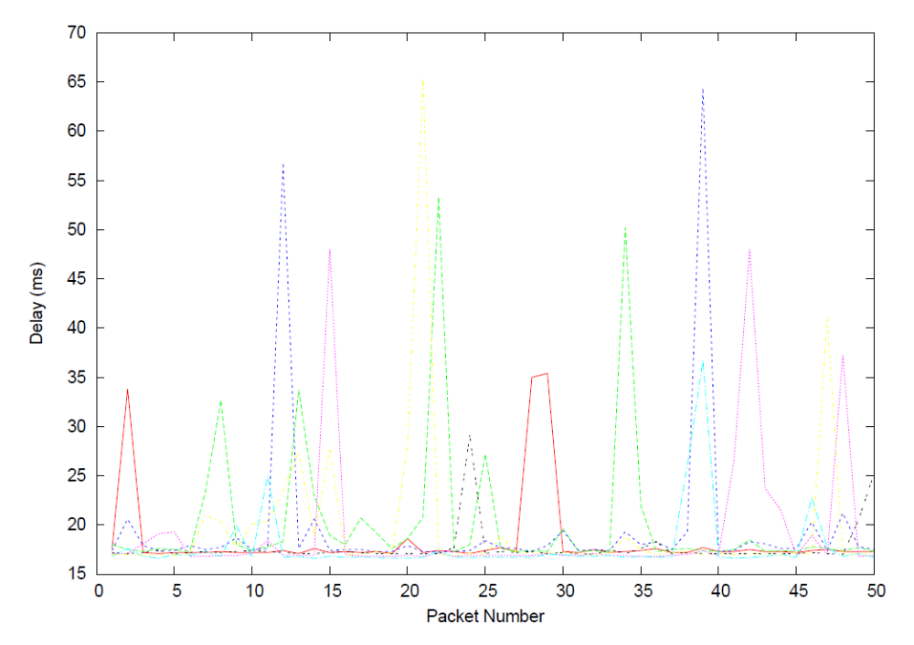
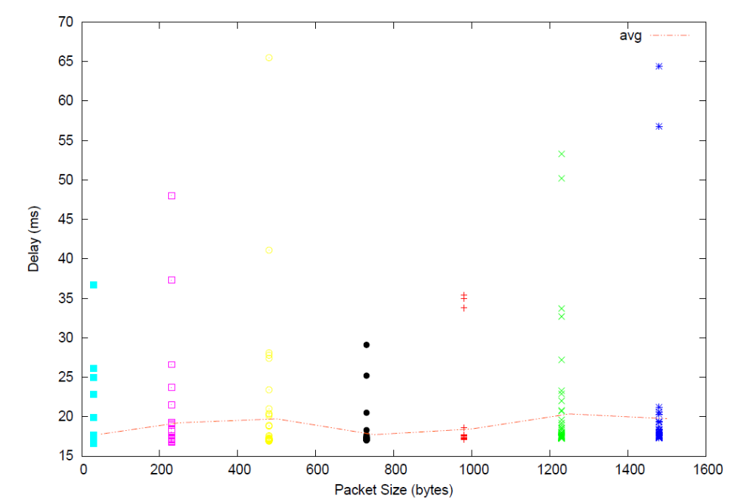

Uni of SG - 6302km t_time = 21ms
- Byte) -145.3ms

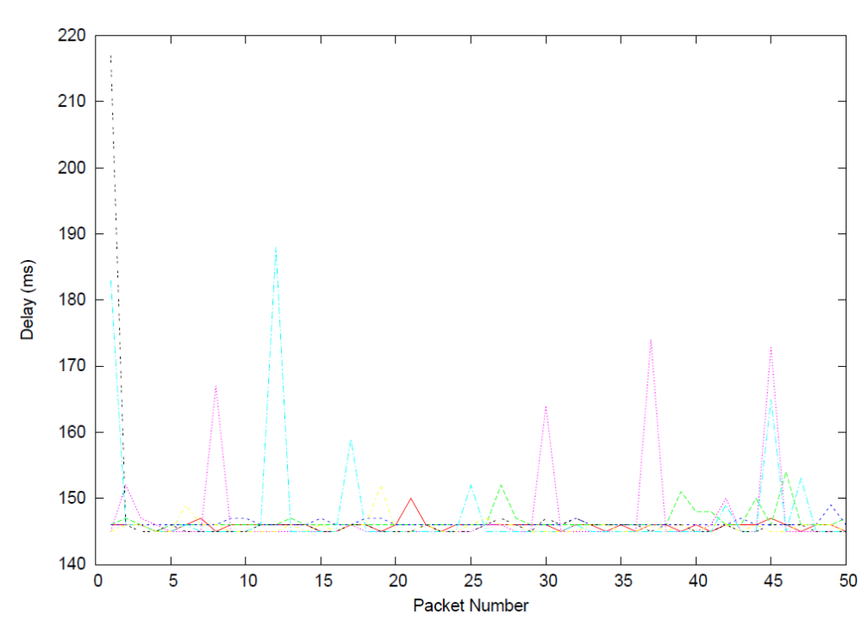

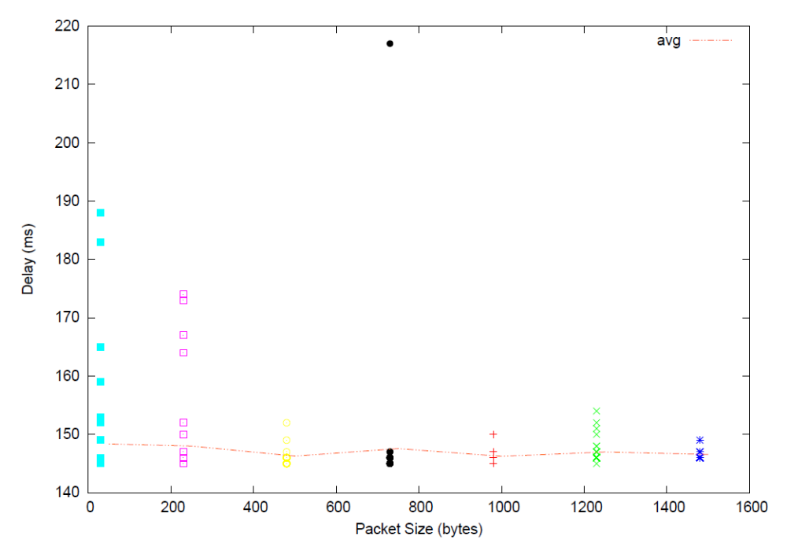

Uni of Berlin - 16084km = 53.6ms
- byte) 16.613ms

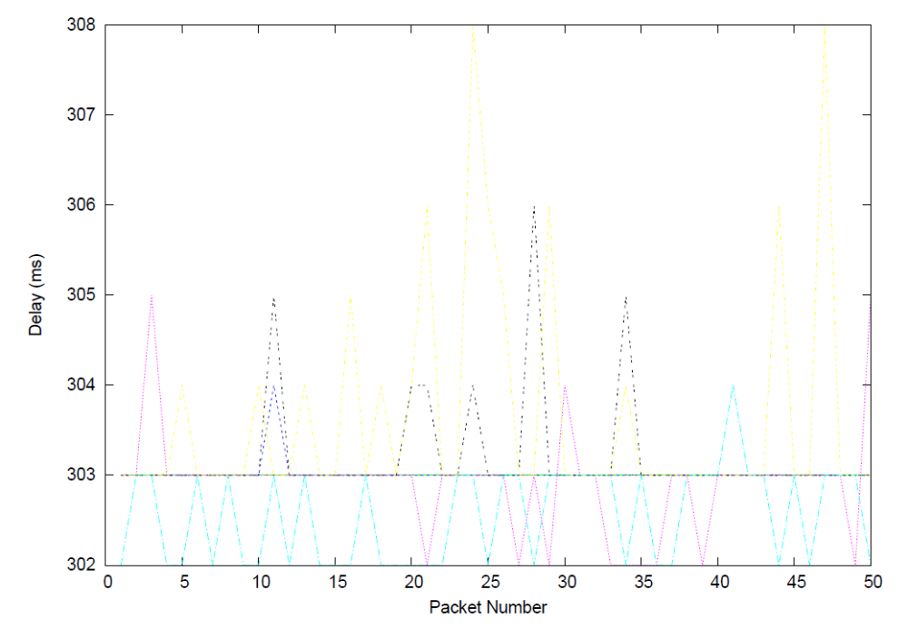

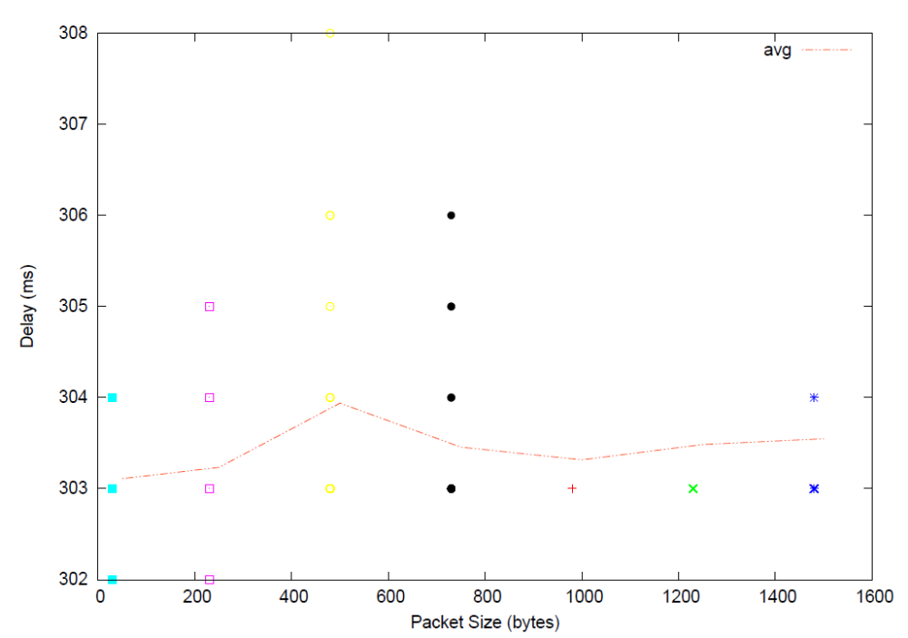

- Most likely queue build up at bottleneck links, which in turn increases the ratio from the minimum of 2.
Due to traffic, packets may travel on routes that are less direct (longer) than the shortest route.

- From the graphs of all the destinations we can clearly see that delays vary and is most likely due to the processing and queue delays.

- For packets traveling to Singapore, it appears that medium size packets (~500bytes) result in the smallest delay
- Packets travelling to QLD, likewise to Singapore
- Berlin has the smallest delay when transmitting packets of size ~950bytes.

Overall trend appears to be that packets that are too large or too small will result in increased delays. For packets that are too small it may be due to the larger quantities of packet headers that need to be processed. Too large and a greater likelihood of congestion.

- Propagation – Not dependent, as it is related to the physical properties of the link.
- Transmission delay – Proportional, since this delay given by L/R (R is bandwidth and L is Packet size)
- Queuing delay – Not dependent, It is more dependent on the congestion of the network rather than the size of packets.
- Processing delay – Depends on packet size, or more so the size of the header of this packet.

