|  |  |  |  |  |  |  |  |  |  |  |
| --- | --- | --- | --- | --- | --- | --- | --- | --- | --- | --- |
| Code Testing Criteria | | | | | | | | | | |
| **Project Name:** | | | Registration Plate Reader | | | | | | | |
| **Type of Test:** | | | Linear Search Functionality | | | | | | | |
| **Version No:** | | | V1.0 | **Client Name:** | | Active Systems PTY | | | | |
| **Description:** | | | Testing the function of linear search including variable screenshots of variable values. All code tests used the data list of {1asd-123, 1cdf-456, 1hij-789, 1klm-000} | | | | | | | |
| **Date:** | | | 24/03/2023 | | | | | | | |
| **Developer:** | | James Chellew | | | **Tester:** | | James Chellew | | | |
| Test Case no. | Part of code tested | | Description of input in textbox (key) | | | Describe action of code | | Expected action of code | | Pass / Fail |
| 1 | If statement for null entry | | No text/white space | | | Displayed “Enter valid search entry” in user feedback bar | | Display “Enter valid search entry” in user feedback bar | | Pass |
| 2 | For loop – iterating for each element in list until match | | “1asd-123” | | | Iterated once (first element match) | | Loop once | | pass |
| 3 | For loop – iterating for each element in list until no match | | “No match” | | | Looped 4 times | | Loop 4 times | | pass |
| 4 | IF statement – check for list element match. | | “1asd-123” | | | Compared key to first element in list -> key and list element matched. Displayed message box “Registration plate exists” | | Compare key to list element. Key will match first list element. Display contents of the IF statement -> Message box display “Registration plate exists” | | pass |
| 5 | IF statement – check for list element no match. | | “No match” | | | Compared key to first element in list, then compared again with key prefixed with a “z” -> no match. This looped 4 times with no match each time. Executed else statement -> message box “Registration plate does not exist” | | Compare untagged and tagged key to each list item in the list. Will execute else statement -> Message box stating “Registration plate does not exist” | | pass |
|  |  | |  | | |  | |  | |  |
|  |  | |  | | |  | |  | |  |
| Linear Search Testing Criteria | | | | | | | | | | |
| Test for null entry into TextBox | | | | | | | | | Yes √ | No× |
| Test IF compare statement | | | | | | | | | Yes √ | No× |
| Test loop variable | | | | | | | | | Yes √ | No× |
| Test error message | | | | | | | | | Yes √ | No× |
| Test Boolean found | | | | | | | | | Yes × | No√ |

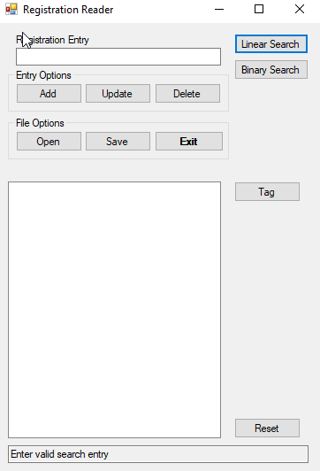Test case 1 image(s):

Test case 2 image(s):

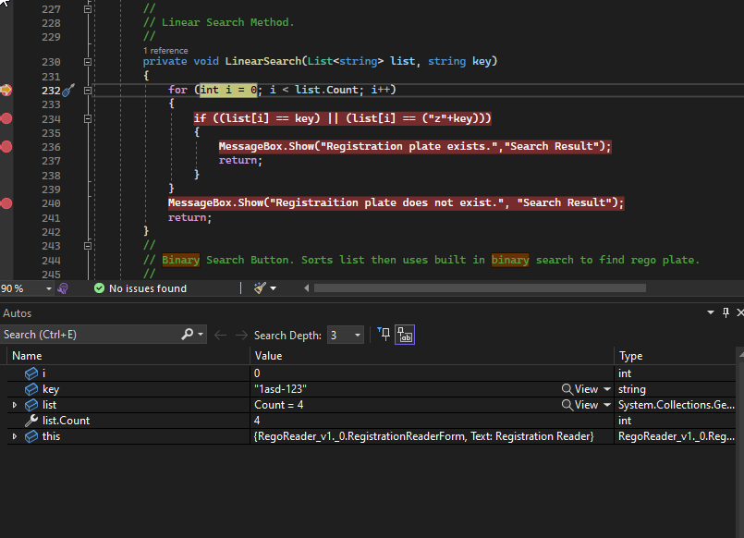

Test case 3 image(s):

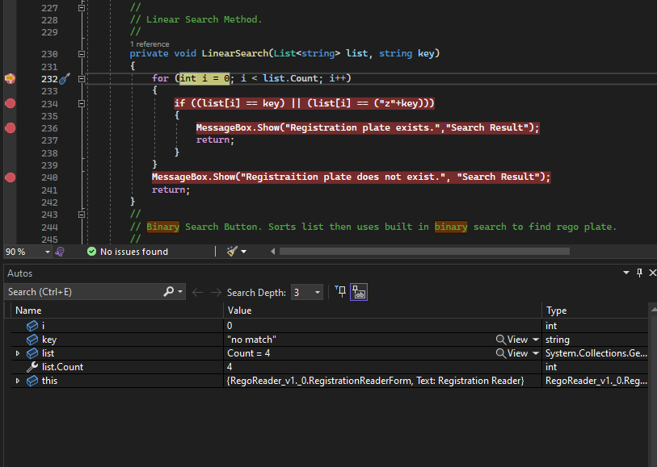

Test case 4 image(s):

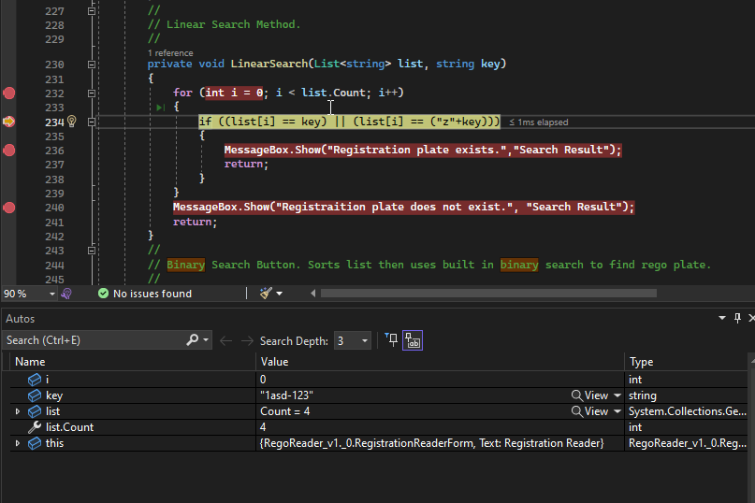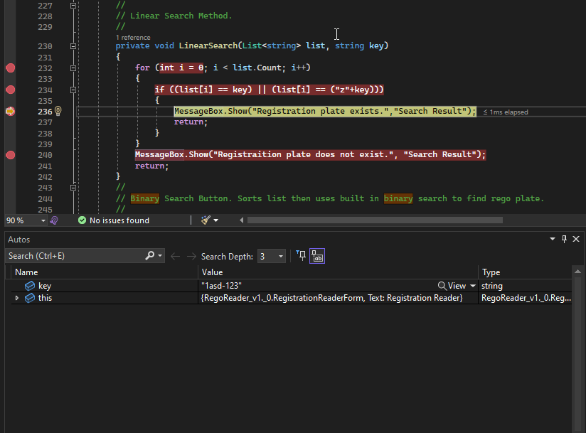

Test case 5 image(s):

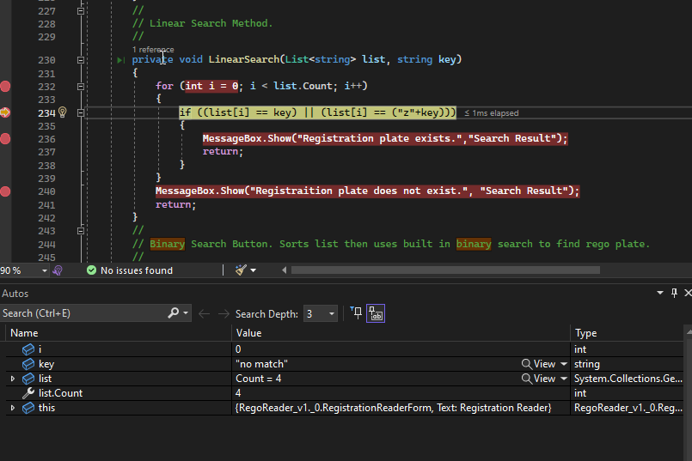 First loop:

Second Loop:

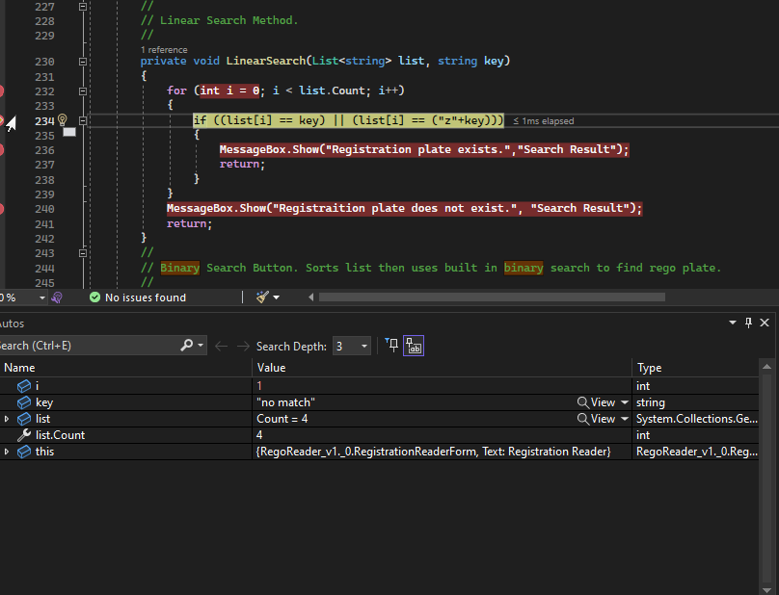

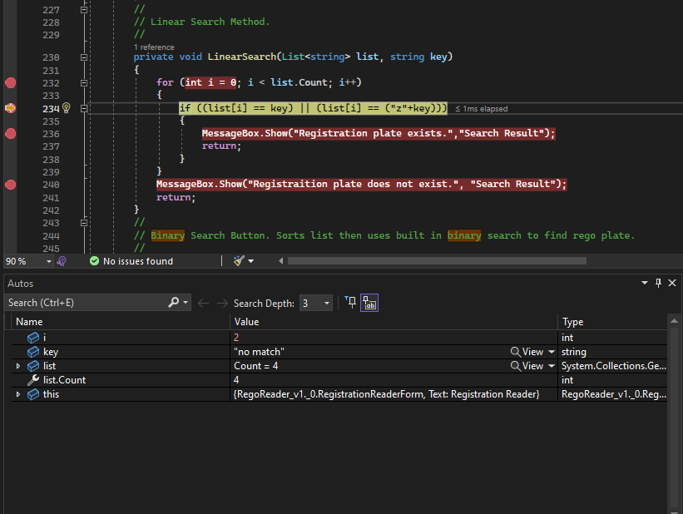 Third Loop:

Forth Loop:

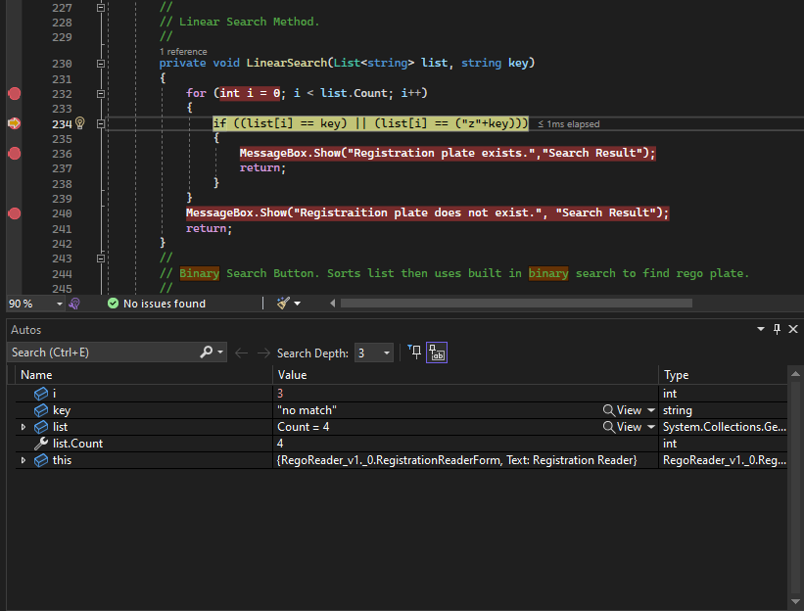

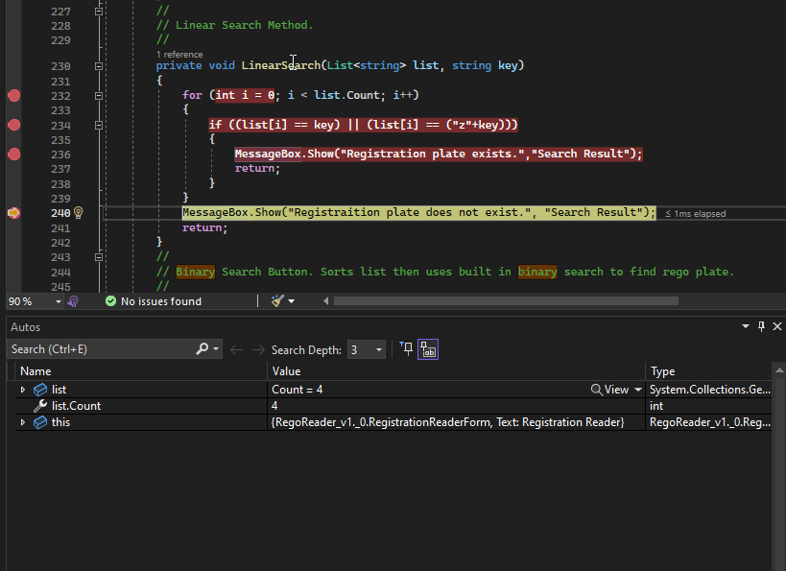 Else (result) code executed: