Tales of Bol Noy

Publisher Proposal

Executive Summary goes here

1. **Market Evaluation**
   1. **Game Value Proposition**

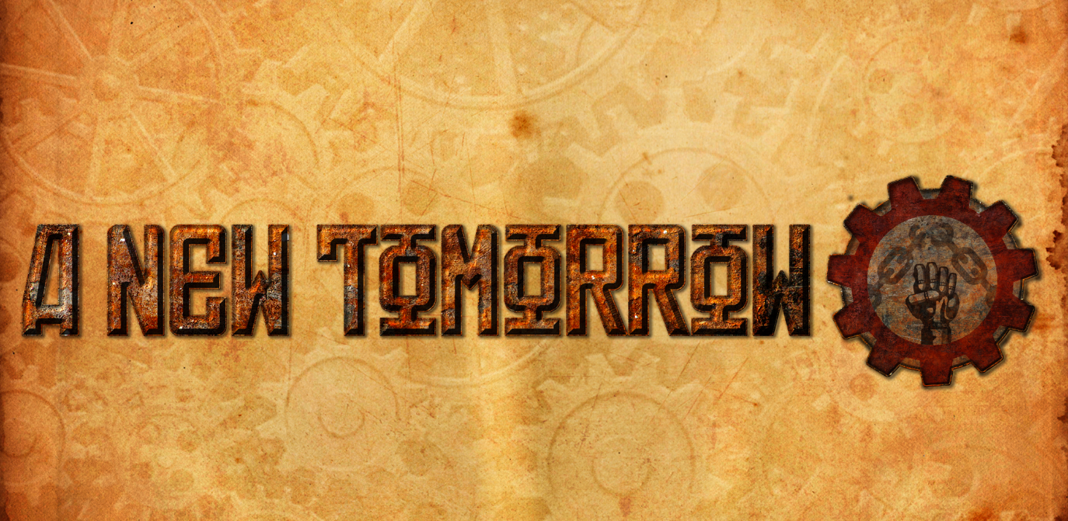A New Tomorrow is an unforgiving First person stealth game. It is designed for play on PC but could be ported to console with relative ease.

Figure 1 – A New Tomorrow Title

The game is inspired by other stealth games such as the Dishonoured series, Thief and Deus Ex, where one of the main mechanics is about navigating an environment while avoiding any hazards and enemies that can spot you. Our game, however, shifts the environment to an alternate reality world of Glavanya, with a Russian revolution setting. This is a time in history, and an aesthetic, that has been rarely covered in games. The game is set in a factory, where the player must navigate the varying environments while locating and hacking terminals. There are collectibles scattered around the map to aid in navigation and to improve the players stealth capabilities. It has a 3D realistic art style to help improve the player’s immersion with the first-person style.

The game has been designed around the needs of players looking to sit down and spend a few hours on a hard game that is unlikely to be completed on the first attempt. For example, the ‘Hardcore Gamer’, someone who comes home from work and sits down to unwind on a game they can concentrate fully on, giving them a sense of achievement. The game is one singular hard level, with various collectables to help improve the players chances of a stealth approach.

* 1. **Marketing Personas**

In terms of Bartle’s player types, A New Tomorrow’s target players can be classified as either achievers (people who like to explore the whole / unlock all the collectables / complete difficult games) or explorers (people who like to explore the environment and find all it’s secrets).

The majority of the personas assume that the players will be time rich. They are sitting down to plays long sessions of games. This fits with the criteria of achievers and explorers.

**1.2.1 Marketing Persona: Thomas**

|  |  |
| --- | --- |
| **Thomas** | **Role: Obsessive Gamer** |
|  | **Description**:  Thomas is an obsessive gamer. He spends all of his free time in front of a screen. Almost bordering on addiction Thomas is looking for a game that keeps him entertained for hours. He games because it’s easier than getting a job. He doesn’t care about achievements, but he doesn’t want to stop playing. |
| **Quote:**  Yo dude, I’ve just bought a pizza. I’ve had a hard day doing nothing, and I just wanna sit and chill on game man. |
| **User Goals:**  Spend all day gaming. Play something that helps him escape from his dingy living room. |

|  |  |
| --- | --- |
| **Becky** | **Role: Gaming Hobbyist** |
|  | **Description**:  Becky lives an average life. When she has free time, she likes to play games to experience new, magical worlds. She has all the latest gear, but doesn’t spend all her time gaming. |
| **Quote:**  Oh man, the new Tomb Raider game is sooo good. I love its art and the story was like life changing. I can’t wait to see which new games I can try when I have time. |
| **User Goals:**  To spend some free time in the day to play some new unique games. Mainly likes the art work but likes exploring to find it all. |

**1.2.2 Marketing Persona: Becky**

**1.2.3 Marketing Persona: Carl**

|  |  |
| --- | --- |
| **Carl** | **Role: Game Completionist** |
|  | **Description**:  Carl can’t help but complete games. It’s his passion, and his skill. He gets a rush from completing games, The harder the better. He will brag about his achievements. |
| **Quote:**  I once completed dark souls with my hands tied while blindfolded. I bet you can’t even beat the first boss, can you. |
| **User Goals:**  He hangs around internet social sites bragging about all of his gaming achievements to other completionists. |

**1.2.4 Marketing Persona: Damien**

|  |  |
| --- | --- |
| **Damien** | **Role: Casual Gamer** |
|  | **Description**:  Damien spends his time on the waves, but when he’s home he’ll chill on the couch with a cool glass of coke, and play games or watch T.V. |
| **Quote:**  oh brah it's just like dude you get the best barrels ever dude it's just like you pull in and you just get spit right out of 'em and you just drop in and you jus' smack lip WAPAAH y'drop down s'na BAaAaAH and then after that you just drop in just ride the barrel and get pitted so pitted like that. |
| **User Goals:**  After a gnarly day on the waves he just wants to come home, chill out and play some games to pass the time. |

1. **Route to Market – Self Publishing for PC Release**
   1. **Market Position**

**2.1.1 Sales Channels**

This game will use one sales channel (Itch.io), though it is anticipated that, if there is demand for it, we could push our game onto other sales channels. However, this has not been currently considered so, as such we will not be including it in this revenue model.

We anticipate that we will sale approximately 10,000 units at an average net receipt of £5 per unit. However, this does assume that the game will not be discounted in the first 6 months after release. We anticipate sales to peak in month 2-3 and then fall off slowly for the next 3-4 months.

**2.1.2 Advertising**

Our studio currently has no in house advertising expertise and we have little funding or it either. One method we have devised for dealing with this problem is to follow low cost routes, such as sending free copies to various Youtubers to gain exposure and hopefully get their followers to see the game. We would have to ensure this was at a low cost, as it could end up being a very costly area of development.

**2.1.3 Further Work**

Due to the nature of product launches, especially how ‘polar’ game launches can be, we have prepared a 7 month sales roadmap. We will be monitoring actual sales performance against our projections and will adjust our funding in various areas as necessary.

1. **Route to market – Publisher**

We have also been approached by publisher ‘X’ who are keen to fund our game. They like our concept and are willing to fund up to 12 months of development (£100,000). They will instigate a 50:50 royalty split after advances have been repaid. Depending on sales they would then like us to port the game to Xbox One, PS4 and Nintendo Switch.

* 1. **Market Position**

Developer ‘X’ are a fairly well known and profitable publisher that can be reliably trusted to fund our game. They are taking a fairly large split of the profits, but it should be noted our total profit is predicted to be much larger and it is much more reliable with the extra marketing funding to effectively advertise our game.

* 1. **Advertising**