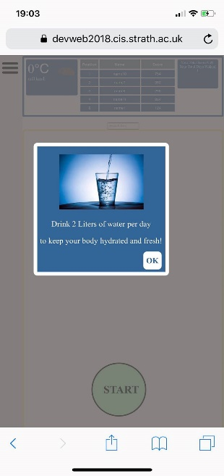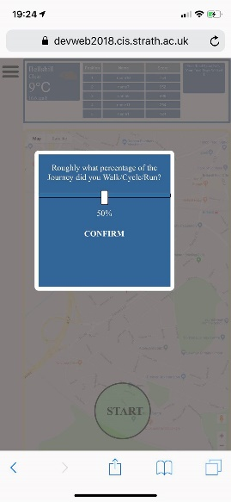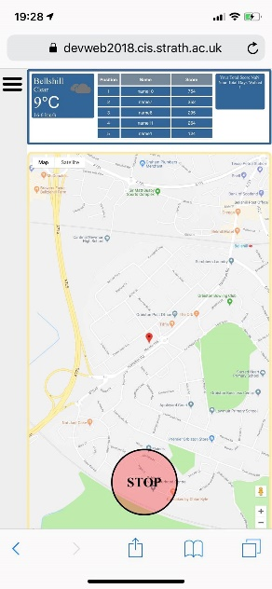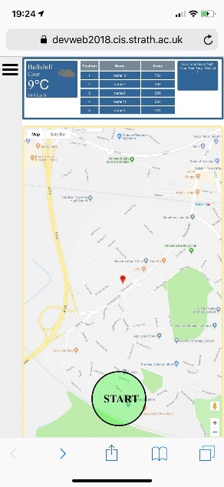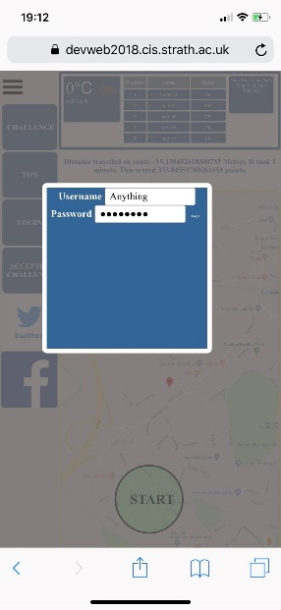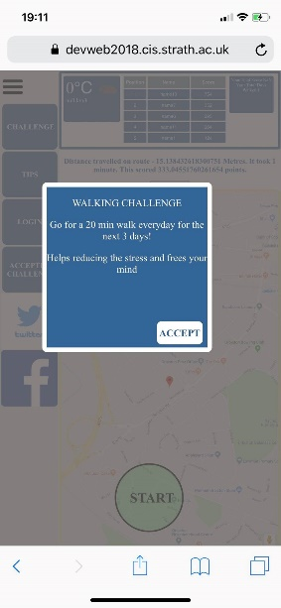

**PROGRESS END SCREEN**

Once stopped, the user estimates how they travelled so the points are split accordingly.

**PROGRESS SCREEN**

Once started this screen will record the users progress and will update the map as they roam until stop is pressed.

**HOME**

This screen shows the weather, a scoreboard, days walked and a location map.

**ENTRY SCREEN**

This screen is also accessed from the sidebar and gives different randomised tips on health.

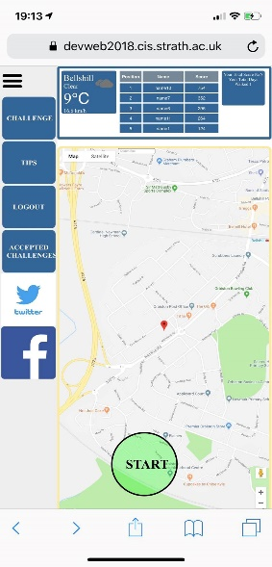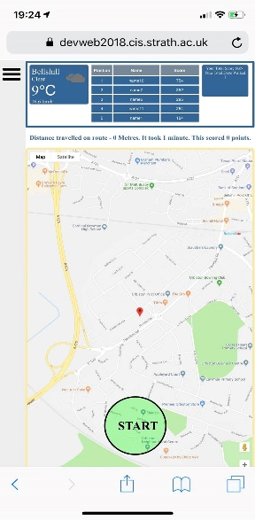

**STATS SCREEN**

The users travelled distance, time taken and points scored on their previous trip is shown above the map.

**CHALLENGE SCREEN**

User has option of accepting a random challenge. If user accepts challenge it will show in the accepted challenges menu.

**LOGIN SCREEN**

May be utilized upon further development of the app, so to login simply enter any random combination of letters in both boxes.

**NAVBAR SCREEN**

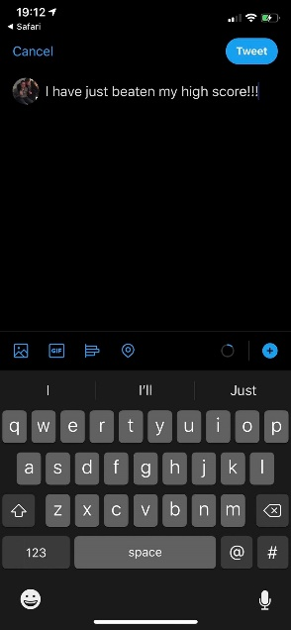



**SOCIAL MEDIA PAGES**

Pressing the Twitter or Facebook logo will take the user to a page like this, which lets the user tell there friends of their accomplishments!

<https://devweb2018.cis.strath.ac.uk/~xeb16155/commute/index.php>