Smart Commute App

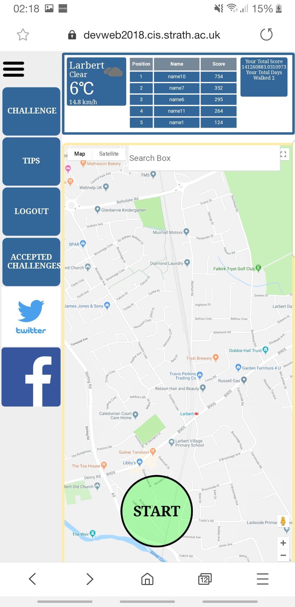

# Aim:

* To provide a system to encourage users to commute to and from work in a healthier and more eco-friendly way.

Our app achieves this as it provides users with a platform to log their commute and achieve scores based on how far they walked.

Our app makes use of GPS location to determine where the user is, this allows us to use the Google Maps API to display the map to their destination.



# Device Compatibility:

# Development Environments:

* We rely on the user to tell us the percentage of their commute that they walked.

Ideally, we would optimise the app using mobile sensors to tell us if a user is in a vehicle or not, based on their speed.

* Location map.
* Navigation bar.
* Weather widget.
* Scoreboard.
* Challenges.
* Tips.
* Social media share options.
* Search for destination + get directions.

Features:

Limitations:

Alexander Fan, Darren Nailen, Hasib Ahmed, James Conway, Kristian Feherek, Leonard Magyar