BDSH Unfunded Projects

Fiscal Year 2020

18 November, 2020

fy <- 2020

# BDSH Projects

The BDSHub worked on a total of 66 without funding support during the 2020FY.

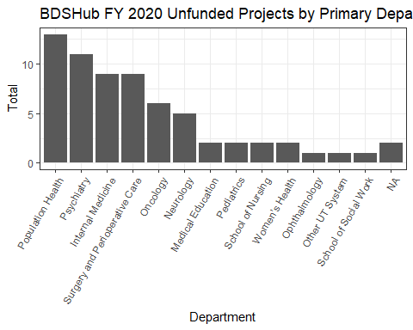

# BDSH Unfunded Effort

## `stat_bin()` using `bins = 30`. Pick better value with `binwidth`.

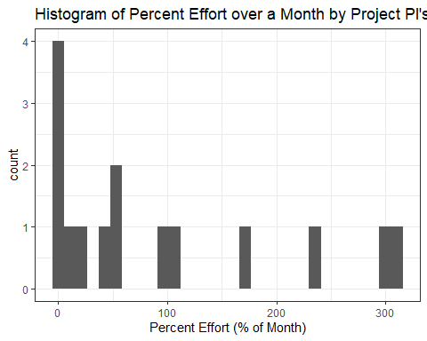

## `stat_bin()` using `bins = 30`. Pick better value with `binwidth`.

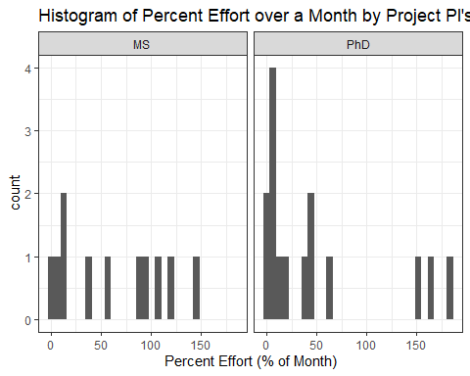

## `stat_bin()` using `bins = 30`. Pick better value with `binwidth`.

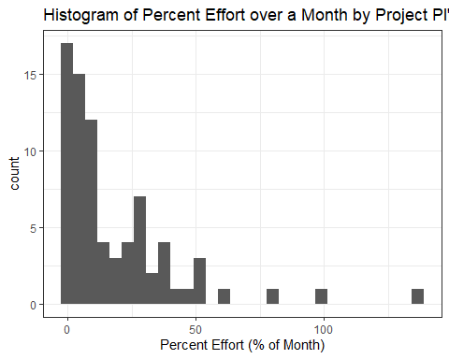

## `stat_bin()` using `bins = 30`. Pick better value with `binwidth`.

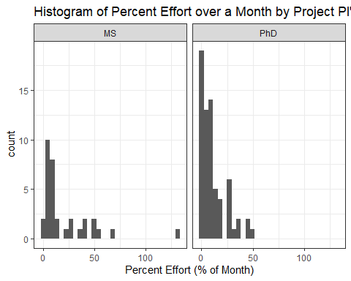

# Project Appendix

### Internal Medicine

|  |  |  |  |
| --- | --- | --- | --- |
| projectID | projectName | projectPIName | projectStatus |
| 20010 | ACS Postcare-O | Elizabeth Kvale | Active |
| 20034 | Meals on Wheels | Elizabeth Jacobs | Active |
| 20053 | Cristal Brown MA Thesis | Cristal Brown | Active |
| 20055 | Home Monitoring-AHA | Elizabeth Jacobs | Active |
| 1009 | CPC | Elizabeth Jacobs | Closed - Analysis Completed |
| 1004 | PSA Shared Decision Making | Elizabeth Jacobs | Closed - Funding Declined |
| 20052 | COVID-19 HCW Testing | Parker Hudson | Dormant - Analysis Completed |
| 1013 | CPRIT Palliative Care | Elizabeth Kvale | Dormant - Grant Submitted |
| 20023 | K23 | Tessa Novick | Dormant - Grant Submitted |

### Medical Education

|  |  |  |  |
| --- | --- | --- | --- |
| projectID | projectName | projectPIName | projectStatus |
| 20050 | Texas Cancer Registry Missing Data | Charlotte Heron | Closed - Analysis Completed |
| 20004 | Quadriceps Brace | Benjamin Kopp | Dormant - Loss to Follow-up |

### Neurology

|  |  |  |  |
| --- | --- | --- | --- |
| projectID | projectName | projectPIName | projectStatus |
| 20014 | Warach Stroke | Steven Warach | Active |
| 20035 | Predicting Cognitive Decline | Robin Hilsabeck | Active |
| 20008 | MS Telemedicine | Ethan Meltzer | Closed - Funding Declined |
| 20059 | Austin Seroprevalence-COVID 19 | Esther Melamed | NA |
| 20061 | Novel Imaging AD biomarkers for Men vs Women | Adrienne Dula | NA |

### Oncology

|  |  |  |  |
| --- | --- | --- | --- |
| projectID | projectName | projectPIName | projectStatus |
| 20028 | LWABS | Michael Pignone | Active |
| 20019 | Metastatic Colorectal Cancer Nutrition Pilot | Krystle Zuniga | Closed - Funding Declined |
| 20006 | T Cell K22 | Todd Triplett | Dormant - Grant Submitted |
| 20029 | Pancreatic Cancer | Kyaw Aung | Dormant - Grant Submitted |
| 20032 | Metastatic Colorectal Cancer Nutrition Pilot Extension | Krystle Zuniga | Dormant - Grant Submitted |
| 20030 | Preclinical Metastatic Colorectal Cancer Models | Anna Capasso | Dormant - Loss to Follow-up |

### Ophthalmology

|  |  |  |  |
| --- | --- | --- | --- |
| projectID | projectName | projectPIName | projectStatus |
| 20065 | Natalie Homer- Wound dehiscence | Natalie Homer | Closed - Analysis Completed |

### Other UT System

|  |  |  |  |
| --- | --- | --- | --- |
| projectID | projectName | projectPIName | projectStatus |
| 20011 | NORC | Deanna Hoelscher | Closed - Funding Declined |

### Pediatrics

|  |  |  |  |
| --- | --- | --- | --- |
| projectID | projectName | projectPIName | projectStatus |
| 20036 | Pilot Pediatric Obesity | Megan Gray | Active |
| 20048 | Project SUENO | Megan Gray | Dormant - Grant Submitted |

### Population Health

|  |  |  |  |
| --- | --- | --- | --- |
| projectID | projectName | projectPIName | projectStatus |
| 1011 | eCATCH pulmonary phenotype | Elizabeth Matsui | Active |
| 20046 | UTnUC | Richard Peters | Active |
| 20051 | COVID-19 Contact Tracing | Tim Mercer | Active |
| 20064 | Homeless COVID Testing | Tim Mercer | Active |
| 20070 | Families and Schools Together (FAST) | Carmen Valdez | Active |
| 20076 | Bringing Health Home | Freya Spielberg | Active |
| 20077 | AHRQ SHIP Application | William(Bill) Tierney | Active |
| 20005 | Diet Goal CDS | Marissa Burgermaster | Closed - Funding Awarded |
| 20009 | P50 | Elizabeth Matsui | Closed - Funding Declined |
| 20016 | CUC Empanelment | William(Bill) Tierney | Closed - Funding Declined |
| 20001 | HCV Model | Tim Mercer | Dormant - Grant Submitted |
| 20007 | PCORI | Freya Spielberg | Dormant - Grant Submitted |
| 20049 | Carmen Valdez-June 2020 Submission | Carmen Valdez | Dormant - Loss to Follow-up |

### Psychiatry

|  |  |  |  |
| --- | --- | --- | --- |
| projectID | projectName | projectPIName | projectStatus |
| 20012 | Gene Stats | Mbemba Jabbi | Active |
| 20075 | Microbiota: Potential link between inflammation and depression, with E. Buerel | Charles Nemeroff | Active |
| 20017 | AFSP Cancer-Suicide | Charles Nemeroff | Closed - Funding Declined |
| 20020 | Child Trauma | Charles Nemeroff | Closed - Funding Declined |
| 1005 | ASS Concordance with PHQ and QID | Jorge Almeida | Closed - Loss to Follow-up |
| 20003 | Prenatal Depression | Jeffrey Newport | Dormant - Grant Submitted |
| 20013 | Blue Sky, R21: Brain aging and depression related suicide | Mbemba Jabbi | Dormant - Grant Submitted |
| 20033 | Nemeroff-Prediction of PTSD and Alcohol Abuse After Trauma in Adolescents | Charles Nemeroff | Dormant - Grant Submitted |
| 20047 | Alzheimer, MDD, and Immune Activity | Marisa Toups | Dormant - Grant Submitted |
| 1007 | Immune Activity and MDD | Marisa Toups | Dormant - Manuscript Submitted |
| 20038 | PTSD R34 | Suzannah Creech | NA |

### School of Nursing

|  |  |  |  |
| --- | --- | --- | --- |
| projectID | projectName | projectPIName | projectStatus |
| 20063 | Clinical Trial for Self-help program in Diabetes & Multiple Chronic Conditions | Kim Miyong | Active |
| 1008 | HoLA | Alex Garcia | Closed - Analysis Completed |

### School of Social Work

|  |  |  |  |
| --- | --- | --- | --- |
| projectID | projectName | projectPIName | projectStatus |
| 20044 | Epinet | Molly Lopez | Active |

### Surgery and Perioperative Care

|  |  |  |  |
| --- | --- | --- | --- |
| projectID | projectName | projectPIName | projectStatus |
| 20045 | PCORI | Prakash Jayakumar | Active |
| 20054 | Kelly Chambers med students | Kelly Chambers | Active |
| 20060 | Seton COVID Hospitalization | Alex B Haynes | Active |
| 1010 | PROs in Shared Decision Making Arthritis Patients | Kevin Bozic | Closed - Funding Awarded |
| 20015 | Congenital Heart Disease | Carlos Mery | Closed - Loss to Follow-up |
| 20040 | Prehabilitation: Abdominal Cancer Patients | Savannah Wooten | Closed - Loss to Follow-up |
| 20002 | Health Literacy and PROs | Kenneth Furlough | Dormant - Grant Submitted |
| 20025 | AHRQ R18 | Prakash Jayakumar | Dormant - Grant Submitted |
| 20072 | Jayakumar & Ring: PCORI Shoulder pain intervention implemented with PTs (usual care vs CFT) | Prakash Jayakumar | NA |

### Women’s Health

|  |  |  |  |
| --- | --- | --- | --- |
| projectID | projectName | projectPIName | projectStatus |
| 20067 | HCW Survey for COVID-19 | Alison Cahill | Active |
| 20073 | Cerner COVID-19 | Alison Cahill | Active |