Reversible R Markdown Document

Your subtitle

Your Name

Created 2019-06-21

RPLACEHOLDER

This is an example Reversible R Markdown document. It will preserve code elements for restoration in your final .docx file.

You can use things like inline RPLACEHOLDER comments.

You can use code chunks to generate output and they will be restored:

summary(cars)

## speed dist   
## Min. : 4.0 Min. : 2.00   
## 1st Qu.:12.0 1st Qu.: 26.00   
## Median :15.0 Median : 36.00   
## Mean :15.4 Mean : 42.98   
## 3rd Qu.:19.0 3rd Qu.: 56.00   
## Max. :25.0 Max. :120.00

## Inline text

RPLACEHOLDER

You can include calculations inline like so: 2 plus 3 equals 5. Even empty inline chunks RPLACEHOLDER will be stored and marked with hidden text in the Word document.

## Chunks with plots

You can of course also embed plots, for example:

plot(pressure)

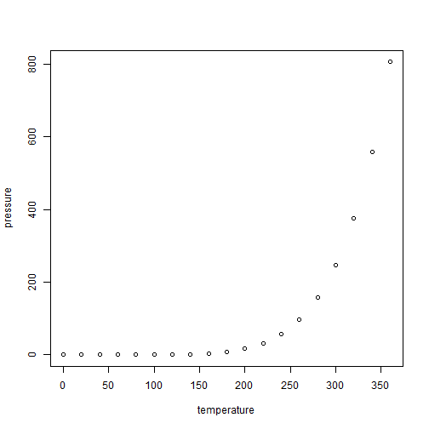

## Track Changes

**redoc** supports [Critic Markup](http://criticmarkup.com/users-guide.php) syntax for comments. You can include edits and they will be converted to tracked changes in your Word document . By default , your system username is used as the author of changes, but this can be set with the comment_author argument in redoc() or your document YAML.

So if I add some changes here, what does it do? where does it go? Does it create a new word file? Does it overwrite the old? Lets test it out and see what happens.

So what happens when I make changes in word without using tracked changes?

And what about what happens when I have track changes on?

df[, c(“Hello”, “bye”)]