An introduction to landscape genetics
An important goal in conservation genetics is to identify the geographical determinants of genetic diversity and genetic differentiation. Which populations have high and low genetic diversity, and which landscape features influence population connectivity? The field of landscape genetics is seeking answers to these questions by combining population genetic results with geographical information.
Let’s start with an example. Here is a map of the Dijle-Demer basin, a Flemish drainage in the area between the cities of Mechelen, Leuven, Aarschot, Diest and Diepenbeek. The flow direction is marked with arrows. Flemish rivers and streams contain many constructions that potentially constrain the migration of fishes. In the Dijle-Demer basin, these constructions include water mills (red dots; n = 46), weirs (blue dots; n = 57), tunnels (yellow dots; n = 14) and sluices (green dots; n = 4). The questions is, to what extent are these structures affecting the genetic structure (genetic diversity and genetic differentiation) of populations? Each of these constructions was visited to measure “vertical barrier height” in centimeter, as an index of the potential impact of these barriers (a barrier causing a vertical drop in the water level of 100 cm is expected to be more difficult for upstream migration then a barrier of 40 cm).
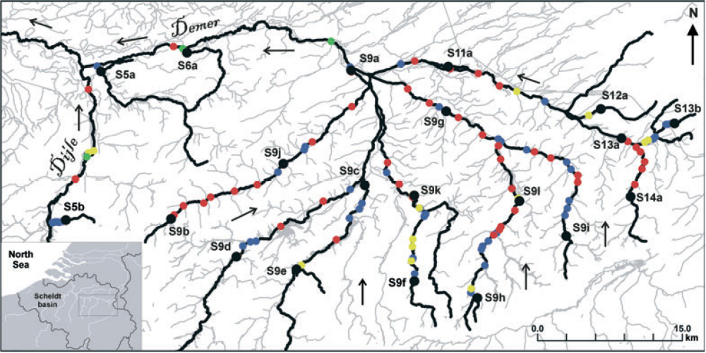
To solve this issue, we take an “umbrella” species approach, anticipating that the population structure of one species is indicative for many other species. Among all riverine fish, the three-spined stickleback is the most common one, enabling us to select many sampling locations (with more populations generating a better geographical resolution), and to collect many individuals per sample (with more individuals, we can obtain more precise estimates of allele frequencies). For this study, we selected 21 locations (black dots and black labels) and obtained 50 individual sticklebacks per sample, so 1050 individuals in total. These were genotyped with 6 microsatellite markers. This information was used to calculate allelic richness (AR; n=21 populations) as a measure of genetic diversity, and pairwise Fst as a measure of genetic differentiation (n x (n-1)/2 = 21 x 20/2 = 210 population pairs).
In addition, geographical information was obtained with the help of a geographical information system (GIS):
- First, a downstream reference site was chosen (labeled S4a, located 37 km downstream from S5a; which is outside the map). Then, for every location, we calculated geographic parameters, such as the upstream distance from location S4a, the number of migration barriers, and the cumulative vertical barrier height. All this information was merged with allelic richness in a dataset named “geogenvar” (21 rows).
- Second, the geographical calculations were performed in a pairwise fashion, such as pairwise geographical distance, pairwise number of migration barriers, and pairwise cumulative barrier height between any two populations. All this information was merged with pairwise Fst in a dataset named “geogendist” (210 rows).

Assignment
Download the file “6 - Conservation Genetics – Riverscape genetics.R” and open it in RStudio. Follow the instructions step by step. Once you have imported “geogenvar” and “geogendist”, you can study the relationships between AR and Fst on the one hand (i.e. the genetic parameters), and the geographical information (i.e. “distance”, “all_barriers, barrier_height”, etc...) on the other hand. Which statistical analyses do you propose to investigate barrier impact? Do you think there is a straightforward way to measure barrier impact? Why or why not? Do you have suggestions for improving the study?
> colnames(geogenvar)
[1] "population"
[2] "AR"
[3] "mills"
[4] "weirs"
[5] "tunnels_sluices"
[6] "all_barriers"
[7] "barrier_height"
[8] "distance"
[9] "log10.habitat.width."
[10] "log10.upstream.distance."

> colnames(geogendist)
[1] "pop1"
[2] "pop2"
[3] "fst"
[4] "mills"
[5] "weirs"
[6] "tunnels_sluices"
[7] "all_barriers"
[8] "barrier_height"
[9] "distance"
[10] "log10.habitat.width."
[11] "log10.upstream.distance."
[12] "fst_predicted"

Enjoy,
Joost

