The goal of this project is to provide a soft engineered robotic solution to the problem of drop foot in patients. This is a condition where the person is unable to raise the foot from the ankle and thus has a profound negative effect on the patient’s gait. The designed device is an attachment for shoes that allows the patient to return to a normal gait or as mechanically possible.

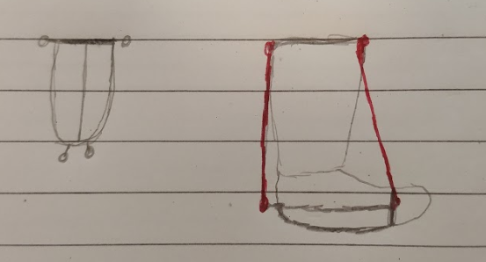

The diagram on the left shows the basis of the design. It is based around 4 artificial tendons (2 on the heel and 2 on the ball of the foot) which are connected to a servo motor. To move the foot these tendons are manipulated within the range of motion that the ankle biologically allows to avoid injury to the user. The servo motors are held in place by a strap around the leg above the calf muscle.



On the right is an overhead view of the strap used to attach the tendons to the foot. This strap reduces the cost of the unit by removing the need for a full shoe as well as making it adjustable for the user over time. The tendons are attached to the circles in the diagram with the line at the top being a loop that goes around the ball of the foot, while the semicircle below this goes around the heel. The mid line is to allow force to be exerted upwards on the foot without the strap moving off the foot.

The device would then be programmed safely by having a set degree of movement that it can pull the foot through as to avoid injury. This system will also have a fixed tendon on the back that is not attached to a motor as to take the weight of the body when a large amount of force is taken during the end of a step.