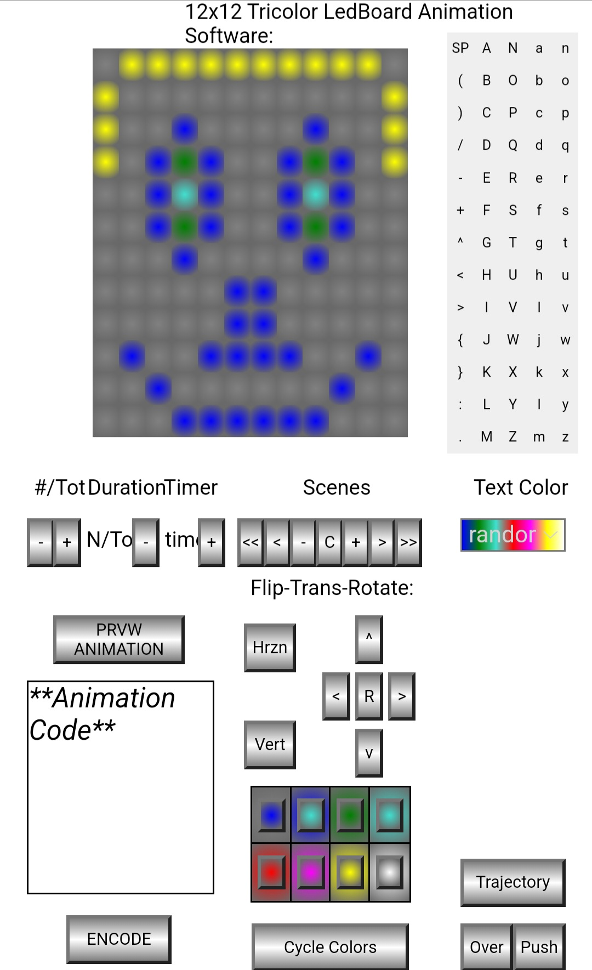 | 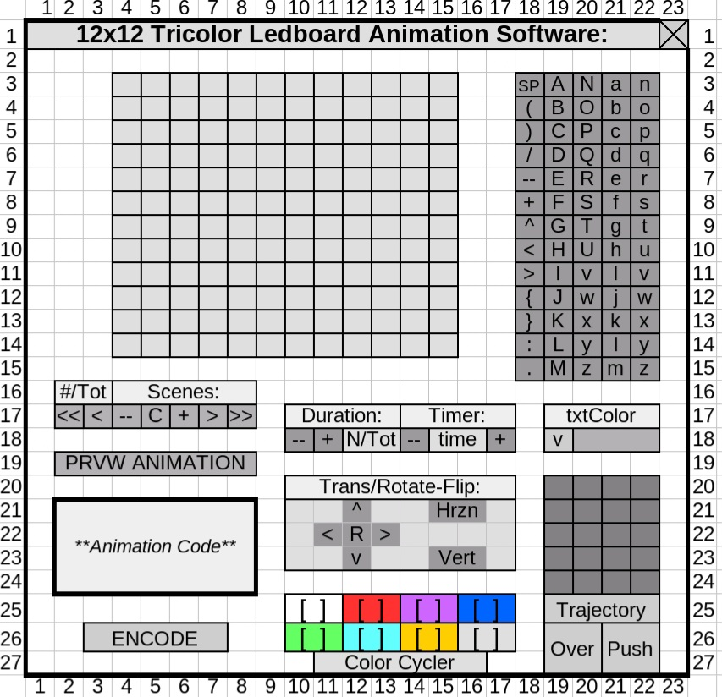

<!DOCTYPE html>
<html>
<head>
<style>
/*** Variables ***/
:root {
--Dw: calc((1/21.5)*100%);
--Dh: calc((1/30)*100%);
}

/*** Main Grid ***/
.grid-container {position: relative; width: 100%; height: 100vh; font-family: Arial, sans-serif;}

/*** Labels ***/
.section-label {position: absolute; font-size: 75%;}

/*** Buttons ***/
/* LED Buttons */
.btn-led {position: absolute; width: var(--Dw); height: var(--Dh);
background-image: radial-gradient(circle at center, gray, dimgray 85%);
cursor: pointer; transition: background-color 0.2s; border: none; outline: none;}

/* Character Buttons */
.btn-char {position: absolute; width: var(--Dw); height: var(--Dh);
background-color: light-gray; border: 0px solid #666; font-size: 5%;
display: flex; align-items: center; justify-content: center;}

/* Control Buttons */
.btn-control {position: absolute; display: flex;
width: var(--Dw); height: var(--Dh);
background-image: linear-gradient(to top, gray, white, gray);
font-size: 60%; align-items: center; justify-content: center;}

/* Color Cycle Buttons */
.color-cycle-btn {position: absolute; width: 70%; height: 60%; cursor: pointer;
background-image: radial-gradient(circle at center, transparent, dimgray 85%);}

/** Button Handlers **/
.btn-led:hover, .btn-char:hover, .btn-control:hover,
.btn-color:hover {filter: brightness(90%);}

/*** Other Controls ***/
/* Color Boxes */
.color-box {position: absolute; width: calc(1.5*var(--Dw)); height: calc(1.75*var(--Dh));
border: 1px solid black; display: flex; align-items: center; justify-content: center;
background-image: radial-gradient(circle at center, transparent, dimgray);}

/* Animation Code Box */
.animation-code {position: absolute; border: 1px solid black;
font-style: italic; font-size: 0.05em
display: flex; align-items: center;
justify-content: center; background-color: white;}

/* Colored Text Box */
.colored-text {position: absolute; width: calc(4*var(--Dw));
align-items: center; justify-content: center; color: transparent;
background-image: linear-gradient(to top, lightgray, transparent, lightgray);
background-image: linear-gradient(to right, lightgray, transparent, lightgray);}

.random-colored-text {position: absolute; width: calc(4*var(--Dw));
align-items: center; justify-content: center; color: lightgray;
background-image: linear-gradient(to top, lightgray, transparent, gray);
background-image: linear-gradient(to right, blue, green, turquoise, red, magenta, yellow, white);}

</style>
</head>

<body>
<div id="gridContainer" class="grid-container"></div>

<script>

//****Constants****//

//**Color Pallet**//
const colors = ['gray', 'blue', 'green', 'turquoise',
'red', 'magenta', 'yellow', 'white', 'random'];

//**Character Grid**//
const charGrid = [
['SP', 'A', 'N', 'a', 'n'],
['(', 'B', 'O', 'b', 'o'],
[')', 'C', 'P', 'c', 'p'],
['/', 'D', 'Q', 'd', 'q'],
['-', 'E', 'R', 'e', 'r'],
['+', 'F', 'S', 'f', 's'],
['^', 'G', 'T', 'g', 't'],
['<', 'H', 'U', 'h', 'u'],
['>', 'I', 'V', 'l', 'v'],
['{', 'J', 'W', 'j', 'w'],
['}', 'K', 'X', 'k', 'x'],
[':', 'L', 'Y', 'l', 'y'],
['.', 'M', 'Z', 'm', 'z']];

//*****Start Create Interface Function*****//
function createInterface() {
const container = document.getElementById('gridContainer');

//****TriColor LED grid (12x12)****//
for (let row = 0; row < 12; row++) {
for (let col = 0; col < 12; col++) {
const button = document.createElement('button');
button.className = 'btn-led';
button.style.left = `calc(${(col + 3)}*var(--Dw))`;
button.style.top = `calc(${(row + 1.5)}*var(--Dh))`;

// Add color cycling functionality
button.currentColorIndex = 0;
button.addEventListener('click', function() {
// Increment color index, wrapping around to 0 when it reaches the end
this.currentColorIndex = (this.currentColorIndex + 1) % (colors.length-1);

// Set button background with gradient using the current color
const currentColor = colors[this.currentColorIndex];
this.style.backgroundImage = `radial-gradient(circle at center, ${currentColor}, dimgray 85%)`;
});

container.appendChild(button);
}}

//****Alpha Character Grid****//
for (let row = 0; row < charGrid.length; row++) {
for (let col = 0; col < charGrid[row].length; col++) {
const button = document.createElement('button');
button.className = 'btn-char';
button.textContent = charGrid[row][col];
button.style.left = `calc(${(col + 16.5)}*var(--Dw))`;
button.style.top = `calc(${(row + 1)}*var(--Dh))`;
button.onclick = () => console.log(`Char ${charGrid[row][col]} clicked`);
container.appendChild(button);}}

//****Labels****//
const control_labels = [

//Title//
{textContent: '12x12 Tricolor LedBoard Animation Software:', x: 6.5, y: 0},

//Static Labels//
{textContent: 'Scenes', x: 11, y: 14.7},
{textContent: 'Flip-Trans-Rotate:', x: 9, y: 17.8},
{textContent: 'Duration', x: 2.8, y: 14.7},
{textContent: 'Timer', x: 5.7, y: 14.7},
{textContent: 'Text Color', x: 17.5, y: 14.7},

//Dynamic Labels//
{textContent: '#/Tot', x: 0.75, y: 14.7},
{textContent: 'N/Tot', x: 2.75, y: 16.3},
{textContent: 'time', x: 5.75, y: 16.3}];

control_labels.forEach(lbl_ctrl => {
const label = document.createElement('div');
label.className = 'section-label';
label.textContent = lbl_ctrl.textContent;
label.style.left = `calc(${lbl_ctrl.x}*var(--Dw))`;
label.style.top = `calc(${lbl_ctrl.y}*var(--Dh))`;
container.appendChild(label);})

//****Buttons****//
const control_buttons = [

//Scene Controls//
{text: '<<', x: 8.5, y: 16, w: 1},
{text: '<', x: 9.5, y: 16, w: 1},
{text: '-', x: 10.5, y: 16, w: 1},
{text: 'C', x: 11.5, y: 16, w: 1},
{text: '+', x: 12.5, y: 16, w: 1},
{text: '>', x: 13.5, y: 16, w: 1},
{text: '>>', x: 14.5, y: 16, w: 1},

//Frame Controller//
{text: '-', x: 0.5, y: 16, w: 1},
{text: '+', x: 1.5, y: 16, w: 1},

//Timer Control//
{text: '-', x: 4.5, y: 16, w: 1},
{text: '+', x: 7, y: 16, w: 1},

//Direction-Rotation-Flip Panel//
{text: '^', x: 13, y: 19, w: 1},
{text: '<', x: 11.75, y: 20.75, w: 1},
{text: '>', x: 14.25, y: 20.75, w: 1},
{text: 'v', x: 13, y: 22.5, w: 1},
{text: 'R', x: 13, y: 20.75, w: 1},
{text: 'Hrzn', x: 8.75, y: 19.25, w: 2},
{text: 'Vert', x: 8.75, y: 22.25, w: 2},

//Color Cycler//
{text: 'Cycle Colors', x: 9.05, y: 28.5, w: 6},

//Alpha Motion//
{text: 'Trajectory', x: 17, y: 26.5, w: 4},
{text: 'Over', x: 17, y: 28.5, w: 2},
{text: 'Push', x: 19, y: 28.5, w: 2},

//Preview-Encode Animation//
{text: 'PRVW ANIMATION', x: 1.5, y: 19, w: 5},
{text: 'ENCODE', x: 2, y: 28.25, w: 4}];

control_buttons.forEach(btn_ctrl => {
const button = document.createElement('button');
button.className = 'btn-control';
button.textContent = btn_ctrl.text;
button.style.left = `calc(${btn_ctrl.x}*var(--Dw))`;
button.style.top = `calc(${btn_ctrl.y}*var(--Dh))`;
button.style.width = `calc(${btn_ctrl.w}*var(--Dw))`;
button.style.height = `calc(1.5*var(--Dh))`;
container.appendChild(button);})

//****Color Boxes with Buttons****//
const colorBoxControls = [
{color: 'gray', x: 9, y: 24.25},
{color: 'blue', x: 10.5, y: 24.25},
{color: 'green', x: 12, y: 24.25},
{color: 'turquoise', x: 13.5, y: 24.25},
{color: 'red', x: 9, y: 26},
{color: 'magenta', x: 10.5, y: 26},
{color: 'yellow', x: 12, y: 26},
{color: 'white', x: 13.5, y: 26}];

//Append Color Boxes with Buttons to Container//
colorBoxControls.forEach(ctrl => {
const colorBox = document.createElement('div');
colorBox.className = 'color-box';
colorBox.style.backgroundColor = ctrl.color;
colorBox.style.left = `calc(${ctrl.x}*var(--Dw))`;
colorBox.style.top = `calc(${ctrl.y}*var(--Dh))`;
const button = document.createElement('button');
button.className = 'color-cycle-btn';
button.style.backgroundColor = ctrl.color;

colorBox.appendChild(button); container.appendChild(colorBox);});

//****Animation Code Box****//
const codeBox = document.createElement('div');
codeBox.className = 'animation-code';
codeBox.textContent = '**Animation Code**';
codeBox.style.left = `calc(0.5*var(--Dw))`;
codeBox.style.top = `calc(21*var(--Dh))`;
codeBox.style.width = `calc(7*var(--Dw))`;
codeBox.style.height = `calc(6.5*var(--Dh))`;
container.appendChild(codeBox);

//****Colored Text Box****//
const comboBox = document.createElement('select');
comboBox.id = 'myComboBox'; comboBox.className = 'colored-text';
colors.forEach(color => {const option = document.createElement('option');
option.value = color; option.textContent = color; comboBox.appendChild(option);});

comboBox.addEventListener('change', function() {this.className = 'colored-text';
if (this.selectedIndex === 8) {
this.className = 'random-colored-text'; this.style.backgroundColor = '';
} else {this.style.backgroundColor = colors[this.selectedIndex];}});

comboBox.style.backgroundColor = colors[comboBox.selectedIndex];
if (comboBox.selectedIndex === 3) {comboBox.className = 'random-colored-text';}
comboBox.style.backgroundColor = colors[comboBox.selectedIndex];
comboBox.style.left = `calc(17*var(--Dw))`; comboBox.style.top = `calc(16*var(--Dh))`;
comboBox.style.cursor = 'pointer'; container.appendChild(comboBox);

//****Color Cycler Function****//
document.querySelectorAll('.color-cycle-btn').forEach((btn) => {
btn.addEventListener('click', (e) => {
e.stopPropagation();
const currentBox = btn.parentElement;
const currentColor = btn.style.backgroundColor;

//*Find Color Index*//
const currentIndex = colors.findIndex(color => {

//*Convert Colors to RGB*//
const tempDiv = document.createElement('div');
tempDiv.style.color = color;
document.body.appendChild(tempDiv);
const rgbColor = window.getComputedStyle(tempDiv).color;
document.body.removeChild(tempDiv);

tempDiv.style.color = currentColor;
document.body.appendChild(tempDiv);
const rgbCurrent = window.getComputedStyle(tempDiv).color;
document.body.removeChild(tempDiv);

return rgbColor === rgbCurrent;});

//*Get Next Color (cycle back to start if at end)*//
const nextColorIndex = (currentIndex + 1) % (colors.length-1);
const nextColor = colors[nextColorIndex];
//**Update Button Colors**//
btn.style.backgroundColor = nextColor;});});

} //*****End Of CreateInterface Function*****//
//*****Create Interface On Page Load*****//
createInterface();
</script>
</body>
</html>

