Guild Headquarters

Name: The Shell
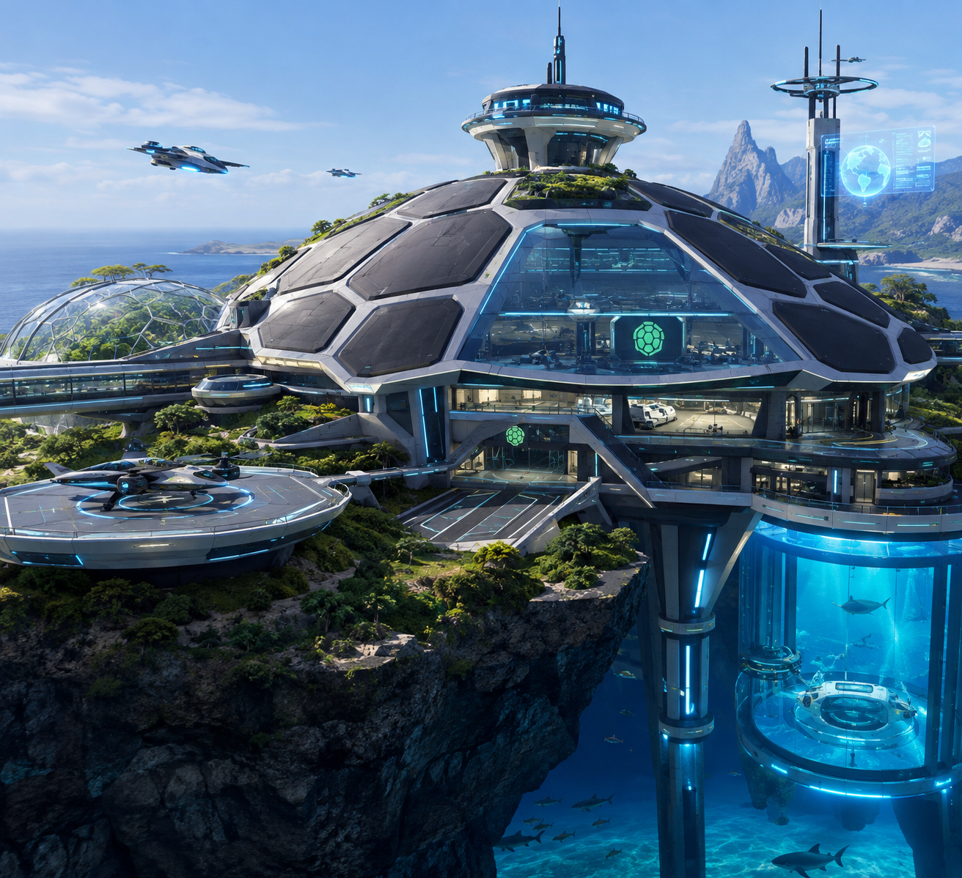

The headquarters look like a turtle shell on the outside, but on the inside is a futuristic high-tech lab with weapons and maps of the new planet and its terrain. We have instruments to analyze the surface of our new planet for dangerous and hospitable life, geography, and meteorology. Additionally, it holds a set of rules monitoring and regulating engineering design within the Shell to ensure it follows certain guidelines (GLP, PPE, IEEE, etc.). It smells like sweat, blood, metal, wood, and hard work. You hear beeping radars, water, hammering, and the sound of air units taking off and landing.

Luminis Sea Region

A tropical warm environment that is breezy and humid. The sea surrounds high cliffs and dense jungles, both abundantly filled with plants and animals including seagulls, megaladons, turtles, mermaid (top half fish/bottom human), tall trees, and fast growing pineapples and other fruits. Bad storms hit the island occasionally causing floods and other disasters that are hazardous to human life. We are able to harness the wind and water to create power for our HQ, fleets, and weapons. The cliffs and water provide strategic protection from danger, and also offer many natural resources such as diamonds, emeralds, redstone, seafood, and plants.

