**Test Cases for the “Peach Galaxy” Software**



# Test Cases for User-Testing:

## File Input

|  |  |  |  |  |  |
| --- | --- | --- | --- | --- | --- |
| Test Case ID | Test Case | Input | Expected Output | Output | Success Status |
| 1.1 | Load Teaching file into the teaching field | Teaching  _sample.csv | Allows the user to edit blank fields then loads file into the dashboard | Allows the user to edit blank fields then loads file into the dashboard | Passed |
| 1.2 | Load a non-Teaching file into the teaching field | Publication  s_sample.csv | Error indicating that the file is not valid. File is not loaded | “Not a valid teaching file.” The information is not displayed on the dashboard | Passed |
| 1.3 | Load Publications file into the teaching field | Publications  _sample.csv | Allows the user to edit blank fields then loads file into the dashboard | Allows the user to edit blank fields then loads file into the dashboard | Passed |
| 1.4 | Load a non-Publications file into the teaching field | Teaching  _sample.csv | Error indicating that the file is not valid. File is not loaded | “Not a valid publications file.” The information is not displayed on the dashboard | Passed |
| 1.5 | Load Presentations file into the teaching field | Presentations  _sample.csv | Allows the user to edit blank fields then loads file into the dashboard | Allows the user to edit blank fields then loads file into the dashboard | Passed |
| 1.6 | Load a non-Presentations file into the teaching field | Teaching  _sample.csv | Error indicating that the file is not valid. File is not loaded | “Not a valid presentations file.” The information is not displayed on the dashboard | Passed |
| 1.7 | Load Grants and clinical funding file into the teaching field | GrantsClinicalFunding  _sample.csv | Allows the user to edit blank fields then loads file into the dashboard | Allows the user to edit blank fields then loads file into the dashboard | Passed |
| 1.8 | Load a non-Grants and clinical funding file into the teaching field | Teaching  _sample.csv | Error indicating that the file is not valid. File is not loaded | “Not a valid grants and funding file.” The information is not displayed on the dashboard | Passed |
| 1.9 | When loading a file with incomplete fields, the user can opt to edit them | Load the Teaching_sample.csv file | The user is given the option to edit and may actually do so without errors. | A message appears stating ‘File contains 35 records with missing mandatory fields. Do you want to edit these entries or discard?’ Selecting edit opens a viewer which highlights the missing fields and allows the user to enter the appropriate information | Passed |
| 1.10 | When loading a file with incomplete fields, the user can opt to edit them | Load the Teaching_sample.csv file | The user is given the option to ignore fields and may actually do so without errors. | A message appears stating ‘File contains 35 records with missing mandatory fields. Do you want to edit these entries or discard?’ Selecting discard sends the user straight to the dashboard to view the complete information. | Passed |

## Sorting

|  |  |  |  |  |  |
| --- | --- | --- | --- | --- | --- |
| Test Case ID | Test Case | Input | Expected Output | Output | Success Status |
| 2.1 | Create New Sort Order with one sort option | Click on ‘Create New Sort Order’, create one called ‘Test’ and sort by ‘Program’ | Newly created sort order ‘Test’ will appear in drop down menu beside ‘Select Sort Order’ | ‘Test’ appears on the drop down menu | Passed |
| 2.2 | ‘Select Sort Order’ changes the information displayed on the dashboard, and that information is correctly sorted | Select the new sort order based on ‘Program’ from the drop down menu | The dashboard will display only the program information and display it in alphabetical order | The dashboard displayers ‘Continuing Medical Education’, ‘Postgraduate Medical Education’ and ‘Undergraduate Medical Education’ | Passed |
| 2.3 | Create New Sort Order with two sort options | Click on ‘Create New Sort Order’, create one called ‘Test2’ and sort by ‘Program’ and ‘Start Date’ | Newly created sort order ‘Test2’ will appear in drop down menu beside ‘Select Sort Order’ | ‘Test2’ appears on the drop down menu | Passed |
| 2.4 | ‘Select Sort Order’ for ‘Test2’ correctly sorts the information | Select ‘Test2’ from the drop down menu | The dashboard will the information sorted first by program, with subcategories for the start dates in chronological order | The dashboard displayers ‘Continuing Medical Education’, ‘Postgraduate Medical Education’ and ‘Undergraduate Medical Education’ and each one it subcategorized by years in increasing order | Passed |

## Visualization

|  |  |  |  |  |  |
| --- | --- | --- | --- | --- | --- |
| Test Case ID | Test Case | Input | Expected Output | Output | Success Status |
| 3.1 | The program allows the user to visualize the data in a pie chart | Load the teaching_sample.csv file and click on the entry for ‘Baggins, Bilbo’ | The visualization tab on the right displays a pie chart with correctly sized subdivisions for the number of different kinds of courses Bilbo has taught | The pie chart on the right is displayed, with one segment for ‘Continuing Medical Education’ with 5 courses that is smaller than the sections for the 6 courses taught in each of ‘Postgraduate Medical Education’ and ‘Undergraduate Medical Education’ | Passed |

## Others

|  |  |  |  |  |  |
| --- | --- | --- | --- | --- | --- |
| Test Case ID | Test Case | Input | Expected Output | Output | Success Status |
| 4.1 | The Peach Galaxy program works on macOS devices | Install the .dmg provided with the Phase I system handout | The program correctly installs and functions as it does on Windows | The program installed and appeared to have all the same features, along with some platform specific differences in appearance | Passed |
| 4.2 | Pie charts displayed on the dashboard can be exported to PDF files | Load the ‘teaching_sample.csv’ file, display the pie chart for ‘Bilbo Baggins’ and click the ‘Export to PDF’ button | The user is prompted to name and save a PDF file on their system | After clicking export to PDF, the file explorer opened and a file was saved on the user system. Opening the file revealed the same pie chart as on the dashboard | Passed |
| 4.3 | Pie charts displayed on the dashboard can be printed | Load the ‘teaching_sample.csv’ file, display the pie chart for ‘Bilbo Baggins’ and click the ‘Print’ button | The user is prompted to select a printer to send the file to | A system prompt is opened allowing the user to select a printer they have installed and the pie chart is printed | Passed |

# Test Cases using QT Testing

This particular test case was done using “QT creator” and their test functions. These methods tested the “CSV Reader” functions for inputting and reading files. The creators of the Peach Galaxy software left these test cases behind which were examined and utilized by Team Orion.

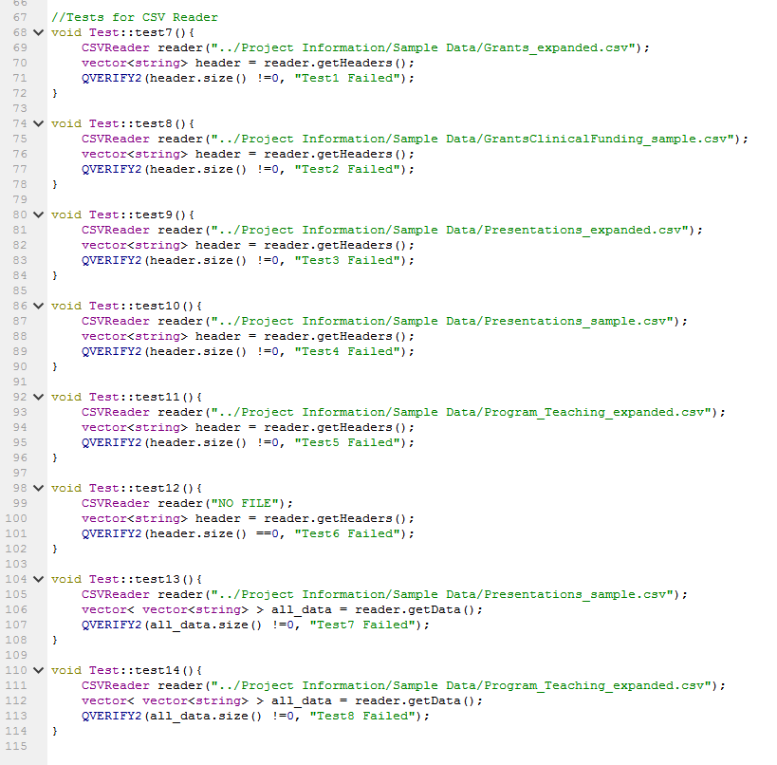

Additionally the following tests were implemented to test QSortListIO, RecordManager, TeachingTreemodel, GrantFundingTreeModel, PresentationTreeModel, & PublicationTreeModel

Test 1: test QSortListIO. This test will test saveList and readList functions in QSortListIO class, by first, creating a QStringList to store the order, then use saveTestSort function to save the order, then will implement readList function to get the order, if the order we get is same with the order we saved, then the test will pass.

Test 2: Verifies that the RecordsManager constructor populates the correct headers from the .csv input file.

Test 3: Verifies that the TeachingTreeModel constructor successfully creates a TeachingTreeModel object.

Test 4: Verifies that the GrantTreeModel constructor successfully creates a GrantTreeModel object.

Test 5: Verifies that the PresentationTreeModel constructor successfully creates a PresentationTreeModel object.

Test 6: Verifies that the PublicationTreeModel constructor successfully creates a PublicationTreeModel object.

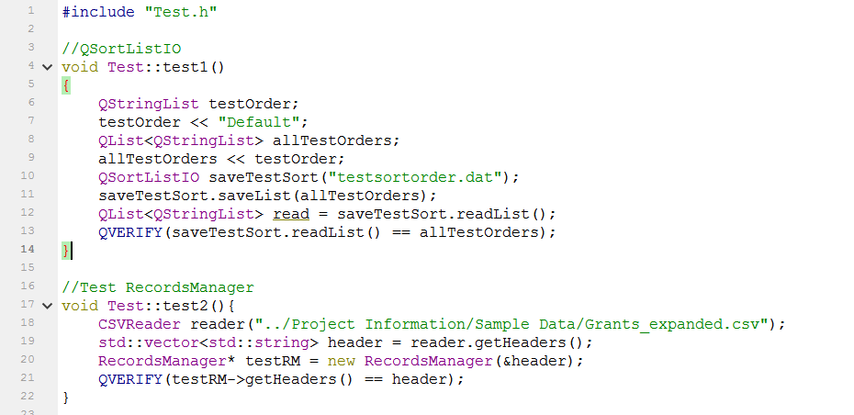

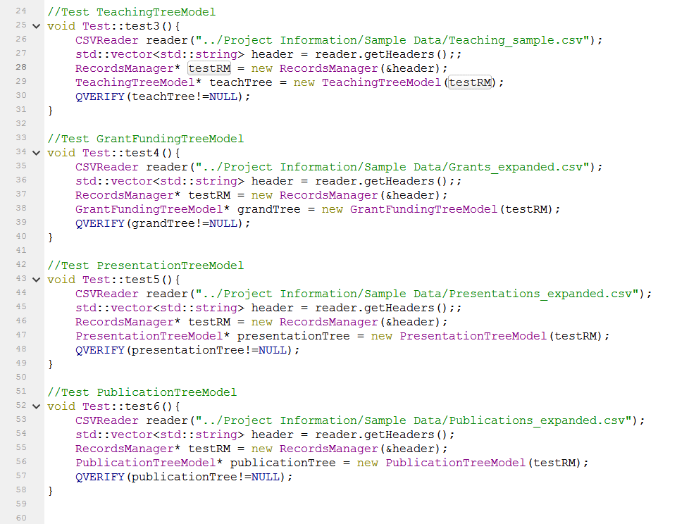

**Output**

