This is a test document that can be used for testing the different [IDShield Office text pattern matchers] (text like this should match) {as well as text like this, depending on your settings. Its hard to believe that someone would want to redact all this text, but apparently there is a need for it}
[These {brackets are (contained [ in [another set] of ] ) ] brackets.}

It may be that the brackets contain important data like a social security number: 111 – 22 – 3333 or maybe its just a phone number: 215 – 555 – 1212.

[111 – 22 – 3333] [ this outside [ bracket ] is unbalanced )

It could be an ssn: 111 – 22 – 3333 or an ssn. 111-22-3333.

Maybe you want to redact a name of someone which is found in the document like John Smith or John Smith or maybe even Smith, John.

[ I am not sure if this document will make it easier to test, but I think I have added a few helpful test cases to it, it would also be good if I added an image just underneath this to see if it can match brackets around an image
we will see, the brackets open above this image and will close here, so it should match depending on the OCR output]

(It would also be good if our [matching was able to match bracketed text that spans multiple pages, in this case I have begun the brackets] here on page 1 and will continue typing until the document has reached page 2, at that point I will close off this set of brackets so we can see if it will match the brackets on multiple pages. I am not sure what else should be added to the set of test cases in this document, maybe some dummy bank or CC#’s should be added so that our rules that find those sorts of things could be tested out as well. They are things that our customers generally need redacted from a document so that seems like a good idea to test those as well.)

These sets should not match ( ) [ ] { }
These sets should match ( a ) [ b ] { c }

CC#’s
6011-4567-2256-5555
5491 – 1243 – 1233 – 5555
3785.2143.3321.5555

or Bank Account #:
12-3456789
12 – 55553432
39482-3393

Tax Id: 11.222.3333
Tax Id#: 11 – 222 – 3333

Email: john.smith@smith.com
John_smith@smith.com

dl# D252-4444-3247-02
dl: H887 – 3322 – 8011 – 02
Drivers License # J102-2211-8901-04

[last match]

It would also be helpful if this document spanned more than two pages. So this text is being added to make the document larger. After this text we will add an additional image file.

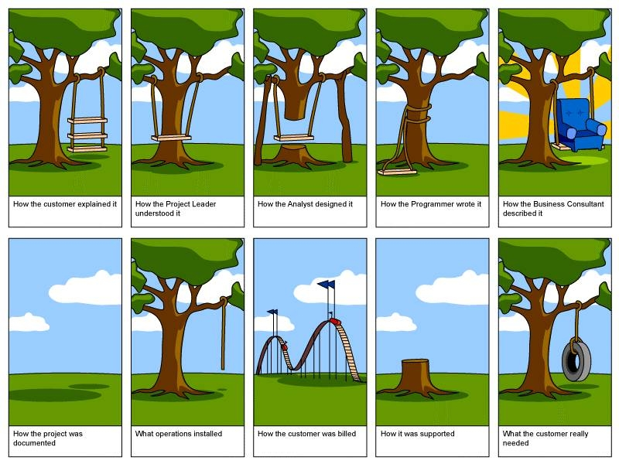

Here are some different names to search for:
Bjarne Stroustrup

Or maybe Bill Gates

and Steve Jobs

and Steve Wozniak

