Basic Relationships:
- Delta angle (delta):
  - delta = ( angle(T_{out}) – angle(T_{in}) ) * IfTrue( bCurveConcaveLeft )
+ (angle(T_{in}) – angle(T_{out}) ) * IfTrue ( ! bCurveConcaveLeft )
Note: If delta < 0°, delta = delta + 360°
- delta = ( 2 * sin ^{–1} (CL/(2r)) ) * IfTrue( ! bDeltaOver180)
+ ( 2 * pi – 2 sin (CL/(2r)) ) * IfTrue( bDeltaOver180)
- angle(R_{in})
= ( angle(T_{in}) + 90° ) * IfTrue( bCurveConcaveLeft )
+ ( angle(T_{in}) – 90°) * IfTrue ( ! bCurveConcaveLeft )
Note: If angle(R_{in}) > 360°, angle(R_{in}) = angle(R_{in}) – 360°:
If angle(R_{in}) < 0°, angle(R_{in}) = angle(R_{in}) + 360°
- angle(R_{out})
= ( angle(T_{out}) - 90° ) * IfTrue ( bCurveConcaveLeft )
+ ( angle(T_{out}) + 90° ) * IfTrue ( ! bCurveConcaveLeft )
Note: If angle(R_{out}) < 0°, angle(R_{out}) = angle(R_{out}) + 360°
If angle(R_{out}) > 360°, angle(R_{out}) = angle(R_{out}) - 360°
- Start angle (center point C to start point S)
= ( angle(T_{in}) – 90° ) * IfTrue ( bCurveConcaveLeft )
+ ( angle(T_{in}) + 90° ) * IfTrue ( ! bCurveConcaveLeft )
Note: If Start angle < 0°, Start angle = Start angle + 360°
If Start angle > 360°, Start angle = Start angle - 360°
- End angle (center point C to end point E)
= ( angle(T_{out}) – 90° ) * IfTrue ( bCurveConcaveLeft )
+ ( angle(T_{out}) + 90° ) * IfTrue ( ! bCurveConcaveLeft )
Note: If End angle < 0°, End angle = End angle + 360°
If End angle > 360°, End angle = End angle - 360°
- Middle ordinate (m):
m = r – r * cos(delta /2)
OR
m = sqrt ((X_{Q} – X_{M}) ^ 2 + (Y_{Q} – Y_{M}) ^2) – mid point of curve & mid point of chord
- Chord Bearing (CB & T_{in}):
angle(CB) = ( angle(T_{in}) + delta /2 ) * IfTrue ( bCurveConcaveLeft )
+ (angle(T_{in}) – delta /2 ) * IfTrue ( ! bCurveConcaveLeft )
Note: If angle(CB) > 360°, angle(CB) = angle(CB) – 360°
Note: If angle(CB) < 0°, angle(CB) = angle(CB) + 360°
- Chord Bearing (CB & T_{out}):
angle(CB) = ( angle(T_{out}) + delta /2 ) * IfTrue ( ! bCurveConcaveLeft )
+ (angle(T_{out}) – delta /2 ) * IfTrue ( bCurveConcaveLeft )
- Chord Length (CL):
CL = 2r * sin (delta /2)
OR
CL = 2 * sqrt ((X_{Q} - X_{S}) ^ 2 + (Y_{Q} - Y_{S}) ^2) – mid point of the chord & starting point
OR
CL = sqrt ((X_{E} - X_{S}) ^ 2 + (Y_{E} - Y_{S}) ^2) – starting and ending points
- Radius (r):
R = sqrt ((X_{C} - X_{S}) ^ 2 + (Y_{C} - Y_{S}) ^2) – starting and center points
OR
R = sqrt ((X_{E} – X_{C}) ^ 2 + (Y_{E} – Y_{C}) ^2) – ending and center points
- Arc Length (S):
S = pi * r * delta / 180 (delta – in Degree)
S = r * delta (delta – in Radian)
- Center point C:
X_{C} = X_{S} + r * cos (angle(R_{in}))
Y_{C} = Y_{S} + r * sin (angle(R_{in}))
OR:
X_{C} = X_{E} - r * cos (angle(R_{out}))
Y_{C} = Y_{E} - r * sin (angle(R_{out}))
- End point E:
X_{E} = X_{S} + CL * cos (angle(CB))
Y_{E} = Y_{S} + CL * sin (angle(CB))
- Middle point of the curve (M):
X_{M} = (X_{C} + r * sin (CB) ) * IfTrue( bCurveConcaveLeft )
+ (X_{C} - r * sin (CB) ) * IfTrue( ! bCurveConcaveLeft )
Y_{M} = ( Y_{C} - r * cos (CB) ) * IfTrue( bCurveConcaveLeft )
+ ( Y_{C} + r * cos (CB) ) * IfTrue( ! bCurveConcaveLeft )
- Mid point of the chord (Q) & Staring point (S):
X_{Q} = X_{S} + (CL/2) * cos(CB)
Y_{Q} = Y_{S} + (CL/2) * sin(CB)
OR
X_{Q} = (X_{S} + X_{E}) / 2
Y_{Q} = (Y_{S} + Y_{E}) / 2
- Degree of curve (D):
- Arc definition (in Degree): D = 18000 / (pi * r), 0 < D < 360°
- Chord definition (in Degree): r = 50 / sin (D/2) , r > 50/pi feet
- Tangent distance (t):
t = r * abs( tan (delta /2) ) , t = 0 if delta == 180°, 360°, ……
OR
t = sqrt ((X_{P} - X_{S}) ^ 2 + (Y_{P} - Y_{S}) ^2) – starting point & external point
- External distance (e):
e = abs ( ( r/cos (delta /2) )– r ), e = 0 if delta == 180°, 360°, ….
OR
e = sqrt ((X_{M} – X_{P}) ^ 2 + (Y_{M} – Y_{P}) ^2) – mid point of curve & external point
- External point (P):
If delta < 180°
X_{P} = X_{S} + t * cos (T_{in})
Y_{P} = Y_{S} + t * sin (T_{in})
Else if delta > 180°
X_{P} = X_{S} - t * cos (T_{in})
Y_{P} = Y_{S} - t * sin (T_{in})
P doesn’t exist if T_{in} == 180° or 360°
- Chord mid point, Arc mid point, mid ordinate, Chord bearing
X_{M} = (X_{Q} + m * sin (CB) ) * IfTrue( bCurveConcaveLeft )
+ (X_{Q} - m * sin (CB) ) * IfTrue( ! bCurveConcaveLeft )
Y_{M} = ( Y_{Q} - m * cos (CB) ) * IfTrue( bCurveConcaveLeft )
+ ( Y_{Q} + m * cos (CB) ) * IfTrue( ! bCurveConcaveLeft )
- Radius, Chord length, Mid ordinate
r = ( m ^ 2 + (CL/2) ^ 2 ) / (2 * m) ⬄ CL = 2 * sqrt ( 2 * r * m – m ^2)
Note: For calculating m, bDeltaOver180 must be given

Additional Relationships:
Precondition for the following relationships:
-- Start point or mid point or end point or center point is known already.
-- Radius or Chord length or Degree of curve is known already.
-- Anything else is unknown at this point.

- T_{in} & CB are known values:
- If 0 < T_{in} - CB < 180° OR –360° < T_{in} - CB < -180° ➔ T_{in} > CB, bCurveConcaveLeft = 0
- ElseIf –180° < T_{in} - CB < 0 OR 180°< T_{in} - CB < 360° ➔ T_{in} < CB, bCurveConcaveLeft = 1
- T_{out} & CB are known values:
- If 0 < CB – T_{out} < 180° OR –360° < CB - T_{out} < -180° ➔ T_{out} < CB, bCurveConcaveLeft = 0
- ElseIf –180° < CB - T_{out} < 0 OR 180°< CB - T_{out} < 360° ➔ T_{out} > CB, bCurveConcaveLeft = 1
- T_{in} & T_{out} are known values:
- bCurveConcaveLeft must be obtained from user input
- Once bCurveConcaveLeft is known, R_{in} and R_{out} can be calculated using equations in Basic Relationships section. And so on and so forth.
- T_{in} & R_{in} are known values:
- These two parameters alone can not determine a certain curve, however, they can be used to determine curve direction (bCurveConcaveLeft value) using equation #2 in Basic Relationships section.
- R_{in} & R_{out} are known values:
- bCurveConcaveLeft must be obtained from user input
- Once bCurveConcaveLeft is known, T_{in} and T_{out} can be calculated using equations in Basic Relationships section. And so on and so forth.
- T_{in} & R_{out} are known values:
- bCurveConcaveLeft must be obtained from user input.
Exception: abs(T_{in} - R_{out}) = 90°, bCurveConcaveLeft is set and can’t be changed.
- Once bCurveConcaveLeft is known, R_{in} and T_{out} can be calculated using equations in Basic Relationships section. And so on and so forth.
- T_{out} & R_{out} are known values:
- These two parameters alone cannot determine a certain curve, however, they can be used to determine curve direction (bCurveConcaveLeft value) using equation #3 in Basic Relationships section.
- T_{out} & R_{in} are known values:
- bCurveConcaveLeft must be obtained from user input
Exception: abs(T_{out} - R_{in}) = 90°, bCurveConcaveLeft is set and can’t be changed.
- Once bCurveConcaveLeft is known, R_{out} and T_{in} can be calculated using equations in Basic Relationships section. And so on and so forth.
- CB & R_{in} are known values:
- bCurveConcaveLeft must be obtained from user input
- Once bCurveConcaveLeft is known, T_{in} can be calculated using equations in Basic Relationships section. And so on and so forth.
- CB & R_{out} are known values:
- bCurveConcaveLeft must be obtained from user input
- Once bCurveConcaveLeft is known, T_{out} can be calculated using equations in Basic Relationships section. And so on and so forth.

Constraints:
- CL <= 2r
- For all angles: 0° < angle <= 360°
- abs (CB - R_{in}) < 90°, abs (CB - R_{out}) < 90°

Note:
- pi – 3.1415926……
- bCurveConcaveLeft – curve concaves to the left (Counter-Clock-Wise)
- ( ! bCurveConcaveLeft ) – curve concaves to the right (Clock-Wise)
- bDeltaOver180 – delta angle is greater than 180 °
- ( ! bDeltaOver180) – delta angle is less than or equal to 180 °
- IfTrue( ) should return 1 or 0 by evaluating the parameter (true or false).

------------------------------------------------------------------------------------------------------------

Figure 1
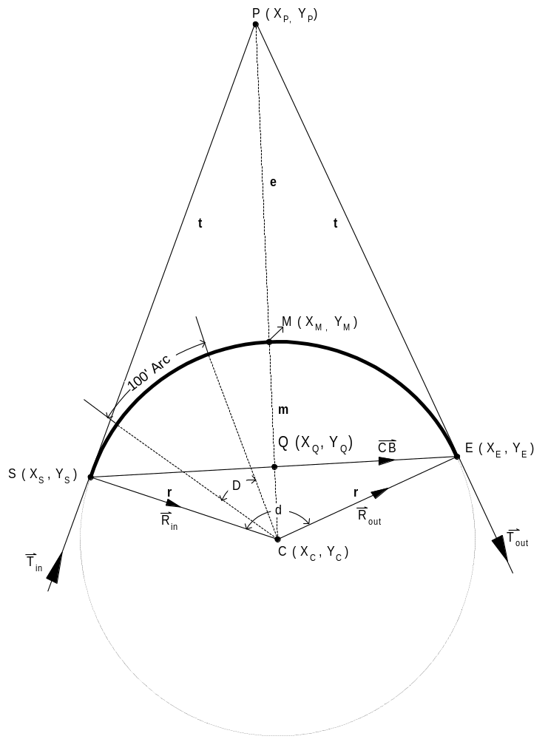
S – Start point of the curve
E – End point of the curve
C – Center point of the curve
M – Midpoint of the curve
P – Point of intersection, which is the point where the back and for-word tangents intersect.
Q – Midpoint of the chord
CB – Chord Bearing
T_{in} – Tangent-in
T_{out} – Tangent-out
R_{in} – Radial-in
R_{out} – Radial-out
D – Degree of curve (arc definition)
d – Delta angle
r – Radius
m – Middle ordinate, which is the distance from midpoint of the curve to the midpoint of the long
chord.
t – Tangent distance, which is the distance along the tangents from the P to the S or E.
e – External distance, which is the distance from the P to the midpoint of the curve.

Figure 2

(1)
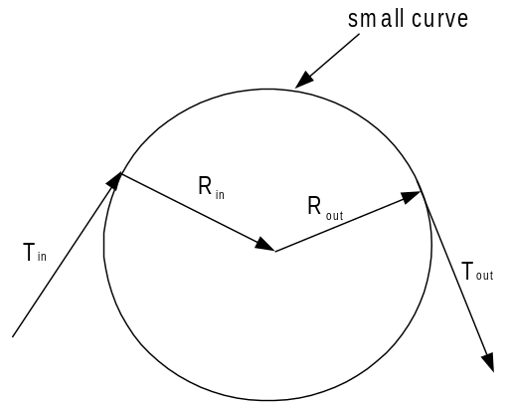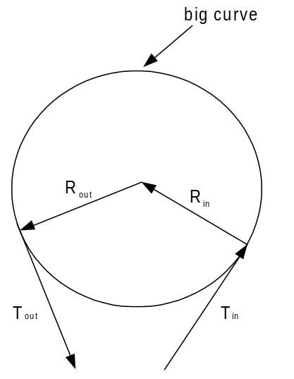

concave right concave left

OR
(2)
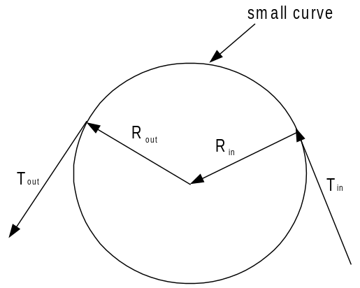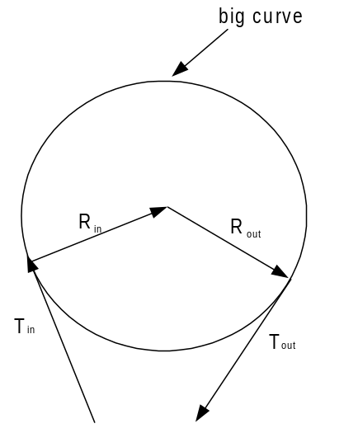

concave left concave right

