TutorialVB1 – Visual Basic Sample Application

Introduction
This is a tutorial demonstrating how the UCLID Input Funnel can be used in a simple VB application. Use of input receivers will be demonstrated. The Highlighted Text input receiver provides point-and-click input of data from text files. The Spot Recognition input receiver provides point-and-click input of data from image files. Enhancement and extension of the application to use validated input is demonstrated in subsequent tutorials.

Application Creation
This portion of the tutorial will create the simple application.

- New Visual Basic project. Run Visual Basic and create a new Standard EXE project.

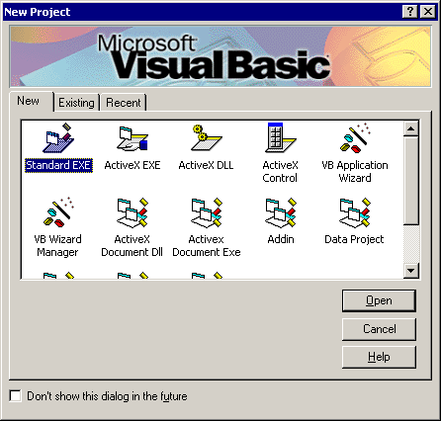

- Add controls to the form. Add the static text, edit box (txtInput), text window button (cmdText), and image window button (cmdImage) to the form.
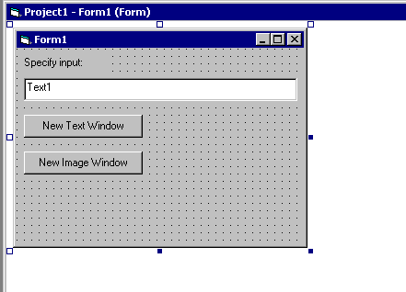

- Include the UCLID Component License Manager, UCLID Exception Management, and the UCLID Input Funnel in the collected References for the project.

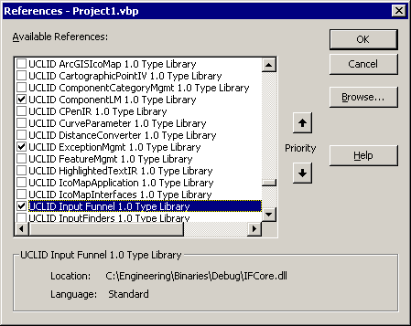

- Create an error handler subroutine and use it to handle errors.

Private Sub Error_Handler(strErrNum As String)

' Create a COMUCLIDException object
Dim pEx As New UCLIDEXCEPTIONMGMTLib.COMUCLIDException
pEx.createFromString strErrNum, Err.Description

' Display the error to the user
pEx.display
End Sub

- Declare an Input Manager object and create a new input receiver when either button is clicked. Copy the following code.

Option Explicit

Private WithEvents m_pFunnel As UCLID_INPUTFUNNELLib.InputManager

Private Sub cmdImage_Click()
' Specify error handler
On Error GoTo ErrorHandler

' Ask Input Funnel to create the Input Receiver
m_pFunnel.CreateNewInputReceiver "Spot Recognition Window"
Exit Sub

ErrorHandler:
Error_Handler 10000
End Sub

Private Sub cmdText_Click()
' Specify error handler
On Error GoTo ErrorHandler

' Ask Input Funnel to create the Input Receiver
m_pFunnel.CreateNewInputReceiver "Highlighted Text Window"
Exit Sub

ErrorHandler:
Error_Handler 10001
End Sub

- At application start, create and initialize a license manager, create the Input Manager, set the visibility of input receivers to True, and enable input. Apply the following code to the Form_Load event. Note that a valid license key must be provided.

Private Sub Form_Load()
' Specify error handler
On Error GoTo ErrorHandler

' Create and Initialize License Manager

Dim pLM As New UCLID_COMLMLib.UCLIDComponentLM
pLM.Initialize "INSERT LICENSE KEY HERE!!!!"

' Create the Input Manager object
Set m_pFunnel = New InputManager

' Set visibility of Input Receivers
m_pFunnel.ShowWindows True

' Enable Text input
m_pFunnel.EnableInput1 "Text", "Please specify value for X"

' Create a C-Pen Input Receiver
m_pFunnel.CreateNewInputReceiver "C-Pen"

Exit Sub

ErrorHandler:
Error_Handler 10002
End Sub

- Direct input received from the Input Manager to the text box. Apply the following code to the OnInputReceived event from the Input Manager.

Private Sub m_pFunnel_NotifyInputReceived(ByVal pTextInput As UCLID_INPUTFUNNELLib.ITextInput)
' Specify error handler
On Error GoTo ErrorHandler

' Display received text in text box
txtInput = pTextInput.GetText
Exit Sub

ErrorHandler:
Error_Handler 10004
End Sub

- Add a Form Unload message handler to destroy the input funnel. Apply the following code.

Private Sub Form_Unload(Cancel As Integer)
' Specify error handler
On Error GoTo ErrorHandler

' Cleanup the input funnel
m_pFunnel.Destroy
Exit Sub

ErrorHandler:
Error_Handler 10003
End Sub

- Run and test the application. File “a.txt” is appropriate for the Highlighted Text input receiver. File “b.tif” is appropriate for the Spot Recognition input receiver. Note that text from either input receiver is automatically directed to the text box.

