TutorialVB2 – Visual Basic Sample Application

Introduction
This is a tutorial demonstrating how validated input from the UCLID Input Funnel can be used in a simple application.

Application Creation
Copy the files from the “Tutorials/VB2/Code (Original)” folder to the “Tutorials/VB2/Code” folder. Note that a valid license key must be provided. An alternative is to continue working with the Tutorials/VB1 project files. It is appropriate to build the TutorialVB2 executable and verify proper behavior.

There is a “Final (plus VB3)” folder that contains the source code after integration of this project with the CLTestIR DLL from Tutorial VB3. The source code depends on the CLTestIR DLL already being registered.

Add Calculation button
This portion of the tutorial adds a button to perform a simple distance calculation.

- Add the command button (cmdCalculate).

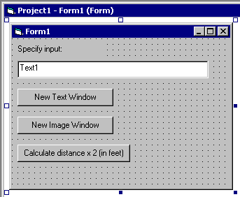

- Add required Project References. Subsequent code will use UCLID Distance Converter, UCLID Exception Management, and UCLID Land Records IV.

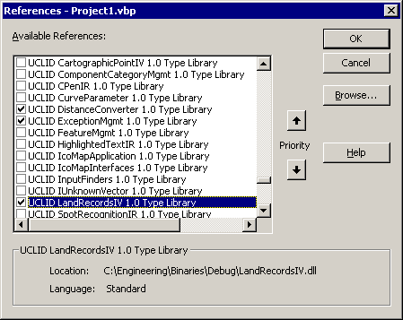

- Add a command handler for the new button. Create a Distance object and set the units to feet. Initialize the Distance object with the text received from the Input Funnel. Compute a new distance as twice the original. Display the calculated distance in a MsgBox.

Private Sub cmdCalculate_Click()
' Set error handler
On Error GoTo errHandler

' Create a Distance object
Dim pDistance As New UCLIDLANDRECORDSIVLib.Distance

' Set units to feet
pDistance.GlobalDefaultDistanceUnit = kFeet

' Apply the received text
pDistance.InitDistance txtInput

' Compute the new distance
Dim dTwiceDistanceInFeet As Double
dTwiceDistanceInFeet = pDistance.GetDistanceInUnit(kFeet) * 2

' Display new distance in MsgBox
MsgBox dTwiceDistanceInFeet
Exit Sub

errHandler:
Error_Handler 10005
End Sub

- Run and test the application. Show that you can enter any valid input string and that the new distance will be twice the entered distance and be converted to feet. Examples of valid input include: “5 feet 6 inches”, “6 m”, “5 ft”, etc.

