TutorialVB3 – Visual Basic Sample Application

Introduction
This is a tutorial demonstrating how a simple command-line style input receiver can be created in Visual Basic. Use of the new input receiver within both TutorialVB2 and TutorialVC2 is included.

Project Creation and Definition
This section demonstrates the basic steps required to create a simple input receiver in Visual Basic.

- Create an ActiveX DLL project.

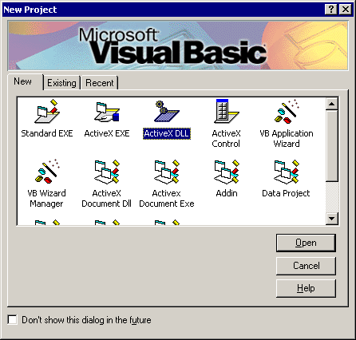

- Change the name of the class module from Class1 to CommandLineIR.

- Select the “Project1 Properties…” item under the Project menu. Change the name of the project from Project1 to CLTestIR.

Application Creation
The next task is to implement an Input Receiver.

- Add UCLID Exception Management and Input Funnel libraries to the collection of Project References.

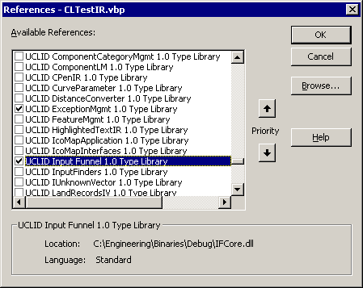

- Make CLTestIR.dll’s version binary compatible:

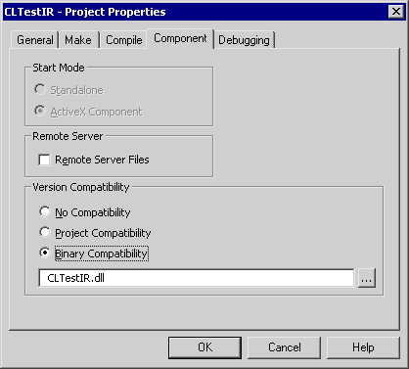

- Implement the IInputReceiver interface. Add the following code to the CommandLineIR class module.

Implements UCLID_INPUTFUNNELLib.IInputReceiver

- Stub each Input Receiver method within the CommandLineIR class module. Any methods included in the interface that should not be implemented will just be left empty.

Private Sub IInputReceiver_DisableInput()

End Sub

Private Sub IInputReceiver_EnableInput(ByVal strInputType As String, ByVal strPrompt As String)

End Sub

Private Property Get IInputReceiver_HasWindow() As Boolean

End Property

Private Property Get IInputReceiver_InputIsEnabled() As Boolean

End Property

Private Property Get IInputReceiver_ParentWndHandle() As Long

End Property

Private Property Let IInputReceiver_ParentWndHandle(ByVal RHS As Long)

End Property

Private Sub IInputReceiver_SetEventHandler(ByVal pEventHandler As UCLID_INPUTFUNNELLib.IIREventHandler)

End Sub

Private Sub IInputReceiver_ShowWindow(ByVal bShow As Boolean)

End Sub

Private Property Get IInputReceiver_WindowHandle() As Long

End Property

Private Property Get IInputReceiver_WindowShown() As Boolean

End Property

- Add a form (frmCLDialog) to the project. Set the Caption to “Command Line Input Receiver”.

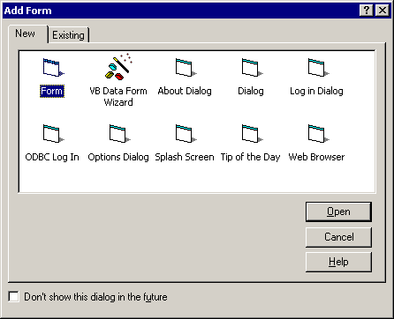

- Add a static text label (lblPrompt) and an edit box for input (txtInput). Resize the form to just include the label and edit box.

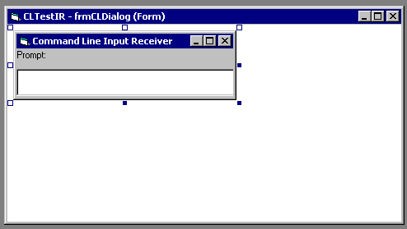

- Create an error handler subroutine and use it to handle errors.

Private Sub Error_Handler(strErrNum As String)
Dim ex As ICOMUCLIDException
Set ex = New COMUCLIDException
ex.CreateFromString strErrNum, Err.Description
ex.AddDebugInfo "Error Number", Err.Number

' convert the UCLIDException to a string and throw as a COM error with
' description
Dim strMsg As String
strMsg = ex.AsStringizedByteStream

' throw the exception to the caller
Err.Raise vbObjectError, "", strMsg
End Sub

- Connect form and class. Add a private object to the class module.

Private m_pDialog As frmCLDialog

Implement the Initialize method on the class module.

Private Sub Class_Initialize()
' Specify error handler
On Error GoTo ErrorHandler

' Create the dialog object
Set m_pDialog = New frmCLDialog
End Sub

Implement Input Receiver Functionality
The next step is to add code to the stubbed Input Receiver methods.

- Create a private window handle member of the class module.

Private m_lParentWindowHandle As Long

- Create a public IIREventHandler member of the form.

Public m_pHandler As UCLID_INPUTFUNNELLib.IIREventHandler

- Create a public Boolean member of the form to manage enabled and disabled state.

Public m_bEnabled As Boolean

- Add code to the class module. Note that the event handler and the enabled / disabled flag are deferred to the dialog. The window handler of the input receiver is the hWnd member of the dialog. Create the dialog as modeless and with input originally disabled. Note that most of the following methods implement error handling.

Private Sub Class_Initialize()
' Specify error handler
On Error GoTo ErrorHandler

' Create the dialog object
Set m_pDialog = New frmCLDialog
m_pDialog.Show False

' Disable input
m_pDialog.m_bEnabled = False
Exit Sub

ErrorHandler:
Error_Handler 11000
End Sub

Private Sub IInputReceiver_DisableInput()
' Specify error handler
On Error GoTo ErrorHandler

' Disable input
m_pDialog.m_bEnabled = False
Exit Sub

ErrorHandler:
Error_Handler 11001
End Sub

Private Sub IInputReceiver_EnableInput(ByVal strInputType As String, ByVal strPrompt As String)
' Specify error handler
On Error GoTo ErrorHandler

' Set prompt
m_pDialog.lblPrompt = strPrompt

' Set enabled flag
m_pDialog.m_bEnabled = True
Exit Sub

ErrorHandler:
Error_Handler 11002
End Sub

Private Property Get IInputReceiver_HasWindow() As Boolean
' This input receiver has a window
IInputReceiver_HasWindow = True
End Property

Private Property Get IInputReceiver_InputIsEnabled() As Boolean
' Specify error handler
On Error GoTo ErrorHandler

' Return flag from dialog object
IInputReceiver_InputIsEnabled = m_pDialog.m_bEnabled
Exit Sub

ErrorHandler:
Error_Handler 11003
End Property

Private Property Let IInputReceiver_ParentWndHandle(ByVal RHS As Long)
' Store the handle
m_lParentWindowHandle = RHS
End Property

Private Property Get IInputReceiver_ParentWndHandle() As Long
' Return data member
IInputReceiver_ParentWndHandle = m_lParentWindowHandle
End Property

Private Sub IInputReceiver_SetEventHandler(ByVal pEventHandler As UCLID_INPUTFUNNELLib.IIREventHandler)
' Specify error handler
On Error GoTo ErrorHandler

' Store
Set m_pDialog.m_pHandler = pEventHandler
Exit Sub

ErrorHandler:
Error_Handler 11004
End Sub

Private Sub IInputReceiver_ShowWindow(ByVal bShow As Boolean)
' Specify error handler
On Error GoTo ErrorHandler

' Display or hide
m_pDialog.Visible = bShow
Exit Sub

ErrorHandler:
Error_Handler 11005
End Sub

Private Property Get IInputReceiver_WindowHandle() As Long
' Specify error handler
On Error GoTo ErrorHandler

IInputReceiver_WindowHandle = m_pDialog.hWnd

Exit Sub

ErrorHandler:

Error_Handler 11006
End Property

Private Property Get IInputReceiver_WindowShown() As Boolean
' Specify error handler
On Error GoTo ErrorHandler

' Return flag from dialog object
IInputReceiver_WindowShown = m_pDialog.Visible
Exit Sub

ErrorHandler:
Error_Handler 11007
End Property

Send Event from Command Line
The next step is to send text from the dialog to the input funnel. Catch the KeyDown message from the edit box. Note that no data will be sent to the input funnel if disabled. Create and initialize a TextInput object. Send the TextInput object to the event handler. Clear the text from the edit box. Complete the development by building the CLTestIR DLL. Use the Make CLTestIR.dll command from the File menu.

Private Sub txtInput_KeyDown(KeyCode As Integer, Shift As Integer)
' Specify error handler
On Error GoTo ErrorHandler

' Ignore the return if disabled
If Not m_bEnabled Then
Exit Sub
End If

' Check for return
If KeyCode = 13 Then
' Send text event to event handler
If Not m_pHandler Is Nothing Then
' Create a TextInput object
Dim pInput As UCLID_INPUTFUNNELLib.TextInput
Set pInput = New UCLID_INPUTFUNNELLib.TextInput

' Initialize the TextInput with text from edit box
pInput.InitTextInput Nothing, txtInput

' Send TextInput to event handler
m_pHandler.OnInputReceived pInput

' Clear the edit box
txtInput = ""
End If
End If
Exit Sub

ErrorHandler:
HandleError 11008
End Sub

Integration with TutorialVB2
This portion of the tutorial integrates the command-line input receiver with the TutorialVB2 application.

- Open the project in the “Tutorials/VB2/Code” folder. Alternatively, a new folder can be created before copying the files from the “Tutorials/VB2/Code (Final)” folder.

- Add CLTestIR to Project References.

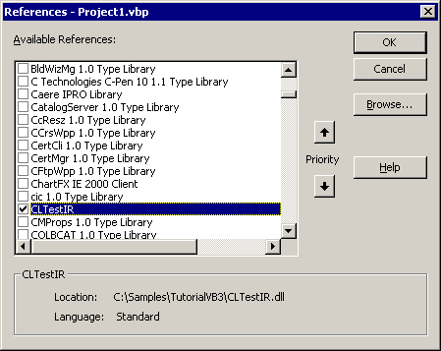

- Add a button (cmdCLIR) to the form.

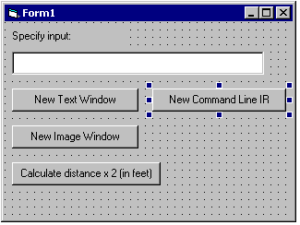

- Add code to support the new button.

Private Sub cmdCLIR_Click()
' Set error handler
On Error GoTo errHandler

' Create the Input Receiver
Dim pIR As UCLID_INPUTFUNNELLib.IInputReceiver
Set pIR = New CLTestIR.CommandLineIR

' Connect the new input receiver to Input Funnel
m_pFunnel.ConnectInputReceiver pIR
Exit Sub

errHandler:
Error_Handler 12001
End Sub

- Run and test the application. Show that distance input is accepted from any of the three input receivers.

