TutorialVB4 – Visual Basic Sample Application

Introduction
This is a tutorial demonstrating how a simple input validator can be created in Visual Basic. Use of the new input validator within the Tutorials/VB5 project is included.

Project Creation and Definition
This section demonstrates the basic steps required to create a simple input validator in Visual Basic.

- Create an ActiveX DLL project.

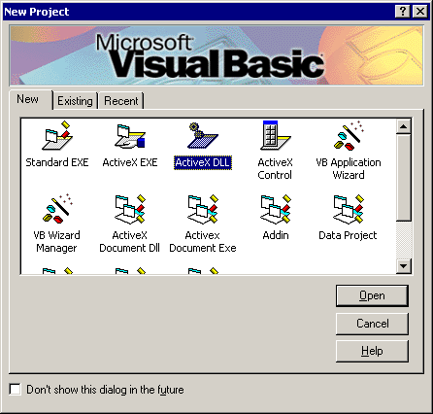

- Change the name of the class module from Class1 to ParcelIDIV.

- Select the “Project1 Properties…” item under the Project menu. Change the name of the project from Project1 to ParcelIDValidator. Save the project.

Application Creation
The next task is to implement an Input Validator.

- Add UCLID Exception Management and Input Funnel libraries to the collection of Project References.

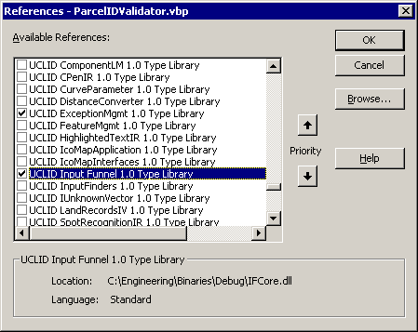

- Make ParcelIDValidator.dll’s version binary compatible:

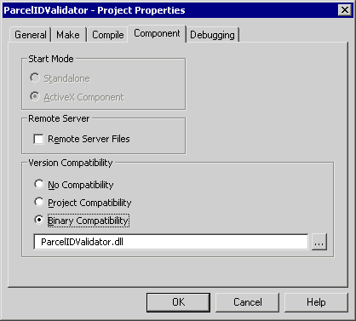

- Create an error handler subroutine and use it to handle errors.

Private Sub Error_Handler(strErrNum As String)
Dim ex As ICOMUCLIDException
Set ex = New COMUCLIDException
ex.CreateFromString strErrNum, Err.Description
ex.AddDebugInfo "Error Number", Err.Number

' convert the UCLIDException to a string and throw as a COM error with
' description
Dim strMsg As String
strMsg = ex.AsStringizedByteStream

' throw the exception to the caller
Err.Raise vbObjectError, "", strMsg
End Sub

- Implement the IInputValidator interface. Add the following code to the ParcelIDIV class module.

Implements UCLID_INPUTFUNNELLib.IInputValidator

- Stub each Input Validator method within the ParcelIDIV class module.

Private Function IInputValidator_GetInputType() As String

End Function

Private Function IInputValidator_ValidateInput(ByVal pTextInput As UCLID_INPUTFUNNELLib.ITextInput) As Boolean

End Function

Implement Input Validator Functionality
The next step is to add code to the stubbed Input Validator methods.

- Define the input type string.

Private Function IInputValidator_GetInputType() As String
'This is an input validator for Parcel ID's
IInputValidator_GetInputType = "Parcel ID"
End Function

- Add code to examine and parse the input text. Note that the input parameter is a TextInput object, not a text string.

Private Function IInputValidator_ValidateInput(ByVal pTextInput As UCLID_INPUTFUNNELLib.ITextInput) As Boolean
' Set error handler
On Error GoTo errHandler

'Default to invalid
Dim bResult As Boolean
bResult = False

'Retrieve text string
Dim txtInput As String
txtInput = pTextInput.GetText

'String must have exactly 9 characters
If Len(txtInput) = 9 Then
'Decompose the input
Dim txtLeft As String
txtLeft = Left(txtInput, 4)

Dim txtRight As String
txtRight = Right(txtInput, 4)

Dim txtMid As String
txtMid = Mid(txtInput, 5, 1)

'Check for XXXX-XXXX format
If IsNumeric(txtLeft) And IsNumeric(txtRight) And txtMid = "-" Then
bResult = True
End If
End If

'Return
IInputValidator_ValidateInput = bResult

Exit Function
errHandler:
Error_Handler 14000
End Function

- Build the DLL. Use the Make ParcelIDValidator.dll command from the File menu. Testing the Input Validator requires an application that uses an input funnel.

Testing the Input Validator
This section creates a new VB project (Tutorials/VB5) to test the Parcel ID Input Validator. This project will also be used to test the Parcel ID Input Finder that will be created in the VB6 Tutorial.

- Create a Standard EXE application.

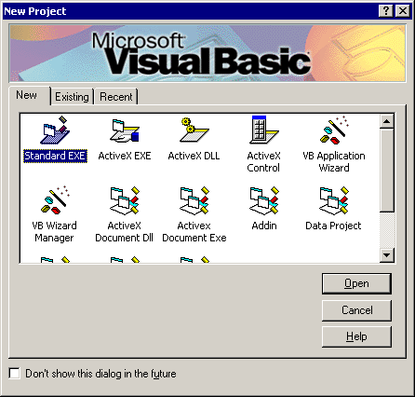

- Add UCLID Exception Management, UCLID Input Funnel, UCLIDComponentLM, and ParcelIDValidator to Project References.

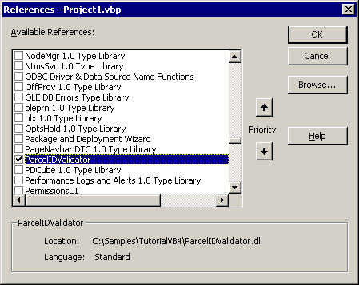

- Add labels, an edit box (txtInput), a read-only edit box (txtOutput), and two Input Receiver buttons (cmdText & cmdImage) to the form.

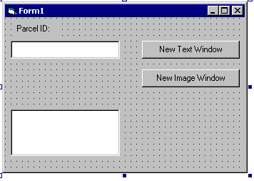

- Create an error handler subroutine and use it to handle errors.

Private Sub Error_Handler(strErrNum As String)

' Create a COMUCLIDException object
Dim pEx As New UCLIDEXCEPTIONMGMTLib.COMUCLIDException
pEx.createFromString strErrNum, Err.Description

' Display the error to the user
pEx.display
End Sub

- Add an input funnel data member. Add code to initialize the license key and create the input funnel during Form_Load. Note that a valid license key must be specified. Set visibility for input receivers. Create a parcel ID validator and enable this type of input.

Private WithEvents m_pFunnel As UCLID_INPUTFUNNELLib.InputManager

Private Sub Form_Load()
' Set error handler
On Error GoTo errHandler

' Create and Initialize License Manager
Dim pLM As New UCLID_COMLMLib.UCLIDComponentLM
pLM.Initialize "Insert license key here!"

' Create the Input Manager object
Set m_pFunnel = New InputManager

' Set visibility of Input Receivers
m_pFunnel.ShowWindows True

' Create a Parcel ID Validator object
Dim pIV As UCLID_INPUTFUNNELLib.IInputValidator
Set pIV = New ParcelIDValidator.ParcelIDIV

' Enable Parcel ID input
m_pFunnel.EnableInput2 pIV, "Specify parcel ID"
Exit Sub

errHandler:
Error_Handler 15003
End Sub

- Add code to create the appropriate input receiver for each button.

Private Sub cmdImage_Click()
' Set error handler
On Error GoTo errHandler

' Ask Input Funnel to create the Input Receiver
m_pFunnel.CreateNewInputReceiver "Spot Recognition Window"
Exit Sub

errHandler:
Error_Handler 15000
End Sub

Private Sub cmdText_Click()
' Set error handler
On Error GoTo errHandler

' Ask Input Funnel to create the Input Receiver
m_pFunnel.CreateNewInputReceiver "Highlighted Text Window"
Exit Sub

errHandler:
Error_Handler 15002
End Sub

- Add a button to the form (cmdRetrieve) to retrieve parcel information from a database.

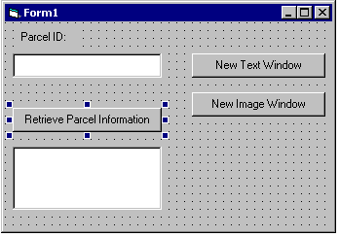

- Add an event handler for the input funnel.

Private Sub m_pFunnel_NotifyInputReceived(ByVal pTextInput As UCLID_INPUTFUNNELLib.ITextInput)
' Set error handler
On Error GoTo errHandler

' Display received text in text box
txtInput = pTextInput.GetText
Exit Sub

errHandler:
Error_Handler 15004
End Sub

- Add code to retrieve and display parcel information. For the purposes of this application all data will be fabricated.

Private Sub cmdRetrieve_Click()
' Set error handler
On Error GoTo errHandler

' Clear the output and return if no parcel ID available
If txtInput = "" Then
txtOutput = ""
Exit Sub

End If

' Create database connection

' Send parcel ID to database and retrieve associated info

' Display parcel data
If txtInput = "1234-2345" Then
txtOutput = "Parcel ID: 1234-2345" + vbCrLf + "Information: Known"
Else
txtOutput = "Parcel ID: " + txtInput + vbCrLf + "Information: Unknown"
End If
Exit Sub

errHandler:
Error_Handler 15001
End Sub

- Run and test the application. Note that the prompt provided in the call to EnableInput2 is visible for each input receiver. Show that text not in the form of XXXX-XXXX from any of the input receivers fails validation. Also show that valid text is accepted from any of the input receivers.

- Extend functionality of the validator. Note that connection to a database for retrieval of parcel information can also be used in the validation of parcel ID’s. This is left as an exercise for the student.

