TutorialVB6 – Visual Basic Sample Application

Introduction
This is a tutorial demonstrating use of the COMUCLIDException class.

Project Creation and Definition
This section creates a simple application in Visual Basic to examine a COMUCLIDException object and display its information in two different ways.

- Create a Standard EXE project.

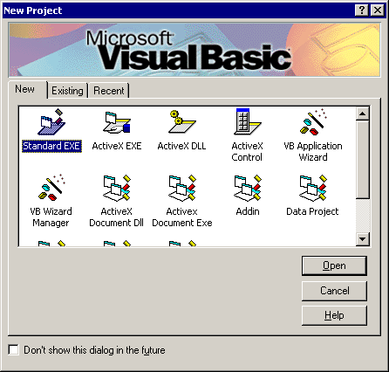

- Add UCLID ComponentLM, UCLID ExceptionMgmt, and UCLID IUnknownVector libraries to Project References.

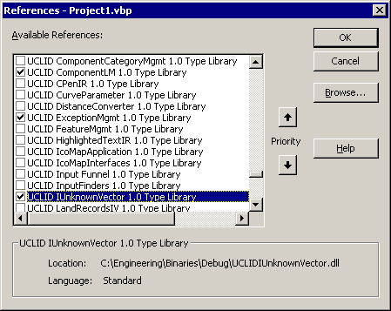

- Add a group of 2 radio buttons (btnUCLID, btnMessage) and a command button (cmdTest) to the form.

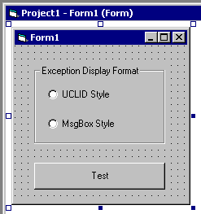

- Add code to Form_Load(). Create and initialize a license manager. Note that a valid license key must be used.

Private Sub Form_Load()
On Error GoTo errHandler

' Create and Initialize License Manager
Dim pLM As New UCLID_COMLMLib.UCLIDComponentLM
pLM.Initialize "Insert your license key here!"
Exit Sub

errHandler:
' Create a COMUCLIDException object
Dim pEx As New COMUCLIDException
pEx.CreateFromString "16001", Err.Description

' Display the error
pEx.Display
End Sub

- Add code to cmdTest_OnClick(). Create an IUnknownVector object and call an inappropriate method on it. Note that the At() method is not supported when the vector is empty. Check the button state within the error handler and display the exception.

Private Sub cmdTest_Click()
On Error GoTo errHandler

'Create a UCLID IUnknownVector object
Dim pVec As New UCLIDIUNKNOWNVECTORLib.IUnknownVector

' Attempt object retrieval from empty vector
' This will throw a UCLID Exception
Dim pUnknown As IUnknown
Set pUnknown = pVec.At(0)

Exit Sub

errHandler:
' Create a COMUCLIDException object
Dim pEx As New COMUCLIDException
pEx.createFromString “16000", Err.Description

' Check chosen display method
If btnUCLID.Value = True Then
' Just display the exception with UCLID dialog
pEx.display
ElseIf btnMessage.Value = True Then
' Display the topmost error number and text in
' a MsgBox
MsgBox "Error Code = " + pEx.getTopELICode + vbCrLf + "Error Description = " + Ex.getTopText
Else
' Display an error message to the user
MsgBox "Please select a display method"
End If
End Sub

- Run and test the application. Note the basic data from only the most recent exception that is displayed in the MsgBox.

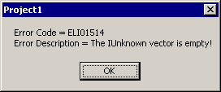

Note that the “Details…” button on the UCLID display dialog provides additional features beyond display and description of the most recent error.

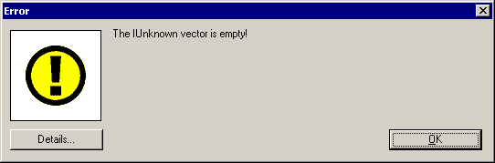

- Each error level in the stack can be viewed.
- Debug information can be attached.
- The complete exception stack can be written to a file.
- A stringized copy of the complete exception stack can be copied to the clipboard.

