TutorialVC1 – Visual C++ Sample Application

Introduction
This is a dialog-based application that has three input fields. The user provides a starting point, a bearing or direction, and a distance. The application computes the end point. The purpose of the application is to demonstrate use of the MFC AppWizard to create a simple application. Enhancement and extension of the application to use the UCLID Input Funnel, input receivers, and input validators is demonstrated in subsequent tutorials.

Application Creation
This portion of the tutorial will step through the application wizard and create a simple application.

- Visual C++ App-Wizard. Start by creating a new project. Select the MFC AppWizard (exe) option. For this example, the location is the “C:\Tutorials\VC1\Code” directory and the project name is TutorialVC1.

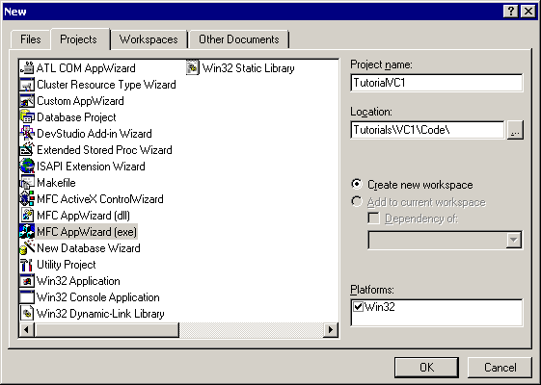

- Create a dialog-based application.

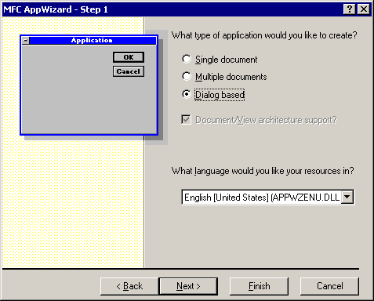

- The default features are sufficient. For this example, the About box was removed as unnecessary. Automation support is not needed. Support for ActiveX controls will be required in later tutorials.

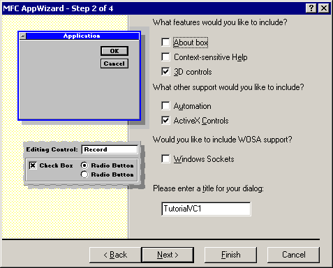

- The remaining default choices are sufficient.

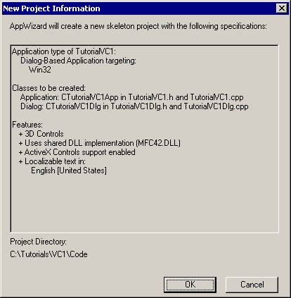

Populating the Dialog
This portion of the tutorial will populate the dialog with static text, edit boxes, and a button. The general arrangement of the controls is shown. ID values are suggested for the controls to allow better alignment with subsequent tutorials.

- Remove static text and Cancel button. Move the OK button to the bottom right corner of the dialog.

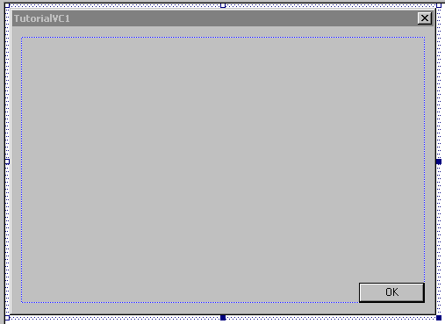

- Add static text labels for the upcoming edit boxes. The default ID of IDC_STATIC can be retained.

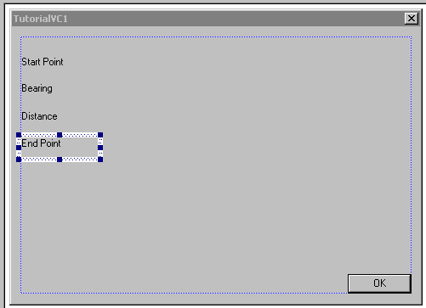

- Add edit boxes. The suggested ID’s are IDC_EDIT_START, IDC_EDIT_BEARING, IDC_EDIT_DISTANCE, and IDC_EDIT_END. Note that the end point edit box is read-only.

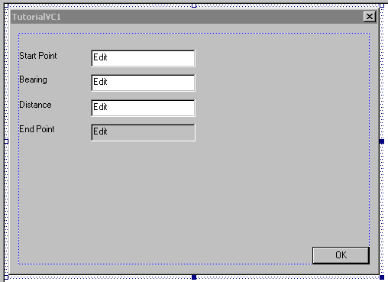

- Add the Calculate button. The suggested ID is ID_CALCULATE. The dialog can also be resized for a better user experience.

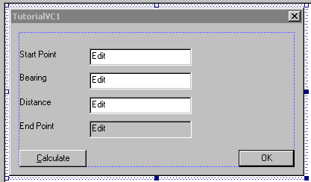

Data Handling and Calculation
This portion of the tutorial will add data members, message handlers, and code to perform the basic calculation.

- Add data members to the dialog using Class Wizard. The data types for IDC_EDIT_BEARING and IDC_EDIT_DISTANCE should be double since they are numbers to be used in calculation. Note that for calculation purposes, the bearing will be represented in radians and the distance will be represented in feet. The data types for IDC_EDIT_START and IDC_EDIT_END should be CString.

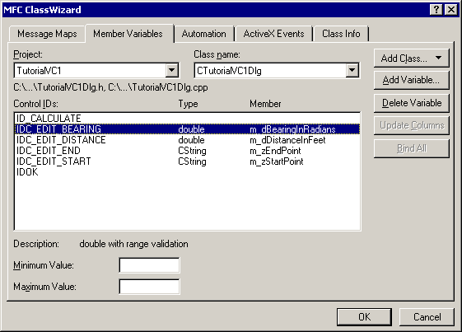

- Add a message handler for the Calculate button.

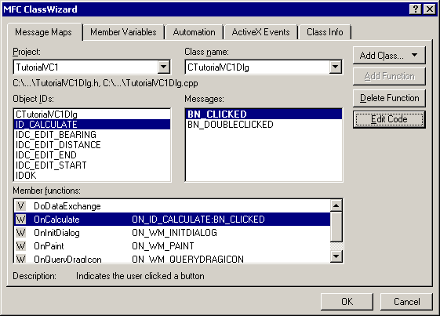

- Add code for calculation and display of the end point to OnCalculate(). Note that the cosine and sine functions require including math.h.

#include <math.h>
void CTutorialVC1Dlg::OnCalculate()
{
// Retrieve the data
UpdateData( TRUE );

// Parse the start point string into X and Y elements
int iCommaPos = strchr( m_zStartPoint, ',' ) - (LPCTSTR)m_zStartPoint;

// Convert X and Y strings into numbers
double dStartX, dStartY;
dStartX = atof( m_zStartPoint.Left(iCommaPos) );
dStartY = atof( m_zStartPoint.Right(
m_zStartPoint.GetLength() - iCommaPos - 1) );

// Compute the end point
double dEndX, dEndY;
dEndX = dStartX + cos(m_dBearingInRadians) * m_dDistanceInFeet;
dEndY = dStartY + sin(m_dBearingInRadians) * m_dDistanceInFeet;

// Format the result as a string and display in edit box
m_zEndPoint.Format( "%f , %f", dEndX, dEndY );
UpdateData( FALSE );
}

- Run and test the application. Note that the parsing of input data is not very flexible. Also, input of bearing data must be in radians.

