TutorialVC2 – Visual C++ Sample Application

Introduction
This is a tutorial that builds on the dialog-based application from TutorialVC1. The purpose of the tutorial is to demonstrate how the UCLID Input Funnel can be integrated into an existing application. Use of input receivers and input validators will also be demonstrated. The Highlighted Text input receiver provides point-and-click input of data from text files. The Spot Recognition input receiver provides point-and-click input of data from image files. The C-Pen input receiver provides data scanned from paper documents. Enhancement and extension of the application to use of additional input receivers and input validators is demonstrated in subsequent tutorials.

Project Creation
The working directory for the TutorialVC2 project is “Tutorials/VC2/Code”. Copy the files from the “Tutorials/VC2/Code (Original)” folder. An alternative is to continue working with the TutorialVC1 project files. In this case, screen shots and certain source code pieces will differ because of the class name and file name differences. It is appropriate to build the TutorialVC2 executable and verify proper behavior.

Add Input Funnel ActiveX Control
This portion of the tutorial adds the input funnel to the project. Display of the Highlighted Text and Spot Recognition input receivers will also be included.

- Add COM support to the application. Initialize and release the COM libraries within CTutorialVC2App::InitInstance(). The following code snippet surrounds declaration and use of the CTutorialVC2Dlg object. Note the enclosing curly braces that define the scope of the dialog object.

BOOL CTutorialVC2App::InitInstance()
{
AfxEnableControlContainer();

// Standard initialization
// If you are not using these features and wish to reduce the size
// of your final executable, you should remove from the following
// the specific initialization routines you do not need.

#ifdef _AFXDLL
Enable3dControls(); // Call this when using MFC in a shared DLL
#else
Enable3dControlsStatic(); // Call this when linking to MFC statically
#endif

// Initialize the COM libraries
CoInitialize( NULL );

{
CTutorialVC2Dlg dlg;
m_pMainWnd = &dlg;
int nResponse = dlg.DoModal();
if (nResponse == IDOK)
{
// TODO: Place code here to handle when the dialog is
// dismissed with OK
}
else if (nResponse == IDCANCEL)
{
// TODO: Place code here to handle when the dialog is
// dismissed with Cancel
}
}

// Release the COM libraries
CoUninitialize();

// Since the dialog has been closed, return FALSE so that we exit the
// application, rather than start the application's message pump.
return FALSE;
}

- Add the Input Manager Class ActiveX control to the dialog. Right click in the dialog and select “Insert ActiveX control…”. Note that the Path text will be different than the image below depending on where the Input Funnel DLLs were installed. Resize the ActiveX control object within the dialog to avoid obscuring the other controls.

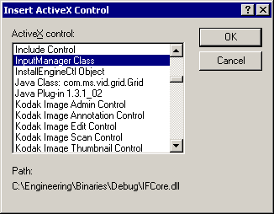

- Create the input funnel data member (m_InputFunnel) using Class Wizard. Class Wizard will also create three class wrappers associated with the control.

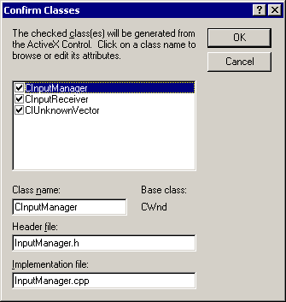

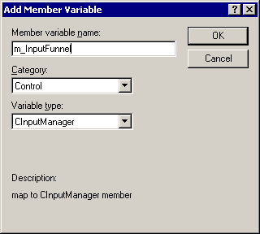

- Add buttons to the dialog for the Highlighted Text and Spot Recognition input receivers. Appropriate ID’s are ID_HTWINDOW and ID_SRWINDOW.

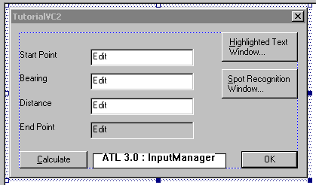

- Use Class Wizard to add a message handler for the Highlighted Text button. The following code creates the input receiver.

void CTutorialVC2Dlg::OnHtwindow()
{
// Use the input funnel to create the input receiver
m_InputFunnel.CreateNewInputReceiver( "Highlighted Text Window" );
}

- Use Class Wizard to add a message handler for the Spot Recognition button. The following code creates the input receiver.

void CTutorialVC2Dlg::OnSrwindow()
{
// Use the input funnel to create the input receiver
m_InputFunnel.CreateNewInputReceiver( "Spot Recognition Window" );
}

- The following code must be included in OnInitDialog() to allow the input receivers to be visible.

BOOL CTutorialVC2Dlg::OnInitDialog()
{
CDialog::OnInitDialog();

// Set the icon for this dialog. The framework does this automatically
// when the application's main window is not a dialog
SetIcon(m_hIcon, TRUE); // Set big icon
SetIcon(m_hIcon, FALSE); // Set small icon

// Set visibility of input receivers
m_InputFunnel.ShowWindows( VARIANT_TRUE );

return TRUE; // return TRUE unless you set the focus to a control
}

- Add license information to the dialog code. Without a valid license key the input funnel methods will not work. The following code should be added near the top of the TutorialVC2Dlg.cpp file below the #includes. Note that the path to the DLL may be different depending on location of the input funnel software.

#import "COMLM.dll"
using namespace UCLID_COMLMLib;

Add an #include directory to your project settings pointing to the installation directory of the Input Funnel DLLs. Note that either a relative path or an absolute path can be used.

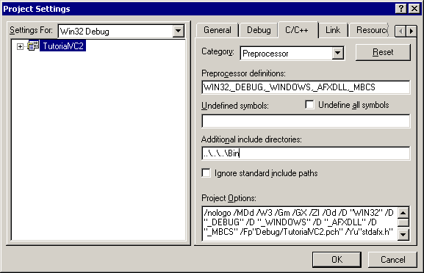

The following code should be added before returning from the dialog constructor. Note that a valid license key is required!

BOOL CTutorialVC2Dlg::OnInitDialog()
{
// ..

// Declare license object
IUCLIDComponentLMPtr ipLicense( __uuidof(UCLIDComponentLM) );

// TODO: Initialize license object with valid key
ipLicense->Initialize( "Insert your license key here!" );

// ..
}

- Add an OnClose() message handler to clean up input receivers in the input funnel.

void CTutorialVC2Dlg::OnClose()
{
// ..

// Clean up the input funnel
m_InputFunnel.Destroy();

CDialog::OnClose();

// ..
}

- Build and test the application. Input receiver windows should be creatable.

Add Input Funnel Event Handling
At this stage, input receivers can be created but no data transport is available. The next step adds handling of events from the input funnel. Data from an input receiver is provided to the input funnel. The input funnel can validate the data (but not in this section yet) and then fire an event to the application.

- Replace double data members with strings for bearing and distance edit boxes. From the Class Wizard, delete the m_dBearingInRadians and m_dDistanceInFeet variables. Create new m_zBearing and m_zDistance variables.

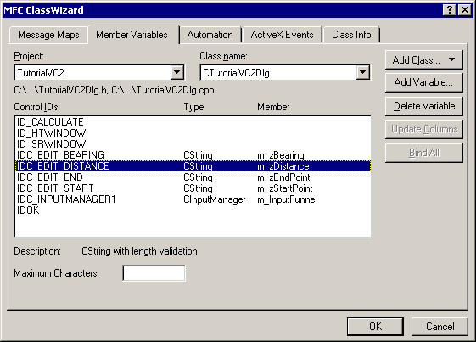

The OnCalculate() code requires slight modification to support the new data members.

void CTutorialVC2Dlg::OnCalculate()
{
// ..

// Retrieve the data
UpdateData( TRUE );

// Parse the start point string into X and Y elements
int iCommaPos = strchr( m_zStartPoint, ',' ) - (LPCTSTR)m_zStartPoint;

// Convert X and Y strings into numbers
double dStartX, dStartY;
dStartX = atof( m_zStartPoint.Left(iCommaPos) );
dStartY = atof( m_zStartPoint.Right(
m_zStartPoint.GetLength() - iCommaPos - 1) );

// Retrieve bearing and distance
double dBearingInRadians = atof( m_zBearing );
double dDistanceInFeet = atof( m_zDistance );

// Compute the end point
double dEndX, dEndY;
dEndX = dStartX + cos(dBearingInRadians) * dDistanceInFeet;
dEndY = dStartY + sin(dBearingInRadians) * dDistanceInFeet;

// Format the result as a string and display in edit box
m_zEndPoint.Format( "%f , %f", dEndX, dEndY );
UpdateData( FALSE );

// ..
}

- Enable reception of input from the input funnel. The following code should be added before returning from OnInitDialog().

BOOL CTutorialVC2Dlg::OnInitDialog()
{
// ..

// Enable input from funnel
m_InputFunnel.EnableInput1( "Text", "Please specify input!" );

// ..

return TRUE; // return TRUE unless you set the focus to a control
}

The following code should be added near the top of the TutorialVC2Dlg.cpp file. These DLLs provide access to the input funnel methods and events.

#import "UCLIDIUnknownVector.dll"
using namespace UCLIDIUNKNOWNVECTORLib;

#import "IFCore.dll"
using namespace UCLID_INPUTFUNNELLib;

- Add an event handler for the ActiveX control. Right click on the ActiveX control object in the dialog and select “Events…”. Select Add Handler for the OnInputReceived event.

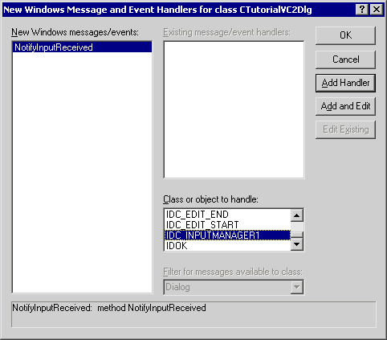

- Add the following code to the event handler.

void CTutorialVC2Dlg::OnNotifyInputReceivedInputmanager1(LPDISPATCH pTextInput)
{
// ..

// Create the text input object
ITextInputPtr ipTextInput = pTextInput;

// Retrieve the received text
BSTR _bstrText( ipTextInput->GetText() );

// Display the received text in the starting point field
m_zStartPoint = _bstrText;
UpdateData( FALSE );

// ..
}

- Run and test the application. Open the file “a.txt” from the Highlighted Text input receiver or “b.tif” from the Spot Recognition input receiver. Input from either of the input receivers should be displayed in the Starting Point edit box.

Direct Input Funnel Data to Edit Boxes
So far, the data received and processed by the input funnel is only displayed in the Starting Point edit box. The next step adds the capability of displaying input funnel data in the active edit box.

- Add a private dialog data member (long m_lControlID) that stores the ID of the active edit box. Set the control ID to IDC_EDIT_START in OnInitDialog(). Note that OnInitDialog now returns FALSE because focus is being set to a control.

BOOL CTutorialVC2Dlg::OnInitDialog()
{
// ..

// Begin with the starting point
m_lControlID = IDC_EDIT_START;
GetDlgItem( m_lControlID )->SetFocus();

// ..

return FALSE; // return TRUE unless you set the focus to a control
}

- Also use Class Wizard to add EN_SETFOCUS message handlers for the Starting Point, Bearing, and Distance edit boxes.

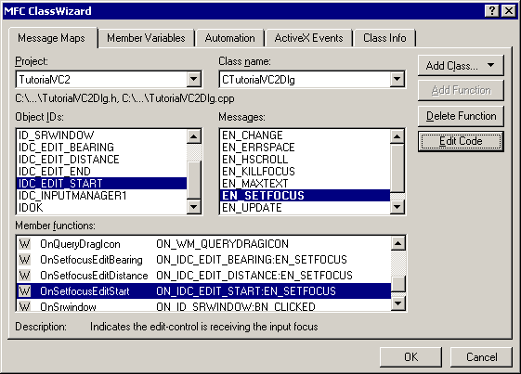

- Add code to the OnSetfocusEditBearing() method to store the appropriate control ID. Similar code will be added to OnSetfocusEditDistance() and OnSetfocusEditStart().

void CTutorialVC2Dlg::OnSetfocusEditBearing()
{
// ..

// Set the control ID
m_lControlID = IDC_EDIT_BEARING;

// ..
}

void CTutorialVC2Dlg::OnSetfocusEditDistance()
{
// ..

// Set the control ID
m_lControlID = IDC_EDIT_DISTANCE;

// ..
}

void CTutorialVC2Dlg::OnSetfocusEditStart()
{
// ..

// Set the control ID
m_lControlID = IDC_EDIT_START;

// ..
}

- Modify the event handler as follows to display the received text in the active edit box. The code changes only in the last section of the method.

void CTutorialVC2Dlg::OnNotifyInputReceivedInputmanager1(LPDISPATCH pTextInput)
{
// ..

// Create the text input object
ITextInputPtr ipTextInput = pTextInput;

// Retrieve the received text
BSTR _bstrText( ipTextInput->GetText() );

// Display the received text in the active edit box
CString zText( _bstrText );
GetDlgItem( m_lControlID )->SetWindowText( zText );

// ..
}

- Run and test the application. Input funnel data is now displayed in the most recently active edit box. Click in the Starting Point field and then select a highlighted text entry. Click in the Bearing field and select another entry. Click in the Distance field and select another entry.

Automatically Move Between Edit Boxes
So far, input data is automatically displayed in the active edit box. It would be useful to advance to the next edit box after data has been received. This step adds that capability to the application.

- Add code at the end of the OnNotifyInputReceivedInputmanager1() method to change focus to the next edit box.

void CTutorialVC2Dlg::OnNotifyInputReceivedInputmanager1(LPDISPATCH pTextInput)
{
// ..

// Create the text input object
ITextInputPtr ipTextInput = pTextInput;

// Retrieve the received text
BSTR _bstrText( ipTextInput->GetText() );

// Display the received text in the active edit box
CString zText( _bstrText );
GetDlgItem( m_lControlID )->SetWindowText( zText );

// Automatically set focus to the next field
GetDlgItem( m_lControlID )->PostMessage( WM_KEYDOWN, VK_TAB, 1 );

// ..
}

- Run and test the application. Reception of data from the input funnel now advances the user to the next edit box.

Add Data Validation
At this point in development of the application the data is not validated. In fact, if you click the Calculate button, the OnCalculate() method converts the user-provided strings into appropriate numbers. This portion of the tutorial adds validation of the input funnel data. Validation is done by the Input Validator object specified in the call to EnableInput1().

- Set expected data type for each edit box. Add the appropriate lines to OnSetfocusEditBearing(), OnSetfocusEditDistance(), and OnSetfocusEditStart(). In addition, the call to EnableInput1() inside OnInitDialog() can be removed.

void CTutorialVC2Dlg::OnSetfocusEditBearing()
{
// ..

// Set the control ID
m_lControlID = IDC_EDIT_BEARING;

// Enable input from funnel
m_InputFunnel.EnableInput1( "Bearing", "Please specify bearing..." );

// ..
}

void CTutorialVC2Dlg::OnSetfocusEditDistance()
{
// ..

// Set the control ID
m_lControlID = IDC_EDIT_DISTANCE;

// Enable input from funnel
m_InputFunnel.EnableInput1( "Distance", "Please specify distance..." );

// ..
}

void CTutorialVC2Dlg::OnSetfocusEditStart()
{
// ..

// Set the control ID
m_lControlID = IDC_EDIT_START;

// Enable input from funnel
m_InputFunnel.EnableInput1( "Cartographic Point", "Please specify starting point..." );

// ..
}

BOOL CTutorialVC2Dlg::OnInitDialog()
{
// ..

CDialog::OnInitDialog();

// Set the icon for this dialog. The framework does this automatically
// when the application's main window is not a dialog
SetIcon(m_hIcon, TRUE); // Set big icon
SetIcon(m_hIcon, FALSE); // Set small icon

// Set visibility of input receivers
m_InputFunnel.ShowWindows( VARIANT_TRUE );

// Begin with the starting point
m_lControlID = IDC_EDIT_START;
GetDlgItem( m_lControlID )->SetFocus();

return FALSE; // return TRUE unless you set the focus to a control

// ..
}

- Run and test the application. Show that valid input data is accepted into the appropriate edit boxes. An example of a proper starting point is “10, 10”.

- Show that when validation fails the Input Correction dialog is displayed. In this example, distance text was selected when a Bearing was expected.

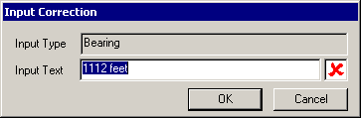

If the invalid input has an associated image as it would from the Spot Recognition window, the received image is also visible in the Input Correction dialog. This display facilitates user correction. In this example, distance information was scanned from an image and recognized when a Bearing was expected.

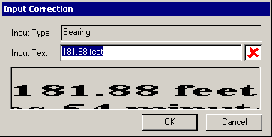

- Run and test the application. Select inappropriate text from an input receiver and experiment with the results.

Use Validated Input in Calculation
So far, the data used in the calculation is taken from a simple conversion of the text string. The validated input object provides improved functionality and frees the developer from having to parse the input string and convert it to an appropriate format. This section will demonstrate how to retrieve a bearing converted to radians and a distance converted to feet. The retrieved values will be used directly in the calculation.

- Create and use dialog data members to store start point, bearing (in radians), and distance (in feet). Add the following private data members to the TutorialVC2Dlg header file.

double m_dStartX;
double m_dStartY;
double m_dBearingInRadians;
double m_dDistanceInFeet;

- Add the following #import statements with the others in the TutorialVC2Dlg.cpp file.

#import "UCLIDDistanceConverter.dll"
using namespace UCLIDDISTANCECONVERTERLib;

#import "LandRecordsIV.dll"
using namespace UCLIDLANDRECORDSIVLib;

#import "CartographicPointIV.dll"
using namespace UCLIDCARTOGRAPHICPOINTIVLib;

- To retrieve and use validated input, modify the event handler as follows. Note that the new data members are set from the validated input objects.

void CTutorialVC2Dlg::OnNotifyInputReceivedInputmanager1(LPDISPATCH pTextInput)
{
// ..

// Create the text input object
ITextInputPtr ipTextInput = pTextInput;

// Retrieve the received text
BSTR _bstrText( ipTextInput->GetText() );

// Retrieve the validated input object, if any
IUnknownPtr ipValidatedInputObj = ipTextInput->GetValidatedInput();
switch( m_lControlID )
{
case IDC_EDIT_START:
// Retrieve X and Y components of the start point
if (ipValidatedInputObj.GetInterfacePtr())
{
ICartographicPointPtr ipPoint = ipValidatedInputObj;
if (ipPoint != NULL)
{
ipPoint->GetPointInXY(&m_dStartX, &m_dStartY);
}
}
else
{
MessageBox("UNEXPECTED ERROR: No validated input object was received!");
}
break;

case IDC_EDIT_BEARING:
// Retrieve bearing value in radians
if (ipValidatedInputObj.GetInterfacePtr())
{
IBearingPtr ipBearing = ipValidatedInputObj;
if (ipBearing != NULL)
{
m_dBearingInRadians = ipBearing->GetBearingInRadians();
}
}
else
{
MessageBox("UNEXPECTED ERROR: No validated input object was received!");
}
break;

case IDC_EDIT_DISTANCE:
// Retrieve distance in feet
if (ipValidatedInputObj.GetInterfacePtr())
{
IDistancePtr ipDistance = ipValidatedInputObj;
if (ipDistance != NULL)
{
m_dDistanceInFeet = ipDistance->GetDistanceInUnit( kFeet );
}
}
else
{
MessageBox("UNEXPECTED ERROR: No validated input object was received!");
}
break;
}

// Display the received text in the active edit box
CString zText( _bstrText );
GetDlgItem( m_lControlID )->SetWindowText( zText );

// Automatically set focus to the next field
GetDlgItem( m_lControlID )->PostMessage( WM_KEYDOWN, VK_TAB, 1 );

// ..
}

- Update OnCalculate() as follows to use the validated data. Note that parsing of strings is not required since the data members are set to valid values inside the event handler.

void CTutorialVC2Dlg::OnCalculate()
{
// ..

// Retrieve the data
UpdateData( TRUE );

// Compute the end point
double dEndX, dEndY;
dEndX = m_dStartX + cos(m_dBearingInRadians) * m_dDistanceInFeet;
dEndY = m_dStartY + sin(m_dBearingInRadians) * m_dDistanceInFeet;

// Format the result as a string and display in edit box
m_zEndPoint.Format( "%f , %f", dEndX, dEndY );
UpdateData( FALSE );

// ..
}

- Run and test the application. Choose ALL input data from one of the input receiver windows and correct input if needed. It is important to get all of the data from an input receiver because at this point in the tutorial that is the only way that data is validated and provided to the data members used in OnCalculate().

Add Support for Keyboard Input
At this point, data entered from the keyboard is not subject to validation and does not go through the input funnel. In addition, the relevant data members are not set inside the event handler. This section adds support for validation and use of keyboard input.

- Use Class Wizard to add EN_KILLFOCUS message handlers for the Start Point, Bearing, and Distance edit boxes.

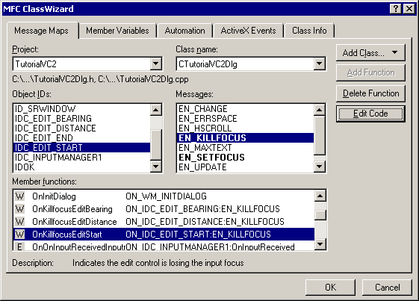

- Add code to each handler to allow the input funnel to process the data.

void CTutorialVC2Dlg::OnKillfocusEditBearing()
{
// Retrieve text
UpdateData( TRUE );

// Send data to input funnel
if (!m_zBearing.IsEmpty())
{
m_InputFunnel.ProcessTextInput( m_zBearing );
}
}

void CTutorialVC2Dlg::OnKillfocusEditDistance()
{
// Retrieve text
UpdateData( TRUE );

// Send data to input funnel
if (!m_zDistance.IsEmpty())
{
m_InputFunnel.ProcessTextInput( m_zDistance );
}
}

void CTutorialVC2Dlg::OnKillfocusEditStart()
{
// Retrieve text
UpdateData( TRUE );

// Send data to input funnel
if (!m_zStartPoint.IsEmpty())
{
m_InputFunnel.ProcessTextInput( m_zStartPoint );
}
}

- Run and test the application. Notice that input data can be provided from input receivers and from the keyboard. Invalid text from any source is presented to the user for correction.

Default Distance Unit
The next flaw to be resolved is in the Distance field. The application will crash if you type a number into the Distance field and then hit Tab. The crash is because a unit-less number is not a valid distance. This section adds a default unit for Distance data.

- Add a local distance object in the constructor and set its units to feet.

// Set default unit for Distance to feet
CTutorialVC2Dlg::CTutorialVC2Dlg(CWnd* pParent /*=NULL*/)
: CDialog(CTutorialVC2Dlg::IDD, pParent)
{
// ..

// TODO: Initialize license object with valid key
ipLicense->Initialize( "Insert your license key here!" );

// Set default unit for Distance to feet
IDistancePtr ipDistance( __uuidof(Distance) );
ipDistance->put_GlobalDefaultDistanceUnit( kFeet );
}

- Run and test the application. Demonstrate that a unit-less input is treated as having units of feet. Note that distance input with units of inches is automatically converted to feet.

Disable Input When Appropriate
Another problem with the application is that input can always be received. A better situation would have input received only when one of the three logical (start point, bearing, distance) fields had the focus. Once focus moves to the End Point edit box or the Calculate button, input should be disabled.

- Use Class Wizard to add an EN_SETFOCUS message handler to the Ending Point edit box.

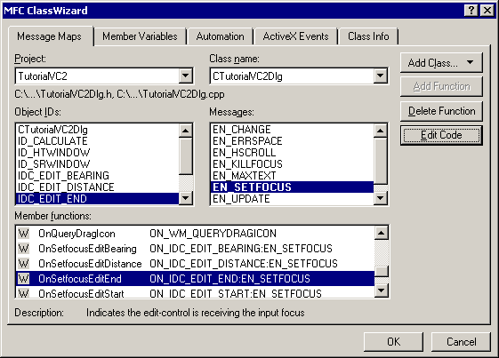

- Add code to the message handler to disable input. The same code should also be added to OnCalculate().

void CTutorialVC2Dlg::OnSetfocusEditEnd()
{
// Disable input
m_InputFunnel.DisableInput();
}

void CTutorialVC2Dlg::OnCalculate()
{
// Disable input
m_InputFunnel.DisableInput();

// Retrieve the data
UpdateData( TRUE );

// ..
}

- Run and test the application. Notice that input is no longer accepted from the input receivers after focus has moved to the Ending Point edit box or the Calculate button.

Add Support for C-Pen Input Receiver
To this point, the only input receivers available to the input manager are Highlighted Text Window and Spot Recognition Window. This section adds support for the C-Pen input receiver. The same process is used to support any windowless input receiver. Note that this input receiver requires C-Pen software libraries to be installed on the PC.

- Create the input receiver within OnInitDialog().

BOOL CTutorialVC2Dlg::OnInitDialog()
{
CDialog::OnInitDialog();

// Set the icon for this dialog. The framework does this automatically
// when the application's main window is not a dialog
SetIcon(m_hIcon, TRUE); // Set big icon
SetIcon(m_hIcon, FALSE); // Set small icon

// Set visibility of input receivers
m_InputFunnel.ShowWindows( VARIANT_TRUE );

// Create a C-Pen input receiver
m_InputFunnel.CreateNewInputReceiver( "C-Pen" );

// Begin with the starting point
m_lControlID = IDC_EDIT_START;
GetDlgItem( m_lControlID )->SetFocus();

return FALSE; // return TRUE unless you set the focus to a control
}

- Run and test the application. Show that text from documents can be scanned with the C-Pen and validated by the Input Funnel.

First Optimization
This portion of the tutorial describes a problem with MFC messages received out of order. One solution is given. Other solutions are possible but left to the student. When input is taken from the keyboard, it is possible for the EN_SETFOCUS message to be received for the subsequent control before the EN_KILLFOCUS message handler has completed execution. A problem occurs because the OnSetfocus handler sets the control ID member to be the new control before the OnInputReceived event has been processed. Proper behavior requires that the control ID not be changed until after the event has been processed.

- Demonstration of the problem. Start the application and type “10” into the Starting Point field. Press the Tab key to move to the Bearing field. When the Input Correction dialog appears, provide a valid starting point such as “10, 10”. The application should crash. If you debug the application you will find The following event sequence:

  - OnKillfocusEditStart() begins execution.
  - ProcessTextInput() is called on the input funnel object.
  - OnSetfocusEditBearing() begins execution. This method will change the m_lControlID data member and cause the upcoming problem.
  - OnKillfocusEditStart() completes execution.
  - The text event is fired by the input manager and received by the event handler.
  - Processing of the received expects to find a valid bearing because of the change to m_lControlID.

- One way to get around the problem is to add a new data member (long m_lKeyboardInputControlID) to the dialog. Initialize the ID to zero in the dialog constructor.

CTutorialVC2Dlg::CTutorialVC2Dlg(CWnd* pParent /*=NULL*/)
: CDialog(CTutorialVC2Dlg::IDD, pParent)
{
//..

m_lKeyboardInputControlID = 0;

// ..
}

- Modify each OnKillfocus handler to set the keyboard ID immediately before processing the input. Clear the keyboard ID immediately after processing.

void CTutorialVC2Dlg::OnKillfocusEditBearing()
{
// Retrieve text
UpdateData( TRUE );

// Send data to input funnel
if (!m_zBearing.IsEmpty())
{
m_lKeyboardInputControlID = IDC_EDIT_BEARING;
m_InputFunnel.ProcessTextInput( m_zBearing );
m_lKeyboardInputControlID = 0;
}
}

void CTutorialVC2Dlg::OnKillfocusEditDistance()
{
// Retrieve text
UpdateData( TRUE );

// Send data to input funnel
if (!m_zDistance.IsEmpty())
{
m_lKeyboardInputControlID = IDC_EDIT_DISTANCE;
m_InputFunnel.ProcessTextInput( m_zDistance );
m_lKeyboardInputControlID = 0;
}
}

void CTutorialVC2Dlg::OnKillfocusEditStart()
{
// Retrieve text
UpdateData( TRUE );

// Send data to input funnel
if (!m_zStartPoint.IsEmpty())
{
m_lKeyboardInputControlID = IDC_EDIT_START;
m_InputFunnel.ProcessTextInput( m_zStartPoint );
m_lKeyboardInputControlID = 0;
}
}

- Modify the event handler to check the keyboard ID before displaying the received text. Also, posting the WM_KEYDOWN message is only needed when the input was not provided via the keyboard. The following code changes are appropriate for OnNotifyInputReceivedInputmanager1().

void CTutorialVC2Dlg::OnNotifyInputReceivedInputmanager1(LPDISPATCH pTextInput)
{
// Create the text input object
ITextInputPtr ipTextInput = pTextInput;

// Retrieve the received text
BSTR _bstrText( ipTextInput->GetText() );

// Determine the appropriate control ID
long lID = m_lKeyboardInputControlID == 0 ? m_lControlID
: m_lKeyboardInputControlID;

// Retrieve the validated input object, if any
IUnknownPtr ipValidatedInputObj = ipTextInput->GetValidatedInput();
switch( lID )
{
case IDC_EDIT_START:
// Retrieve X and Y components of the start point
if (ipValidatedInputObj.GetInterfacePtr())
{
ICartographicPointPtr ipPoint = ipValidatedInputObj;
if (ipPoint != NULL)
{
ipPoint->GetPointInXY( &m_dStartX, &m_dStartY );
}
}
else
{
MessageBox("UNEXPECTED ERROR: No validated input object was received!");
}
break;

case IDC_EDIT_BEARING:
// Retrieve bearing value in radians
if (ipValidatedInputObj.GetInterfacePtr())
{
IBearingPtr ipBearing = ipValidatedInputObj;
if (ipBearing != NULL)
{
m_dBearingInRadians = ipBearing->GetBearingInRadians();
}
}
else
{
MessageBox("UNEXPECTED ERROR: No validated input object was received!");
}
break;

case IDC_EDIT_DISTANCE:
// Retrieve distance in feet
if (ipValidatedInputObj.GetInterfacePtr())
{
IDistancePtr ipDistance = ipValidatedInputObj;
if (ipDistance != NULL)
{
m_dDistanceInFeet = ipDistance->GetDistanceInUnit( kFeet );
}
}
else
{
MessageBox("UNEXPECTED ERROR: No validated input object was received!");
}
break;
}

// Display the received text in the active edit box
CString zText( _bstrText );
GetDlgItem( lID )->SetWindowText( zText );

// Automatically set focus to the next field
if (!m_lKeyboardInputControlID)
{
GetDlgItem( lID )->PostMessage( WM_KEYDOWN, VK_TAB, 1 );
}
}

- Run and test the application. Show that the sequence given in Step 1 is now accepted.

Second Optimization
This portion of the tutorial describes a second potential optimization. In certain circumstances, data goes through the validation process twice.
- When a selection is made within an input receiver, the associated text is sent to the input manager.
- The input manager validates the data based on expected type before the OnInputReceived event is fired.
- When the dialog catches or sinks the event, the validated text is displayed in the appropriate edit box.
- The dialog also posts a WM_KEYDOWN message to change focus to the next field.
- The current code validates the displayed text (again) as part of the OnKillfocus message handler.

Appropriate modifications are left as an exercise for the student.

