TutorialVC3 – Visual C++ Sample Application

Introduction
This is a dialog-based application that demonstrates use of the COMUCLIDException class. A similar example using Visual Basic is provided in the Tutorials/VB6/Code folder.

Application Creation
This portion of the tutorial will step through the application wizard and create a simple application.

- Visual C++ App-Wizard. Start by creating a new project. Select the MFC AppWizard (exe) option. For this example, the location is the “C:\Tutorials\VC3\Code” directory and the project name is TutorialVC3.

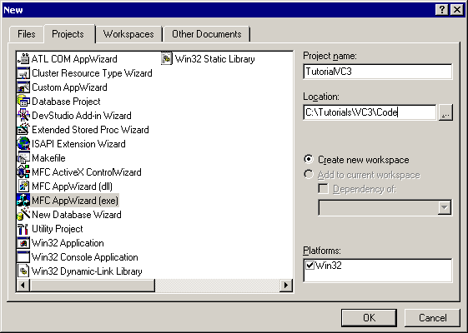

- Create a dialog-based application.

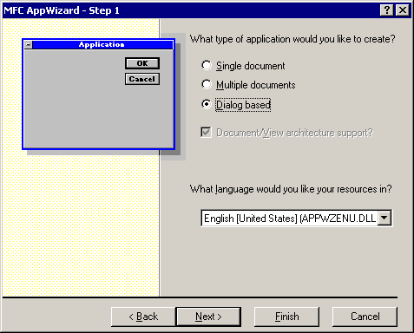

- The default features are sufficient. For this example, the About box was removed as unnecessary. Automation support is not needed. Support for ActiveX controls will be required in later tutorials.

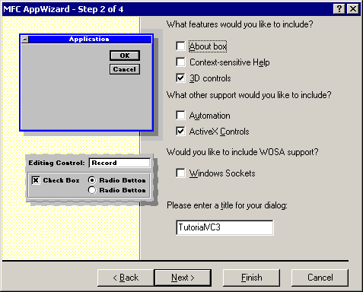

- The remaining default choices are sufficient.

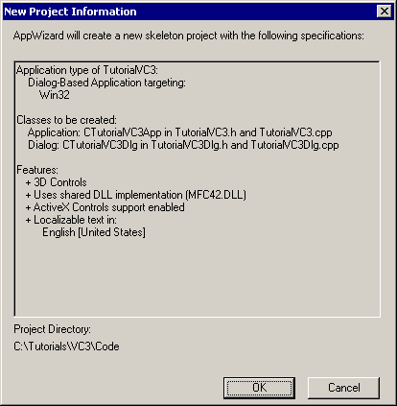

Populating the Dialog
This portion of the tutorial will populate the dialog with static text, edit boxes, and a button. The general arrangement of the controls is shown. ID values are suggested for the controls to allow better alignment with subsequent tutorials.

- Remove static text and both buttons.

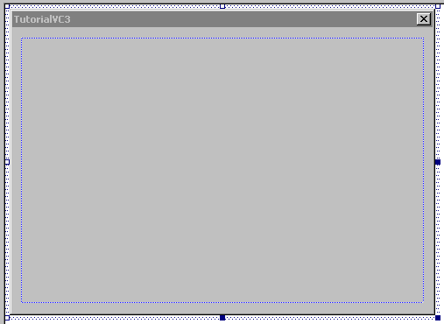

- Add a group box and two radio buttons. Appropriate IDs are IDC_RADIO_UCLID and IDC_RADIO_MESSAGE.

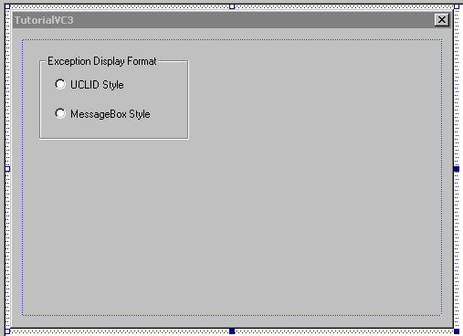

- Add the Test button. The suggested ID is IDC_TEST. The dialog can also be resized for a better user experience.

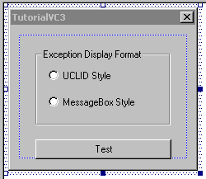

Data Handling and Calculation
This portion of the tutorial will add data members, message handlers, and code to perform the basic calculation.

- Add COM support to the application. Initialize and release the COM libraries within CTutorialVC3App::InitInstance(). The following code snippet surrounds declaration and use of the CTutorialVC3Dlg object. Note the enclosing curly braces that define the scope of the dialog object.

BOOL CTutorialVC3App::InitInstance()
{
AfxEnableControlContainer();

// Standard initialization
// If you are not using these features and wish to reduce the size
// of your final executable, you should remove from the following
// the specific initialization routines you do not need.

#ifdef _AFXDLL
Enable3dControls(); // Call this when using MFC in a shared DLL
#else
Enable3dControlsStatic(); // Call this when linking to MFC statically
#endif

// Initialize the COM libraries
CoInitialize( NULL );

{
CTutorialVC3Dlg dlg;
m_pMainWnd = &dlg;
int nResponse = dlg.DoModal();
if (nResponse == IDOK)
{
// TODO: Place code here to handle when the dialog is
// dismissed with OK
}
else if (nResponse == IDCANCEL)
{
// TODO: Place code here to handle when the dialog is
// dismissed with Cancel
}
}

// Release the COM libraries
CoUninitialize();

// Since the dialog has been closed, return FALSE so that we exit the
// application, rather than start the application's message pump.
return FALSE;
}

- Add required #import statements for the COMLM, UCLIDExceptionMgmt, and UCLIDIUnknownVector DLLs. Also modify the Project Settings to point to the installation directory.

#import "COMLM.dll"
using namespace UCLID_COMLMLib;

#import "UCLIDExceptionMgmt.dll"
using namespace UCLIDEXCEPTIONMGMTLib;

#import "UCLIDIUnknownVector.dll"
using namespace UCLIDIUNKNOWNVECTORLib;

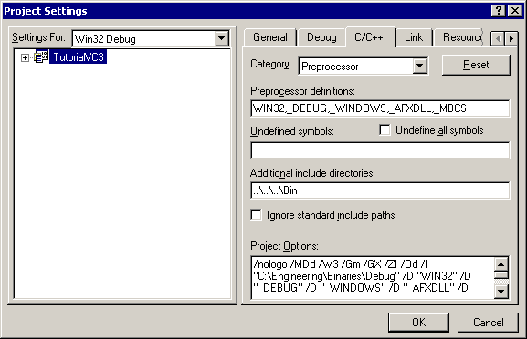

- Add appropriate licensing code to the dialog constructor.

// Declare license object
IUCLIDComponentLMPtr ipLicense( __uuidof(UCLIDComponentLM) );

// TODO: Initialize license object with valid key
ipLicense->Initialize( "Insert your license key here!" );

- Use Class Wizard to create a message handler for the Test button.

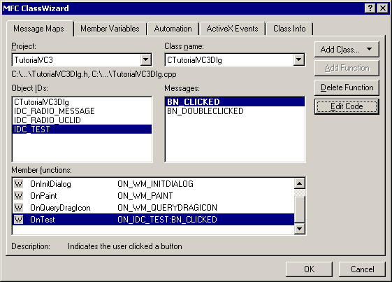

- Add code to OnTest() to create and initialize an exception object. Add the appropriate code to display the exception object.

BOOL CTutorialVC3Dlg::OnTest()
{
// First create and populate the exception
try
{
// Create IUnknownVector object
IIUnknownVectorPtr ipVec( __uuidof(IUnknownVector) );

// Call inappropriate method
// This will throw a UCLID Exception
IUnknownPtr ipTemp;
ipTemp = ipVec->at( 0 );

}
catch (_com_error& ex)
{
// Retrieve the error description
_bstr_t _bstrDescription = ex.Description();
char *pszDescription = _bstrDescription;

// Convert the description into a UCLID Exception
ICOMUCLIDExceptionPtr ipEx( __uuidof(COMUCLIDException) );
ipEx->createFromString( "ELI45678", pszDescription );

// Check UCLID Style radio button
if (((CButton *)GetDlgItem( IDC_RADIO_UCLID ))->GetCheck() == 1)
{
// Just display the UCLID Exception
ipEx->display();
}
else if (((CButton *)GetDlgItem( IDC_RADIO_MESSAGE ))->GetCheck() == 1)
{
// Retrieve topmost exception information
CString zCode ( ipEx->getTopELICode().operator const char *() );
CString zText( ipEx->getTopText().operator const char *() );

// Provide strings to message box
CString zTotal;
zTotal.Format( "Error code = %s\r\nError description = %s",
zCode, zText );
MessageBox( zTotal.operator LPCTSTR(), "Exception data",
MB_ICONEXCLAMATION | MB_OK );
}
else
{
MessageBox( "Please select a display method", "Error",
MB_ICONEXCLAMATION | MB_OK );
}
}
}

- Run and test the application. Note the basic data from only the most recent exception that is displayed in the MessageBox.

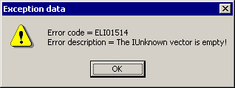

Note that the “Details…” button on the UCLID display dialog provides additional features beyond display and description of the most recent error.

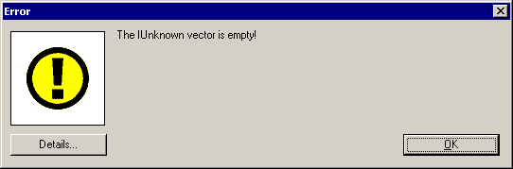

- Each error level in the stack can be viewed.
- Debug information can be attached.
- The complete exception stack can be written to a file.
- A stringized copy of the complete exception stack can be copied to the clipboard.

