TutorialVC4 – Visual C++ Sample Application

Introduction
This tutorial creates an Input Finder used to select and highlight Parcel ID strings in a text file. Input Finders are used by the Highlighted Text Window input receiver.

Application Creation
This portion of the tutorial will step through the application wizard and create the input finder.

- Visual C++ App-Wizard. Start by creating a new project. Select the ATL COM AppWizard option. For this example, the location is the C:\Tutorials\VC4\Code directory and the project name is ParcelIDFinder.

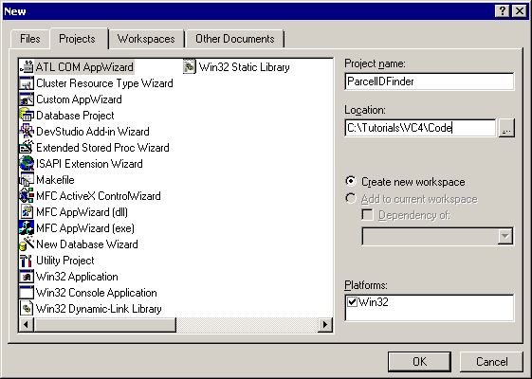

- App-Wizard Settings. Add MFC support.

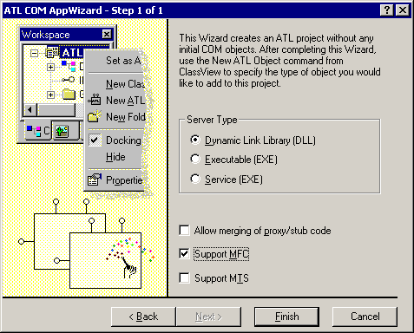

- Add a New ATL object to the project.

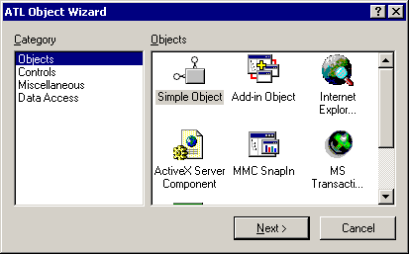

Choose ParcelIDIF for the short name and accept the associated defaults.

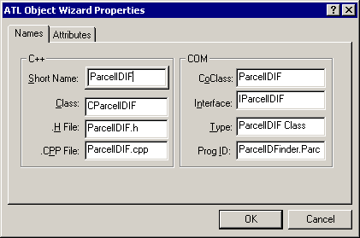

Include support for the ISupportErrorInfo interface.

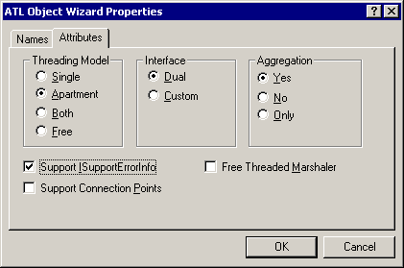

- Do a full build before implementing any interfaces. This allows the project to clean up various internal dependencies.

- Select Implement Interfaces for the CParcelIDIF class, adding the UCLID Input Finders type library. Note that the location of the type library will be your Input Funnel installation directory.

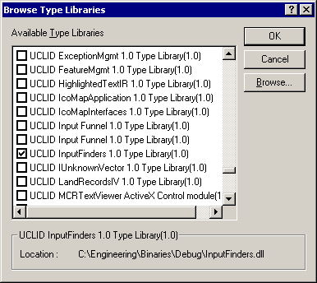

Select the IInputFinder interface.

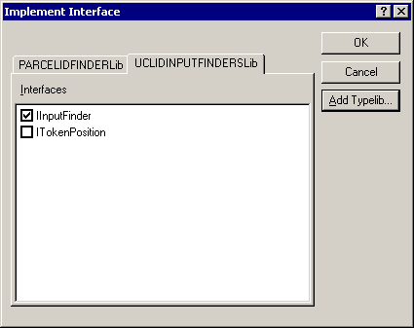

- Select Implement Interfaces for the CParcelIDIF class, adding the UCLID Component Category Management type library. Note that the location of the type library will be your Input Funnel installation directory.

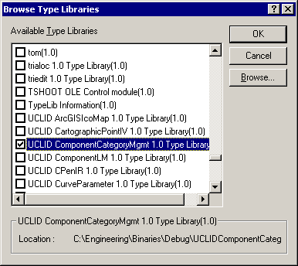

Select the ICategorizedComponent interface.

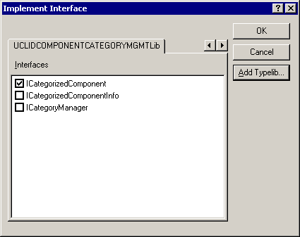

- Add string and vector to the collection of #include files. These files provide support for the string and vector STL types used in the subsequent parsing code.

#include <string>
#include <vector>

- Import the IUnknownVector DLL. Add the following code above the other #import statements. Modify the path information for the existing #imports and add the appropriate path to Project Settings.

#import "UCLIDIUnknownVector.dll"
using namespace UCLIDIUNKNOWNVECTORLib;

#import "UCLIDComponentCategoryMgmt.dll" raw_interfaces_only, raw_native_types, no_namespace, named_guids

#import "InputFinders.dll" raw_interfaces_only, raw_native_types, no_namespace, named_guids

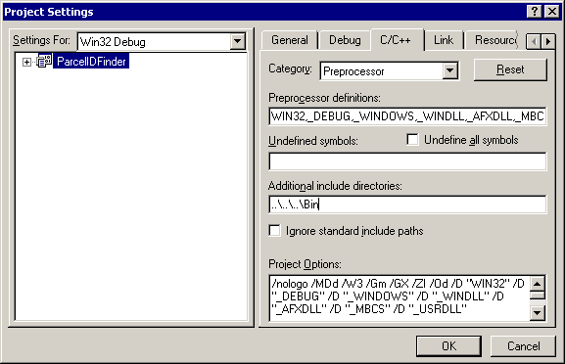

- Implement the getComponentDescription() method on the ICategorizedComponent interface.

STDMETHOD(getComponentDescription)(BSTR * pbstrComponentDescription)
{
if (pbstrComponentDescription == NULL)
return E_POINTER;

// Provide a description
*pbstrComponentDescription = ::SysAllocString(L"Highlight Parcel ID" );
return S_OK;
}

- Implement the finder code by adding code to the ParseString() method.

STDMETHOD(ParseString)(BSTR strInput, IIUnknownVector * * ippTokenPositions)
{
if (ippTokenPositions == NULL)
return E_POINTER;

// Create vector for interim storage of positions
CComPtr<IIUnknownVector> ipUnknownVec;
HRESULT hr = ipUnknownVec.CoCreateInstance(__uuidof(IUnknownVector));
if (FAILED(hr))
{
return E_FAIL;
}

// Create local copy of string for parsing
_bstr_t bstrInput( strInput );
std::string strTemp( bstrInput );

// Create vector for starting positions of parcel IDs
std::vector<int> vecStartPositions;

////////////////////////
// Do the actual parsing
////////////////////////

// Get the string size
int iLen = strTemp.size();

// Search for each dash in the string
int iStartPos = 0;
int iPos = 0;
bool bDone = false;
while (!bDone)
{
// Find the next dash
iPos = strTemp.find( '-', iStartPos );

// Check for no more dashes
if (iPos == -1)
{
bDone = true;
break;
}

// Check for too early
if (iPos < 4)
{
// Update the start position for the next search
iStartPos = iPos + 1;
continue;
}

// Check for too late
if (iLen - iPos < 5)
{
bDone = true;
break;
}

// Check for four digits before the dash
// and 4 digits after the dash
bool bFound = false;
if (isdigit( strTemp[iPos - 1] ) &&
isdigit( strTemp[iPos - 2] ) &&
isdigit( strTemp[iPos - 3] ) &&
isdigit( strTemp[iPos - 4] ) &&
isdigit( strTemp[iPos + 1] ) &&
isdigit( strTemp[iPos + 2] ) &&
isdigit( strTemp[iPos + 3] ) &&
isdigit( strTemp[iPos + 4] ))
{
bFound = true;
}

// Store starting position in vector
if (bFound)
{
vecStartPositions.Push_back( iPos - 4 );
}

// Update the start position for the next search
iStartPos = iPos + 1;

// Have we finished searching?
if (iLen - iStartPos < 5)
{
bDone = true;
}
}

///////////////////////////////////////////
// Store ITokenPosition objects into vector
///////////////////////////////////////////
for (unsigned long n = 0 ; n < vecStartPositions.size(); n++)
{
// Create ITokenPosition object
CComPtr<ITokenPosition> ipTokenPos;
HRESULT hr = ipTokenPos.CoCreateInstance(__uuidof(TokenPosition));
if (FAILED(hr))
{
return E_FAIL;
}

// Store position information into the object
hr = ipTokenPos->InitTokenPosition(
vecStartPositions[n],
vecStartPositions[n] + 8,
n );
if (FAILED(hr))
{
return E_FAIL;
}

// Add object to vector
ipUnknownVec->Push_back( ipTokenPos );
}

// Provide IUnknownVector to caller
*ippTokenPositions = ipUnknownVec.Detach();
return S_OK;
}

- Register the Input Finder in the proper category by adding appropriate code to the DLLRegisterServer() method in the ParcelIDFinder.cpp file.

///////////////////////////////////////
// Definitions for Category ID and Name
///////////////////////////////////////
const std::string HT_IF_CATEGORYNAME = "UCLID Highlighted Text Input Finders";

// {01236221-458A-11d6-826D-0050DAD4FF55}
static const GUID CATID_HT_INPUT_FINDERS =
{ 0x1236221, 0x458a, 0x11d6, { 0x82, 0x6d, 0x0, 0x50, 0xda, 0xd4, 0xff, 0x55 } };

STDAPI DllRegisterServer(void)
{
// registers object, typelib and all interfaces in typelib
HRESULT hr = _Module.RegisterServer(TRUE);

try
{
// Create the category if not already present
CComPtr<ICatRegister> ptrCR;
HRESULT hr = ptrCR.CoCreateInstance( CLSID_StdComponentCategoriesMgr,
NULL, CLSCTX_ALL );
if (SUCCEEDED(hr))
{
CATEGORYINFO rgcc;
rgcc.catid = CATID_HT_INPUT_FINDERS;
rgcc.lcid = 0x409;
_bstr_t _bstrCategoryName = HT_IF_CATEGORYNAME.c_str();
wcscpy(rgcc.szDescription, _bstrCategoryName);
ptrCR->RegisterCategories(1, &rgcc);

// Register Parcel ID input finder under UCLID Input Finders category
CATID rgcid;
rgcid = CATID_HT_INPUT_FINDERS;
ptrCR->RegisterClassImplCategories( CLSID_ParcelIDIF, 1, &rgcid );
}
else
{
// Cannot create the category, just return
return hr;
}
}
catch (...)
{
// Ignore any exception
}

// Return
return hr;
}

Testing the Input Finder
Testing of the Parcel ID Finder can be done using the Project1.exe file created during TutorialVB5.

- Force a search of the registry for new Input Finders. Delete the “InputFinders.lst” file located in the bin directory for the Input Funnel.

- Run the application.

- Create a Highlighted Text Input Receiver by clicking the New Text Window button.

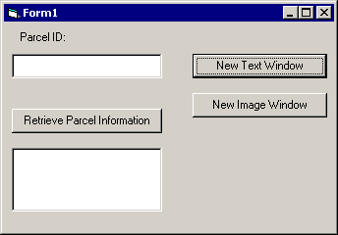

- Open the “a.txt” file.

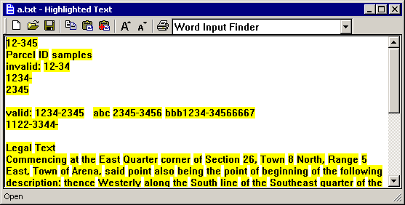

- Select the Highlight Parcel ID finder from the combo box. Note that each of the valid parcel ID strings are highlighted and can be selected straight into the parcel ID field in the dialog.

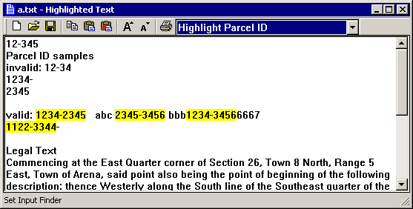

- Show that choosing a different Finder and selecting its highlighted text brings up the Input Correction dialog.

