Instructions for setting up a VPN connection from Home to Extract
- Open Settings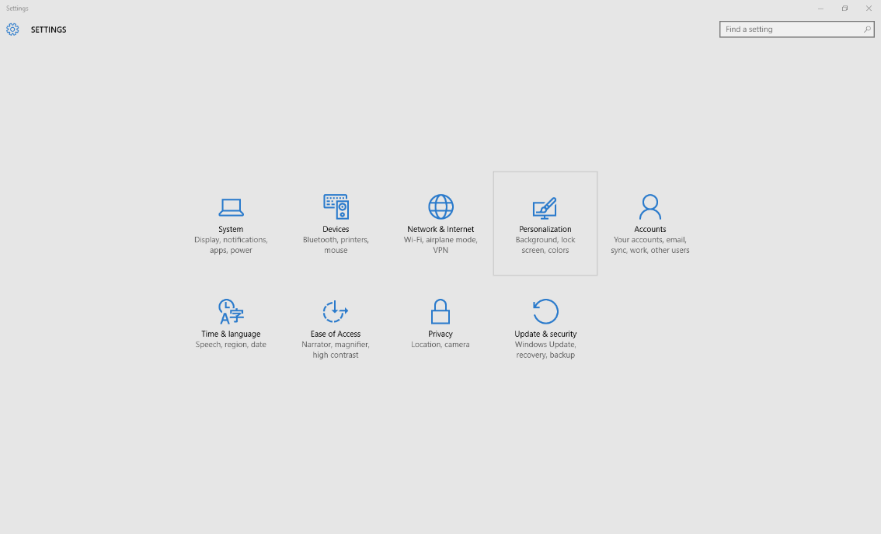

- Click on “Network & Internet”
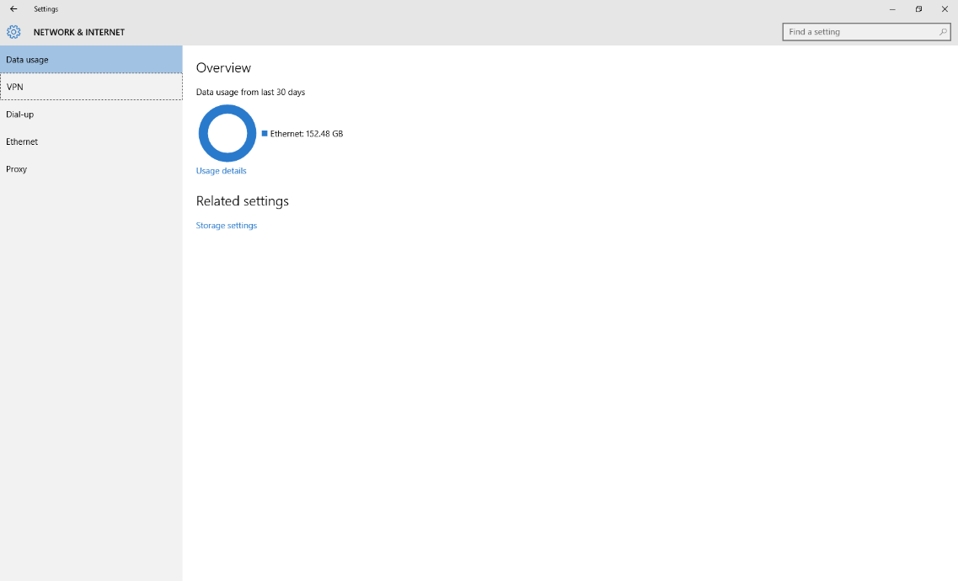
- Click on “VPN”
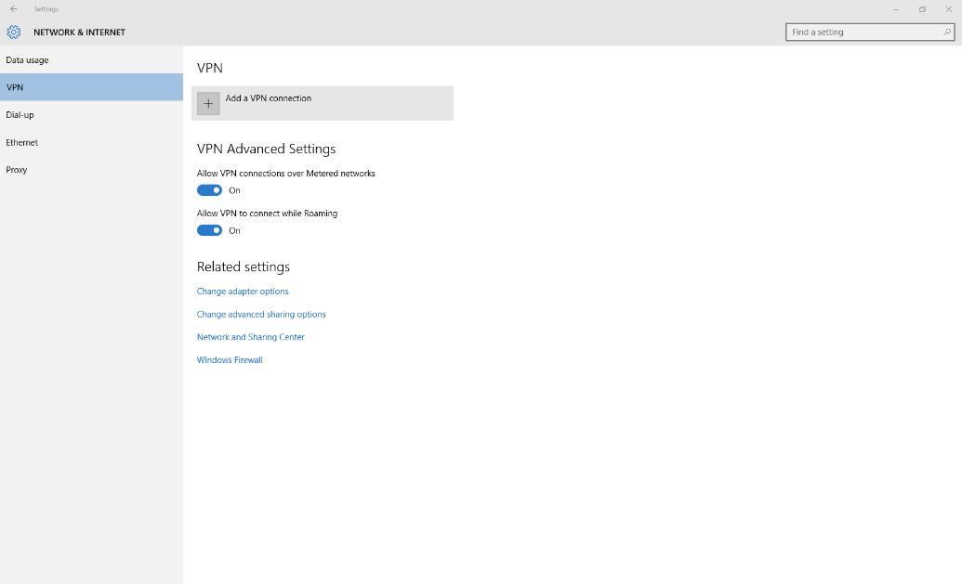
- Click on “Add a VPN Connection”
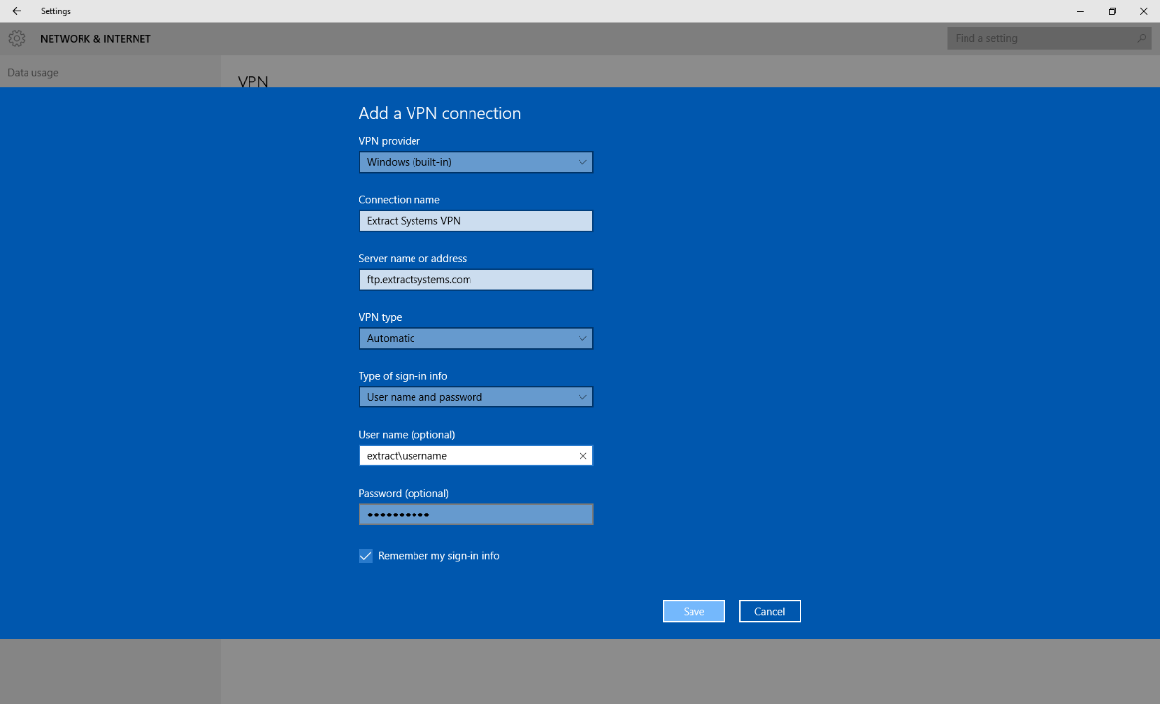
- For “VPN provider” select: Windows(built-in)
- For “Connection name” fill in: Extract Systems VPN
- For the “Server name or address” fill in: ftp.extractsystems.com
- For “VPN type” select: Automatic
- For “Type of sign-in info” select: User name and password
- For “User name (optional)” fill in: extract\first_last
  - first_last is same as what is used to login on your computer
- For the “password”, use your password for logging into you computer
- Click on Save
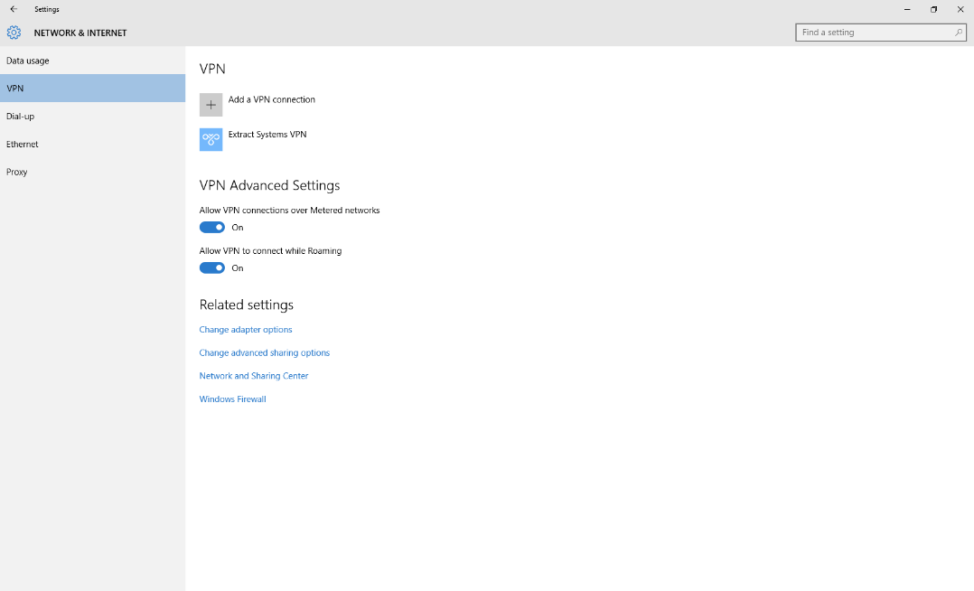
- There should now be a “Extract Systems VPN” on the VPN settings page
- To connect Click on “Extract Systems VPN”
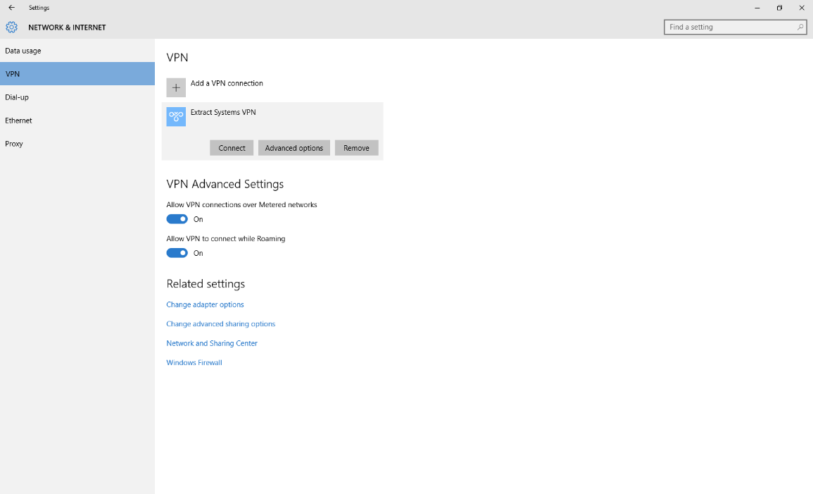
- Click on the Connect button
  - Please note that when you are connected all of your internet traffic from your computer goes through our network.
- Once connected if you are connecting to your computer in the office
  - From the start menu search for “Remote Desktop Connection”
  - Open “Remote Desktop Connection”
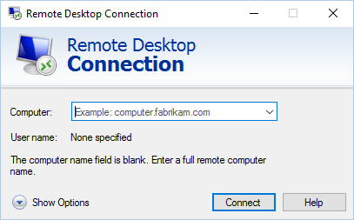
  - Click “Show options”
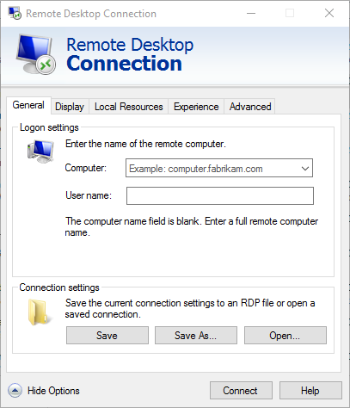
  - For Computer put in your computer name
    - Sometimes when connected from a VPN the computer name will not resolve to an IP address, if the connection does not work, you will need to put in the IP address
  - For Username use the extract\first_last
    - First_last is the same as what you use to login to your computer
  - Click on the “Display” tab
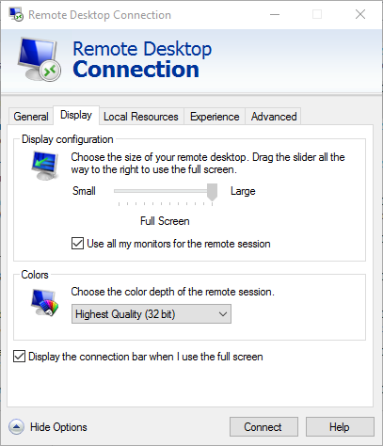
  - Check the “Use all my monitors for the remote session” box
    - This will allow multiple monitors to be used for the remote desktop connection if it is supported by both the machine you are connecting from and the machine you are connecting to.
  - Click “Connect”
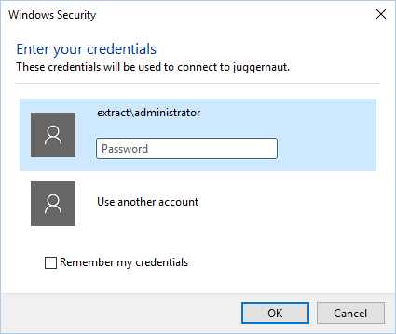
  - You will be prompted for your password
  - Click OK

