文件管理

一、项目要求：

1、使用jsp创建动态网页；

2、使用验证码进行登录验证；

3、使用servlet进行服务器端的事务处理；

4、使用jsp、EL表达式及servlet进行信息传递及页面跳转；

5、使用Tomcat作为后台服务器。

二、项目实现

1、整体的功能介绍

本程序主要完成文件上传功能和文件下载功能。

文件上传界面对应的代码为fileUpload.jsp文件，后台控制代码为fileUploadServlet文件。

文件下载界面对应的代码为fileDownload.jsp文件，后台控制代码为fileDownloadServlet文件和browsPictureServlet文件。

1. 流程图

（1）文件上传

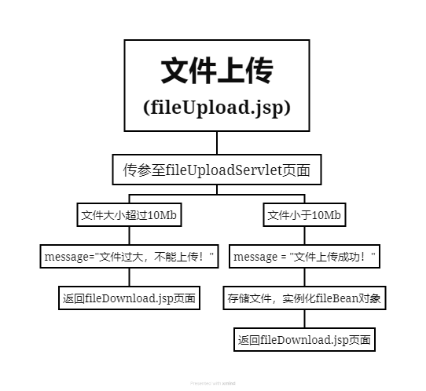

（2）文件下载

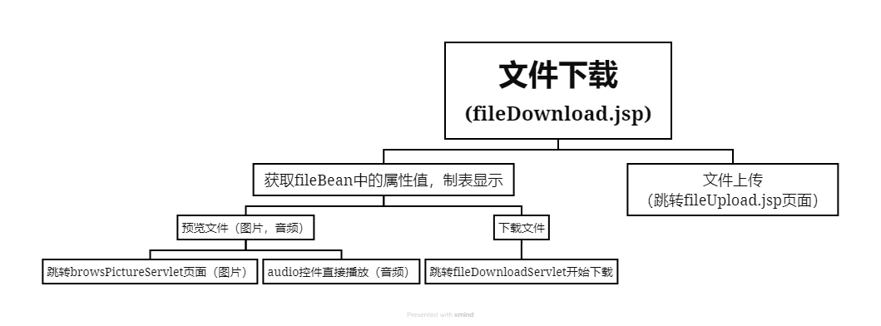

3、具体的实现

（1）文件上传

对应的界面为：

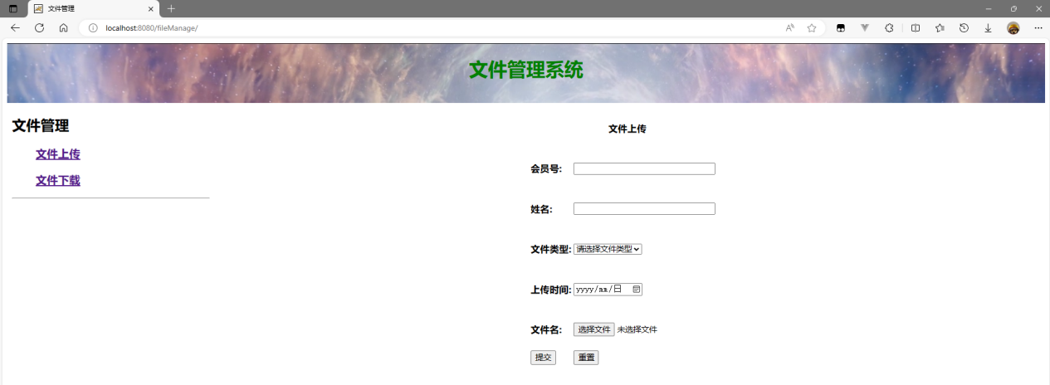

界面代码：index.jsp

具体的代码：

<body>

<div class="up">

<iframe src="top.html" name="top" scrolling="no" class="top"></iframe>

<div class="down">

<iframe src="left.html" name="left" scrolling="no" class="left"></iframe>

<iframe src="fileDownload.jsp" name="right" class="right"></iframe>

</div>

</div>

</body>

界面代码：fileUpload.jsp

具体的代码：

<body>

<form action="fileUpload.do" enctype="multipart/form-data"

method="post">

<table align="center">

<tr>

<td colspan="2" align="center"><h4>文件上传</h4></td>

</tr>

<tr>

<td><h4>会员号:</h4></td>

<td><input type="text" name="userId" size="30" /></td>

</tr>

<tr>

<td><h4>姓名:</h4></td>

<td><input type="text" name="username" size="30" /></td>

</tr>

<tr>

<td><h4>文件类型:</h4></td>

<td><select name="filetype">

<option value="" selected="selected">请选择文件类型</option>

<option value="file">普通文件</option>

<option value="img">图片文件</option>

<option value="mp3">音频文件</option>

</select></td>

</tr>

<tr>

<td><h4>上传时间:</h4></td>

<td><input name="userDate" type="date" /></td>

</tr>

<tr>

<td><h4>文件名:</h4></td>

<td><input type="file" name="filename" size="30" /></td>

</tr>

<tr>

<td><input type="submit" value="提交" /></td>

<td><input type="reset" value="重置" /></td>

</tr>

</table>

</form>

</body>

后台代码为fileUploadServlet.java

具体的代码：

package com.zyh;

import java.io.\*;

import javax.servlet.RequestDispatcher;

import javax.servlet.ServletException;

import javax.servlet.annotation.MultipartConfig;

import javax.servlet.annotation.WebServlet;

import javax.servlet.http.HttpServlet;

import javax.servlet.http.HttpServletRequest;

import javax.servlet.http.HttpServletResponse;

import javax.servlet.http.Part;

@WebServlet(name = "/fileUploadServlet", urlPatterns = { "/fileUpload.do" })

@MultipartConfig(location = "D:\\", fileSizeThreshold = 1024)

public class fileUploadServlet extends HttpServlet {

private static final long serialVersionUID = 1L;

private String getFilename(Part part) {

String fname = null;

String header = part.getHeader("content-disposition");

System.out.println(header);

fname = header.substring(header.lastIndexOf("=") + 2, header.length() - 1);

return fname;

}

protected void doGet(HttpServletRequest request, HttpServletResponse response)

throws ServletException, IOException {

request.setCharacterEncoding("UTF-8");

String path = this.getServletContext().getRealPath("/");

String userName = request.getParameter("username");

String userId = request.getParameter("userId");

String fType = request.getParameter("filetype");

String date = request.getParameter("userDate");

Part p = request.getPart("filename");

String message = "";

if (p.getSize() > 10 \* 1024 \* 1024) {//限制大小10MB

p.delete();

message = "文件太大，不能上传！";

} else {

path = path + "\\source\\" + userId +"\\"+ fType;

File f = new File(path);

if (!f.exists()) {

f.mkdirs();

}

String fname = getFilename(p);

System.out.println(fname);

p.write(path + "\\" + fname);

fileBean fb = new fileBean(fname,fType,userName,date,userId);//将参数存入fileBean

request.setAttribute("fb", fb);

request.getRequestDispatcher("/fileDownload.jsp");

message = "文件上传成功！";

}

request.setAttribute("message", message);

RequestDispatcher rd = request.getRequestDispatcher("/fileDownload.jsp");

rd.forward(request, response);

}

protected void doPost(HttpServletRequest request, HttpServletResponse response)

throws ServletException, IOException {

doGet(request, response);

}

}

（2）文件下载

对应的界面为：fileDownload.jsp

界面代码为：

<body>

<table align="center" border="1" cellspacing="0" width="90%"

height="90%">

<caption>

<h1>请选择下载的文件</h1>

<h2 style="color: red;">${message}</h2>

</caption>

<tr align="center">

<td><h3>序号</h3></td>

<td><h3>文件名</h3></td>

<td><h3>文件类型</h3></td>

<td><h3>上传人</h3></td>

<td><h3>上传时间</h3></td>

<td colspan="2"><h3>操作</h3></td>

</tr>

<tr align="center">

<td><h4>01</h4></td>

<td><h4>背景图片</h4></td>

<td><h4>img</h4></td>

<td><h4>zyh</h4></td>

<td><h4>2024-05-04</h4></td>

<td><a href="/fileManage/fileDownloadServlet?filename=bg.jpg&filetype=img&userId=22023237">下载图片</a></td>

<td><a href="/fileManage/browsPictureServlet?filename=bg.jpg&userId=22023237">查看图片</a></td>

</tr>

<tr align="center">

<td><h4>02</h4></td>

<td><h4>Bon Jovi - It's My Life</h4></td>

<td><h4>mp3</h4></td>

<td><h4>zyh</h4></td>

<td><h4>2024-05-04</h4></td>

<td><a href="/fileManage/fileDownloadServlet?filename=Bon Jovi - It's My Life.mp3&filetype=mp3&userId=22023237" >下载音频</a></td>

<td><audio src="source/22023237/mp3/Bon Jovi - It's My Life.mp3" controls="controls"></audio></td>

</tr>

<tr align="center">

<td><h4>03</h4></td>

<td><h4>test</h4></td>

<td><h4>file</h4></td>

<td><h4>zyh</h4></td>

<td><h4>2024-05-04</h4></td>

<td colspan="2"><a href="/fileManage/fileDownloadServlet?filename=test.docx&filetype=file&userId=22023237">下载文件</a></td>

</tr>

<%

response.setContentType("text/html;charset=UTF-8");

fileBean fb = (fileBean)request.getAttribute("fb");

if (fb != null){

out.print("<tr align='center'>");

out.print("<td><h4>04</h4></td>");

out.print("<td><h4>" + fb.getFileName() + "</h4></td>");

out.print("<td><h4>" + fb.getFileType() + "</h4></td>");

out.print("<td><h4>" + fb.getUserName() + "</h4></td>");

out.print("<td><h4>" + fb.getUserDate() + "</h4></td>");

if ("img".equals(fb.getFileType())){

out.print("<td><a href=\"/fileManage/fileDownloadServlet?filename="+fb.getFileName()+"&userId="+fb.getUserId()+"&filetype=img\">下载图片</a></td>");

out.print("<td><a href=\"/fileManage/browsPictureServlet?filename="+fb.getFileName()+"&userId="+fb.getUserId()+"\">查看图片</a></td>");

}

if ("mp3".equals(fb.getFileType())){

out.print("<td><a href=\"/fileManage/fileDownloadServlet?filename="+fb.getFileName()+"&userId="+fb.getUserId()+"&filetype=mp3\">下载音频</a></td>");

out.print("<td><audio src=\"source/" +fb.getUserId() + "/mp3/" +fb.getFileName()+ "\" controls=\"controls\"></audio></td>");

}

if ("file".equals(fb.getFileType())){

out.print("<td colspan=\"2\"><a href=\"/fileManage/fileDownloadServlet?filename="+fb.getFileName()+"&userId="+fb.getUserId()+"&filetype=file\">下载文件</a></td>");

}

out.print("</tr>");

}

%>

<tr align="center">

<td colspan="7"><a href="fileUpload.jsp" target="right"><h3>文件上传</h3></a></td>

</tr>

</table>

</body>

后台代码为fileDownloadServlet.java

具体的代码：

package com.zyh;

import java.io.\*;

import java.net.URLEncoder;

import javax.servlet.ServletContext;

import javax.servlet.ServletException;

import javax.servlet.annotation.WebServlet;

import javax.servlet.http.HttpServlet;

import javax.servlet.http.HttpServletRequest;

import javax.servlet.http.HttpServletResponse;

@WebServlet("/fileDownloadServlet")

public class fileDownloadServlet extends HttpServlet {

private static final long serialVersionUID = 1L;

protected void doGet(HttpServletRequest request, HttpServletResponse response)

throws ServletException, IOException {

String filename = request.getParameter("filename");

String filetype = request.getParameter("filetype");

String userId = request.getParameter("userId");

ServletContext servletcontext = this.getServletContext();

String realpath = servletcontext.getRealPath("/source/"+ userId +"/" + filetype + "/" + filename);

File file = new File(realpath);

if (file.exists()) {

FileInputStream fis = new FileInputStream(realpath);

String minetype = servletcontext.getMimeType(filename);

response.setHeader("content-type", minetype);

response.setHeader("Content-Disposition", "attachment;filename=" + URLEncoder.encode(filename,"UTF-8"));

BufferedInputStream bis = null;

byte[] buffer = new byte[1024];

bis = new BufferedInputStream(fis);

OutputStream os = response.getOutputStream();

int i = bis.read(buffer);

while (i != -1) {

os.write(buffer, 0, i);

i = bis.read(buffer);

}

if (bis != null) {

bis.close();

}

if (fis != null) {

fis.close();

}

} else {

response.setContentType("text/html;charset=UTF-8");

PrintWriter out = response.getWriter();

out.println("文件不存在！");

}

}

protected void doPost(HttpServletRequest request, HttpServletResponse response)

throws ServletException, IOException {

doGet(request, response);

}

}

后台代码为browsPictureServlet.java

具体的代码：

package com.zyh;

import java.io.IOException;

import java.io.PrintWriter;

import javax.servlet.ServletException;

import javax.servlet.annotation.WebServlet;

import javax.servlet.http.HttpServlet;

import javax.servlet.http.HttpServletRequest;

import javax.servlet.http.HttpServletResponse;

@WebServlet("/browsPictureServlet")

public class browsPictureServlet extends HttpServlet {

private static final long serialVersionUID = 1L;

protected void doGet(HttpServletRequest request, HttpServletResponse response)

throws ServletException, IOException {

String filename = request.getParameter("filename");

String userId = request.getParameter("userId");

response.setContentType("text/html;charset=utf-8");

PrintWriter out = response.getWriter();

out.println("<html>");

out.println("<head><title>图片预览</title></head>");

out.println("<body>");

out.println("<img src=\"source/" + userId + "/img/" +filename + "\" />");

out.println("<a href=\"fileDownload.jsp\"><input type=\"button\" value=\"返回\" /></a>");

out.println("</body>");

out.println("</html>");

}

protected void doPost(HttpServletRequest request, HttpServletResponse response)

throws ServletException, IOException {

doGet(request, response);

}

}