用户管理

一、项目要求：

1、使用HTML+CSS+JavaScript创建静态网页；

2、使用MySQL为后台数据库；

3、使用servlet进行服务器端的事务处理；

4、使用servlet转发进行页面跳转；

5、使用Tomcat作为后台服务器。

二、项目实现

1、整体的功能介绍

本程序主要完成学生管理系统的增删改查功能。

增加界面对应的代码为add.jsp文件，后台控制代码为addServlet文件。

删除界面对应的代码为delete.jsp文件，后台控制代码为deleteServlet文件和browsPictureServlet文件。

修改界面对应的代码为update.jsp文件，后台控制代码为updateServlet文件和echoUpdate文件。

查询界面对应的代码为query.jsp文件，后台控制代码为queryServlet文件。

1. 流程图
2. 增加
3. 删除
4. 修改
5. 查询

3、具体的实现

（1）增加界面

对应的界面为

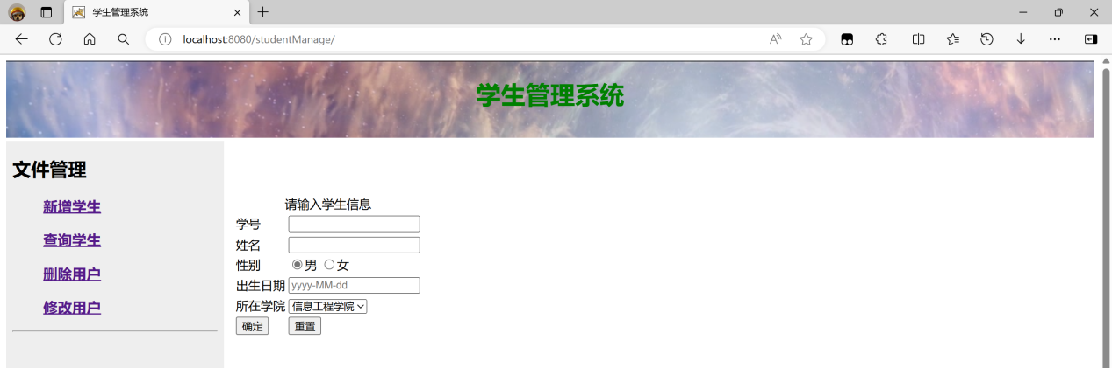

界面代码add.jsp

具体的代码

<%@ page language="java" contentType="text/html; charset=UTF-8"

pageEncoding="UTF-8"%>

<!DOCTYPE html>

<html>

<head>

<meta charset="UTF-8">

<title>新增用户</title>

</head>

<body>

<%

String message = (String) request.getAttribute("msg");

if (message != null) {

%>

<script type="text/javascript">

alert("<%=message%>");

</script>

<%

}

%>

<form action="addServlet" method="post">

${msg}<br /> <br /> <br />

<table style="align: center">

<caption>请输入学生信息</caption>

<tr>

<td>学号</td>

<td><input type="text" name="sno" maxlength="8" /></td>

</tr>

<tr>

<td>姓名</td>

<td><input type="text" name="sname" /></td>

</tr>

<tr>

<td>性别</td>

<td><input type="radio" name="sex" value="男" checked="checked" />男

<input type="radio" name="sex" value="女" />女</td>

</tr>

<tr>

<td>出生日期</td>

<td><input type="text" name="birthday" placeholder="yyyy-MM-dd" /></td>

</tr>

<tr>

<td>所在学院</td>

<td><select name="institute">

<option value="信息工程学院">信息工程学院</option>

<option value="土木工程学院">土木工程学院</option>

<option value="食品工程学院">食品工程学院</option>

<option value="文法学院">文法&nbsp;&nbsp;&nbsp;&nbsp;学院</option>

<option value="地理旅游学院">地理旅游学院</option>

</select></td>

</tr>

<tr>

<td><input type="submit" value="确定" /></td>

<td><input type="reset" value="重置" /></td>

</tr>

</table>

</form>

</body>

</html>

后台代码为addServlet.java：

具体的代码

package com.demo;

import java.io.IOException;

import javax.servlet.RequestDispatcher;

import javax.servlet.ServletException;

import javax.servlet.annotation.WebServlet;

import javax.servlet.http.HttpServlet;

import javax.servlet.http.HttpServletRequest;

import javax.servlet.http.HttpServletResponse;

import com.demo.DaoException;

import com.demo.Student;

import com.demo.StudentDao;

import com.demo.StudentDaoImp;

@WebServlet("/addServlet")

public class addServlet extends HttpServlet {

private static final long serialVersionUID = 1L;

protected void doGet(HttpServletRequest request, HttpServletResponse response)

throws ServletException, IOException {

request.setCharacterEncoding("utf-8");

response.setContentType("text/html;charset=utf-8");

String sno = request.getParameter("sno");

String sname = request.getParameter("sname");

String sex = request.getParameter("sex");

String birthday = request.getParameter("birthday");

String institute = request.getParameter("institute");

Student s = new Student();

s.setSno(sno);

s.setSname(sname);

s.setSex(sex);

s.setBirthday(birthday);

s.setInstitute(institute);

StudentDao dao = new StudentDaoImp();

boolean success;

String message = null;

try {

success = dao.addStudent(s);

if (success) {

message = "插入学生："+sname+"成功";

} else {

message = "插入记录失败";

}

} catch (DaoException e) {

e.printStackTrace();

message = "连接数据库失败！";

} finally {

request.setAttribute("msg", message);

RequestDispatcher rd = request.getRequestDispatcher("add.jsp");

rd.forward(request, response);

}

}

protected void doPost(HttpServletRequest request, HttpServletResponse response)

throws ServletException, IOException {

doGet(request, response);

}

}

（2）删除界面

对应的界面为

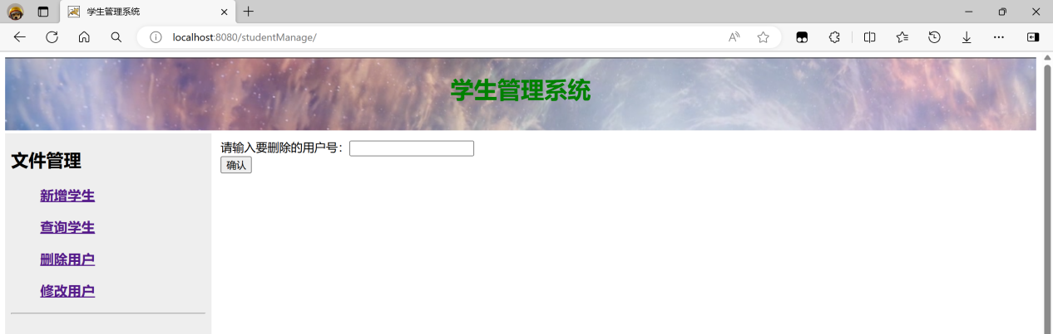

界面代码为delete.jsp:

<%@ page language="java" contentType="text/html; charset=UTF-8"

pageEncoding="UTF-8"%>

<!DOCTYPE html>

<html>

<head>

<meta charset="UTF-8">

<title>删除用户</title>

</head>

<body>

<%

String message = (String) request.getAttribute("msg");

if (message != null) {

%>

<script type="text/javascript">

alert("<%=message%>");

</script>

<%

}

%>

<form action="deleteServlet" method="post">

请输入要删除的用户号：<input type="text" name="sno"><br /> <input

type="submit" value="确认">

</form>

</body>

</html>

后台代码为deleteServlet.java:

package com.demo;

import java.io.IOException;

import javax.servlet.RequestDispatcher;

import javax.servlet.ServletException;

import javax.servlet.annotation.WebServlet;

import javax.servlet.http.HttpServlet;

import javax.servlet.http.HttpServletRequest;

import javax.servlet.http.HttpServletResponse;

@WebServlet("/deleteServlet")

public class deleteServlet extends HttpServlet {

private static final long serialVersionUID = 1L;

protected void doGet(HttpServletRequest request, HttpServletResponse response) throws ServletException, IOException {

request.setCharacterEncoding("utf-8");

response.setContentType("text/html;charset=utf-8");

String sno= request.getParameter("sno");

StudentDao dao = new StudentDaoImp();

String message = null;

try {

int success=dao.removeStudent(sno);

if(success>0){

message = "删除记录成功！";

}else {

message="删除记录失败,找不到该学生！";

}

} catch (DaoException e1) {

e1.printStackTrace();

message = "连接数据库失败！";

}finally {

request.setAttribute("msg", message);

RequestDispatcher rd = request.getRequestDispatcher("delete.jsp");

rd.forward(request, response);

}

}

protected void doPost(HttpServletRequest request, HttpServletResponse response) throws ServletException, IOException {

doGet(request, response);

}

}

（3）修改界面

对应的界面为

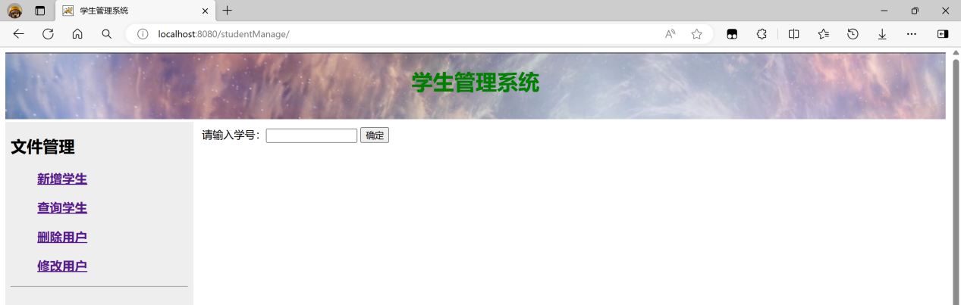

界面代码为update.jsp:

<%@ page language="java" contentType="text/html; charset=UTF-8"

pageEncoding="UTF-8"%>

<%@ page import="java.util.\*,com.demo.\*"%>

<!DOCTYPE html>

<html>

<head>

<meta charset="UTF-8">

<title>修改信息</title>

</head>

<body>

<%

String message = (String) request.getAttribute("msg");

if (message != null) {

%>

<script type="text/javascript">

alert("<%=message%>");

</script>

<%

}

%>

<form action="updateServlet" method="get">

请输入学号：<input type="text" name="sno" size="15" />

<input type="submit" value="确定" />

</form>

</body>

</html>

后台代码为updateServlet.java:

package com.demo;

import java.io.IOException;

import javax.servlet.RequestDispatcher;

import javax.servlet.ServletException;

import javax.servlet.annotation.WebServlet;

import javax.servlet.http.HttpServlet;

import javax.servlet.http.HttpServletRequest;

import javax.servlet.http.HttpServletResponse;

@WebServlet("/updateServlet")

public class updateServlet extends HttpServlet {

private static final long serialVersionUID = 1L;

protected void doGet(HttpServletRequest request, HttpServletResponse response)

throws ServletException, IOException {

StudentDao dao = new StudentDaoImp();

String sno = request.getParameter("sno");

try {

Student list = dao.listStudentOne(sno);

request.getSession().setAttribute("student", list);

RequestDispatcher rd = request.getRequestDispatcher("echoUpdate.jsp");

rd.forward(request, response);

} catch (DaoException e) {

e.printStackTrace();

String message = "连接数据库失败！";

request.setAttribute("msg", message);

RequestDispatcher rd = request.getRequestDispatcher("update.jsp");

rd.forward(request, response);

}

}

protected void doPost(HttpServletRequest request, HttpServletResponse response)

throws ServletException, IOException {

doGet(request, response);

}

}

（4）查询界面

对应的界面为

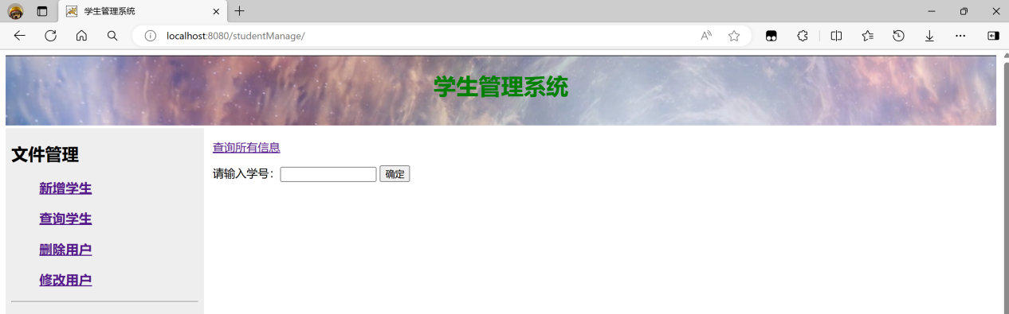

界面代码为query.jsp:

<%@ page language="java" contentType="text/html; charset=UTF-8"

pageEncoding="UTF-8"%>

<!DOCTYPE html>

<html>

<head>

<meta charset="UTF-8">

<title>查询信息</title>

</head>

<body>

<%

String message = (String) request.getAttribute("msg");

if (message != null) {

%>

<script type="text/javascript">

alert("<%=message%>");

</script>

<%

}

%>

<p>

<a href="queryServlet">查询所有信息</a>

</p>

<form action="queryServlet" method="post">

请输入学号：<input type="text" name="sno" size="15" />

<input type="submit" value="确定" />

</form>

</body>

</html>

后台代码为queryServlet.java:

package com.demo;

import java.io.IOException;

import java.util.List;

import javax.servlet.RequestDispatcher;

import javax.servlet.ServletException;

import javax.servlet.annotation.WebServlet;

import javax.servlet.http.HttpServlet;

import javax.servlet.http.HttpServletRequest;

import javax.servlet.http.HttpServletResponse;

import com.demo.StudentDao;

import com.demo.StudentDaoImp;

import com.demo.Student;

@WebServlet("/queryServlet")

public class queryServlet extends HttpServlet {

private static final long serialVersionUID = 1L;

protected void doGet(HttpServletRequest request, HttpServletResponse response)

throws ServletException, IOException {

StudentDao dao = new StudentDaoImp();

try {

List<Student> list = dao.listStudent();

request.getSession().setAttribute("studentList", list);

RequestDispatcher rd = request.getRequestDispatcher("queryAll.jsp");

rd.forward(request, response);

} catch (Exception e) {

e.printStackTrace();

String message = "查询失败";

request.setAttribute("msg", message);

RequestDispatcher rd = request.getRequestDispatcher("query.jsp");

rd.forward(request, response);

}

}

protected void doPost(HttpServletRequest request, HttpServletResponse response)

throws ServletException, IOException {

StudentDao dao = new StudentDaoImp();

String sno = request.getParameter("sno");

try {

Student list = dao.listStudentOne(sno);

request.getSession().setAttribute("student", list);

RequestDispatcher rd = request.getRequestDispatcher("queryOne.jsp");

rd.forward(request, response);

} catch (Exception e) {

e.printStackTrace();

String message = "查询失败";

request.setAttribute("msg", message);

RequestDispatcher rd = request.getRequestDispatcher("query.jsp");

rd.forward(request, response);

}

}

}