|  |  |
| --- | --- |
| A picture of a winding road and trees  CA Report - PHP N00131853 - James Hatt  [Document subtitle] | N00131853  PHP  James Hatt  [Course title] |

**Introduction**

The case study I have been working on is the Tour Bus Company. The entity in this case is the bus itself. My application allows the user to view, create, update (edit) and delete buses. My case study has seven main entities, registration number, make, model, no. of seats, engine size, date bus bought and its next service.

**Login**

The objective for this assignment is to login as a user by entering your “username” and “password”.

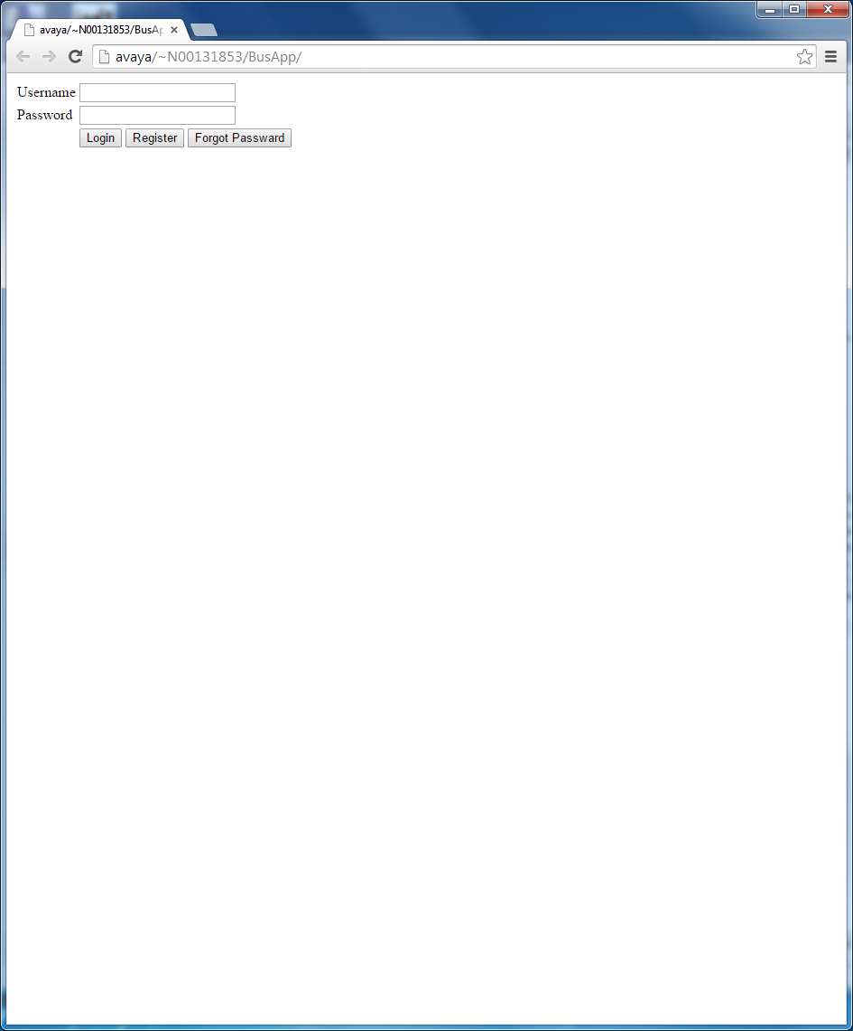

I learnt here that your username and password must match the Username and password in database (MyAdmin). I created a new table called ‘users’. Within users I made two entities called username and password, these simply must match your login in order to get to the next page.

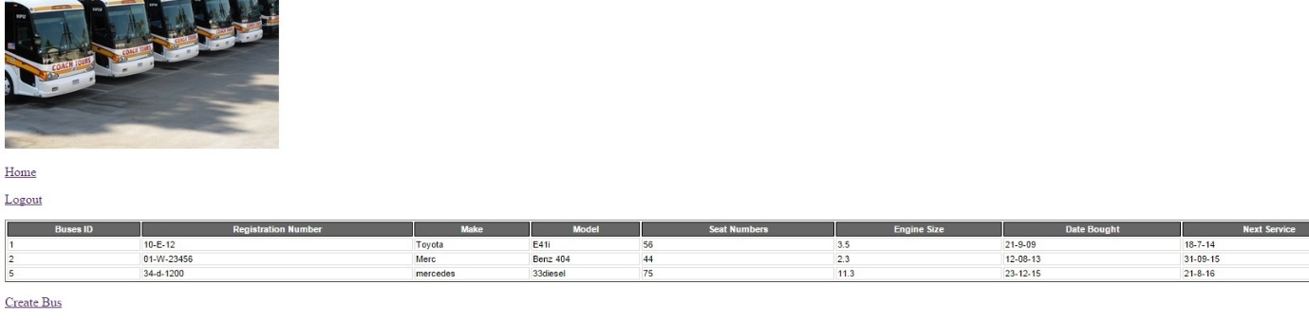

**Home**

This is where login leaves you. What you are seeing here is the home.php page. It displays all of my entities and the buses that follow. *view, edit, delete buttons are to the right they are just out of view.

From here you have many options. If you click create bus, it sends you to the createBusForm page. This is simply a fill in form in order to create a new bus. Once the bus is created it is added to your database. I learnt that not only it is added to your table on the home page but it is also added to your database on myAdmin.

**View**

The next step from here is to view specific buses. This simply just hones in on a particular bus. In my code I used the ‘echo’ command. I learnt that this is simply a ‘print out’ command which suited my viewBus page.

Example: echo '<tr>';

echo '<td>Registration Number:</td>'

. '<td>' . $row['regNo'] . '</td>';

echo '</tr>';

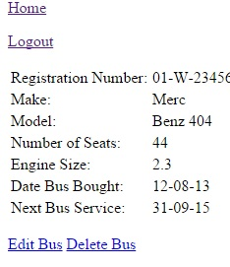

**Edit/Update**

So from here you now have the option to Edit or to Delete. Once Edit is clicked it immediately brings you to the editBusForm page. This is where all of your detailed entities are printed out nicely in a table however, it is editable. You can edit any or all of your entities. This is quite handy as mistakes happen. The updated information is rapidly updated in MyAdmin too.

**Delete**

Lastly is the Delete page. This isn’t really a page when being displayed online. Example, when I’m on the home page I can hit delete. Once I have clicked delete an alert box appears asking me to confirm the deletion. Once confirmed, a row in my table is deleted.

I found the alert box very helpful because it prevents you from accidently deleting a row, which could potentially be very important.

This now brings me onto java script, I learned how to validate a form using the errors messages, I also learnt that you must link the java script to each page where you wish it to show up. I did not initially know this!

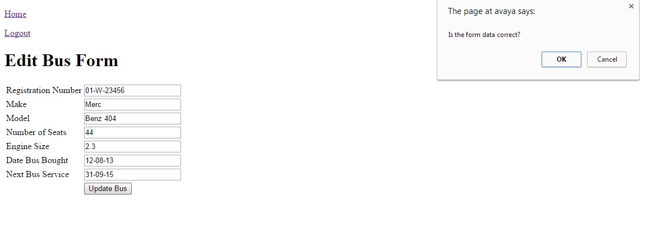

Here is my edit Form which a java script alert box asking me to confirm the update.

**Problems**

I ran into many problems throughout the project. However I fixed them as I went on. I learnt from mistakes, especially to pay close attention to detail. . .I found in my edit/update, that I had many undefined indexes…

I could not figure out how to fix these for quite some time. I came to realization that it was vital to match my entity names to my database names. If they are not named identically they are not linking. . .

**Testing**

I found that testing was also a vital task that must be done after finishing each piece of code and each page. You must check to see if you code works before moving onto anything else. If you are not testing you will end up bringing errors from pages into other pages. Hence your project will contain plenty of bugs and most likely crash.

<END>

**Link to home page **

http://avaya/~N00131853/tourBusApp1/index.php