


Part I
Workspace

Before you start writing any ROS code, you need to set up a workspace for this code to live in. A workspace is simply a set of directories in which a related set of ROS code lives. All of the code for a single project should exist in the same workspace
You can have multiple ROS workspaces, but you can only work in one of them at any one time

Getting set up

We are going to create a workspace called teleop. Within mobile robot navigation, tele-operated refers to a robot under the control of a joystick or other controlled device. To create a workspace Open a Terminal and type in the following:

$ source /opt/ros/indigo/setup.bash

$ mkdir -p ~/teleop_ws/src

$ cd ~/teleop_ws/src

$ catkin_init_workspace

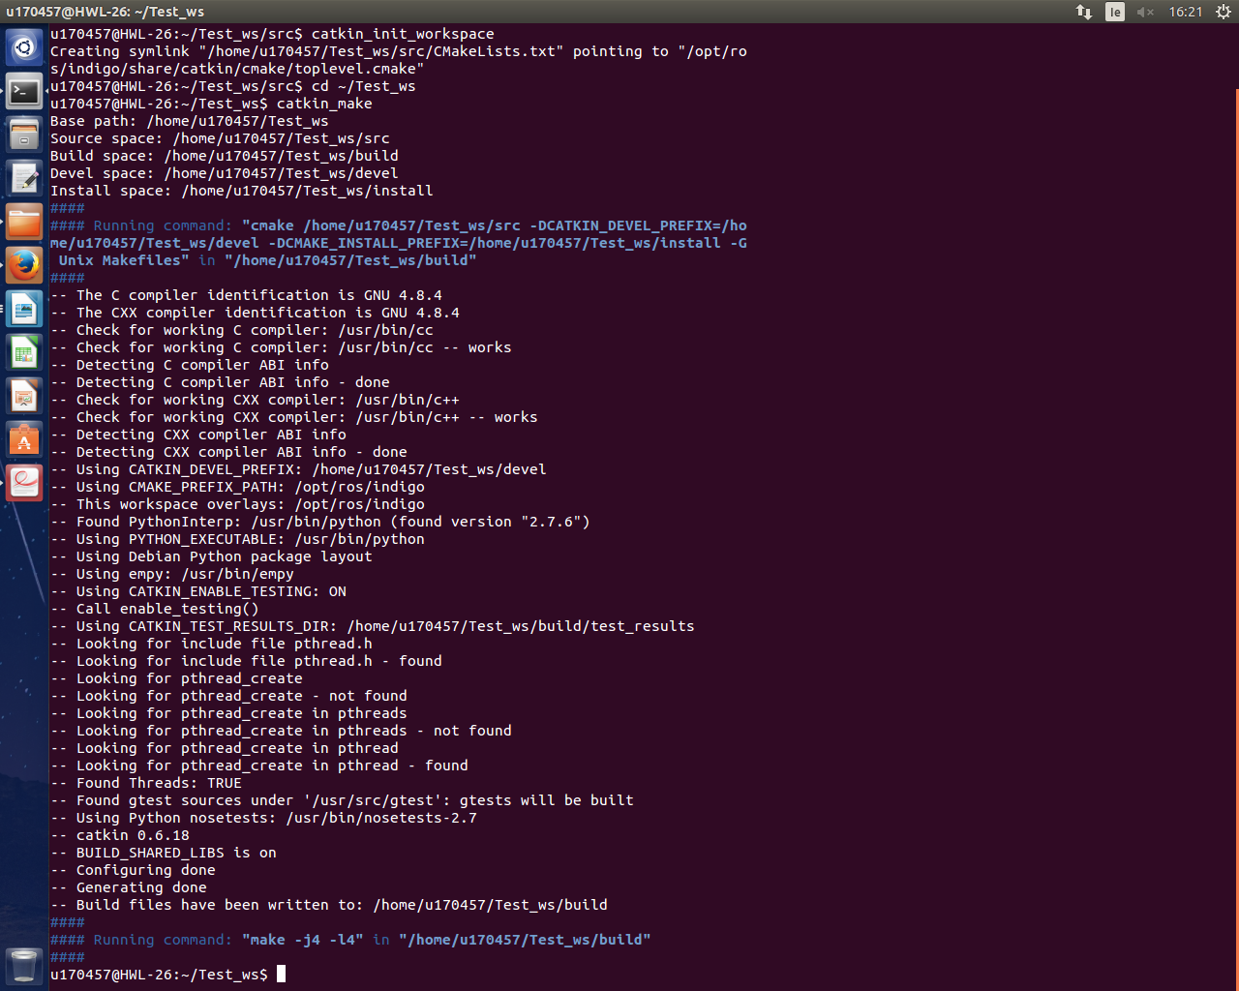
$ cd ~/teleop_ws

$ catkin_make

Running catkin_make will generate a lot of output as it does its work. When it’s done, you’ll end up with two new directories: build and devel.

Package

ROS software is organized into packages, each of which contains some combination of code, data, and documentation. Packages sit inside workspaces, in the src directory.
Each package directory must include a CmakeLists.txt file and a package.xml file that describes the contents of the package and how catkin should interact with it.

Getting set up
To create a package is easy once we are in the src directory of our workspace.
The first argument, Teleop, is the name of the new package we want to create. The following arguments are the names of packages that the new package depends on.

$ source devel/setup.bash

$ cd ~/teleop_ws/src

$ catkin_create_pkg teleop rospy geometry_msgs sensor_msgs

Part II

Lets Get Started

We are now going show how we can implement a number of Tools in ROS. All of these Tools will culminate with a sophisticated two dimensional navigation system, that can display video of its surroundings as well as map out its environment. You are not expected to fully understand whats happening this serves as more of an introduction into what ROS can do.
We are going to be using a lot of different Terminals in this demo, so remember Ctrl-Alt-t is a shortcut to open a new Terminal.

Roscore and Simulation

First thing we are going to do is launch Roscore. You'll remember that Roscore is the network that all the nodes communicate on and it is how we will send and receive data from out robot.
Since we don't all have a mobile robot such as Turtlebot to ourselves we are going to simulate one in Gazebo.
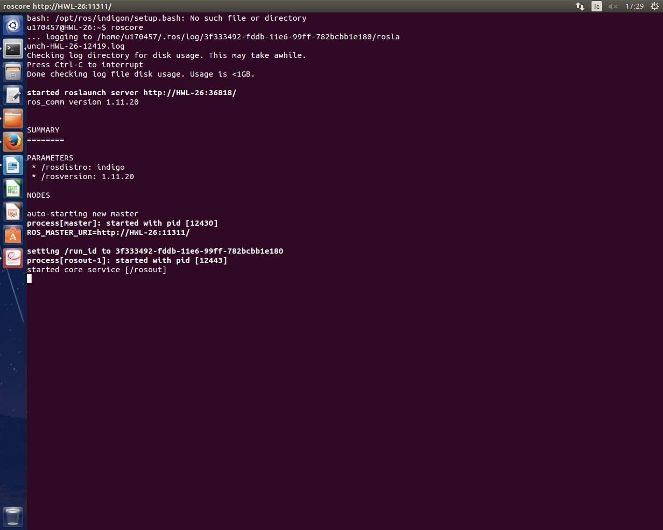
Open New Terminal T1

$ roscore

Open New Terminal T2

$ roslaunch turtlebot_gazebo turtlebot_world.launch

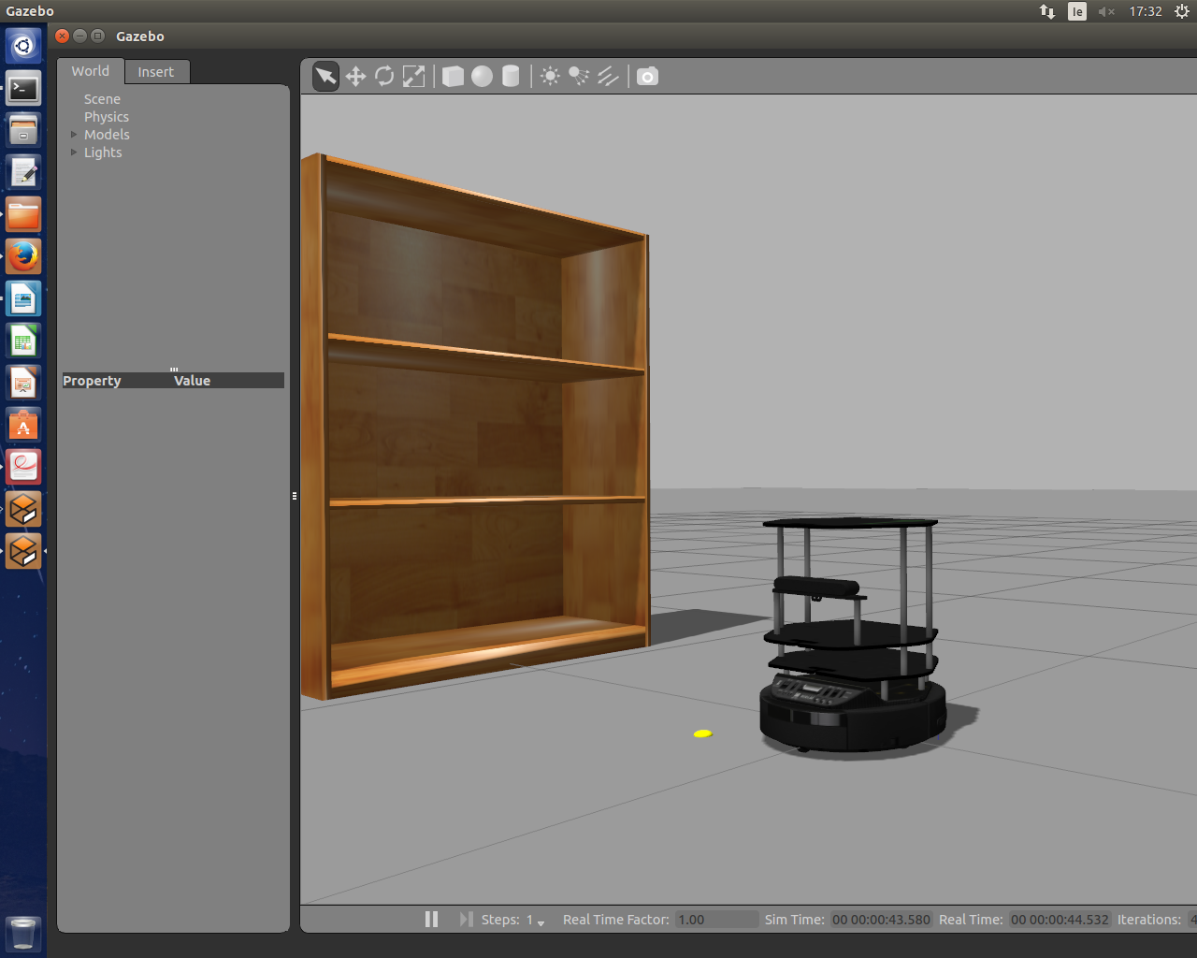

This will open up a pre-set simulation of a turtlebot environment that we can pass all of our messages to over Roscore
Take some time to familiarize your self with the camera controls

Program and Nodes

To get the robot to move we need to create and program two nodes.

- A program that will publish our keyboard key strokes and broadcast them over Roscore
- A program that will subscribe to the first programs message and apply the correct motion to it

In simple terms one Program to say “I pressed the W key ” and one program to say “The up W key means go forward”

Save the following program as key_publisher.py in the file we created teleop_ws/

#!/usr/bin/env python
import sys, select, tty, termios
import rospy
from std_msgs.msg import String

if __name__ == '__main__':
key_pub = rospy.Publisher('keys', String, queue_size=1)
rospy.init_node("keyboard_driver")
rate = rospy.Rate(100)

old_attr = termios.tcgetattr(sys.stdin)
tty.setcbreak(sys.stdin.fileno())

print "Publishing keystrokes. Press Ctrl-C to exit..."

while not rospy.is_shutdown():
if select.select([sys.stdin], [], [], 0)[0] == [sys.stdin]:
key_pub.publish(sys.stdin.read(1))
rate.sleep()
termios.tcsetattr(sys.stdin, termios.TCSADRAIN, old_attr)

This program uses the termios library to capture raw keystrokes, as soon as they are pressed. However it dose not support exteneded keys such as arrows keys ,these will result in std_msgs/String messages that are either weird symbols or multiple messages.

Save the following as keys_to_twist_with_ramps.py in the file we created teleop_ws/

#!/usr/bin/env python
import rospy
import math
from std_msgs.msg import String
from geometry_msgs.msg import Twist

key_mapping = { 'w':[ 0,1], 'x':[ 0, -1],'a':[ 1, 0], 'd': [-1, 0], 's': [ 0, 0] }
g_twist_pub = None
g_target_twist = None
g_last_twist = None
g_last_send_time = None
g_vel_scales = [0.1, 0.1] # default to very slow
g_vel_ramps = [1, 1] # units: meters per second^2

def ramped_vel(v_prev, v_target, t_prev, t_now, ramp_rate):
# compute maximum velocity step
step = ramp_rate*(t_now - t_prev).to_sec()
sign = 1.0 if (v_target > v_prev) else -1.0
error = math.fabs(v_target - v_prev)
if error < step: # we can get there within this timestep-we're done.
return v_target
else:
return v_prev + sign*step # take a step toward the target

def ramped_twist(prev, target, t_prev, t_now, ramps):
tw = Twist()
tw.angular.z = ramped_vel(prev.angular.z, target.angular.z, t_prev, t_now, ramps[0])
tw.linear.x = ramped_vel(prev.linear.x, target.linear.x, t_prev,t_now, ramps[1])
return tw

def send_twist():
global g_last_twist_send_time, g_target_twist, g_last_twist, g_vel_scales, g_vel_ramps, g_twist_pub
t_now = rospy.Time.now()
g_last_twist = ramped_twist(g_last_twist,g_target_twist, g_last_twist_send_time, t_now, g_vel_ramps)
g_last_twist_send_time = t_now
g_twist_pub.publish(g_last_twist)

def keys_cb(msg):
global g_target_twist, g_last_twist, g_vel_scales
if len(msg.data) == 0 or not key_mapping.has_key(msg.data[0]):
return # unknown key
vels = key_mapping[msg.data[0]]
g_target_twist.angular.z = vels[0]*g_vel_scales[0]
g_target_twist.linear.x = vels[1]*g_vel_scales[1]

def fetch_param(name, default):
if rospy.has_param(name):
return rospy.get_param(name)
else:
print "parameter [%s] not defined. Defaulting to %.3f" % (name, default)
return default
if __name__ == '__main__':
rospy.init_node('keys_to_twist')
g_last_twist_send_time = rospy.Time.now()
g_twist_pub = rospy.Publisher('cmd_vel', Twist, queue_size=1)
rospy.Subscriber('keys', String, keys_cb)
g_target_twist = Twist() # initializes to zero
g_last_twist = Twist()
g_vel_scales[0] = fetch_param('~angular_scale', 0.5)
g_vel_scales[1] = fetch_param('~linear_scale', 0.5)
g_vel_ramps[0] = fetch_param('~angular_accel', 1.0)
g_vel_ramps[1] = fetch_param('~linear_accel', 1.0)
rate = rospy.Rate(20)
while not rospy.is_shutdown():
send_twist()
rate.sleep()

Lets get moving

Open New Terminal T3

$ cd teleopbot_ws

$ ./key_publisher.py

//"Right Click on the top of this terminal and click Always on top "
//"This terminal is important and we will be coming back to this "

Open New Terminal T4

$ cd teleopbot_ws

$ ./keys_to_twist_with_ramps.py cmd_vel:=cmd_vel_mux/input/teleop

Open Terminal 3 again

//" Using w,x the robot will move forward and back"
//" Using a,d the robot will rotate"
//" Using s the robot will stop"

Part III
Rviz

Now that we have a robot that moves around lets get in to send messages back about what it sees. For now ignore the Gazebo simulation and imagine we are controlling a robot in another room. We want to see what the robot sees. This is where Riz comes in. Rviz stands for ROS visualization and is a general purpose 3D visualization environment for robots, sensors, and algorithms.
Rviz can plot a variety of data types streaming through a typical ROS system, with heavy emphasis on the three-dimensional nature of the data.

To run Rviz :
Open New Terminal T5

$ rosrun rviz rviz

The default Rviz window will appear and it will look very bare bones at the moment with not much happening.

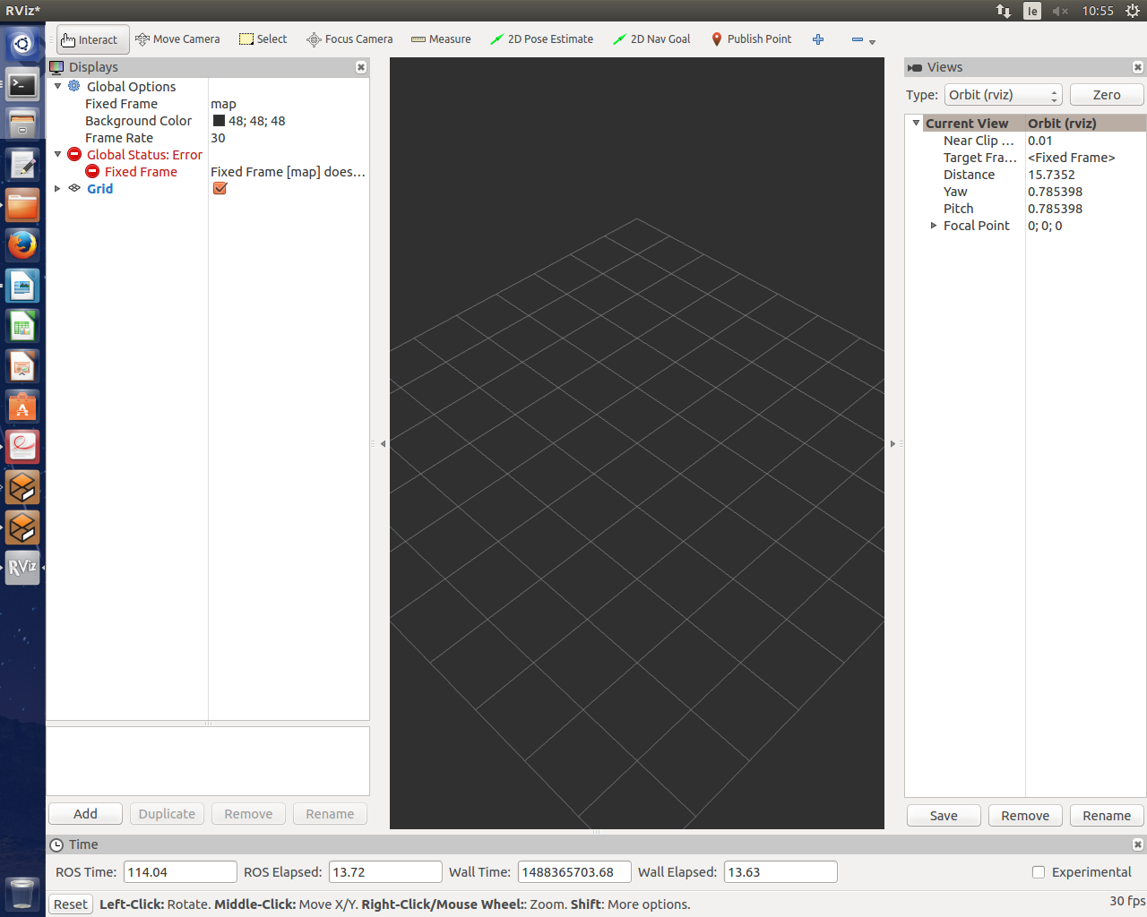

The first task is to choose the frame of reference for the visualization. In our case, we want a visualization perspective that is attached to the robot, so we can follow the robot as it drives around. On any given robot, there are many possible frames of reference, such as the center of the mobile base, various links of the robot’s structure, or even a wheel.

For us we will select a frame of reference attached to the optical center of the Kinect depth camera on the Turtlebot.

To do this :
- In Rviz, at Fixed Frame, right click map, select odom from the menu
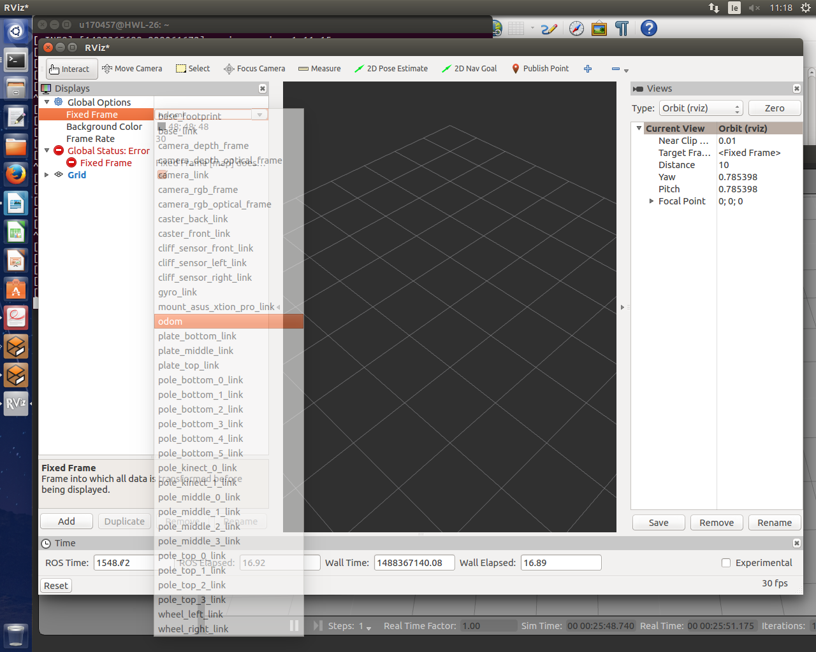

Now we need a point of reference so we are going to add a model robot.

To do this :
- Click add in bottom left corner, select RobotModel from the menu
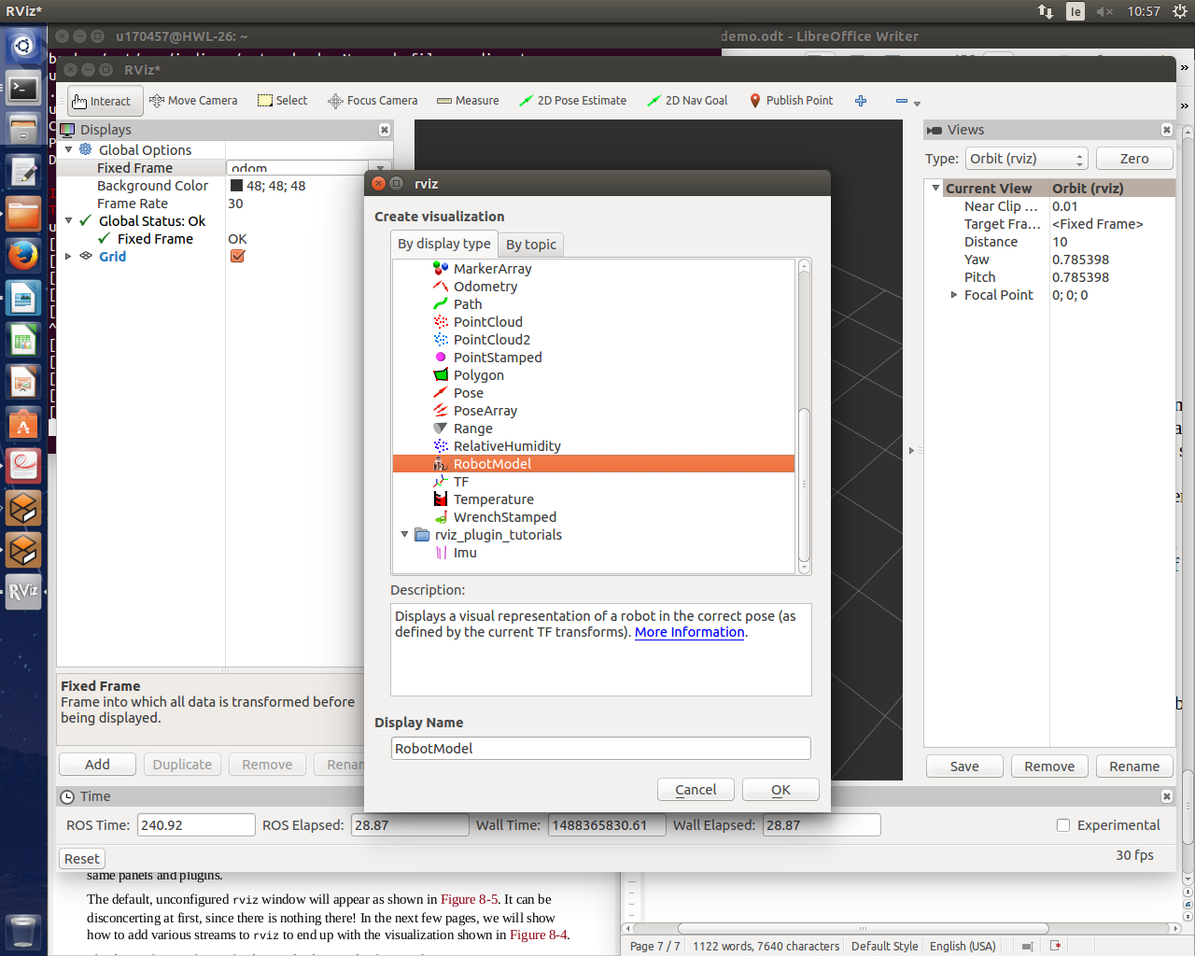

In the same way we added the robot Model, we are going to add two more Items from the same add button, Image and PointCloud2. Image will allow us to see, PointCloud2 will give us a visual of the robots depth sensor.

To calibrate Image :
- Click on Image drop-down menu on left hand side.
- Right click on right hand side of Topic select the second option from the drop-down menu

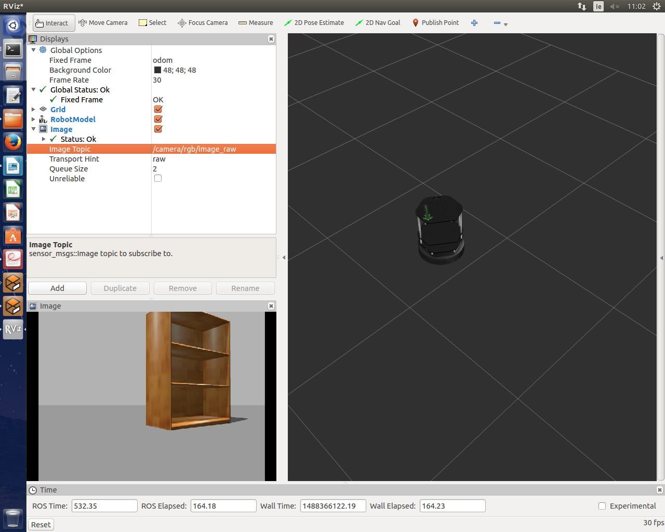

Now using Rviz Open up Terminal T3 and move the robot around to see what the robot sees.

Now to calibrate PointCloud2 :
- Click on PointCloud2 drop-down menu on left hand side.
- Right click on right hand side of Topic select first option from the drop-down menu

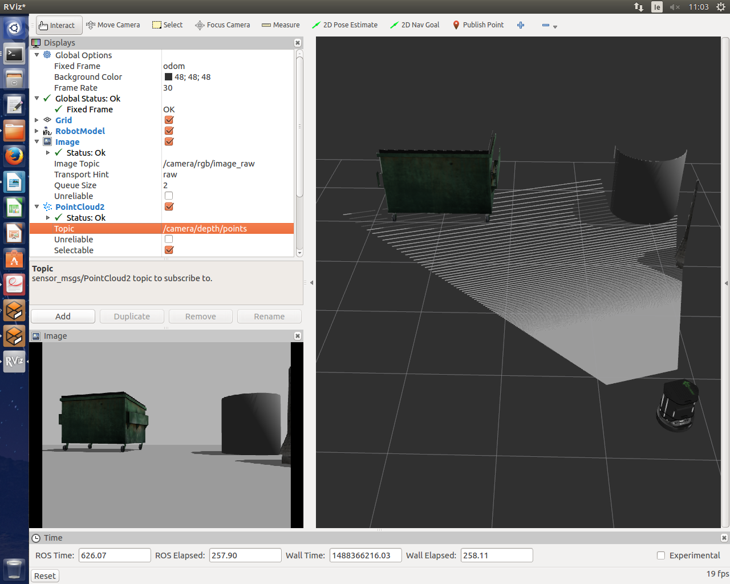
This is how we can visualize what the robot sees if we are using a real robot.

Part IV
Ros Maps

Now that we have a robot that can move around and see we can now put this new found sight to use. Navigation maps in ROS are represented by a 2D grid, where each grid cell contains a value that corresponds to how likely it is to be occupied. Map files are stored as images.

Gmapping

The gmapping tool provides laser-based SLAM (Simultaneous Localization and Mapping), as a ROS node. Using this node, it records what the robot sees it can then create a 2-D occupancy grid map from its recordings.
Although you can build a map using live sensor data, as the robot moves about the world, we’re going to take another approach. We’re going to drive the robot around and save the sensor data to a file.

To do this :
Open New Terminal T6

$ source ~/turtlebot/devel/setup.bash

$ roslaunch turtlebot_gazebo gmapping_demo.launch

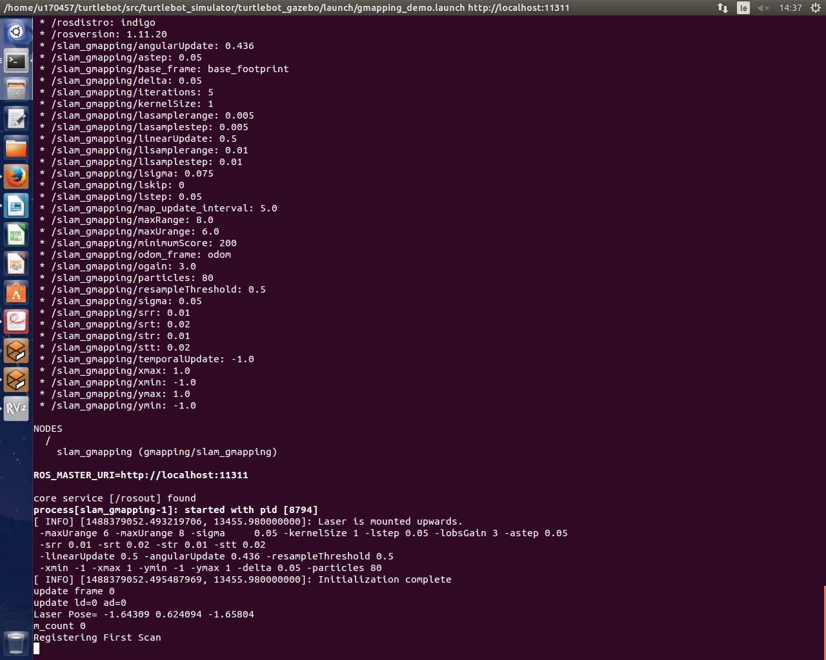

This will start Gmapping recording what the robot sees. Now in order for us too see what Gmapping is recording we need to initializes another instance of Rviz.

To do this :
Open New Terminal T7

$ roslaunch turtlebot_rviz_launchers view_navigation.launch

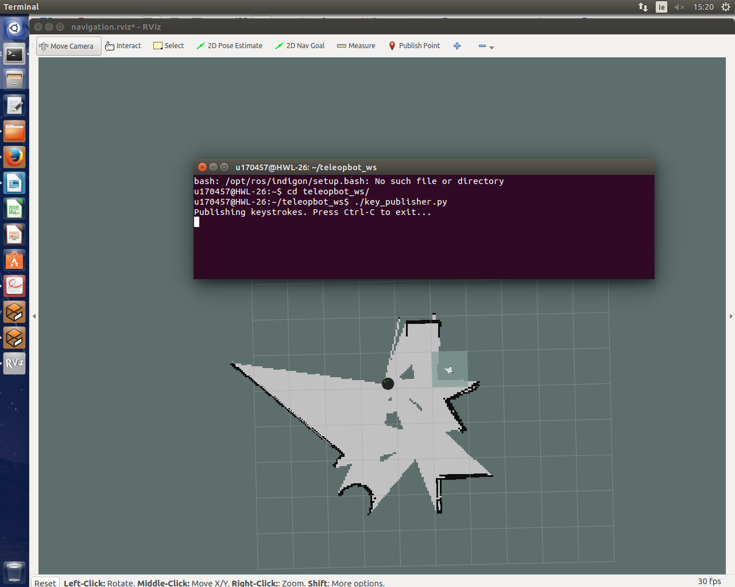
This second instance of Rviz, records what the robot sees and maps it against what it saw from a different position. Using Terminal 3 again drive around and record the area.
Try to cover as much of the map as possible, and make sure you visit the same locations a couple of times. Doing this will result in a better final map.

When your finished mapping
To save your recording as an image :

Open New Terminal T8

$ rosrun map_server map_saver -f My_map

To finish recording :

Open Terminal T7 and Ctrl-c do not Ctrl-z

Open Terminal T8

$ rosrun map_server map_saver -f My_Map

Just to be sure !
Open up your My_Map.pgm to view your saved map

