

Goal
On completion of this worksheet you will have a good understanding of how Topics communicate within a Ros system. Using Publishers and Subscribers you will create your own topics for communicating messages across Ros, aswell as creating your own message type.

Introduction to Topics

Topics as we know are the most common way to exchange data within a Ros system .Topics communicate through peer-to-peer publish /subscriber nodes.
Before nodes can transmit information over topics, Publishers must first announce or advertise the topic name and the message type that are going to be published. Once advertised a subscriber, subscribes to the publisher and receives the information at the rate, the publisher broadcasts it at. The publisher doesn't care who receives the information, nor dose it care how many subscribers are receiving its topic.
The following is a simple Publisher that broadcasts “Hello” over a topic called 'message_hello' with type String.
We are now going to look at the implementation of basic code that will advertise a topic and publish a messages on it but first we need to create a workspace and package.

Creating a workspace and Package

$ mkdir -p ~/HelloWorld_ws/src
$ cd HelloWorld_ws/src
$ catkin_init_workspace

$ cd ~/HelloWorld_ws/
$ catkin_make
$ source devel/setup.bash

$ cd src/
$ catkin_create_pkg lab_3 std_msgs rospy
$ cd ~/HelloWorld_ws/
$ catkin_make

Break down of Publisher code

#!/usr/bin/env python
import rospy
from std_msgs.msg import String

rospy.init_node('publish_hello')

pub = rospy.Publisher('message_hello',String,queue_size=10)
rate= rospy.Rate(2)

Message_to_send = 'Hello'

while not rospy.is_shutdown():
pub.publish(Message_to_send)
rate.sleep()

The first line : #!/usr/bin/env python
Lets the operating system know that this is a python file and passes it into the python interpreter

The second line : import rospy
Appears in all Python nodes and imports all standard function of the node

The third line : from std_msgs.msg import String
The message we are going to send is of type String so we need to import that type from our Package library std_msgs. We can import other types such as ints32, here if required.

The fourth line : rospy.init_node('publish_hello')
Basically means start the node, don't get confused the program and the node are not the same thing , we are using a program to create a node called (publish_hello)

The fifth line: pub = rospy.Publisher('message_hello',String,queue_size=10)
We are advertising. This gives the topic name (message_hello) and the topic a type (String). Behind the scenes the publisher sets up a connection to Roscore. At this point the topic is advertised and ready for other nodes to subscribe to it.

The rest of the code is sending the message over the topic.
rate= rospy.Rate(2)
Message_to_send = 'Hello'
while not rospy.is_shutdown(): +
pub.publish(Message_to_send)
rate.sleep()

First we set the rate at which we want to publish (2) measured in hertz, we define a string called Message_to_send with value 'Hello' .
A while loop is created to continually send the message at 2Hz for as long as the node in active (not rospy.is_shutdown). We then publish the message, then sleep.

Running the Publisher

To run the program, save the code as Publisher_Hello.py within a workspace called HelloWorld_ws.

to run the code :
Open new Terminal T1

$ roscore

Open new Terminal T2

$ chmod +x Publisher_Hello.py
$ ./Publisher_Hello.py

Ros gives us tool to check if our code is working correctly, rostopic list will display all active topics being broad casted across roscore. Since the name of our topic is message_hello we will check if our topic appears we can then check if it is broadcasting the correct type.

With the node running we can then use rostopic, to review all active nodes ,aswell as gathering information on them such as the nodes name, the name of the topic aswell as the message type.

Open new Terminal T3

$ rostopic list
$ rostopic info message_hello

The output to RosTopic List and Info should look something like the following

- u170457@HWL-26:~/Hello_World_ws$ rostopic list
/message_hello
/rosout
/rosout_agg

- u170457@HWL-26:~/Hello_World_ws$ rostopic info message_hello
Type: std_msgs/String

Publishers:
* /publish_hello (http://HWL-26:34154/)

Subscribers: None

Break down of Subscriber code

Now we are going to take a look at simple Subscriber that will receive what our publisher is sending and print the results.

#!/usr/bin/env python
import rospy
from std_msgs.msg import String

rospy.init_node('subscriber')

def callback(message_recived):
print 'I heard ' + message_recived.data

sub = rospy.Subscriber('message_hello',String,callback)

rospy.spin()

The first four lines : Are exactly the same as the publisher, we are letting the operating system know that this is a python file, importing all standard functions and message type and we are initializing the node and calling it ('subscriber')

Things get interesting in the fifth line : def callback(message_recived):
print 'I heard ' + message_recived.data

The callback is the method that dose something to the messages as they come in. Since Ros is event driven the callback must be declared before the actual subscription. Once a node is subscribed to a topic every time the message appears the associated callback is called, with the message as its parameter. In this case every time a message is received the subscriber will simply print it.

In the sixth Line : sub = rospy.Subscriber('message_hello',String,callback)
We subscribe to the topic. We give the name of the topic, the message type of the topic, and the name of the callback function. The subscriber passes this information on to roscore and tries to make a direct connection with the publishers of this topic.

Running the Subscriber
Save the code as Subscriber.py and make sure roscore and Publisher_Hello.py are already running and :

Open new Terminal T4

$ chmod +x Subscriber.py
$ ./Subscriper.py

With the two nodes running we get a the following results:

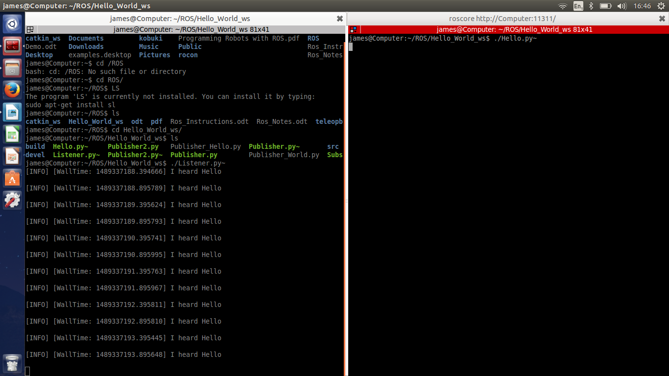
Using Rosrun, we can create a Ros graph of our system. This can help us visualize whats happening, instead of solely depending on what we see in the terminal window.

Open new Terminal T5

$ rosrun rqt_graph rqt_graph

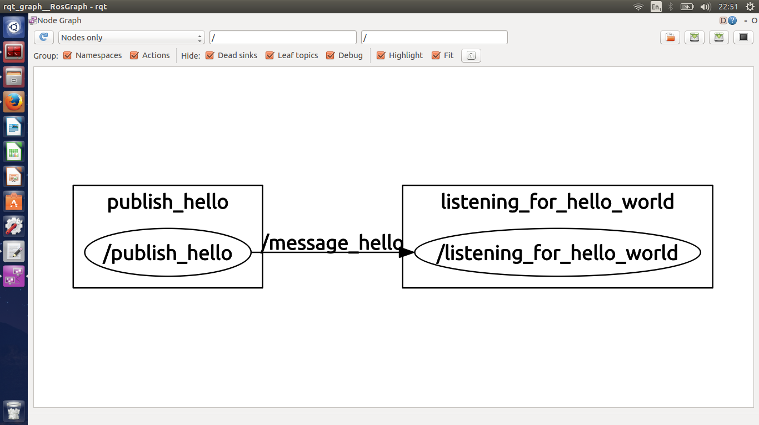

Exercise 1 : Create a new publisher called Publisher_World.py which broadcasts a Topic called “message_world” of Type String with a message “World” , alter Subscriber.py so it is subscribed to Publisher_World.py 's node as well as Publisher_Hello.py 's node and prints out both messages .
Your Ros Graph should like like the following:

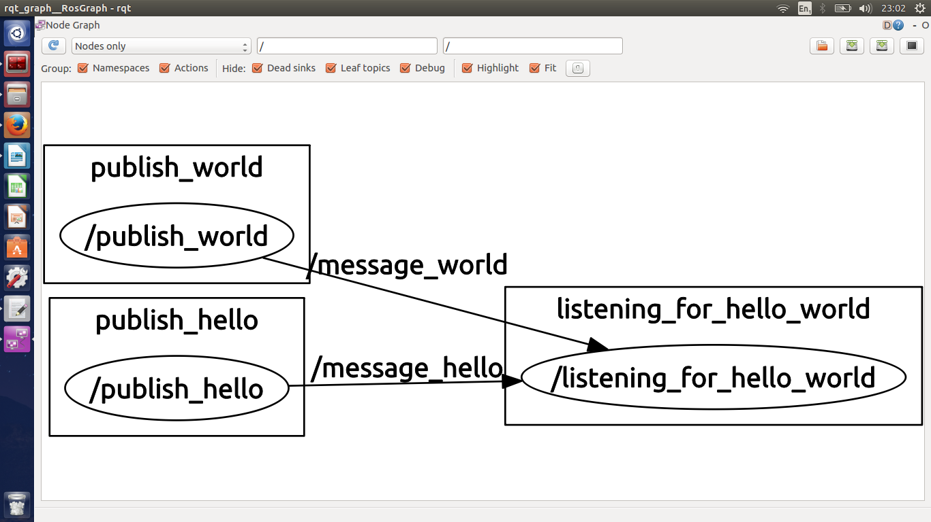

Exercise 2 : Using “from std_msgs.msg import Int32” instead of “from std_msgs.msg import String” create a node that publishes a sequence of Fibonacci numbers starting at 2. Then either alter or create a new subscriber that listens for the new nodes message, and prints them. Your result should look like the following:

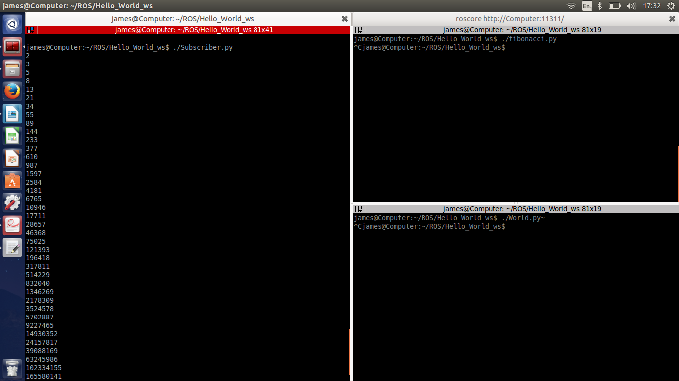

Exercise 3 : Alter the subscriber node from Exercise 2 , so that it takes the Fibonacci values it receives, divides them by 2, then publishes them as a new topic of type Int32. Create a new node that subscribes and prints out the new values. Your result should look like the following:
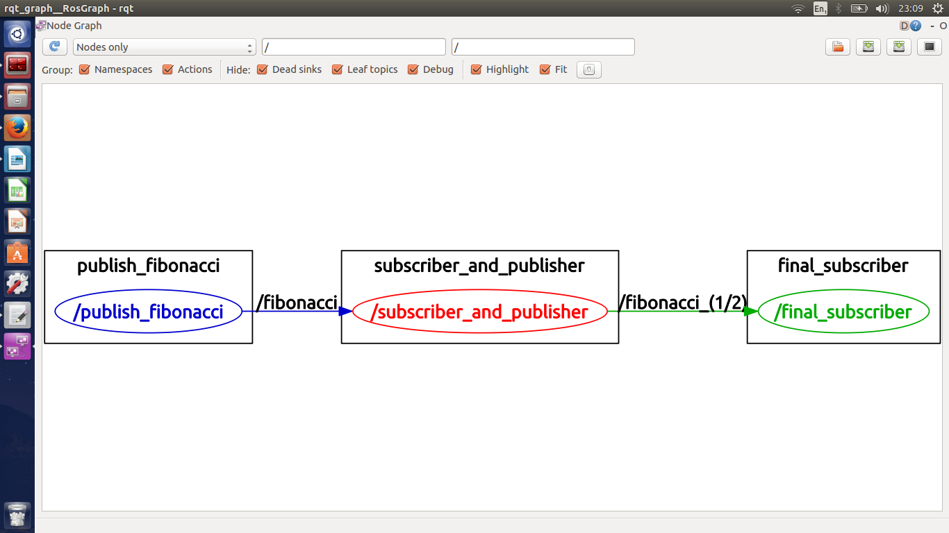

Messages

We have already looked at sending messages of type int32 and type String which are found in the std_msgs package, which we import at the start of our code.
Now that we have a good feel for how to send messages over topics, we are now going to look at how to send a message that isn't already defined by the Ros std_msgs package

This std_msgs package defines the following primitive types :
ROS TYPE | SERIALIZATION | PYTHON TYPE
Bool | Unsigned 8-bit integer | Bool
int8 | Signed 8-bit integer | int
uint8 | Unsigned 8-bit integer | int
int16 | Signed 16-bit integer | int
uint16 | Unsigned 16-bit integer | int
int32 | Signed 32-bit integer | int
uint32 | Unsigned 32-bit integer | int
int64 | Signed 64-bit integer | long
uint64 | Unsigned 64-bit integer | long
float32 | 32-bit IEEE float | float
float64 | 64-bit IEEE float | float
String | ASCII string | String
time | Secs/nsecs unsigened 32-bit int | rospy.Time

Making a message

There are many times when these message types found in std_msgs arnt enough and we have to define our own. Ros messages are defined by message_deffinition files in the msg directory of a package which we will need to create.

$ roscd lab_3
$ mkdir msg
$ cd msg
$ gedit Complex.msg

In this new folder create a file called Complex.msg
float32 real
float32 imaginary

$ cd ~/HelloWorld/
$ catkin_make

What this will do is create a message file for a new message type that we are calling Complex. It defines two values, one real and one imaginary.

Now for the tricky bit, in order to get to generate the new message type we need to get Ros to generate the message creation code. We have to add the message_creation dependency to our package.xml file. This file was generated when we created our package $ catkin_create_pkg lab_3 std_msgs rospy .

The file is located in : /HelloWorld_ws/src/lab_3/package.xml

add the following to the file

<build_depend>message_generation</build_depend>
<run_depend>message_runtime</run_depend>
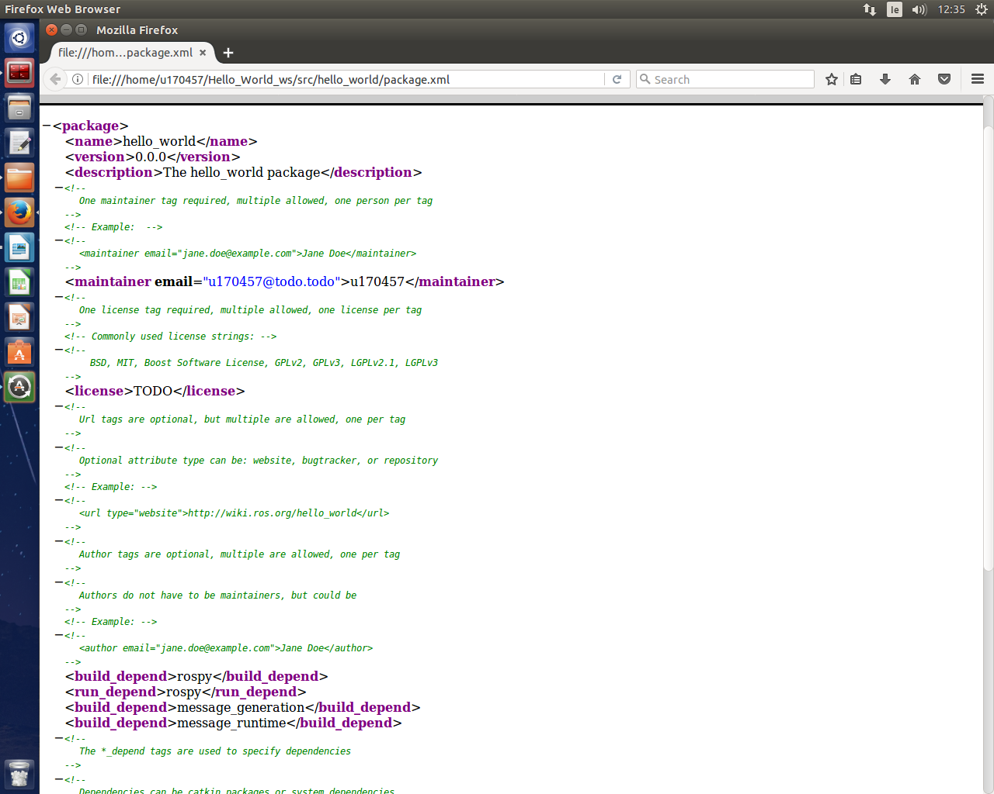

Now we are going to open CmakeList.txt file, found beside the package.xml.The file requires a few changes so that when we run catkin_make to compile, it knows where to look for the message_generation package. The file has tonnes of comments and is split into different sections.
In the first section in the Find_Pakage() method uncomment it and add message_generation so it looks like:

find_package(catkin REQUIRED COMPONENTS
rospy
std_msgs
message_generation)

In the second section (Declare Ros messages,services and actions) uncomment the add_message_files() method and add the name of our file Complex.msg, it should look like

add_message_files(
FILES
Complex.msg )

Then in the generate_message() method alter it so it looks like

generate_messages(
DEPENDENCIES
std_msgs )

In the fifth section (catkin specific configuration) uncomment the catkin_package method and add CATKIN_DEPENDS message_runtime , it should look like

catkin_package(
CATKIN_DEPENDS message_runtime)

Now run catkin_make to complie the message in your workspace root:

$ cd ~/HelloWorld/
$ catkin_make

A good indicator that everything worked is that catkin_make has a lot of out puts as it complies all the new packages and messages we added. Now we can use the message just like any other message in Ros .
To check if the message complied correctly type:

$ rosmsg show Complex

Running a message

The following is the code for a publisher and subscriber that will send and receive messages of our new type, Complex.

Publisher

#!/usr/bin/env python
import rospy
from lab_3.msg import Complex

rospy.init_node("message_Publisher")
pub = rospy.Publisher('complex_message',Complex,queue_size = 5)
rate = rospy.Rate(2)

while not rospy.is_shutdown():
msg=Complex()
msg.real= 6
msg.imaginary= 9
pub.publish(msg)
rate.sleep()

Subscriber

#!/usr/bin/env python
import rospy
from lab_3.msg import Complex

def callback(msg):
print 'Real : ',msg.real
print 'Imaginary : ',msg.imaginary

rospy.init_node('complex_sub')
sub = rospy.Subscriber('complex_message',Complex,callback)
rospy.spin()

Make sure you:
$ source /devel/setup.bash
In each terminal before running the code other wise it will not find your message.

Exercise four : Create a new message Type called Date which consists of a non zero int32 called year, and two Strings called day and month. To do this you will need to create a file called Date.msg in the msg folder aswell as add its dependency to CmakeList.txt. Alter exsisting code to make a publisher subsrciber that will print out todays date.

