WinForms Rich Text Editor

Word® Inspired Rich Text Editor

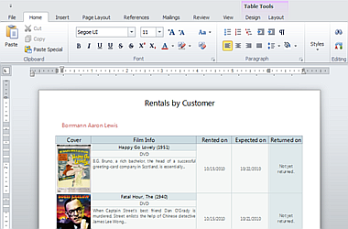

The DevExpress WinForms Rich Text Editor allows you to introduce advanced text editing capabilities into your next application with ease. The XtraRichEdit™ provides comprehensive text formatting options, mail-merge and a rich collection of end-user options so you can deliver your best, without limits or compromise.