Lymphatic Graphs

library(tidyverse)

## -- Attaching packages --------------------------------------- tidyverse 1.3.1 --

## v ggplot2 3.3.3 v purrr 0.3.4  
## v tibble 3.1.0 v dplyr 1.0.5  
## v tidyr 1.1.3 v stringr 1.4.0  
## v readr 1.4.0 v forcats 0.5.1

## -- Conflicts ------------------------------------------ tidyverse_conflicts() --  
## x dplyr::filter() masks stats::filter()  
## x dplyr::lag() masks stats::lag()

library(car)

## Loading required package: carData

##   
## Attaching package: 'car'

## The following object is masked from 'package:dplyr':  
##   
## recode

## The following object is masked from 'package:purrr':  
##   
## some

summ4.df = readRDS("TEST.rds")  
summ5.df = readRDS("TEST_sum.rds")  
  
make_graph = function(all_data, summ_data, ylab, variable_name)  
{  
  
all_data$variable = all_data[[variable_name]]  
summ_data$variable = summ_data[[variable_name]]  
summ_data$std = summ_data[[paste(variable_name, "_std", sep = "")]]  
  
print(summ_data %>% dplyr::select(`treatment`, `n`))  
  
  
plot(ggplot(all_data) + geom_boxplot(aes(y = variable, x = treatment)) +  
 geom_point(aes(y = variable, x = treatment), color = "blue", shape = 16, size = 3, alpha = 0.3) +  
 scale_y_continuous(limits = c(NA,NA)) +  
 labs(y = ylab, x = ""))  
  
plot(ggplot(summ_data) + geom_col(aes(y = variable, x = treatment)) +  
 geom_errorbar(aes(y = variable, x = treatment, ymax = (variable + std), ymin = (variable-std))) +  
 labs(y = ylab, x = ""))  
  
plot(ggplot(summ_data) + geom_col(aes(y = variable, x = treatment)) +  
 geom_errorbar(aes(y = variable, x = treatment, ymax = (variable + std), ymin = (variable-std))) +  
 labs(y = ylab, x = "")+  
 geom_point(aes(y = variable, x = treatment), data = all_data, color = "blue", shape = 16, size = 3, alpha = 0.3))  
  
# Compute the analysis of variance  
res.aov <- aov(variable ~ treatment, data = all_data)  
print(summary(res.aov))  
print(TukeyHSD(res.aov))  
  
  
print(leveneTest(variable ~ treatment, data = all_data))  
aov_residuals <- residuals(object = res.aov)  
print(shapiro.test(x = aov_residuals))  
print(kruskal.test(variable ~ treatment, data = all_data))  
  
print(pairwise.wilcox.test(all_data$variable, all_data$treatment,  
 p.adjust.method = "fdr"))  
}

# Mean Contraction Frequency

make_graph(summ4.df, summ5.df, "Mean contractions / vessel / min", "max_n_cont")

## # A tibble: 4 x 2  
## treatment n  
## <fct> <int>  
## 1 SH 8  
## 2 SH + AFR 8  
## 3 AP 8  
## 4 AP + AFR 8

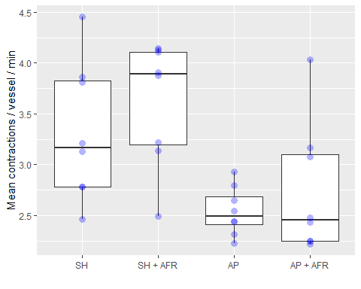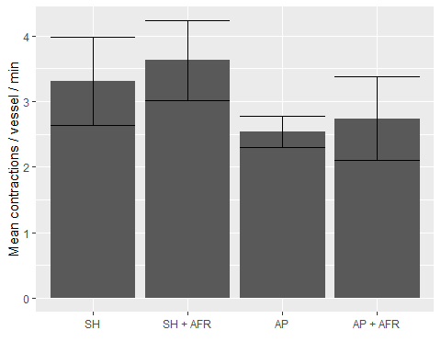

## Df Sum Sq Mean Sq F value Pr(>F)   
## treatment 3 6.057 2.0191 6.243 0.00221 **  
## Residuals 28 9.055 0.3234   
## ---  
## Signif. codes: 0 '***' 0.001 '**' 0.01 '*' 0.05 '.' 0.1 ' ' 1  
## Tukey multiple comparisons of means  
## 95% family-wise confidence level  
##   
## Fit: aov(formula = variable ~ treatment, data = all_data)  
##   
## $treatment  
## diff lwr upr p adj  
## SH + AFR-SH 0.3151972 -0.4611457 1.091539998 0.6873725  
## AP-SH -0.7706473 -1.5469901 0.005695504 0.0522466  
## AP + AFR-SH -0.5730097 -1.3493525 0.203333152 0.2065822  
## AP-SH + AFR -1.0858445 -1.8621873 -0.309501669 0.0035968  
## AP + AFR-SH + AFR -0.8882068 -1.6645497 -0.111864020 0.0202919  
## AP + AFR-AP 0.1976376 -0.5787052 0.973980474 0.8981059  
##   
## Levene's Test for Homogeneity of Variance (center = median)  
## Df F value Pr(>F)  
## group 3 1.0223 0.3977  
## 28   
##   
## Shapiro-Wilk normality test  
##   
## data: aov_residuals  
## W = 0.96709, p-value = 0.4233  
##   
##   
## Kruskal-Wallis rank sum test  
##   
## data: variable by treatment  
## Kruskal-Wallis chi-squared = 13.351, df = 3, p-value = 0.003936

## Warning in wilcox.test.default(xi, xj, paired = paired, ...): cannot compute  
## exact p-value with ties  
  
## Warning in wilcox.test.default(xi, xj, paired = paired, ...): cannot compute  
## exact p-value with ties  
  
## Warning in wilcox.test.default(xi, xj, paired = paired, ...): cannot compute  
## exact p-value with ties  
  
## Warning in wilcox.test.default(xi, xj, paired = paired, ...): cannot compute  
## exact p-value with ties  
  
## Warning in wilcox.test.default(xi, xj, paired = paired, ...): cannot compute  
## exact p-value with ties  
  
## Warning in wilcox.test.default(xi, xj, paired = paired, ...): cannot compute  
## exact p-value with ties

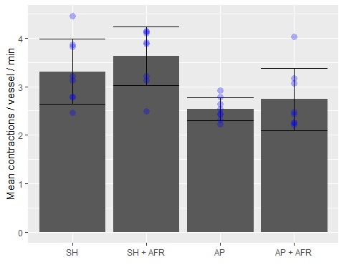

##   
## Pairwise comparisons using Wilcoxon rank sum test with continuity correction   
##   
## data: all_data$variable and all_data$treatment   
##   
## SH SH + AFR AP   
## SH + AFR 0.227 - -   
## AP 0.027 0.023 -   
## AP + AFR 0.124 0.027 1.000  
##   
## P value adjustment method: fdr

# Average contraction amplitude

make_graph(summ4.df, summ5.df, "Mean pixels / vessel", "mean_mag")

## # A tibble: 4 x 2  
## treatment n  
## <fct> <int>  
## 1 SH 8  
## 2 SH + AFR 8  
## 3 AP 8  
## 4 AP + AFR 8

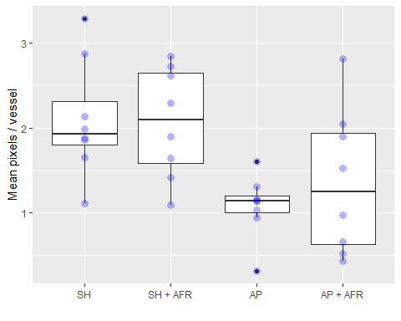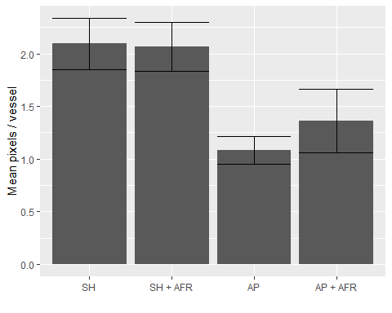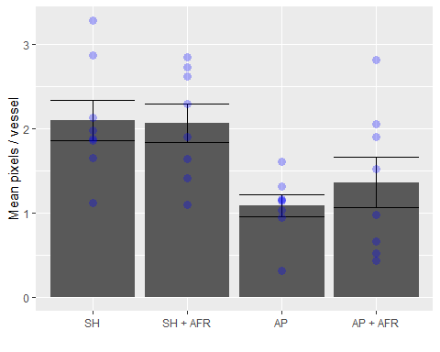

## Df Sum Sq Mean Sq F value Pr(>F)   
## treatment 3 6.216 2.0720 4.725 0.00863 **  
## Residuals 28 12.279 0.4385   
## ---  
## Signif. codes: 0 '***' 0.001 '**' 0.01 '*' 0.05 '.' 0.1 ' ' 1  
## Tukey multiple comparisons of means  
## 95% family-wise confidence level  
##   
## Fit: aov(formula = variable ~ treatment, data = all_data)  
##   
## $treatment  
## diff lwr upr p adj  
## SH + AFR-SH -0.03018752 -0.9342112 0.87383612 0.9997215  
## AP-SH -1.01280563 -1.9168293 -0.10878198 0.0236550  
## AP + AFR-SH -0.73566186 -1.6396855 0.16836179 0.1420010  
## AP-SH + AFR -0.98261810 -1.8866418 -0.07859446 0.0292584  
## AP + AFR-SH + AFR -0.70547433 -1.6094980 0.19854931 0.1682023  
## AP + AFR-AP 0.27714377 -0.6268799 1.18116742 0.8364023  
##   
## Levene's Test for Homogeneity of Variance (center = median)  
## Df F value Pr(>F)   
## group 3 2.318 0.0971 .  
## 28   
## ---  
## Signif. codes: 0 '***' 0.001 '**' 0.01 '*' 0.05 '.' 0.1 ' ' 1  
##   
## Shapiro-Wilk normality test  
##   
## data: aov_residuals  
## W = 0.9711, p-value = 0.5304  
##   
##   
## Kruskal-Wallis rank sum test  
##   
## data: variable by treatment  
## Kruskal-Wallis chi-squared = 10.688, df = 3, p-value = 0.01354  
##   
##   
## Pairwise comparisons using Wilcoxon rank sum exact test   
##   
## data: all_data$variable and all_data$treatment   
##   
## SH SH + AFR AP   
## SH + AFR 0.878 - -   
## AP 0.014 0.014 -   
## AP + AFR 0.196 0.196 0.865  
##   
## P value adjustment method: fdr

# Average Diameter

make_graph(all_data = summ4.df, summ_data = summ5.df, ylab = "Mean pixels / vessel", variable_name = "width")

## # A tibble: 4 x 2  
## treatment n  
## <fct> <int>  
## 1 SH 8  
## 2 SH + AFR 8  
## 3 AP 8  
## 4 AP + AFR 8

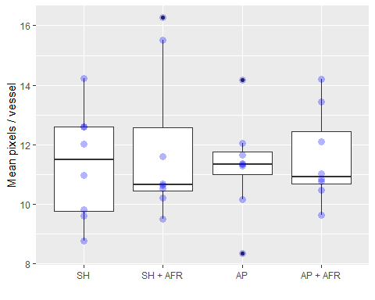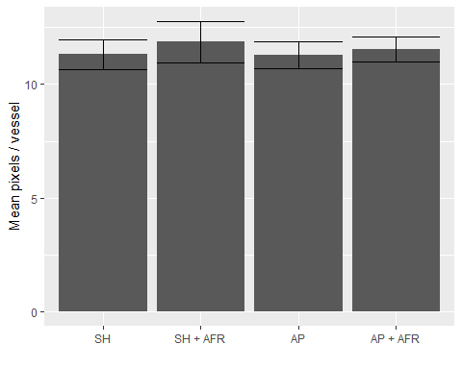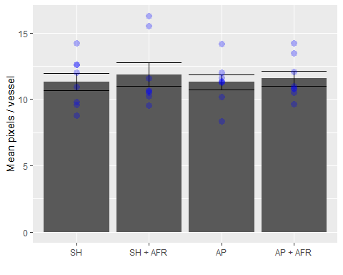

## Df Sum Sq Mean Sq F value Pr(>F)  
## treatment 3 1.71 0.571 0.151 0.928  
## Residuals 28 106.10 3.789   
## Tukey multiple comparisons of means  
## 95% family-wise confidence level  
##   
## Fit: aov(formula = variable ~ treatment, data = all_data)  
##   
## $treatment  
## diff lwr upr p adj  
## SH + AFR-SH 0.54991001 -2.107482 3.207302 0.9416076  
## AP-SH -0.02553014 -2.682922 2.631862 0.9999933  
## AP + AFR-SH 0.23621883 -2.421173 2.893611 0.9948560  
## AP-SH + AFR -0.57544014 -3.232832 2.081952 0.9338955  
## AP + AFR-SH + AFR -0.31369118 -2.971083 2.343701 0.9881741  
## AP + AFR-AP 0.26174897 -2.395643 2.919141 0.9930400  
##   
## Levene's Test for Homogeneity of Variance (center = median)  
## Df F value Pr(>F)  
## group 3 0.343 0.7944  
## 28   
##   
## Shapiro-Wilk normality test  
##   
## data: aov_residuals  
## W = 0.95254, p-value = 0.1701  
##   
##   
## Kruskal-Wallis rank sum test  
##   
## data: variable by treatment  
## Kruskal-Wallis chi-squared = 0.082386, df = 3, p-value = 0.9939  
##   
##   
## Pairwise comparisons using Wilcoxon rank sum exact test   
##   
## data: all_data$variable and all_data$treatment   
##   
## SH SH + AFR AP   
## SH + AFR 0.96 - -   
## AP 0.96 0.96 -   
## AP + AFR 0.96 0.96 0.96  
##   
## P value adjustment method: fdr

# Average contraction duration

make_graph(all_data = summ4.df, summ_data = summ5.df, ylab = "Average Contraction Duration / Vessel", variable_name = "duration")

## # A tibble: 4 x 2  
## treatment n  
## <fct> <int>  
## 1 SH 8  
## 2 SH + AFR 8  
## 3 AP 8  
## 4 AP + AFR 8

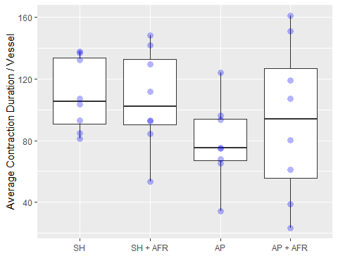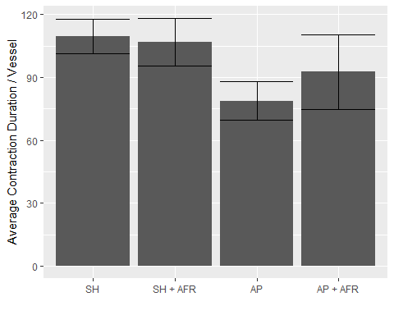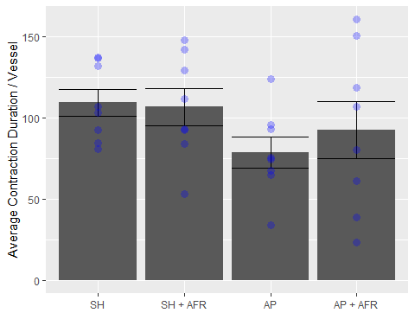

## Df Sum Sq Mean Sq F value Pr(>F)  
## treatment 3 4810 1603 1.331 0.284  
## Residuals 28 33730 1205   
## Tukey multiple comparisons of means  
## 95% family-wise confidence level  
##   
## Fit: aov(formula = variable ~ treatment, data = all_data)  
##   
## $treatment  
## diff lwr upr p adj  
## SH + AFR-SH -2.633452 -50.01539 44.74848 0.9987239  
## AP-SH -30.639102 -78.02104 16.74283 0.3105873  
## AP + AFR-SH -16.810861 -64.19280 30.57107 0.7680952  
## AP-SH + AFR -28.005650 -75.38758 19.37628 0.3874764  
## AP + AFR-SH + AFR -14.177410 -61.55934 33.20453 0.8459495  
## AP + AFR-AP 13.828241 -33.55369 61.21018 0.8552618  
##   
## Levene's Test for Homogeneity of Variance (center = median)  
## Df F value Pr(>F)   
## group 3 2.8611 0.05466 .  
## 28   
## ---  
## Signif. codes: 0 '***' 0.001 '**' 0.01 '*' 0.05 '.' 0.1 ' ' 1  
##   
## Shapiro-Wilk normality test  
##   
## data: aov_residuals  
## W = 0.98725, p-value = 0.962  
##   
##   
## Kruskal-Wallis rank sum test  
##   
## data: variable by treatment  
## Kruskal-Wallis chi-squared = 4.1392, df = 3, p-value = 0.2468  
##   
##   
## Pairwise comparisons using Wilcoxon rank sum exact test   
##   
## data: all_data$variable and all_data$treatment   
##   
## SH SH + AFR AP   
## SH + AFR 1.00 - -   
## AP 0.17 0.39 -   
## AP + AFR 0.77 0.77 0.77  
##   
## P value adjustment method: fdr

# Mean Fractional Pump Flow

make_graph(all_data = summ4.df, summ_data = summ5.df, ylab = "Mean pixels / vessel / min", variable_name = "fpf")

## # A tibble: 4 x 2  
## treatment n  
## <fct> <int>  
## 1 SH 8  
## 2 SH + AFR 8  
## 3 AP 8  
## 4 AP + AFR 8

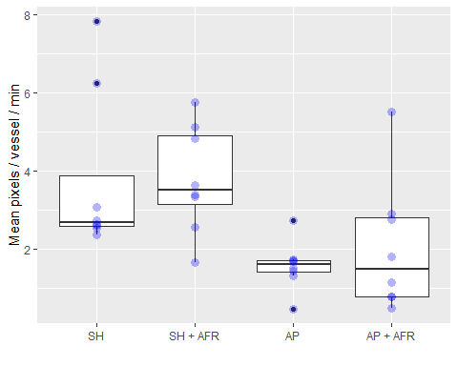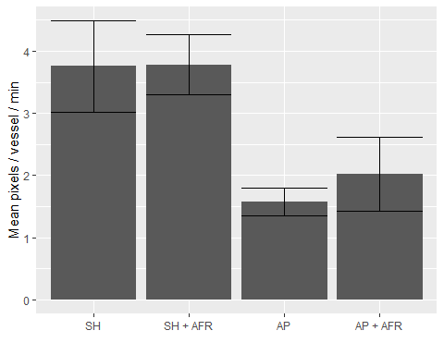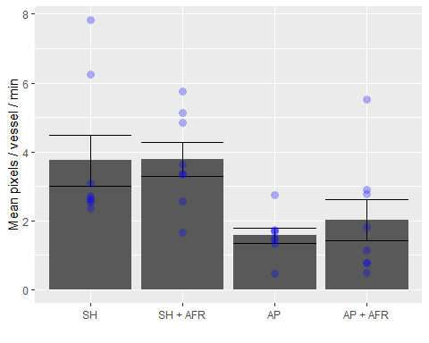

## Df Sum Sq Mean Sq F value Pr(>F)   
## treatment 3 31.79 10.60 4.49 0.0108 *  
## Residuals 28 66.07 2.36   
## ---  
## Signif. codes: 0 '***' 0.001 '**' 0.01 '*' 0.05 '.' 0.1 ' ' 1  
## Tukey multiple comparisons of means  
## 95% family-wise confidence level  
##   
## Fit: aov(formula = variable ~ treatment, data = all_data)  
##   
## $treatment  
## diff lwr upr p adj  
## SH + AFR-SH 0.02709538 -2.070004 2.12419484 0.9999838  
## AP-SH -2.17981591 -4.276915 -0.08271645 0.0393399  
## AP + AFR-SH -1.72805775 -3.825157 0.36904170 0.1346421  
## AP-SH + AFR -2.20691129 -4.304011 -0.10981183 0.0363235  
## AP + AFR-SH + AFR -1.75515314 -3.852253 0.34194632 0.1258166  
## AP + AFR-AP 0.45175815 -1.645341 2.54885761 0.9348247  
##   
## Levene's Test for Homogeneity of Variance (center = median)  
## Df F value Pr(>F)  
## group 3 0.7871 0.5112  
## 28   
##   
## Shapiro-Wilk normality test  
##   
## data: aov_residuals  
## W = 0.89491, p-value = 0.004608  
##   
##   
## Kruskal-Wallis rank sum test  
##   
## data: variable by treatment  
## Kruskal-Wallis chi-squared = 12.097, df = 3, p-value = 0.007059  
##   
##   
## Pairwise comparisons using Wilcoxon rank sum exact test   
##   
## data: all_data$variable and all_data$treatment   
##   
## SH SH + AFR AP   
## SH + AFR 0.6885 - -   
## AP 0.0089 0.0089 -   
## AP + AFR 0.1573 0.0758 0.7984  
##   
## P value adjustment method: fdr

# Mean ejection fraction

make_graph(all_data = summ4.df, summ_data = summ5.df, ylab = "Mean Ejection Fraction", variable_name = "ef")

## # A tibble: 4 x 2  
## treatment n  
## <fct> <int>  
## 1 SH 8  
## 2 SH + AFR 8  
## 3 AP 8  
## 4 AP + AFR 8

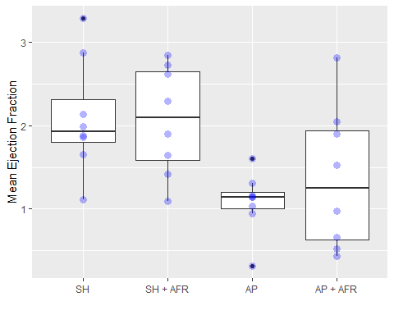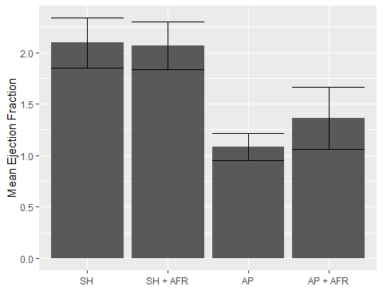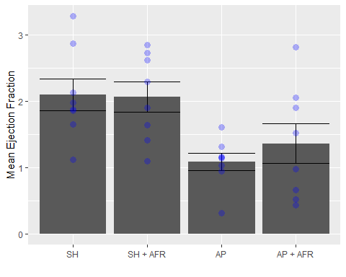

## Df Sum Sq Mean Sq F value Pr(>F)   
## treatment 3 6.216 2.0720 4.725 0.00863 **  
## Residuals 28 12.279 0.4385   
## ---  
## Signif. codes: 0 '***' 0.001 '**' 0.01 '*' 0.05 '.' 0.1 ' ' 1  
## Tukey multiple comparisons of means  
## 95% family-wise confidence level  
##   
## Fit: aov(formula = variable ~ treatment, data = all_data)  
##   
## $treatment  
## diff lwr upr p adj  
## SH + AFR-SH -0.03018752 -0.9342112 0.87383612 0.9997215  
## AP-SH -1.01280563 -1.9168293 -0.10878198 0.0236550  
## AP + AFR-SH -0.73566186 -1.6396855 0.16836179 0.1420010  
## AP-SH + AFR -0.98261810 -1.8866418 -0.07859446 0.0292584  
## AP + AFR-SH + AFR -0.70547433 -1.6094980 0.19854931 0.1682023  
## AP + AFR-AP 0.27714377 -0.6268799 1.18116742 0.8364023  
##   
## Levene's Test for Homogeneity of Variance (center = median)  
## Df F value Pr(>F)   
## group 3 2.318 0.0971 .  
## 28   
## ---  
## Signif. codes: 0 '***' 0.001 '**' 0.01 '*' 0.05 '.' 0.1 ' ' 1  
##   
## Shapiro-Wilk normality test  
##   
## data: aov_residuals  
## W = 0.9711, p-value = 0.5304  
##   
##   
## Kruskal-Wallis rank sum test  
##   
## data: variable by treatment  
## Kruskal-Wallis chi-squared = 10.688, df = 3, p-value = 0.01354  
##   
##   
## Pairwise comparisons using Wilcoxon rank sum exact test   
##   
## data: all_data$variable and all_data$treatment   
##   
## SH SH + AFR AP   
## SH + AFR 0.878 - -   
## AP 0.014 0.014 -   
## AP + AFR 0.196 0.196 0.865  
##   
## P value adjustment method: fdr