Lymphatic Graphs

library(tidyverse)

## -- Attaching packages --------------------------------------- tidyverse 1.3.1 --

## v ggplot2 3.3.3 v purrr 0.3.4  
## v tibble 3.1.0 v dplyr 1.0.5  
## v tidyr 1.1.3 v stringr 1.4.0  
## v readr 1.4.0 v forcats 0.5.1

## -- Conflicts ------------------------------------------ tidyverse_conflicts() --  
## x dplyr::filter() masks stats::filter()  
## x dplyr::lag() masks stats::lag()

summ4.df = readRDS("TEST.rds")

ggplot(summ4.df) + geom_boxplot(aes(y = max_n_cont*2, x = treatment)) +  
 geom_point(aes(y = max_n_cont*2, x = treatment), color = "blue", shape = 1, size = 3) +  
 scale_y_continuous(limits = c(NA,NA)) +  
 labs(y = "Average Contraction Frequency / Vessel", x = "")

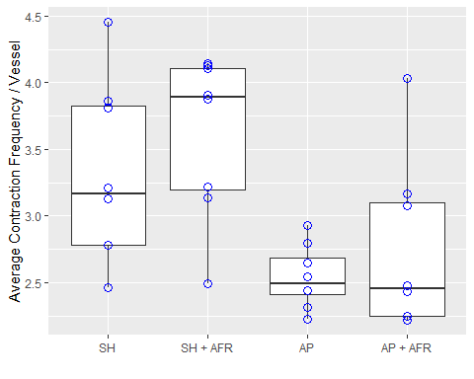

# Compute the analysis of variance  
res.aov <- aov(max_n_cont ~ treatment, data = summ4.df)  
summary(res.aov)

## Df Sum Sq Mean Sq F value Pr(>F)   
## treatment 3 1.514 0.5048 6.243 0.00221 **  
## Residuals 28 2.264 0.0809   
## ---  
## Signif. codes: 0 '***' 0.001 '**' 0.01 '*' 0.05 '.' 0.1 ' ' 1

TukeyHSD(res.aov)

## Tukey multiple comparisons of means  
## 95% family-wise confidence level  
##   
## Fit: aov(formula = max_n_cont ~ treatment, data = summ4.df)  
##   
## $treatment  
## diff lwr upr p adj  
## SH + AFR-SH 0.15759859 -0.2305728 0.545769999 0.6873725  
## AP-SH -0.38532366 -0.7734951 0.002847752 0.0522466  
## AP + AFR-SH -0.28650484 -0.6746762 0.101666576 0.2065822  
## AP-SH + AFR -0.54292225 -0.9310937 -0.154750834 0.0035968  
## AP + AFR-SH + AFR -0.44410342 -0.8322748 -0.055932010 0.0202919  
## AP + AFR-AP 0.09881882 -0.2893526 0.486990237 0.8981059

ggplot(summ4.df) + geom_boxplot(aes(y = mean_mag, x = treatment)) +  
 geom_point(aes(y = mean_mag, x = treatment), color = "blue", shape = 1, size = 3) +  
 scale_y_continuous(limits = c(NA,NA)) +  
 labs(y = "Average Contraction Amplitude / Vessel", x = "")

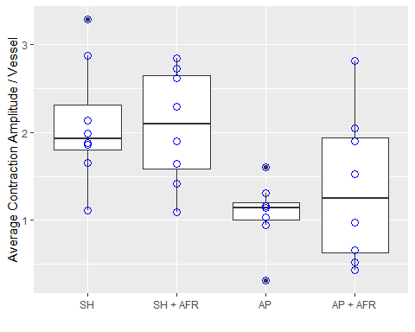

# Compute the analysis of variance  
res.aov <- aov(mean_mag ~ treatment, data = summ4.df)  
summary(res.aov)

## Df Sum Sq Mean Sq F value Pr(>F)   
## treatment 3 6.216 2.0720 4.725 0.00863 **  
## Residuals 28 12.279 0.4385   
## ---  
## Signif. codes: 0 '***' 0.001 '**' 0.01 '*' 0.05 '.' 0.1 ' ' 1

TukeyHSD(res.aov)

## Tukey multiple comparisons of means  
## 95% family-wise confidence level  
##   
## Fit: aov(formula = mean_mag ~ treatment, data = summ4.df)  
##   
## $treatment  
## diff lwr upr p adj  
## SH + AFR-SH -0.03018752 -0.9342112 0.87383612 0.9997215  
## AP-SH -1.01280563 -1.9168293 -0.10878198 0.0236550  
## AP + AFR-SH -0.73566186 -1.6396855 0.16836179 0.1420010  
## AP-SH + AFR -0.98261810 -1.8866418 -0.07859446 0.0292584  
## AP + AFR-SH + AFR -0.70547433 -1.6094980 0.19854931 0.1682023  
## AP + AFR-AP 0.27714377 -0.6268799 1.18116742 0.8364023

ggplot(summ4.df) + geom_boxplot(aes(y = width, x = treatment)) +  
 geom_point(aes(y = width, x = treatment), color = "blue", shape = 1, size = 3) +  
 scale_y_continuous(limits = c(NA,NA)) +  
 labs(y = "Average Diameter / Vessel", x = "")

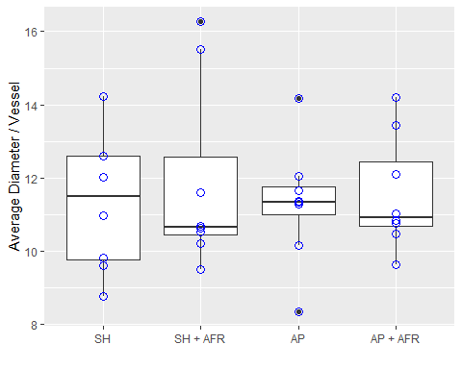

# Compute the analysis of variance  
res.aov <- aov(width ~ treatment, data = summ4.df)  
summary(res.aov)

## Df Sum Sq Mean Sq F value Pr(>F)  
## treatment 3 1.71 0.571 0.151 0.928  
## Residuals 28 106.10 3.789

TukeyHSD(res.aov)

## Tukey multiple comparisons of means  
## 95% family-wise confidence level  
##   
## Fit: aov(formula = width ~ treatment, data = summ4.df)  
##   
## $treatment  
## diff lwr upr p adj  
## SH + AFR-SH 0.54991001 -2.107482 3.207302 0.9416076  
## AP-SH -0.02553014 -2.682922 2.631862 0.9999933  
## AP + AFR-SH 0.23621883 -2.421173 2.893611 0.9948560  
## AP-SH + AFR -0.57544014 -3.232832 2.081952 0.9338955  
## AP + AFR-SH + AFR -0.31369118 -2.971083 2.343701 0.9881741  
## AP + AFR-AP 0.26174897 -2.395643 2.919141 0.9930400

ggplot(summ4.df) + geom_boxplot(aes(y = duration, x = treatment)) +  
 geom_point(aes(y = duration, x = treatment), color = "blue", shape = 1, size = 3) +  
 scale_y_continuous(limits = c(NA,NA)) +  
 labs(y = "Average Contraction Duration / Vessel", x = "")

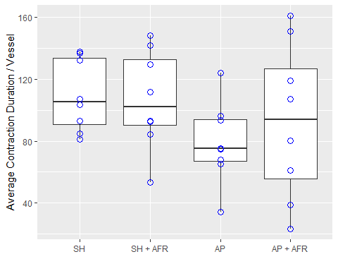

# Compute the analysis of variance  
res.aov <- aov(duration ~ treatment, data = summ4.df)  
summary(res.aov)

## Df Sum Sq Mean Sq F value Pr(>F)  
## treatment 3 4810 1603 1.331 0.284  
## Residuals 28 33730 1205

TukeyHSD(res.aov)

## Tukey multiple comparisons of means  
## 95% family-wise confidence level  
##   
## Fit: aov(formula = duration ~ treatment, data = summ4.df)  
##   
## $treatment  
## diff lwr upr p adj  
## SH + AFR-SH -2.633452 -50.01539 44.74848 0.9987239  
## AP-SH -30.639102 -78.02104 16.74283 0.3105873  
## AP + AFR-SH -16.810861 -64.19280 30.57107 0.7680952  
## AP-SH + AFR -28.005650 -75.38758 19.37628 0.3874764  
## AP + AFR-SH + AFR -14.177410 -61.55934 33.20453 0.8459495  
## AP + AFR-AP 13.828241 -33.55369 61.21018 0.8552618

ggplot(summ4.df) + geom_boxplot(aes(y = fpf, x = treatment)) +  
 geom_point(aes(y = fpf, x = treatment), color = "blue", shape = 1, size = 3) +  
 scale_y_continuous(limits = c(0,NA)) +  
 labs(y = "Mean Fractional Pump Flow", x = "")

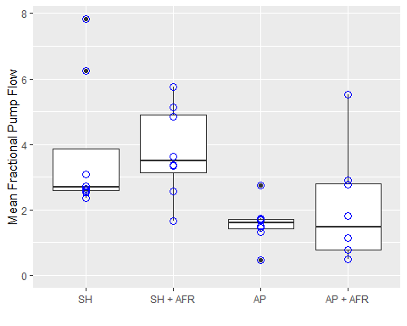

# Compute the analysis of variance  
res.aov <- aov(fpf ~ treatment, data = summ4.df)  
summary(res.aov)

## Df Sum Sq Mean Sq F value Pr(>F)   
## treatment 3 31.79 10.60 4.49 0.0108 *  
## Residuals 28 66.07 2.36   
## ---  
## Signif. codes: 0 '***' 0.001 '**' 0.01 '*' 0.05 '.' 0.1 ' ' 1

TukeyHSD(res.aov)

## Tukey multiple comparisons of means  
## 95% family-wise confidence level  
##   
## Fit: aov(formula = fpf ~ treatment, data = summ4.df)  
##   
## $treatment  
## diff lwr upr p adj  
## SH + AFR-SH 0.02709538 -2.070004 2.12419484 0.9999838  
## AP-SH -2.17981591 -4.276915 -0.08271645 0.0393399  
## AP + AFR-SH -1.72805775 -3.825157 0.36904170 0.1346421  
## AP-SH + AFR -2.20691129 -4.304011 -0.10981183 0.0363235  
## AP + AFR-SH + AFR -1.75515314 -3.852253 0.34194632 0.1258166  
## AP + AFR-AP 0.45175815 -1.645341 2.54885761 0.9348247

ggplot(summ4.df) + geom_boxplot(aes(y = ef, x = treatment)) +  
 geom_point(aes(y = ef, x = treatment), color = "blue", shape = 1, size = 3) +  
 scale_y_continuous(limits = c(0,NA)) +  
 labs(y = "Mean Ejection Fraction", x = "")

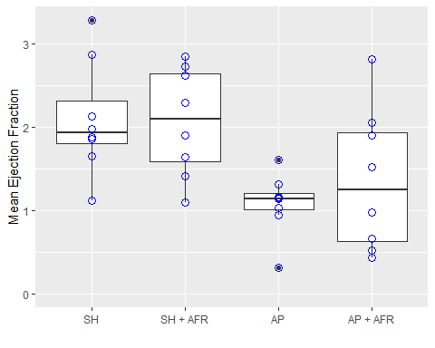

# Compute the analysis of variance  
res.aov <- aov(ef ~ treatment, data = summ4.df)  
summary(res.aov)

## Df Sum Sq Mean Sq F value Pr(>F)   
## treatment 3 6.216 2.0720 4.725 0.00863 **  
## Residuals 28 12.279 0.4385   
## ---  
## Signif. codes: 0 '***' 0.001 '**' 0.01 '*' 0.05 '.' 0.1 ' ' 1

TukeyHSD(res.aov)

## Tukey multiple comparisons of means  
## 95% family-wise confidence level  
##   
## Fit: aov(formula = ef ~ treatment, data = summ4.df)  
##   
## $treatment  
## diff lwr upr p adj  
## SH + AFR-SH -0.03018752 -0.9342112 0.87383612 0.9997215  
## AP-SH -1.01280563 -1.9168293 -0.10878198 0.0236550  
## AP + AFR-SH -0.73566186 -1.6396855 0.16836179 0.1420010  
## AP-SH + AFR -0.98261810 -1.8866418 -0.07859446 0.0292584  
## AP + AFR-SH + AFR -0.70547433 -1.6094980 0.19854931 0.1682023  
## AP + AFR-AP 0.27714377 -0.6268799 1.18116742 0.8364023