**Memorandum**

**To:** Professor Keller

**From:** Group Bladen, J.Hundley, E.Cota, D.Bass, W.Tucker

**Date:** November 27, 2023

**RE:** Beer imports to the U.S.

This memo analyzes beer imports to the U.S. This data comes from the U.S. Department of Commerce sourced by the beer institute of “beerinstitute.org”. The Beer Institute “represents the $409 billion beer industry to support 6,600 brewers and nearly 2.4 million American jobs.”

The data is comprised of annual data and monthly data. The data has four separate series comprised of bottles, cans, drafts, and total. The data is measured in units of 31-gallon barrels. The annual data for total barrels started in 1980. Whereas the annual data for bottles, cans, and drafts started in 1987. The annual data extends to 2022. The monthly data begins in 1999 and extends to 2022.

Market shares are significantly different for the products. Bottles hold most imports, Followed by cans, and then drafts. The 1998 data for bottles is unusually high and unusually low for bottles and cans. I have no explanation on why that is.

This memo uses regression analysis: (take out 1998 of annual 1998,

ANNUAL:

Bottles: This model uses the variable adjusted year, which sets the baseline year to 1980

Models = 54810 * AdjYear – 3,186,285

R2 = 87%

SE = 2,320,795

The y-intercept and the slope are both statistically significant. There are 2 outliers in this data (red markers), years 2006 and 2007. We have decided not to remove these outliers due to them not being significantly outlying.

Cans: This model uses the variable adjusted year, which sets the baseline year to 1980

Model: y = 339,208.94 * AdjYear - 3,704,067

R2: 89%

SE: 1,314,385

The y-intercept and the slope are both statistically significant. There are also 2 outliers in the data, years 2021 and 2022. We did not end up removing these because they were not significantly outlying. The year 1998 is not an outlier but it is not consistent with the years before and after. We are not sure what happened in 1998, but we ended up removing it from the data.

Drafts: This model uses the variable adjusted year, which sets the baseline year to 1980

Model: y = 73,466.39 * AdjYear + 63,156

R2: 95%

SE: 174,545

The y-intercept is not statistically significant, while the slope is. There are two outliers in this data set, years 1998 and 2020. 1998 was removed in this analysis due to it being significant, Compared to 1998 in bottles and cans, it was not as significant. Years 2021 and 2022 are also scattered due to COVID-19. We have decided to remove those 4 years from the data.

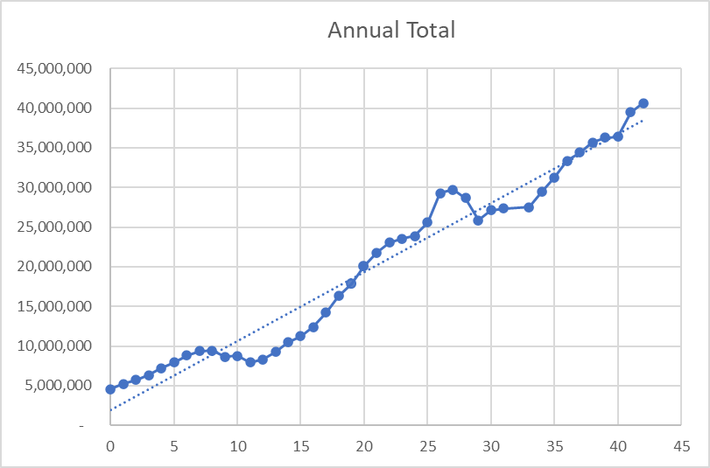

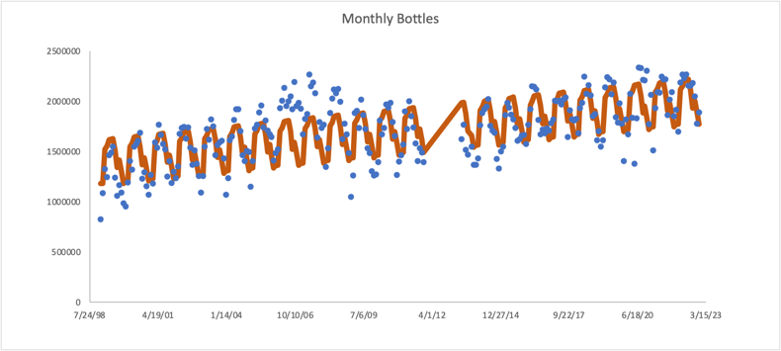

.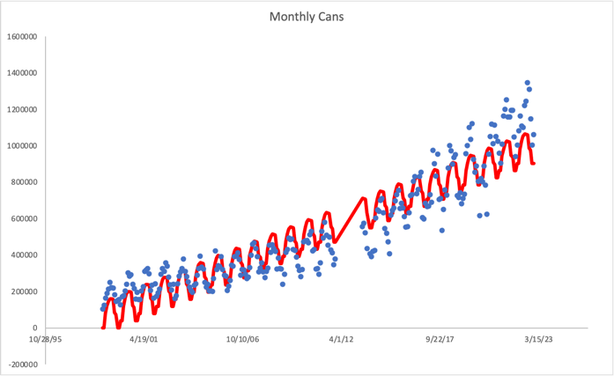

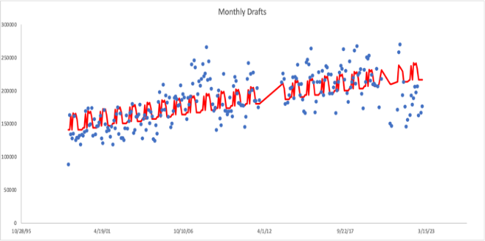

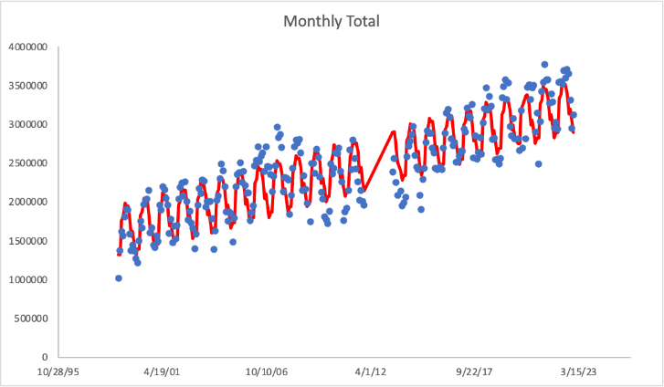

FORECAST on bottles, cans, drafts, and total expected import values.

**2023**: Bottles= $25,301,427, Cans= $13,536,781, Drafts, $2,918,087, Total: $39,388,916

December 2023: Bottles= $1,916,954, Cans= $1,115,830, Drafts= $179,239, Total= $3,194,842