### LAB 1: Convolutional neural network

Tai-Hsiang Huang

MediaTek Inc.

1. **Introduction**

In this work, the Residual Network (ResNet) [1] is implemented to recognize the images in the Cifar-10 data set. Comparing to the traditional convolutional neural network (i.e. Vanilla CNN), the ResNet

* 1. **Procam Model**

Nayar’s procam model [1] is often adopted to describe the conversion all the way from the input intensity to the

1. **Experiment**

The proposed gamut mapping algorithm based on the anchoring theory involves the operation of color transform

## **CNN Models**

The models implemented in this work are not exactly the same as those described in [1]. Specifically, only the basic residual block is adopted in the CNN network, and the sizes of the filters are different from that of the original. For experimental purpose, three different CNN networks are implemented: ResNet, VanillaNet, and Pre-active ResNet. The details of the models are described below.

### ResNet



**Fig. 1.** Determining the maximum backlight *BM* and gamma correction coefficient *Γ* by linear regression. In this example, *BM* = 191.33 and *Γ =* 0.444.

## **Training Hyper-Parameters**

The hyper-parameters used for training are the same for the ResNet, Vanilla Net, and the Pre-active ResNet. The details are listed in Table I.

TABLE I

Training Hyper-Parameters

|  |  |
| --- | --- |
|  | ResNet/ Vanilla Net/ Pre-Active ResNet |
| Method | SGD |
| Momentum | 0.9 |
| Mini-batch size | 128 |
| Total epochs | 164 |
| Learning rate | 0.1, epoch < 81,  0.01, 81<= epoch < 122,  0.001, 122<= epoch |
| Weight decay | 0.0001 |
| Weight initialization | Conv2D.weight: KaiMing_Normal  Conv2D.bias: 0  BatchNorm2D.weight: 1  BatchNorm2D.bias: 0  Linear.weight.std: 0.001  Linear.bias: 0 |
| Loss function | Cross-entropy |

1. **experimental results**

A subjective test including 10 subjects was conducted on the

result is shown in Fig. 5.

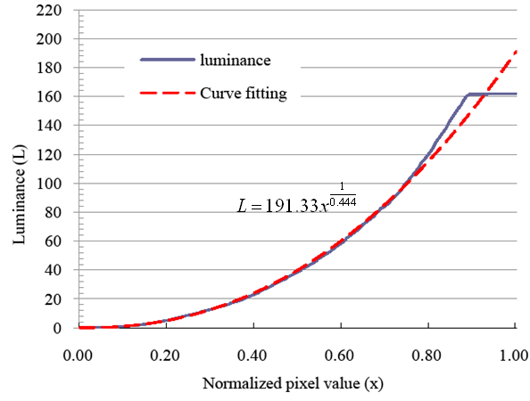

**Fig. 12.** Determining the maximum backlight *BM* and gamma correction coefficient *Γ* by linear regression. In this example, *BM* = 191.33 and *Γ =* 0.444.

1. **Discussion**

In this paper, we have described a method based on the

1. **References**
2. He, K., Zhang, X., Ren, S., & Sun, J. (2016). Deep residual learning for image recognition. In Proceedings of the IEEE conference on computer vision and pattern recognition (pp. 770-778).
3. He, K., Zhang, X., Ren, S., & Sun, J. (2016, October). Identity mappings in deep residual networks. In European Conference on Computer Vision (pp. 630-645). Springer International Publishing.