CHAPTER THREE NOTES: (Residual Plots and Transformations)

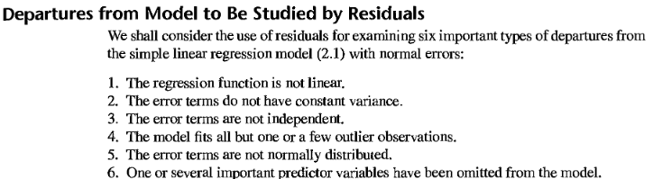

NORMALPROBABILITY PLOT (QQPLOT) ANALYSIS

NORMAL PROBABILITY PLOT (Error Terms are normal)

s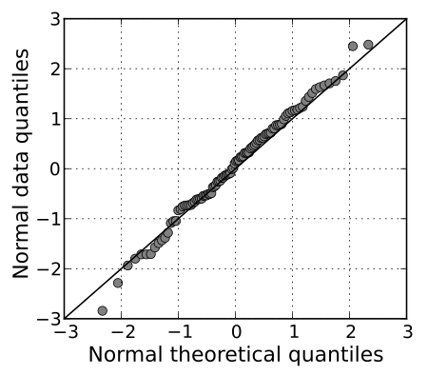

NORMAL PROBABILITY PLOTS (QQ PLOT) HISTOGRAMS

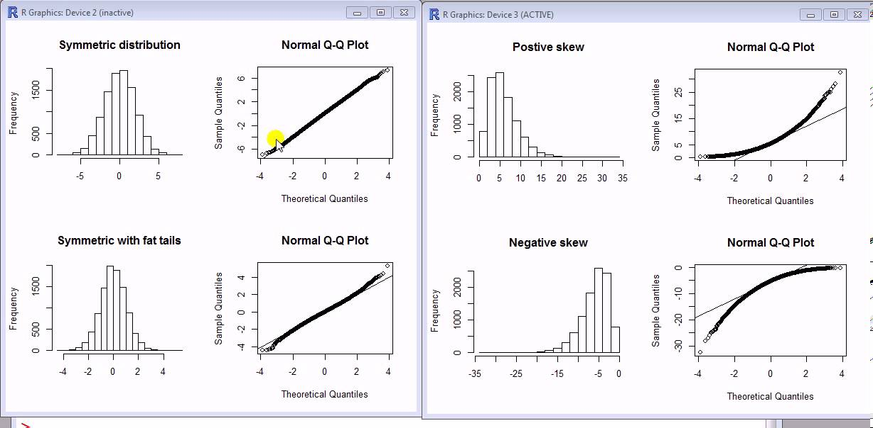

**RESIDUAL PLOT ANALYSIS (CHECKING FOR CONSTANT VARIANCE)**

Residual Plots that support linearity (Constant Variance)

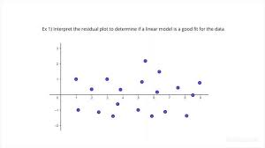

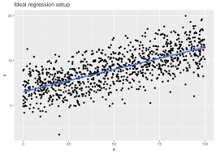

Residual Plots that do not support linearity (Non-Constant Variance)



