Assignment 2

**Selection of Case study for the creation of the database**

There was a choice of two cases which were could choose from so that we could create four linked tables.

The option that we have selected is MovieHouse.

**Design of the tables**

|  |
| --- |
| MovieHouse |
| Movies – FilmID, FilmName, Screen, |
| Actormovies – FilmID*, ActorID* |
| Actors - ActorID, FirstName, Surname, Salary |
| Cinema – CinemaID, CinemaName, |
| Bookings – BookingID, FilmID*, CinemaID* CustomerID* |
| Customer – CustomerID, FirstName, Surname, Address |
| Cinemashows – CinemaID*, FilmID* |
|  |

Key – (PK – underlined FK – *)

**ER Diagram**

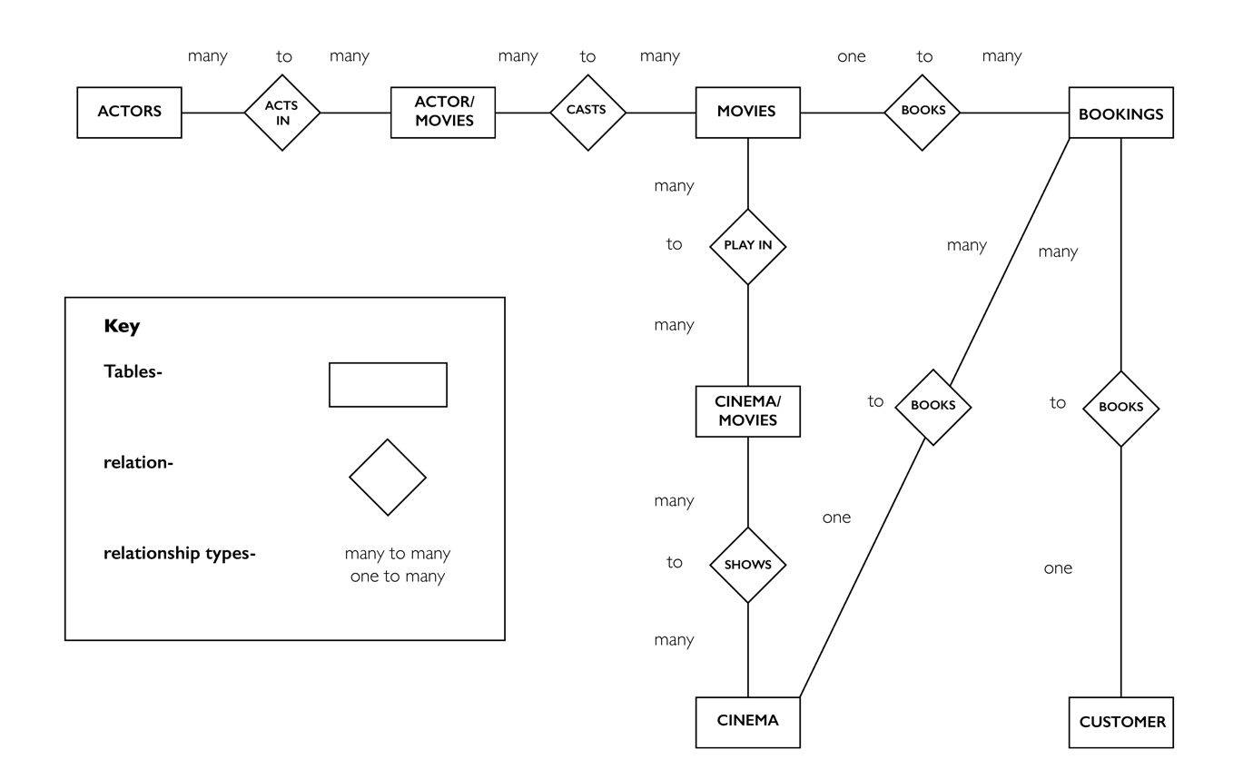

**Primary and Foreign Keys**

**Actors Table**

**Primary Key:** Primary Key Within the actors table will be the ActorID. This is because this is the unique number which will identify each of the actors within the table.

**Movies Table**

**Primary Key:** Primary Key will be the FilmID. This is because this is the unique identifier used for each of the movies which are currently being shown within the cinema.

**Bookings Table**

**Primary Key:** The Primary Key within this table will be the booking ID because this is the unique number that each booking is given so that they would be located within the database easily. This also means that each booking is unique and can be located easily.

**Foreign Key:** There are three foreign keys in this table which are CinemaID, FilmID and CustomerID. These are the three foreign keys because this table must draw information from the Cinema, Movies and Customer table to ensure that the correct bookings can be taken so each customer is able to attend the correct film that they have booked at the correct Cinema of their choice.

**Customer Table**

**Primary Key:** The primary key within the customer table within the database will be the CustomerID. This is because this is the unique field which will be used to identify the customers who have place a booking to see a film which is being shown. This means that each unique customers booking could be located easily.

**Foreign Key:** This table will not contain any foreign keys because this table is passing information into the booking table and is not taking information from another table within the database. So this means that it is not necessary for a foreign key within the table.

**Cinema Table**

**Primary Key:** The primary key within this table. One is the cinema ID. Which is the unique identifier used for each of the Cinemas which exist within the MovieHouse Family. This means that the cinema can be identified easily.

**Foreign Key:** There is no foreign key needed within this table as it is passing information across into another table and is not taking information into this table and is linking to another table.

**Cinemashows**

**Uses a composite key consisting of CinemaID and FilmID:** This means a cinema can show multiple movies and movies can be shown in multiple cinemas.

**Foreign Key:** CinemaID and FilmID, this connects the Cinemas and Movies tables enabling users to select what cinema and what film they want to book.

**Actormovies**

**Uses a composite key consisting of FilmID and ActorID: This means many actors cans star in many movies and a movie can have many actors.**

**Foreign Key:** ActorID and FilmID, this connects the Actors and Movies tables enabling users to see which actors star in which movies.

**Create Tables**

|  |  |  |  |
| --- | --- | --- | --- |
| **Customer Table** | **Booking Table** | **Actors Table** | **Movies Table** |
| CREATE TABLE`customer`( | CREATE TABLE`bookings`( | CREATE TABLE `actors`( | CREATE TABLE `movies`( |
| `CustomerID` SMALLINT(6) NOT NULL, | `BookingID` SMALLINT(6) NOT NULL, | `ActorID` SMALLINT(6) NOT NULL, | `FilmID` SMALLINT(6) NOT NULL, |
| `firstname` char(20) NOT NULL, | `CinemaID` SMALLINT(6) NOT NULL, | `firstname` char(20) NOT NULL, | `filmname` char(20) NOT NULL, |
| `surname` char(20) NOT NULL, | `FilmID` SMALLINT(6) NOT NULL, | `surname` char(20) NOT NULL | PRIMARY KEY (`FilmID`) |
| `address` char(20) NOT NULL, |  | PRIMARY KEY (`ActorID`) | ) |
| PRIMARY KEY (`CustomerID`) |  | ) |  |
| ); |  |  |  |

|  |  |  |
| --- | --- | --- |
| **Cinema Table** | **Cinemashows table** | **Actormovies table** |
| CREATE TABLE`cinema`( | CREATE TABLE`cinemashows`( | CREATE TABLE`actormovies`( |
| `CinemaID` SMALLINT(6) NOT NULL, | `CinemaID` SMALLINT(6) NOT NULL, | `FilmID` SMALLINT(6) NOT NULL, |
| `cinemaname` char(20) NOT NULL, | `FilmID` SMALLINT(6) NOT NULL, | `ActorID` SMALLINT(6) NOT NULL, |
| PRIMARY KEY (`CinemaID`) | FOREIGN KEY (`FilmID`) REFERENCES movies(`FilmID`), | FOREIGN KEY (`FilmID`) REFERENCES movies(`FilmID`), |
| ) | FOREIGN KEY (`CinemaID`) REFERENCES cinema(`CinemaID`) | FOREIGN KEY (`ActorID`) REFERENCES actors(`ActorID`) |
|  | ) | ) |

**Screenshot of the relational model**