**COM427 - Week 11 Practical**

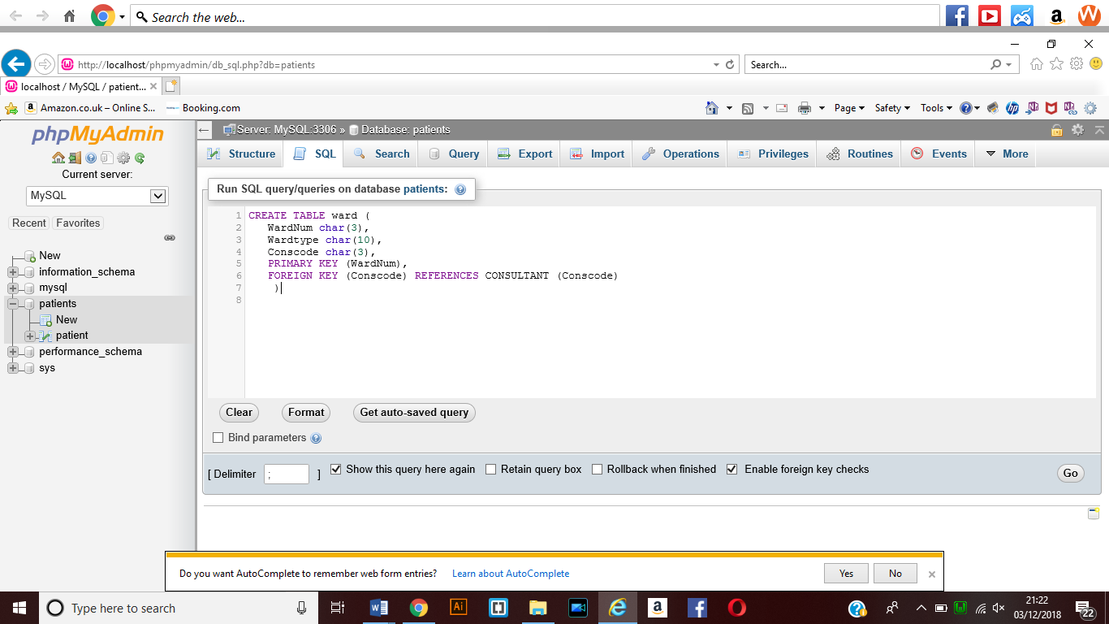**SQL Statement which means that the table would be created called ward when this SQL is executed. The primary key will be WardNum and Foreign key will be conscode.**

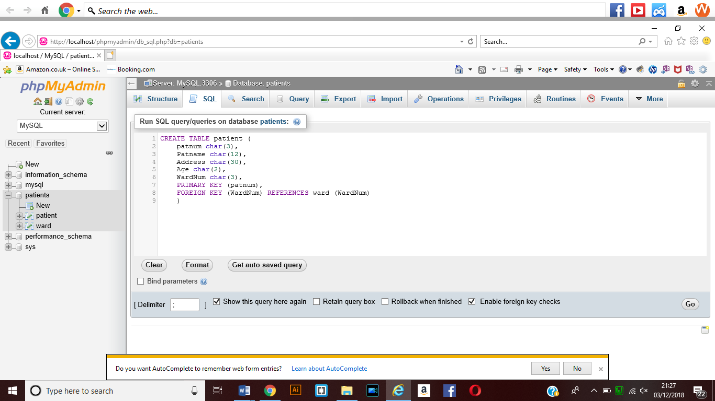

**SQL statement for the creation of the table patient which will allow for the creation of this table when the code is executed.**

**Will have primary key patnum and foreign key will be wardnum**

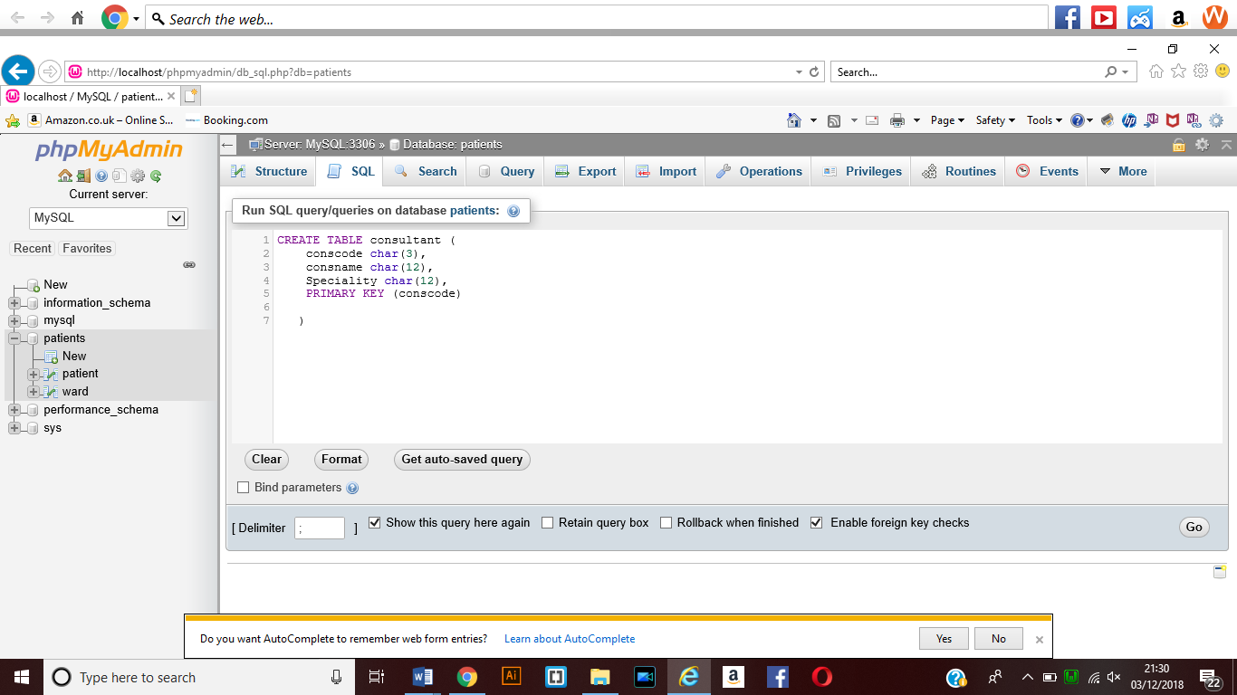

**This SQL Command will create the table consultant when it is run and will have a primary key of conscode.**

**Inserting records into tables using SQL**

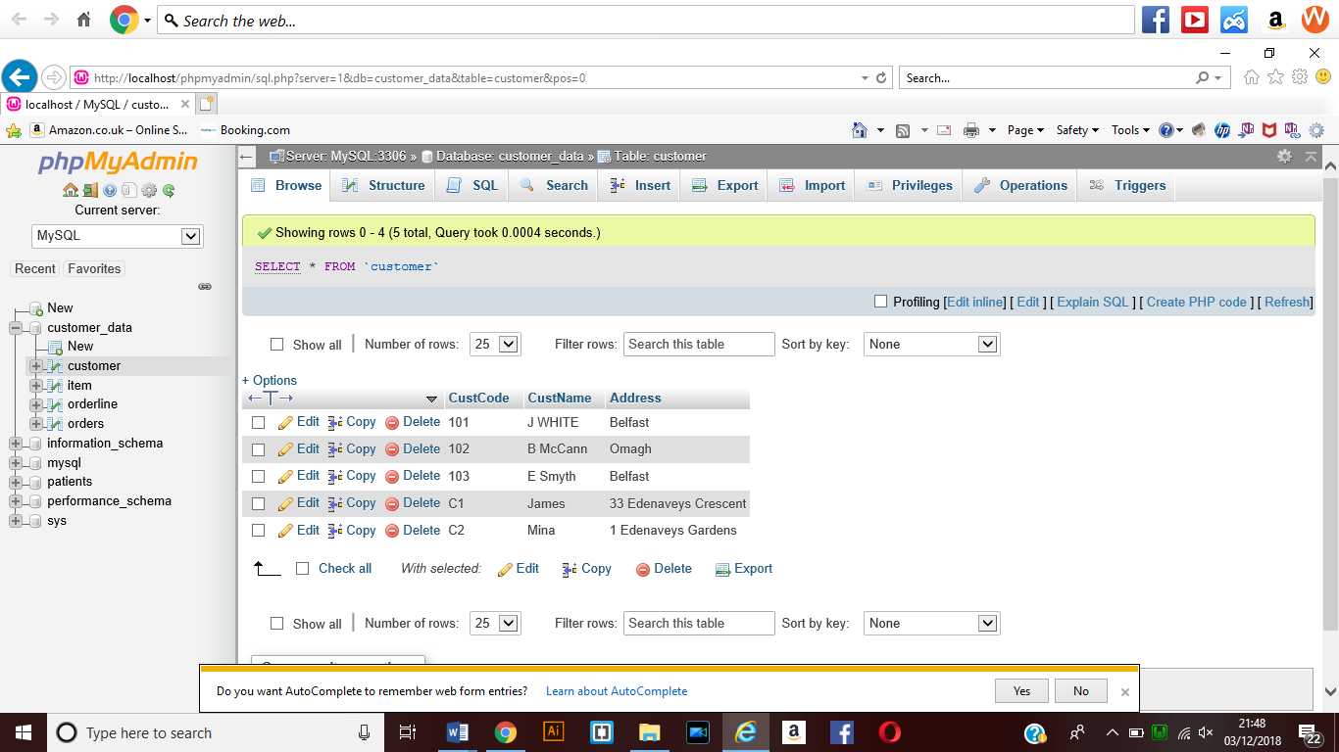

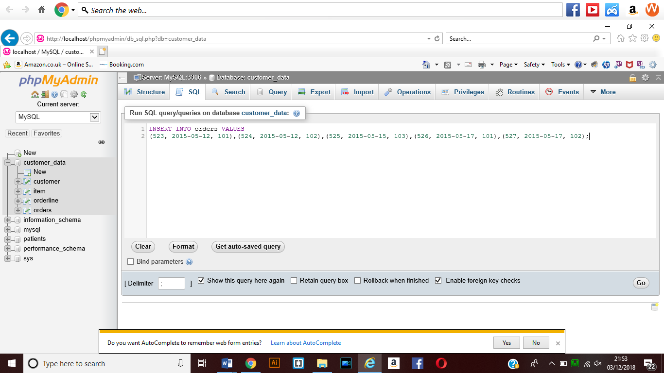 This shows the customer table after the SQL insert statement had been executed so that the information could be added to the database that had been created as part of the week 10 practical work.

Here is the insert SQL statement which would insert the values into the orders table on the database.

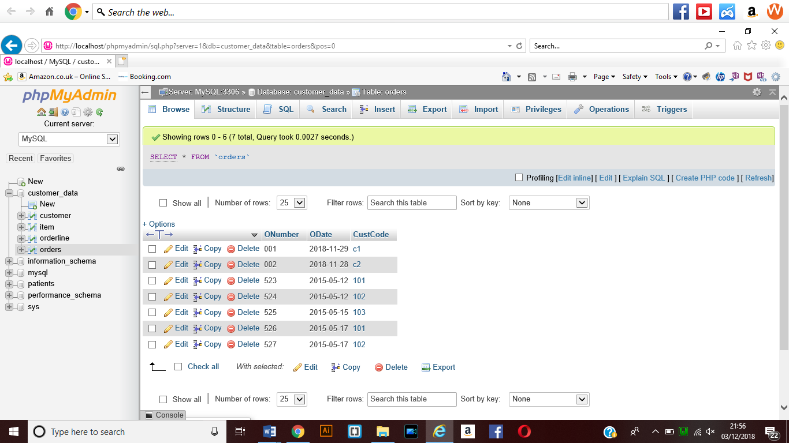

This shows the values have been added to the design which would mean that the data that I had create the SQL statement for was created.

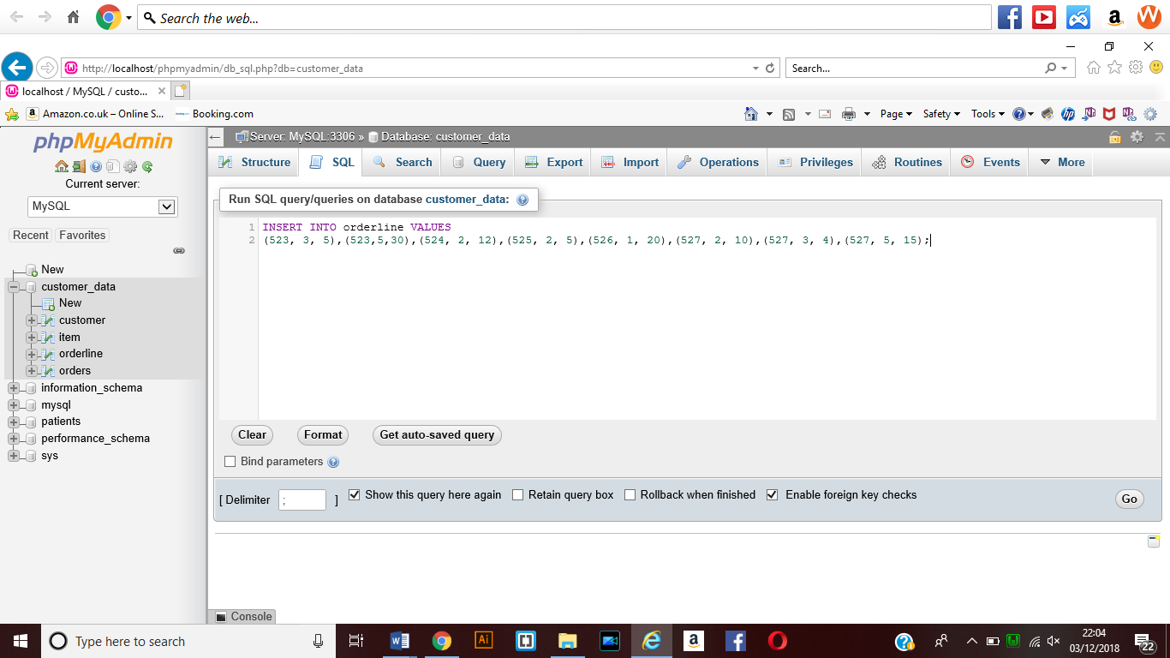

This shows the SQL statement that has been created to insert the values into the orderline table within the database that has been created.

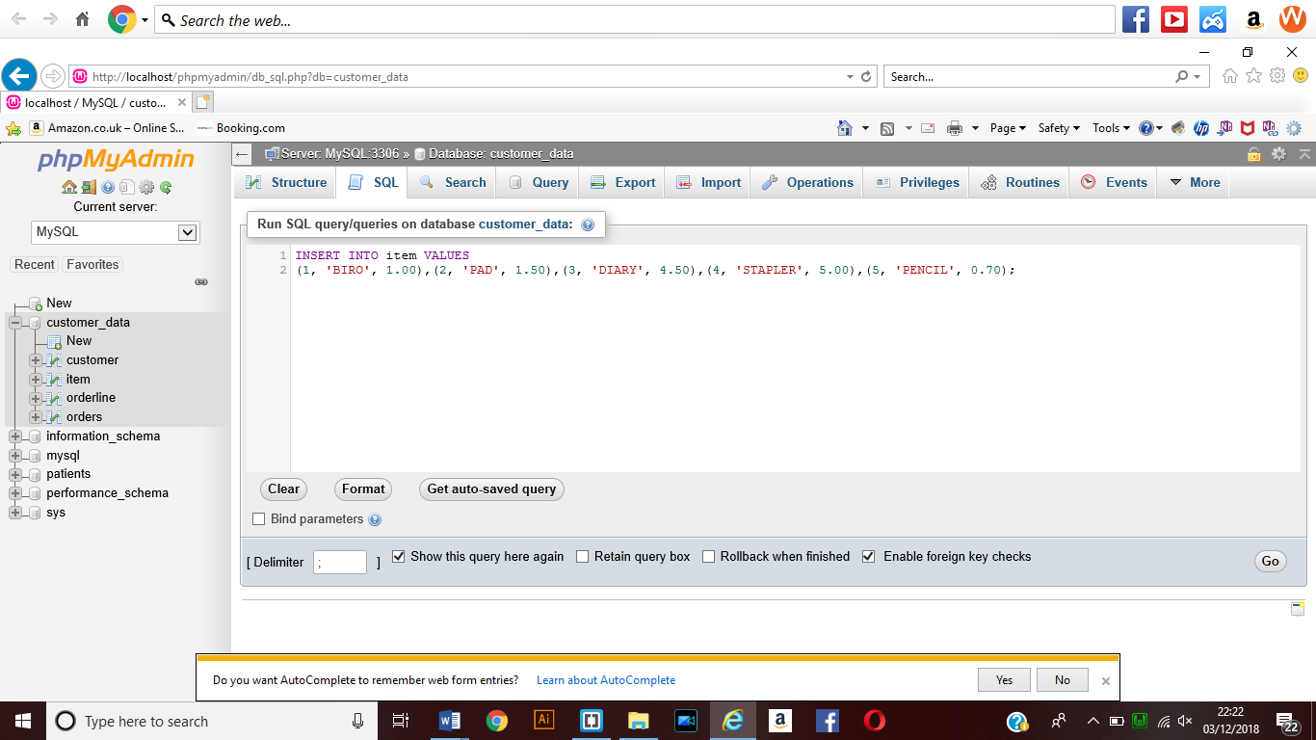

This shows the SQL statement for the values to be added to the item table within the database that had been created.

Deleting Value from the table

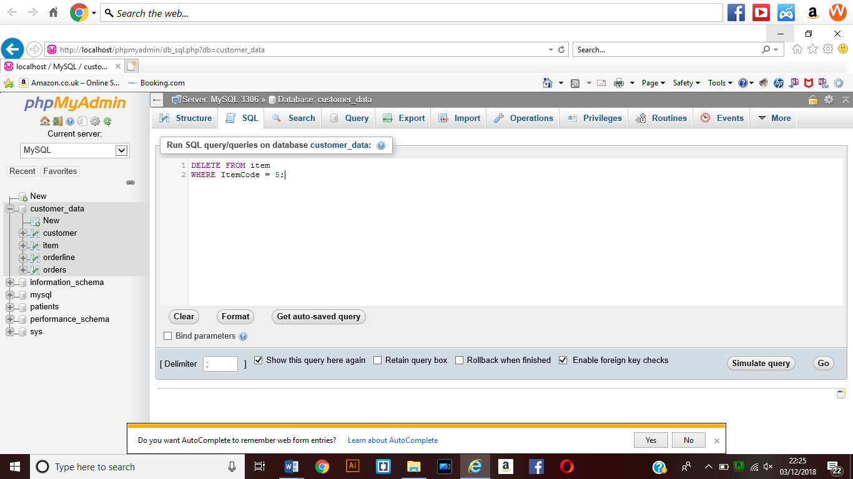

This shows the SQL statement which would mean that you are deleting the value from the item table in the data base. This means that the pencil data will be removed from the database that has been created.

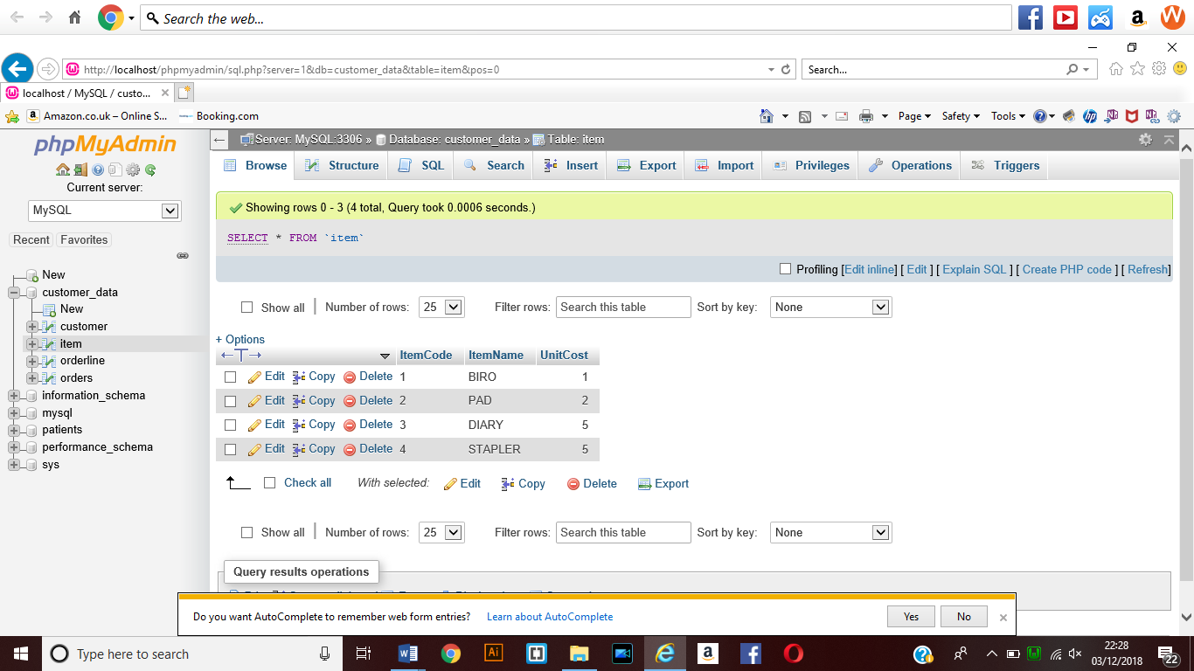

This shows that the code has been executed and the values have been removed that were entered into the delete statement in the SQL.

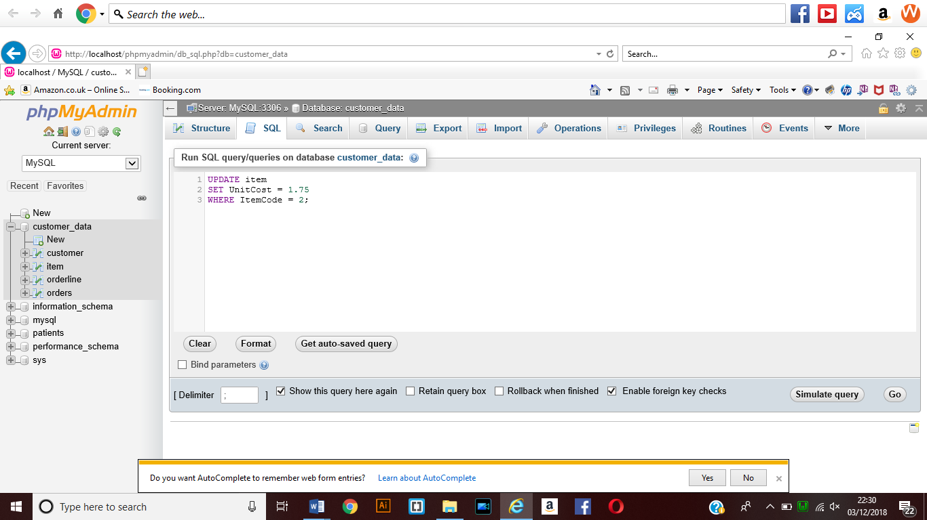This shows the update SQL statement which when executed will update the unit cost for the item which has code of number two which is the Pad data within the item table of the database.

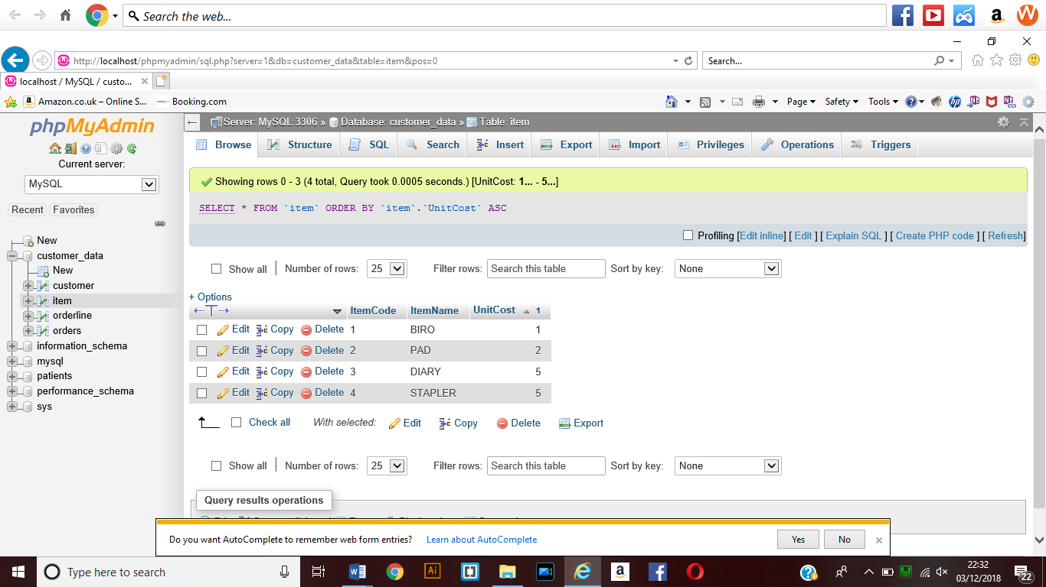

This shows the update to the Unit cost when the SQL code has been executed.

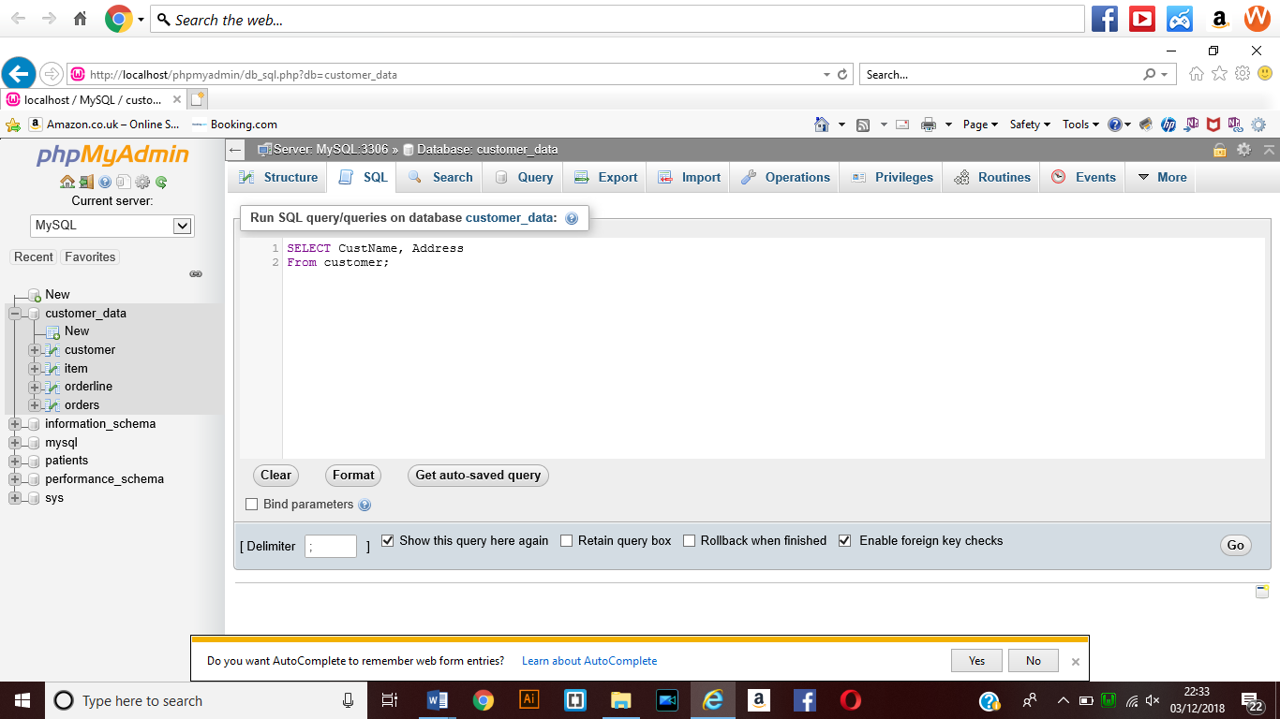

This SQL statement when select the customer name and the address from the customer table within the database that has been created.

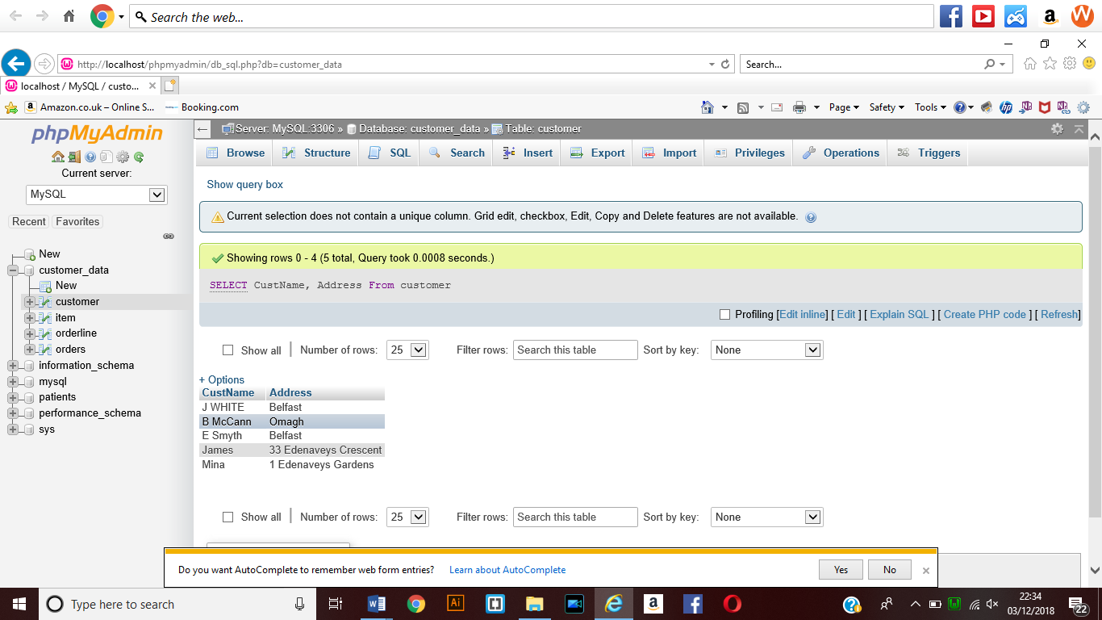

This shows the query results for the SQL statement that has been executed to display the name and address from the customer table within the database.

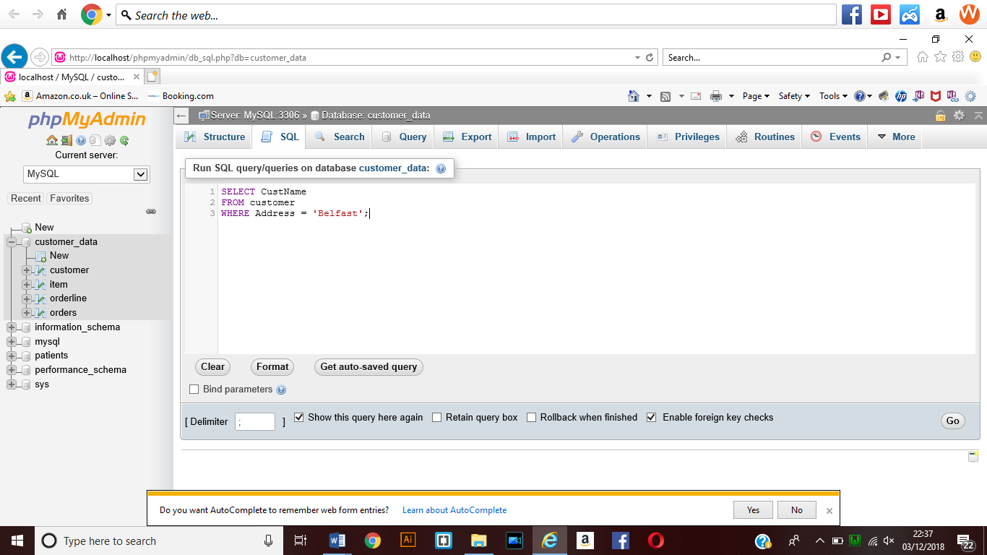

This shows the SELECTION statement that has been created to display the names of the customers where their address is Belfast.

This means that only the customer names will be displayed where the address matches the selection statement that had been entered.

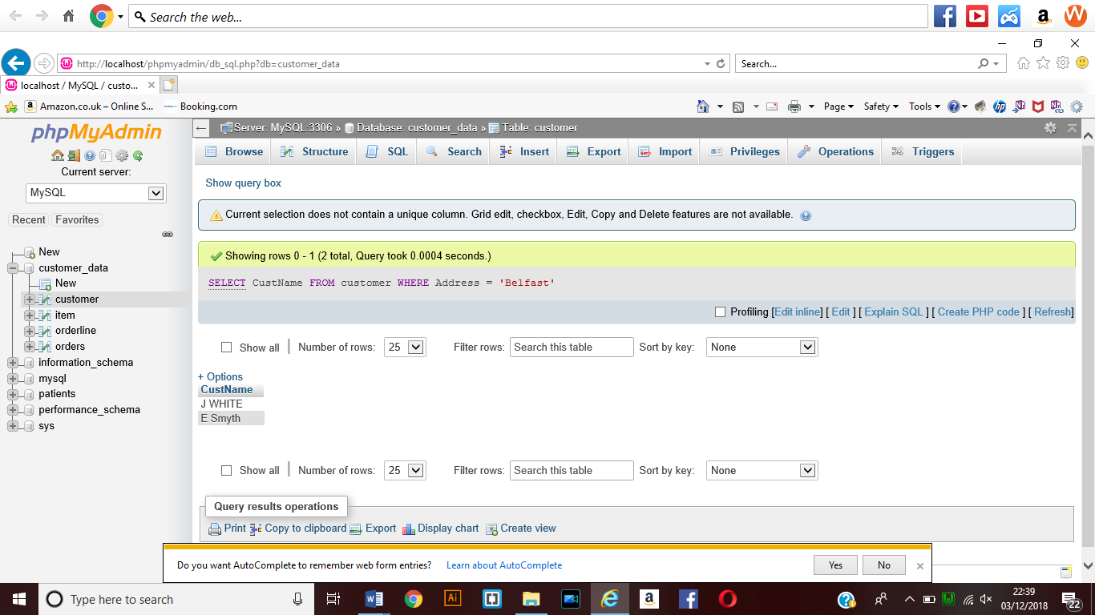

This shows the results of the statement that has been executed which means that the names displayed are those which have been placed within the SQL selection statement that has been created.