COM427 Worksheet 6

# In this week, all php files must be placed in weekly/w6

# 1.

Create 601.html with a form to allow user to enter a number. After user click on the submit button, it goes to 601.php, which receive the number.

* Check if the number is not less than 1;
* If the number is not less than 1, then use a **function**, written by you to calculate the sum of 1+2+…+n

# 2. Create 602.php file to include

a function, with a given parameter $n, which can be used to print all the positive even numbers, no greater than $n$. For example, if $n=11 or $n=10, then it should output 10, 8, 6, 4, 2

# 3. Working with file

Create file inputfile.txt to include the following 4 lines:

Apples are red.

Bananas are yellow.

Carrots are orange.

Dates are brown.

Create 603.php to include the following code in order to output the contents in inputfile.txt.

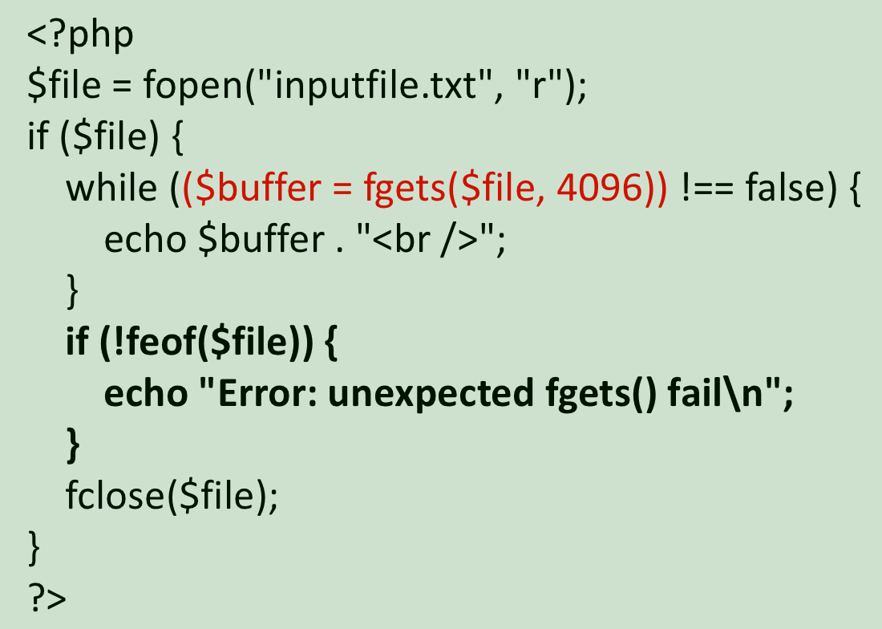

# 4.

Write a program (604.php) to include the following function:

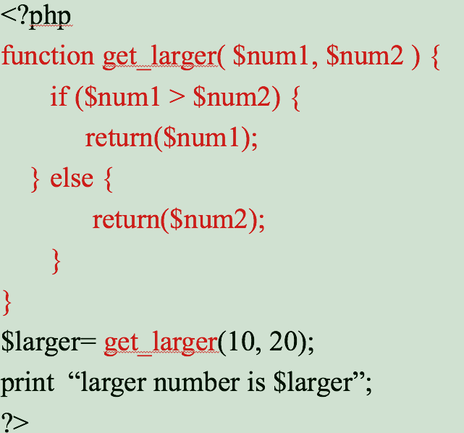

# 5. Create 605.php to implement:

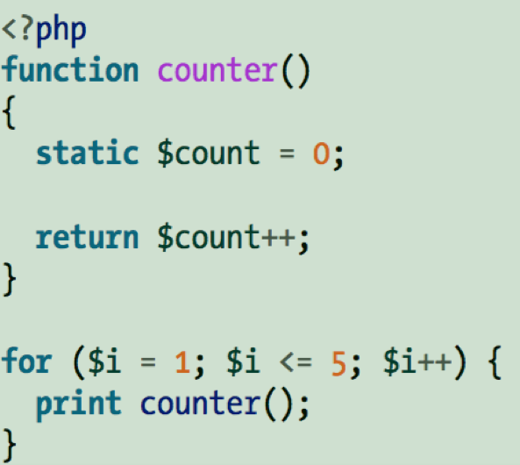

# 6. Create 606.php to implement:

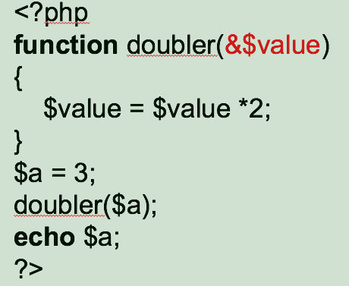

# 7. Create 607.php with

* a function, named **sum_numbers**, to:
  + Take one parameter *n*
  + Calculate the sum 1+2+…+n
  + return the sum
* Call the function and output the result from the function

# 8. Create 608.php to include the following code, which include

* a function, named **find_maximum**, to:
  + Take an array A as its only parameter (we assume array A has positive number)
  + Find the maximum value in the array
  + return the maximum
* Call the function and output the result from the function
* The Code is NOT complete, you should a few lines to complete the task. **Do NOT use the max function from PHP.**

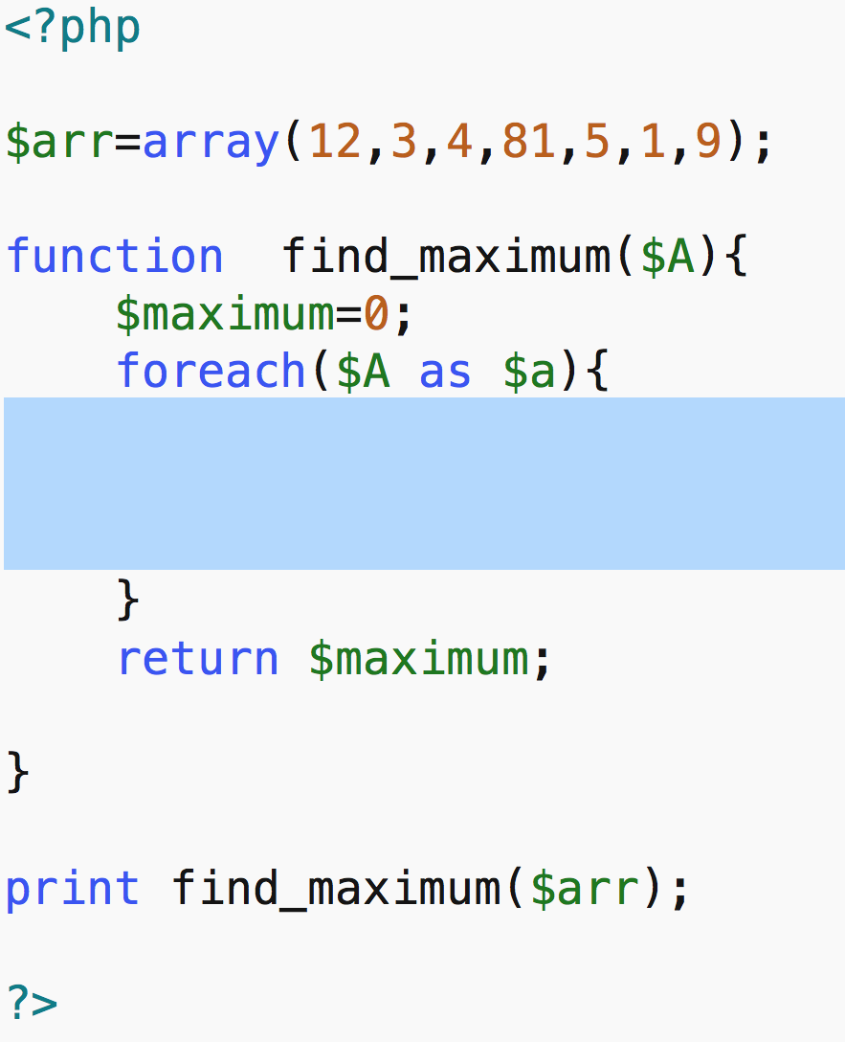

# Wrap up

* zip all the above php files and name the zip file as w6.zip, and make it downloadable via access.html