Vanier College

Computer Science Department

**Tumor Study Organizer**

User Manual

James Kawashima (2148113) – Amanda De Rosa (2070441)

420-331-VA APPLICATION DEVELOPMENT 1

Teacher: Syed Naseem Afzal

Monday, December 12, 2022

Table of Contents

Introduction 2

Interactive Features 2

Graphical User Interface 2

Basic UI 2

User Management System 3

Home Page 3

Studies Page 4

Mice Page 5

Logs Page 6

Account page 7

Settings Page 7

# Introduction

The **TSO** (Tumor Study Organizer) is an invaluable piece of software for pharmacologists all around the world. This piece of software is an interactive database that allows its users to organize information on mice dosing, mice groups, group information, mice information, and which pharmacologist is responsible for which mouse. This manual will provide a useful explanation and demonstration on how the application works to provide the user with enough information to use it.

# Interactive Features

* Login with different users
* View all the different studies being conducted, have been conducted, or going to be conducted. And to also filter through all the studies.
* View different groups of mice and create mice by inputting characteristics to it.
* Perform studies on the mice by giving and modifying doses.
* Euthanizing the mouse if the mouse has suffered enough.
* Create logs that allow the user to automatically catalog changes that have been made.
* Account that displays the user’s information and allows them to take private notes.
* Settings screen: log out, change language, about button, creation of new user.

# Graphical User Interface

# Basic UI

All the features that are used withing this application are located within the menu bar located at the top of the page.



# User Management System

On this page, the person using this application must login to the system by inputting their **username and password** and then press the **Login** button to verify and retrieve the data that corresponds to them.

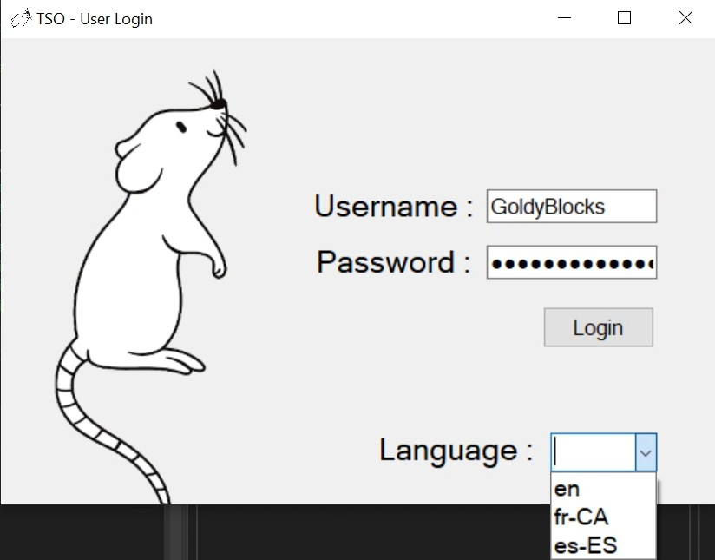

# Home Page

Just a quick recap on what the user is working on with an added calendar to inform the user of the date.

# Studies Page

Within the three different lists of current, previous, and pending studies the user filter specific studies by searching things such as groups of mice, specific users, and specific date.

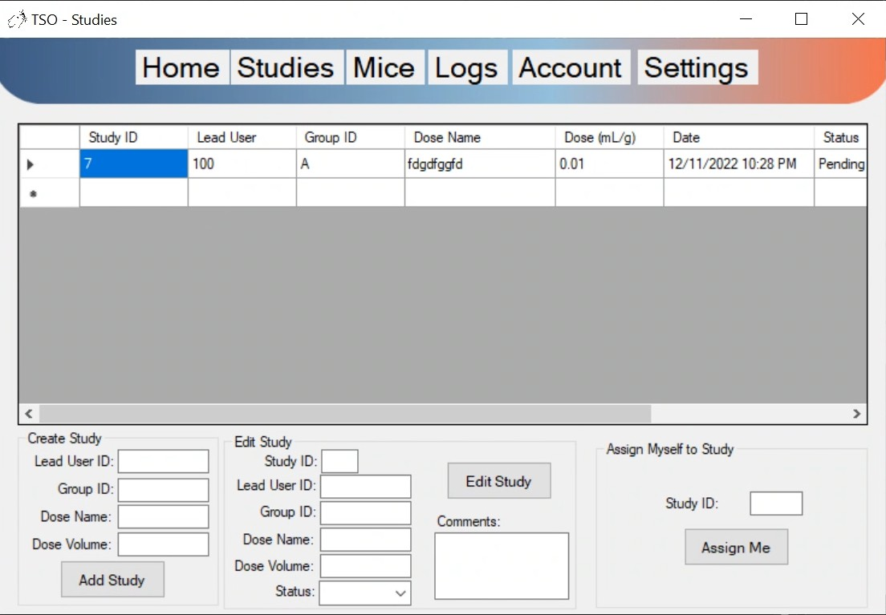

# Mice Page

On this page, you can either create or select a mouse.

Select: Organized by groups you can select what actions you want to do with a mouse such as dosing or putting it down.

Creating: input all the different information such as: Id, groupId, height, length, width, weight, weight, dose, dose2, comments, and tumor Information.

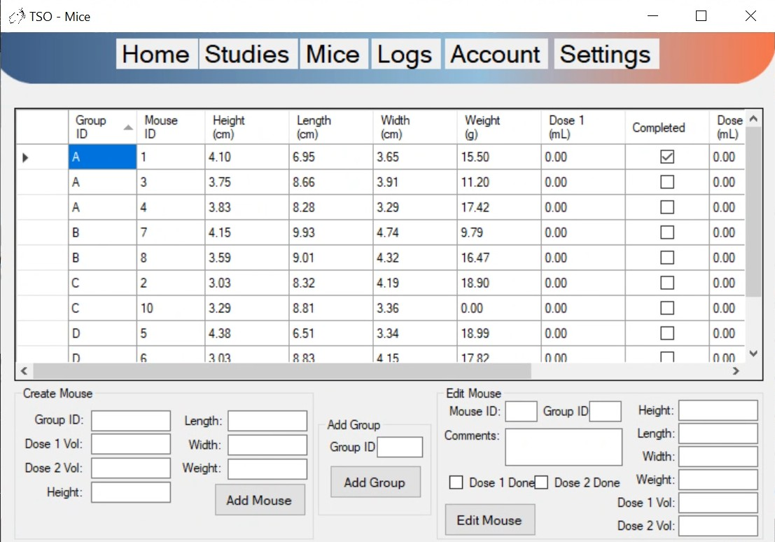

# Logs Page

View and create Logs.

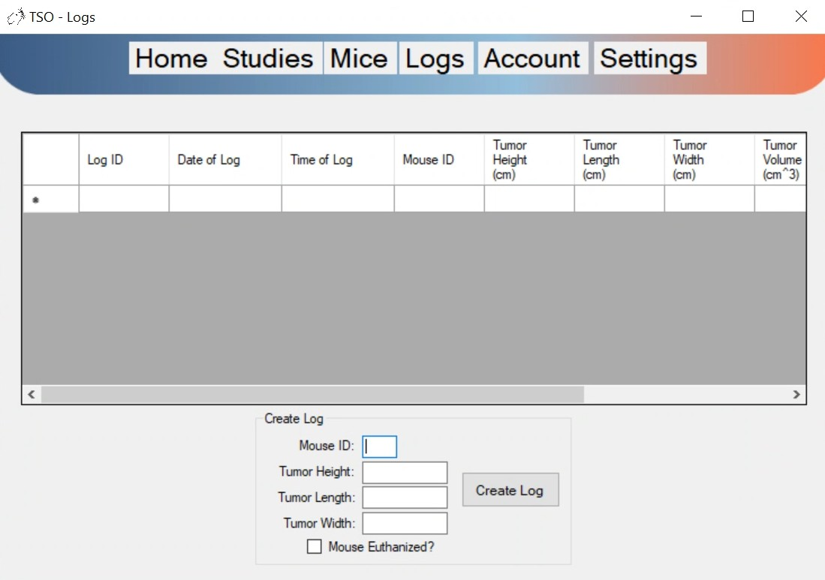

# Account page

This page provides details, private notes, the studies they’re responsible for of the current user.

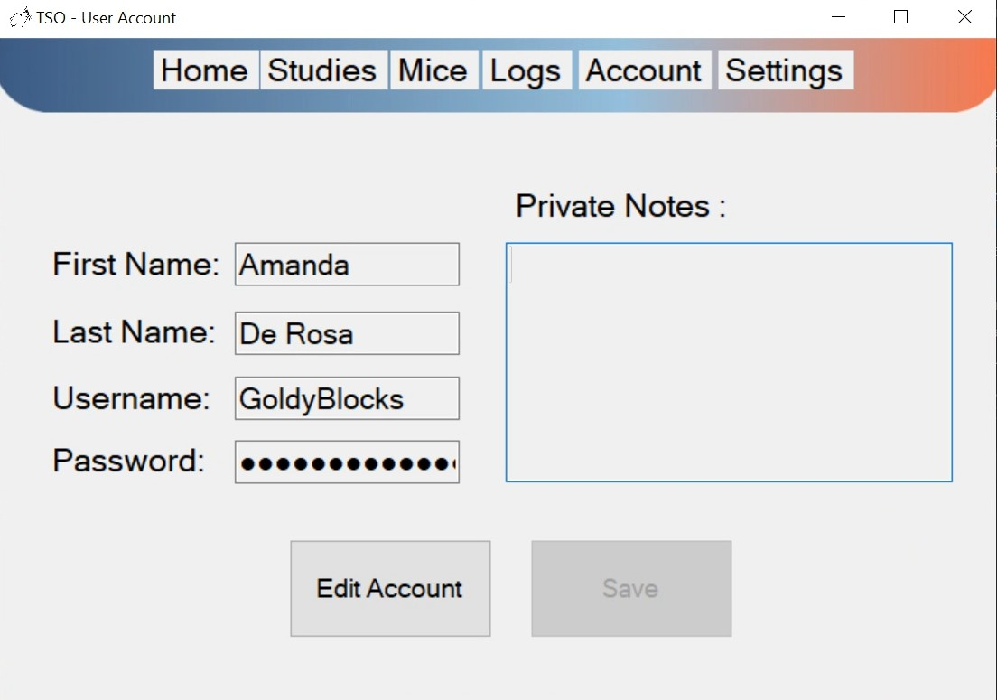

# Settings Page

General application uses such as logging out, an about us, and finally to create a new user.

