James Lawrence

FE 545

I pledge my Honor that I have abided by the Stevens Honor System.

**Homework 6**

**6.1 For various cases compare convergence of Monte Carlo simulations with and without anti-thetic sampling.**

Method:

Explanation:

Code:

MCStatistics.h

MCStatistics.cpp

Analysis:

Output:

Anti-Thetic outputs:

Park Miller outputs:

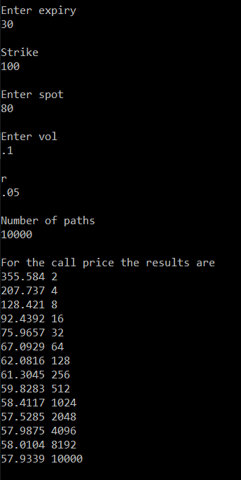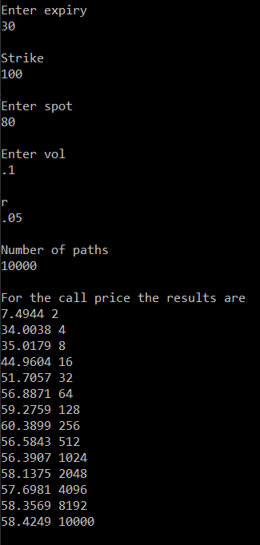

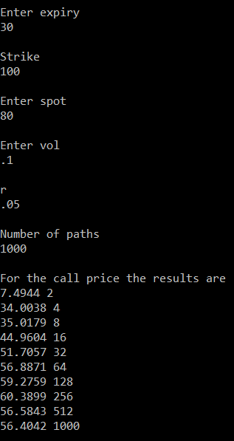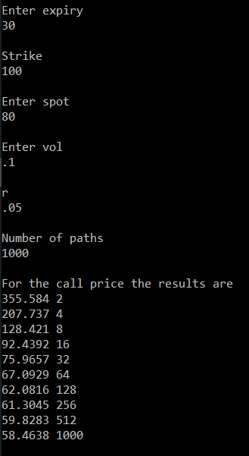

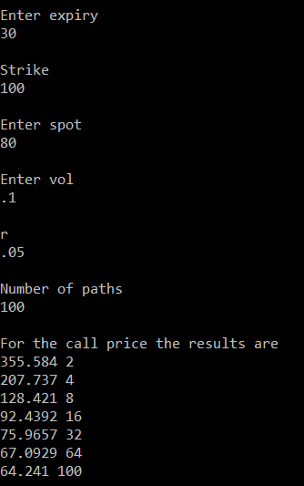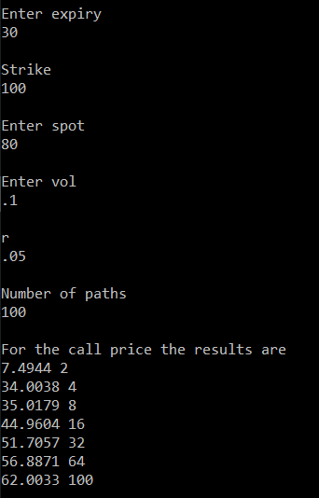

**6.2 Obtain another random number generator and fit it into the class hierarchy given here.**

Method:

Explanation:

Code:

ValueAtRisk.h

ValueAtRisk.cpp

Output #1:

Brief Analysis #1:

Output #2:

Brief Analysis #2:

Verbose Output:

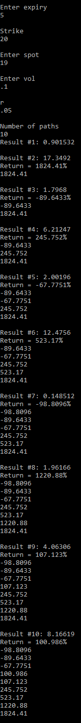

Verbose Output continued:

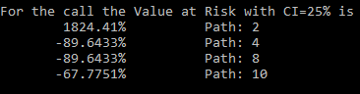

Analysis of Verbose Output:

The output shows each result (Result #) passed to the Value at Risk statistics gatherer class after each path, and displays the percent return (Return =) between each subsequent path. The ordered column of numbers from most negative to most positive is a visualization of the ordered sample returns. The sample return corresponding to the 25% confidence interval is selected to represent the sample Value at Risk. This analysis is returned to the user every so often so the user can see how the Value at Risk tends to decrease with more paths used. The first value tends to be very random due to the list of only a single return to select from.